JAIPUR ENGINEERING COLLEGE AND RESEARCH CENTRE
Year & Sem. – B. Tech II year, Sem.-III
Subject – Technical Communicatio

- Vision of the Institute
- To become a renowned center of outcome based learning, and work towards academic, professional, cultural and social enrichment of the lives of individuals and communities.
- Mission of the Institute
- Focus on evaluation of learning outcomes and motivate students to inculcate research aptitude by project based learning.
- Identify, based on informed perception of Indian, regional and global needs, the areas of focus and provide platform to gain knowledge and solutions.
- Offer opportunities for interaction between academia and industry.
Develop human potential to its fullest extent so that intellectually capable and imaginatively gifted leaders may emerge
- COURSE OUTCOMES:
- Upon the successful completion of the course, the students will be:
- CO1- able to express themselves better in technical writing by understanding the concept, style and methodology used in Technical communication.
- CO2- able to pursue higher studies by working on all aspects of English Language and also develop a better understanding of process and design of technical texts.
CO3- able to get an in depth knowledge of technical communication used in professional life by getting to know all the forms and aspects of Technical Communication
UNIT -1
Contents :-
Introduction to Technical Communication- Definition of technical communication, Aspects
of technical communication, Forms of technical communication, Importance of technical
communication.

Introduction to Technical Communication:-
Technical Writing is a genre of non-fiction writing that encompasses not only technical materials
such as manuals, instructions, specifications, and software documentation, but it also includes
writing produced in day-to-day business operations such as correspondence, proposals, internal

communications, media releases, and many kinds of reports. It includes the communication of
specialized technical information, whether relating to computers and scientific instruments, or
the intricacies of meditation. And because oral and visual presentations are such an important
part of professional life, technical communication also encompasses these as well.
Technical Communication is a process of sharing and making technical documents .Technical
communication can be either written or verbal communication that can help users to accomplish
a defined goal or task. It is helpful to assist users who need specific information on completing
tasks, using products, operating equipment, and so on.
Technical communication and technical writing basically the same things but coming to
technical communication and general communication they are many differences.
Technical Communication
1. It has fixed technical message .
2 . It is always formal.
3 It has a set pattern.
4 it can be Verbal or Written .
5 The audience are fixed.
6 It involves reports ,graphs and pie charts and proper data.
General communication
1. Contains a informal message.
2. Informal style and approach.
3. No fixed pattern of communication.

4. It is non verbal.
5. Audience are varied.
6 . It has no fixed technical term

Characteristics of Technical communication.
It addresses specific audience or particular group.
It showcases the organisation aims and objectives.
It is produced collaboratively.
It is represented in form of words and images.
It is also a replica of culture of a particular organisation vocabulary.

The thing we should always have in mind is the Audience .Technical communication usually
takes place among professionals in their field and they discuss on some on some specific
project on some guidelines , The technical document should be such Firstly in which the reader
should get the organized information that can lead to quick understanding along with decision
making . Secondly it should be fruitful in inviting other ventures.memos, graphics, letters, fliers,
reports, newsletters, presentations, web pages, brochures, proposals, instructions, reviews, press
releases, catalogs, advertisements, handbooks, business plans, policies and procedures,
specifications, instructions, style guides, agendas and so forth.
More or frequently used:-

■ It includes all types of notices, minutes of meeting, circulars quarterly and annually
reports and manuals.
■ Emails, ,web pages, and even social media.
■ Clear and concise to help people get the main idea quickly.
■ Technical terms and technical aids are used. (specific vocabulary, graphics , table ,
diagrams , maps and charts , )
Importance of technical communication
→ It is the heart and soul of the organization as it s helpful in recruiting , functioning ,
decision-making and coordinating whether it is business enterprise, administrative
,academic organization, or medical firm or IT industry.
→ Good qualitative information will always help a company to grow.

→ Technical communication is a field that makes our life easier and more productive

Speaking, writing, reading writing linguistic ability, style in technical communication.

Listening skills are probably one of the most important language skills that you need in order to
be successful in your academic and professional pursuits.
Types of Listening

When we engage in listening we are doing so for many different reasons depending upon the
goals in which we are trying to achieve. There are four different types of listening that are
essential to know when deciding what your goal as the listener is.
The four types of listening are appreciative, empathic, comprehensive, and
critical. Familiarize yourself with these different types of listening so you can strengthen and
improve your ability to critically think and evaluate what you have heard.
Appreciative Listening:-
When you listen for appreciation you are listening for enjoyment. Think about the music you
listen to. You usually listen to music because you enjoy it. The same can be said for appreciative
listening when someone is speaking. Some common types of appreciative listening can be found
in sermons from places of worship, from a motivational speech by people we respect or hold in
high regard, or even from a standup comedian who makes us laugh.
Empathic Listening:-
When you listen empathically you are doing so to show mutual concern. During this type of
listening you are trying to identify with the speaker by understanding the situation in which
he/she is discussing. You are stepping into the other’s shoes to get a better understanding of what
it is he/she is talking about. Usually during this type of listening you want to be fully present in
the moment or mindfully listening to what the speaker is saying. Your goal during this time is to
focus on the speaker, not on yourself. You are trying to understand from the speaker’s
perspective.
Comprehensive Listening:-
If you are watching the news, listening to a lecture, or getting directions from someone, you are
listening to understand or listening to comprehend the message that is being sent. This process is
active. In class, you should be focused, possibly taking notes of the speaker’s main ideas.
Identifying the structure of the speech and evaluating the supports he/she offers as evidence. This
is one of the more difficult types of listening because it requires you to not only concentrate but

to actively participate in the process. The more you practice listening to comprehend, the
stronger listener you become.
Critical Listening:-
Have you ever had to buy an expensive item, such as a new appliance, a car, a cell phone, or an
iPad? You probably did some research beforehand and listened closely to the salesperson when
you went to compare brands. Or perhaps your best friend is telling you about some medical tests
he/she recently had done. You listen closely so you can help your friend understand her results
and the possible ramifications of the findings. Both of these scenarios are examples of critical
listening. Critical listening is listening to evaluate the content of the message. As a critical
listener you are listening to all parts of the message, analyzing it, and evaluating what you heard.
When engaging in critical listening, you are also critically thinking. You are making mental
judgments based on what you see, hear, and read. Your goal as a critical listener is to evaluate
the message that is being sent and decide for yourself if the information is valid.

Technical writing is an audience-centered means of communication that provides a reader with
clear and easy access to information. In the business world, time equates to profit, and profit is
the force behind all business interaction. The technical writer and reader have a vis-à-vis
relationship. The writer recognizes, respects, and addresses the importance of time in effective
and efficient communication by providing documents written in specific formats, using
unambiguous language to send clearly assessable information. The reader in turn thoroughly
understands the information in order to give a thoughtful response.

Unit 2
Comprehension of technical materials/texts and information design and development.
1)Ways of Reading of technical texts:
a)schedule the time to read and recall session:
schedule the reading to make your certification done in time. 30 mins-1 hr for reading when you have much free time and the highest focus.
b) set up a special reading area with no distractions:
find a place where you can get away from your phone, your family, and any other distractions and just read. The idea is to create a place where you can focus and enjoy what you’re doing so you can absorb what you’re reading because you need to keep focused, stay productive.
c)no speed-reading, neither quick reading:
In the century of efficiency, we are trying to absorb the information as soon as possible. But reading demands time. All it benefits are not seen immediately. Usually, after you’ve read the big part of the book. Speed reading does not work.
d) read in stages
start by reading the title of the manual, the preface and then study the table of contents. Then start reading parts of the sections that you discovered are most relevant to you.
e) come back to difficult points:
understand the content of the book. Don’t clarify everything. Make a note and move forward.
2)Comprehending technical manuals:
a)survey:
- State your purpose for reading the material.
- Notice each bold face heading and sub headings.
- Skim over graphs, tables, charts etc to see how they support and explain the text.
b)questions: frame questions
c)read:
- Divide chapter into small sections.
- Ask questions before each paragraph or section and then locate the answers in the text.
- Note down essential points and vocabulary.
- Think, interpret and analyse the first time you read, to avoid unnecessary re-reading.
d)recite:
- make separate notes or outlines and answer questions from memory.
- Discuss.
e) review
3) Interpreting any technical text
a) read a lot ad everyday:
increasing your daily reading load will greatly help you in interpreting ay text. As it broadens your textual analysis drills. And when we talk about “reading” we are referring not only to books but also to other productions, such as news reports, blog posts etc.
b) explain to yourself what you are reading:
try to slow down the text by breaking it down into smaller parts so you do not have to interpret everything at once in the end. Also, adopt some practices that help you understand all the phrases and do not lose parts of speech.
c) study grammar:
while reading, always try to have a dictionary around. Each time you notice a word that you do not know the meaning, note or search. This will help you not miss any important term within the text.
d) write a lot:
reading and writing are very related processes. Therefore writing well will help you develop a better understanding of texts, as you will be more familiar with the structures and how they organize to create meaning.
e) focus on each important key terms and vocabs.
While reading any reading any technical text focus on the key terms and words so that it can help you a lot with the learning of the subjects.
4) Summarising any technical text:
a) the very first step for making a summary is to have a reading skill.
b) underline or mark the main sentence of the passage.
c) after collecting the main points, check for the appropriateness of the ideas for making the summary.
d) prepare the first draft of the summary. You can add or edit any piece of information.
Techniques for summarization:
a)selection:
for making a summary it is very important to select the main idea, keywords and the special terms in the source. They help in getting the idea and making the summary.
b)rejection:
it is a process of removing uwanted and not so important sentences while making summaries as note making examples.
c)substitution:
it is a process in which new sentences get to add up instead of the previous one. Also, several sentences are combined to form one sentence. It reduces the length of the summary.
5) Note making:
Advantages of note making:
i)It is an organized form of important points which can be used in future.
ii) it helps in recollecting and recalling the past events said or heard.
iii) it helps a reader to go through bulky documents quicker.
iv) it helps in concentrating, understanding and providing a permanent record.
v) it distinguishes between main points and details.
Format of note-making:
i)heading
ii)subheading
iii)point
iv)keywords
Procedure of note making:
i)read the passage provided
ii)underline the important sentences. It helps to make headings and subheadings
iii)make a rough note first so as to get an idea.
iv)organize them in logical order or sequence for the final note.
v)use the appropriate note making format.
Methods of note making:
i)split method/page method
ii)diagram/ pattern method
iii)mind map(a visual note making method)
iv)outline method
v)question and prompt format.
6) Information collection:
Ways to collect information:
i)survey
ii)observation and audits
iii)interviews
iv)existing data sources
v)focus group
vi)case studies
Important factors in effective document design:
i)white space
ii)written cues
iii)graphic aid
iv)proportion
v)consistency.
7)ways of Writing for print media:
a)inverted pyramid
b)the five w’s and H
c)simple language
d)narrative structure
ways of Writing for online media:
a)introductory text
b)points of entry
c)key facts first
d)link in and out
e)say it straight
Unit – III

Technical Writing, Grammar and Editing- Technical writing process, forms
of technical discourse, Writing, drafts and revising, Basics of grammar,
common error in writing and speaking, Study of advanced grammar, Editing
strategies to achieve appropriate technical style, Introduction to advanced
technical communication. Planning, drafting and writing Official Notes,
Letters, E-mail, Resume, Job Application, Minutes of Meetings.

UNIT -3 TechnicalWriting,Grammar and Editing-
 What is technical writing ?
 It is art of presenting technical information to the audience in such away that they can
understand and use the information. Today technical writing encompasses all documentation
of complex technical processes. It includes reports, executive summary statements, briefs.
Any time technical information is conveyed in writing at work, it is, by definition, technical
writing.
 This can include high-tech manufacturing, engineering, biotech, energy, aerospace, finance,
IT, and global supply chain.
 The format is no longer bound to lengthy user manuals. Technical information must be
distilled and presented unambiguously. This can come in the form of technical reports,
emails, policy, briefs, and press releases.
In easy words it follows through formal channels , formal communication can be in different forms
like vertical communication, horizontal, upward and others.

Technicalwritingprocess,formsoftechnicaldiscourse,Writing,draftsandrevising,Basicsofgrammar,com
monerrorinwritingandspeaking,Studyofadvancedgrammar,Editingstrategiestoachieveappropriatetech
nicalstyle,Introductiontoadvancedtechnicalcommunication.Planning,draftingandwritingOfficialNotes,
Letters,E-mail,Resume,JobApplication,MinutesofMeetings.
What is Technical writing? „
Writing that focuses on instrumental discourse (discourse that aims to do something) ‰ e.g.
computer manuals (print and help screens) ‰ Assembly instructions for toys, appliances, games

Purpose of all these documents: „ to inform, To be “instruments” or tools for people to use to get
things done. The documents you will write in this course all share this sense of purpose.
Importance of Technical Communication:-
While beginning to work as an engineer We will realize that our job requires While beginning to
work as an engineer you will realize that your job requires you to write proposals, specifications,
reports, conference papers, letters and electronic messages. Writing is perhaps the most important
way in which information is conveyed to managers, fellow engineers…show more content…
Of course, they knew technical knowledge would be important; but they never realized technical
communication in general, and writing in particular would be so crucial to their success. People
who cannot communicate well often find themselves wondering why they did not get the job or
why they were passed over for promotions. Today, effective technical communication is more
important than ever. We live in an age in which whole industries are built around the development,
retention and application of information. The ability to communicate effectively is crucial if you
plan to survive and succeed. Yet, managers regularly report that college graduates do not have
adequate communication skills. Fortunately, you can teach yourself to write and speak effectively
in the technical workplace. The ability to communicate effectively is not something people are
born with. With a little effort, anyone can learn to write and speak…show more content…
• Your performance evaluations will often be based on the documents that you wrote or helped
produce. • Your colleagues will judge your abilities by the effectiveness of your documents or
presentations. • Your company’s clients will judge the quality of your entire company by the
quality of your documents and the presentations you make to them. A lot of good ideas never see
the light of day because the engineers who have them are unable to communicate their ideas.
Therefore, if you want to advance beyond just being a number cruncher, then you need to be able
to communicate effectively; and that includes acquiring at least a minimal proficiency in writing. If

you want to work semi-independently or if you want to supervise other people, the ability to
communicate is critical. In fact, if you talk about leadership skills, communication skills is always
consistently at the top of the list. If you can’t communicate with the people that you’re trying to
direct or lead, then they won’t know what to write proposals, specifications, reports, conference
papers, letters and electronic messages. Writing is perhaps the most important way in which
information is conveyed to managers, fellow engineers,…show more content…
Of course, they knew technical knowledge would be important; but they never realized technical
communication in general, and writing in particular would be so crucial to their success. People
who cannot communicate well often find themselves wondering why they did not get the job or
why they were passed over for promotions. Today, effective technical communication is more
important than ever. We live in an age in which whole industries are built around the development,
retention and application of information. The ability to communicate effectively is crucial if you
plan to survive and succeed. Yet, managers regularly report that college graduates do not have
adequate communication skills. Fortunately, you can teach yourself to write and speak effectively
in the technical workplace. The ability to communicate effectively is not something people are
born with. With a little effort, anyone can learn to write and speak…show more content…
• your performance evaluations will often be based on the documents that you wrote or helped
produce. • Your colleagues will judge your abilities by the effectiveness of your documents or
presentations. • Your company’s clients will judge the quality of your entire company by the
quality of your documents and the presentations you make to them. A lot of good ideas never see
the light of day because the engineers who have them are unable to communicate their ideas.
Therefore, if you want to advance beyond just being a number cruncher, then you need to be able
to communicate effectively; and that includes acquiring at least a minimal proficiency in writing. If
you want to work semi-independently or if you want to supervise other people, the ability to

communicate is critical. In fact, if you talk about leadership skills, communication skills is always
consistently at the top of the list. If you can’t communicate with the people that you’re trying to
direct or lead, then they won’t know what to.

Essential for technical communication

The writing process stages :-

10/26/2020sonia khubchandani 10

 Next is understanding audience
 The audience are the important factor that is to be considered at the top most in technical
writing , you are supposed to write a highly technical subject but in such a way that a
beginner can understand it.
 Accumulating information:-
a).Style of writing

b). Type of document.
c). Type of Audience
d). Resources to be used
e). Subject matter that is to be written.

Stages in detail :-
Designing a document:-
Sorting of information.
Preparing a draft of the outline.
Sequencing the information as per importance.
Arranging as per format.
Essential details and examples with supporting documents.
Provides information about the type of document.
 Creating Document
a). Development of the design
b). Writing style should be simple
c).Avoid jargons
d).User friendly language

e ) Reviewing document
a)Self review
b).Client review
c).Technical review
Publishing Document
a). Soft copy /CD /DVD
b). Print or bind

Technical discourse :-

 There are mainly two types of discourse Written and Oral
 The difference between speech and writing is referred to as channel or medium as both of
the discourses needs some processes .
 Difference between the two is spoken has to understood at the spot whereas written can
be referred several times. Spoken is fast as compared to written.

 Difference between Spoken and Written discourse.
 1.Spoken gestures , body language.
 2 Intonation

 3 .Pitch range
 4. Stress
 5 Rhythm
 6 Pausing and Phrasing: - a small gap difficult to be measured.
Diagram for discourse process:-

What is technical writing ?
 It is art of presenting technical information to the audience in such away that they can
understand and use the information. Today technical writing encompasses all
documentation of complex technical processes. It includes reports, executive summary
statements, briefs. Any time technical information is conveyed in writing at work, it is, by
definition, technical writing.
 This can include high-tech manufacturing, engineering, biotech, energy, aerospace,
finance, IT, and global supply chain.
 The format is no longer bound to lengthy user manuals. Technical information must be
distilled and presented unambiguously. This can come in the form of technical reports,
emails, policy, briefs, and press releases.
In easy words it follows through formal channels, formal communication can be in different
forms like vertical communication, horizontal, upward and others.

Technical Writing
Official Notes, Letters, E-mail, Minutes of Meetings

Forms of communication
 There are various forms of technical communication the very first we will discuss is
Business letter
 A business letter is a document which is written by authorised person of an organisation ,
it is a document which is not only within the premises of the organisation but also outside
the organisation , this can be sent in other organisations, credit departments, suppliers
,customers and employees etc .

Importance of Business letter
 Helps in maintaining business relationship.
 Important media for complex information.
 Valuable source of information for future.
 It helps to serve a large number of people.
 It is economic as compared to other means of communication.

Functions of business letter.
 To create and sustain new business relations, different organisations will have different
purpose of writing it.
 To send greetings.
 To inform about new product or offers and services.
 To request dues and collect dues. (Airtel , Vodafone bill warning, insurance policies ).
 Reminders for different products, services available dates.

 To apply for a job and internship. (Job application)
 Always use greetings before starting .
 Approach should be direct and concise.
 Provide all details required in concise and correct form.
 Proof read your letter as its the replica of the company .(avoid mistakes vocabulary ,
grammar )
 Avoid Jargons .
Essentials of business letter
Heading
Date

 Subject
 Inside address
 Salutation
 Message
 Complimentary message
 Signature

Sample Business Letter About Shipment
 Company, Inc.
 123 Alphabet Drive
 Los Angeles, California 90002
 13 July 2020
 Mr. John Doe
 Customer Service Representative
 Widgets Galore, Inc.
 987 Widget Street
 Miami, Florida 33111
 Dear Mr. Doe:

Greetings”
 I am writing you concerning a recent purchase of widgets. Approximately two weeks
ago, on June , I5 ordered a total of 50 widgets for Company, Inc. via the Widgets Galore
client webpage. I received an email notification two days later confirming the receipt of
payment and the shipment of the widgets. According to your website, shipments should
reach their destination within 3-5 business days of being sent, but I have yet to receive
the widgets. Do you have any information on what may have happened to delay the
shipment or where the shipment is currently?
 I have worked with Widgets Galore, Inc. in the past and have the greatest confidence in
your products and customer service. We need the shipment of widgets soon, however,
and I hoped you might be able to provide me with an idea of when I can expect them.
 Thank you in advance for any help you might be able to offer.
 Sincerely,
 Saksham
 Vice President of Company, Inc.
 555-555-5555

 s.brown@companyinc.com
Email writing :-

 Email is the most common form of business communication so it is important to make
them clear, concise and actionable.
 Important contents :-
 Subject Line Subject line is the first thing a recipient reads. Subject should be short and
to the point and it should highlight the main message of the email. The ideal subject gives
the reader all they need to know or informs them they need to make a decision.
 Greeting :- · Begin with a greeting Always open your email with a greeting. The greeting
should be concise and formal. You may or may not choose to address a person
specifically by name, depending on the context of the message. Some examples of
greetings are:
 State your purpose
 If you are starting the email communication, it is not possible to include a line of thanks
then begin by stating your purpose.
 For example, “I am writing to enquire about …” or “I am writing in reference to …”
Make your purpose clear early on in the email, and then move into the main text of your
email. Remember, people want to read emails quickly, so keep your sentences short and
clear. You’ll also need to pay careful attention to grammar, spelling and punctuation so
that you present a professional image of yourself and your company.
 · Attachments Include URLs or attachments if that will help the recipient .

Never force the recipient to hunt for a URL or attachment in another email.
 · End with a closing
 The last step is to include an appropriate closing with your name.
 Some potential closings:
 I look forward to your response,
 I hope to hear from you soon,
 Thank you for your time,
 Thank you for your attention to this matter,

Sign your name
 It is appropriate to write your name and title in a work at the end of an email.
 Choose the most suitable phrase before typing your name.
 Yours sincerely, (when you know the name of the recipient, (Formal)
 Best regards, or Kind regards, (Formal, Most common) .

Minutes of meeting
 What are meeting minutes for?
 Meeting minutes are the notes that capture what happened at a meeting! Different than
a meeting agenda, it records the decisions made and actions requested by the group.

Despite the team, they are not a minute-by-minute record but include the key details that
the team will want to know. It&#39;s important in meeting minutes to capture information such
as:
 decisions made
 next steps
 action items and who is responsible
 Minutes are the record of who was there and what happened. They are an important
source of information for people who were unable to attend or looking back to reflect on
what happened. They&#39;re also an incredibly effective tool to notify or remind people of
tasks assigned to them or timelines to keep everyone on track.

What should go into meeting minutes?
Here are some of the details that you should into the meeting minutes.
a. Date and time of meeting
b. Names of the participants
c. Agenda items and topics discussed
d. Action plan
2. informal team meeting minutes template
a. date: today&#39;s date
b. attendees
c. List of attendees
 Agenda
 Item 1 including key discussions, decisions made, next steps

 Item 2
 Item 3
 Next steps
 List goes here in format: action item, responsible person, date
 Example: Brian to follow up to this group with a list of target companies by
SAMPLE MOM

EUREKA FORBES
VAISHALI NAGAR
AMARPALI CIRCLE

Noting Reference No. EUP /01/2019-20/131
19/12/19

Minutes of Meeting

Venue : CONFERENCE HALL 01
Date &amp; Time : Thursday AUGUST 19, 2020 at 11:00 AM

Agenda :

1. Dress code in the Organization
2. Any other issues

Members Present :

1. Prof. (Dr.)G.K. Chandna, Chair
2. Dr. Sanjay Kaushik
3. Sh. Bhoopesh Kumawat
4. Dr. Vmprakash Netula
5. Dr. M.P. Singh
6. Sh. Hetram Sharma
7. Dr. Fauzia SIddiqui
8. Dr. Parul Tyagi
9. Dr. Aruchi Mathur

Meeting started at 11:00 AM; following items were discussed –

1. There is a need of proper dress code for the staff to maintain the College decorum.
They are coming casual dress. Therefore,
2. It has been decided that –
a. Every staff should wear their identity card while they are in the campus.
b. Male faculty member will wear formal dress with leather shoe. Every day
clean shave / well groomed beard.
c. Female members will wear sari or collared shirts with trousers .

3. It was also made clear that jeans, sports shoes, T-shirts etc. will not allowed in the campus.
4. All concerned assured that they will follow the same with to come in proper dress from
November 2, 2020.
5 .It also decided that after November 2, 2020; They will be penalized for the same
6 The meeting ended with a vote of thanks.
Warm Regards
Mr……
Designation

RESUME WRITING
Resume Writing-
 -Highlight skills, knowledge, and expertise
 -Concise, easy to read document
 Summary of:
 - Qualification
 - Education
 - Experience
 - Skills
 A One page resume is preferred by most employers
 An employer will evaluate you as a person while scanning your resume, i.e.:
 Neat resume = neat person
 b) Well-organized resume = well-organized person.
 c) Error free resume = careful person
 d) Professional appearance = careful &amp; competent person

 An employer will evaluate you as a person while scanning your resume, i.e.:
 Neat resume = neat person
 b) Well-organized resume = well-organized person
 c) Error free resume = careful person
 d) Professional appearance = careful &amp; competent person

 How to write a Cover letter?
 Rules
 Give enough information to interest the reader, don’t overwhelm.
 Research the company. Address the letter to a specific person.
 Answer an ad if you have 50% of the skills or background that the ad requires.
 Mention the person who referred you if appropriate.

 Contents

 Your address, city, state, zip, and telephone number.
 Date
 Name, title, company, address, city, state, and zip of person you’re writing to.
 Greeting, followed by a colon.
 Paragraph-1:
 What do you want?
 How do you know about the organization?
 Mention enclosure of your resume?

 Paragraph 2:
 Concise overview of work history and skills that will help you perform the job.
 Paragraph 3:
 State confidence in your ability.
 Give information on how you can be contacted (Ph.no., e-mail id)
 Paragraph 4:
 Express appreciation and gratefulness.
Sample
ABC

 B-75 Civil Lines
 Road ,45
 T: (07) 8222 1111
 M: 0400 333 888
 [date]
 Rajeev Batra
 HR Manager
 HCL Ltd.
 PO Box 300
 Green Plains NSW 2008
Dear Ms Forrester
Re: Mechanical Engineer Position
I am writing to apply for the position of Mechanical Engineer as recently advertised on
seek.com.
 I am a highly motivated Mechanical Engineer with a Bachelor of Engineering
(Mechanical Major) I have one year of practical on-site mining experience. I am very
much interested in joining the engineering team at HCL Ltd. given your reputation for
world-leading innovation in open cut and underground mining.
I am very confident in planning and designing projects using AutoCAD and EXTB, and
contributing to the budgeting process. I enjoy the hands-on work that this type of mining role

entails, including checking the technical aspects of drawings and equipment designs and the
maintenance of existing infrastructure.
 I have a thorough knowledge of the processes of open cut and underground mining and
experienced in directing and managing the on-site team, including contractors. I possess
excellent interpersonal and communication skills and my multitasking abilities are
advanced.

 Given my on-site experience I am accustomed to operate in a FIFO environment and
working hard to keep projects running on time and within budget.

 I am keen to employ my skills and enthusiasm as an integral part of your team and I look
forward to being able to discuss this position with you further.

 Yours sincerely

 [sign here]

 ABC

Unit 4.
Advanced Technical Writing
Technical Reports
A technical report (also scientific report) is a document that describes the process, progress, or results of technical or scientific report or the state of a technical or scientific research problem. It basically compiles the description about some process, it may be progress of some activity or an organisation or a scheme. The technical report should ensure all the components necessary in it and in proper sequence. If the target group needs some background to study the report, it should be covered. The information should be factual and purpose specific.
Characteristics of Technical reports ....
- may contain data, design criteria, procedures, literature reviews, research history, detailed tables, illustrations/images, explanation of approaches that were unsuccessful.
- may be published before the corresponding journal literature; may have more or different details than its subsequent journal article.
- may contain less background information since the sponsor already knows it
- may have restricted access
  - classified and export controlled reports
- may contain obscure acronyms and codes as part of identifying information
Characteristics of Technical reports in detail....
- Shape and Size: The report may have 8-10 pages, typed or printed in proper format, with proper margin and spacing. The upper size of the report is related with time, efforts and resources. If necessary, trim it as per requirement.
- Content: The reports should be easy to follow, for a non technical person or a non specialist. The necessary technical details may be covered but, over doze of technicality should be avoided.
- Facts: As per the objective of the report and requirement of the target group of the agency assigning the job, the facts and figures should be covered. The necessary detailing of facts should not be sacrificed.
- Sources: The technical report is the compilation of information from various sources, like publication in journals and books, technical brochures, personal and written communication with experts, site visits, surveys, etc. The sources of information should be reliable.
- Documentation: As mentioned, the information compiled in the report is collected from different sources. There is a tradition of acknowledging the sources as references or other modes. This transparency will be liked by the original writers. All the information, data, opinions should be well documented
- Target Readers: Some times, the report is prepared by a committee, appointed for the purpose. So, it is ought to be specific. In other cases, it is desirable that the report aims at some specific group, so that it can meet with the expectations of that group. Too general report may not be useful to any body.
- Titles and subtitles: The report may cover different aspects of the work. They may be given some titles or headings. In case of a detailed report, under each title, there may be a lot of content. It may be further sub divided in to subtitles. The titles and subtitles, help the readers in discriminating one topic or an aspect from the other and one subtopic from the other. On the writer side, it helps in proper organisation of the report, with proper focusing and on user side it helps in proper understanding of the report. If somebody is interested in a specific aspect of the report, he can refer accordingly.
- Physical Arrangement: The physical presentation of the report is concerned with typing and printing. The graphical or pictorial information may not be reproduced properly in computer or machine printing. Photo copying or scanning is advisable. A loose report or a strip binding or a spiral binding is not impressive and durable. Hard paper binding is advisable.
- Graphics: In addition to description in alphanumeric form, the reports may have graphs, line diagrams, photographs, histograms, tables, pie charts, bar charts, line graphs, flow charts, block diagrams, etc. Graphics makes the report to be followed easily, more illustrative and authentic. It is an art to make the report impressive, by using graphics.
Types of Technical Reports
- Only some forms of technical reports are highlighted here. Depending on the nature of activity, there can be many more types.
- 1) Technical background report
This type of report is a technical description, to give some background of topics like wind power, environment protection, VLSI technology, etc. The other technical writings may be for the general understanding of students, teachers or a common public. Here, the target audience is not specific. Technical background report is usually meant for a specific group. While inviting proposals for hospitals, engineering institutes, technical survey, etc. the government, semi government and private organisations may give some background about the requirement
- 2) Instructions Report:
When the students perform the laboratory experiments, to record the procedure, they describe it in the instruction form. For uniformity, teachers also, prepare standard instruction manual for the students. It may be typed and given in advance, so that the students can perform the practical systematically. It covers objective or aim of the experiment, instruments required to carry out the experiment, some theoretical concept necessary, procedure of actual experiment including some precautions necessary for the safety of the instruments and users.
- 3) Feasibility Study Report:
When a new product is to be developed or a new technology is to be adopted for the existing product, or a model is to be changed or a new manufacturing process is proposed, feasibility study is necessary. Some experimentation may be done on the prototype, alternative technologies may be studied, various procedures may be analysed and different revisions of models are tried After experimentation, analysis, study or survey the final outcome is expected. The report may justify or otherwise, the new product, technology, procedure, model or technique. The justification may be based on the state of art technology and its awareness, available or trainable manpower, availability of equipment and material, infrastructure, resources, etc.
4) Recommendation report:
- When a government, semi government or a private organization, gets number of offers from different persons or agencies or organisations for a specific work, the offers are critically reviewed by the expert committee. The parties may be given the opportunity of presentation and demonstration. After this exercise the committee prepares and submits a report, to accept a particular product, procedure, technology, option or offer by a particular party. The decision may be based on the capability of the proposer and financial considerations. In a purchase committee recommendation, negotiations and discounts are also helpful.

5) Evaluation Report:
Report of the evaluation committee helps the management in taking the decision. Similarly, for a syllabus revision, assessment scheme, result analysis, ragging, student discipline, proposal for new courses, etc. issues committee may be formed and may give report.
6) Primary Research Report:
It may not be related to some original work. Some experimentation may be done in house or some external facility may be used for the experimentation, some supporting survey may be carried out. The experimentation and survey work generates some data, which is analysed to draw conclusion. The report may cover the experimentation, equipments, hardware, software, infrastructure, background of the problem and final outcome of the research
7) Technical specifications:
While marketing the product, two types of manuals are used. Commercial manual describes the general details and cost aspect. The technical manual covers the detailed specifications of the product. It covers construction, materials, dimensions, size, weight, functions, operational features and special features. It may also, cover the market potential. A lot of alphanumeric data, tables, graphs, pictures are involved here. The stress is not laid on the quality of language but, facts and figures, highlighting the quality and performance characteristics of the product. It is aimed at convincing the consumer. For smaller consumer goods, the presentation style may be simple. For major items, with high costing, the target readers may be purchase officers or marketing managers. Some better style of presentation is preferable.
8) Report Length Proposal:
Some proposal report may be the result of years of work. Large number of people may be involved in the study and analysis. The population of samples may also, be very large. Such reports are published in a book form, by many government and semi government agencies. Many private industries and organisations can use such reports for their activities. In addition to some common features, it may include feasibility study, literature survey, qualifications of investigators, and other persons involved in the process. Sometimes, this type of report may be the compilation of many other reports. The scope of the report is very wide. Large many details are covered here.
9) Business Prospectus:
To start a new business or to expand or diversify the existing business, the businessman or an entrepreneur requires support of other people. The businessman or an entrepreneur has to prepare the blue print of his business plan. The business activity should be described at length, the market potential should be identified, the capacity of other manufacturers or businessmen should be reviewed, the import and export problems should be covered, and total plan of full fledged activity should be developed. The requirement of manpower, infrastructure, etc. should be studied and reported. In some cases, phase wise plan for five or ten years may be proposed. Initially profitability may not be there. By future projection, the breakeven point and state of profitability should be forecasted.
The technical reports can also be classified as following types, based on the objective.
- Progress reports
- Trip reports
- Equipment evaluation reports
- Laboratory report
- Summary report
- Data Archival report
- A technical activity report
- Inspection report
- Investigation report
Structure and format of Reports:
- Shape: The reports may be typed or printed. The report may be in a bound form, if it is to be submitted outside.
- Cover page: Depending on the number of pages spiral binding, strip binding or hard paper binding is used. Standard A4 size, unlined, white plain papers are used. Hand written report is discouraged. The report usually starts with a cover page or the title page. The cover page covers title of the report, the name of agency or individual or group submitting the report, with complete address and contact details. It should also indicate the agency to which it is submitted.
- Summary: After the cover page, the successive page(s) may cover the summary of the report. It gives some idea about the purpose and scope of the report.
- Index: The index or table of contents, with page wise references is desirable. It gives clear cut idea, about the details covered in the report. If the report is very lengthy, just like a book, the index helps in referring particular part of the report. If somebody is interested in the particular process or procedure, it can be referred on specified pages.
- Introduction:
The main part of the report follows the introduction. If the report is about some research or experimentation, it is necessary to explain the actual problem. What is the actual problem for the research or investigation that should be specified in the introduction, it defines the scope of the research or the investigation. How the research was carried out or what was the nature of investigation or experimentation that is specified here. Thus, it defines the background, which specifies technological, economical, social, political, legal condition under which the research or investigation was necessary .
- Main body or Core: The main body or core of the report is covered here. It first tries to identify the problem. How the problem was originated and what are the actual symptoms of the problem? This part basically deals with tools and techniques. In case of a software based problem, algorithms and flow charts may be covered. In electronics, waveforms are recorded.
- Results: In technical and scientific research, based on investigations, results are derived. The results are usually presented as observation tables giving a lot of alphanumeric data. The results are tabulated. Using the observations, some graphs and histograms are developed. The errors, means and standard deviations are found.
Conclusion:
After getting the results, a lot of statistical analysis is done. To derive fruitful conclusion, large number of proper samples are taken under proper condition. If the condition is not proper, if the sample size is less and if the samples are not proper, the process may give wrong conclusion.
- Recommendation:
- After completion of the research or the investigation, the results are analysed. There is some conclusion of the work. Using the conclusion, recommendations are made for the future course of action. If the research is for a new process, procedure or material, with encouraging results the new process, procedure or material is recommended for routine practice.
- References & Bibliography:
For any research work, a lot of papers published in journals and presented in conferences are available. It is an art to scan large number of references and select the relevant references.
- Appendices:
While writing the report, the researcher or the investigator has a lot of material. He tries to arrange the material in a logical sequence. The flow and content should be such that one can easily read and follow the report. In this process some information, particularly factual data, is necessary to make the report authentic. If all the information is covered in the main body, the flow is not smooth. Such data is usually covered at the end, as appendices.
2) Technical Proposal
- Document that lists and defines the technical requirements of a contract or project, and explains the approach and plan formulated to address them.
or
- A technical proposal is a written official document to carry out some activity, with specified conditions on either side, with some financial consideration. It is a written/printed document, indicating their interest in providing the service, with specified conditions; procure material or equipment of given specifications; develop software for required application with given constrain; construct a building, road, bridge, railway line/station, dam, power house of given specifications; carry out research on a given problem or to solve some problem. The proposal also indicates financial expectations and other conditions like payment terms and time frame or schedule of completing the assignment.
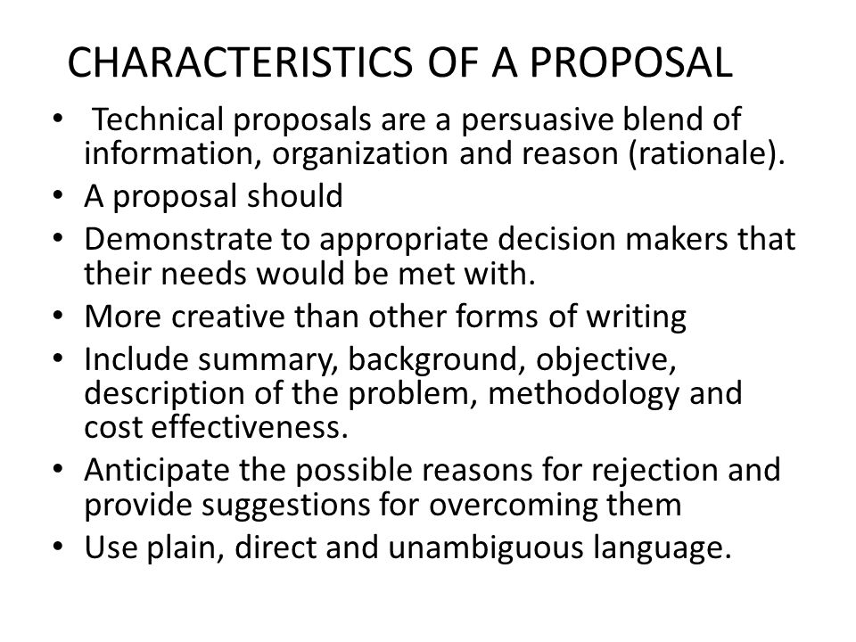
Types of Proposals:
- Business Proposals:
- Supply of material, construction of roads, buildings, railway, a garden, a bridge, a dam, a party plot, a parking lot, etc; providing services for transportation, washing, catering, safety, security, insurance, fire fighting, training, consultation, recruitment, maintenance, etc; procurement of equipment, hardware, software, stationary, etc: all these can be considered as business proposals.
Research Proposals:
- Research proposals may be invited internally or externally. Government and public undertakings, private organizations, and educational institutes encourage the research activities. For the technological growth of the nation and survival of the industries in global competition, research is inevitable. There are certain funding agencies at national and international level for the research. From time to time, they invite research proposals on thrust areas and other areas decided by them. There are some government organizations, exclusively set up to carry out full time research, in specific area already identified or areas which may be identified in future.
Educational Proposals:
- Education spans from playgroup, kindergarten, primary school, secondary school, higher secondary school; under graduate colleges of various faculties like arts, commerce, science, law, pharmacy, engineering; post graduate institute and institutes offering Ph.D. programmes in various faculties and various branches in case of engineering. At lower, school level, local authority may be involved. In all the cases, proposals are to be submitted to the competent authority, to initially start the institute with specified intake and later on to continue to run the institute. For schools and colleges, not offering professional courses, usually proposals are not invited. A particular trust or a body plans to start a school or a college. It prepares the proposal in a specified format and approaches the concerned authority. Here, as the proposals are not invited by advertisement or common circular or general announcement, the number of proposers may be less. There is not much competition of other proposers. The assessment is on individual basis, depending on the fulfillment of requirements and bonafide intentions of the trust. There may be indirect competition of other institutes in the area. So, the proposer should be aware about the availability and demand of seats, absorption to further studies or employment, available quality of education in the area, target group of students, transport and other infrastructure facility.
- Accreditation Proposals:
There is a national board accreditation for the accreditation of programmes offered by engineering institutes. Accreditation is programme wise, for the strengths and weaknesses, as per specified format. The detailed criterion cover teaching learning aspects, management aspects, administrative aspects and financial aspects. The information covers student intake, admission process, result, recruitment, student feedback, teacher feedback, employer feedback, etc. The visiting team interacts with the students, the faculty, the supporting staff, the management, the administration, the guardians and the employers, too. Similarly, for Institutes and Universities, there is NAAC accreditation. These accreditations are not mandatory but, are useful for the institute or university to find its strengths and weaknesses and get third party assessment.
Structure and format of technical proposal
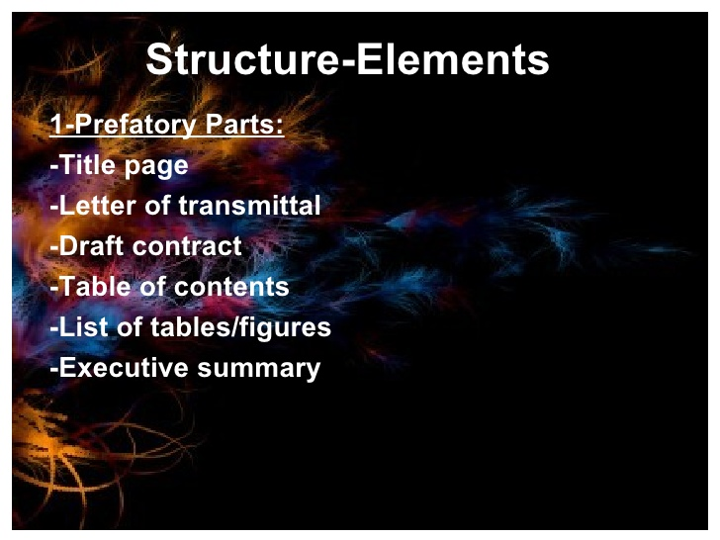
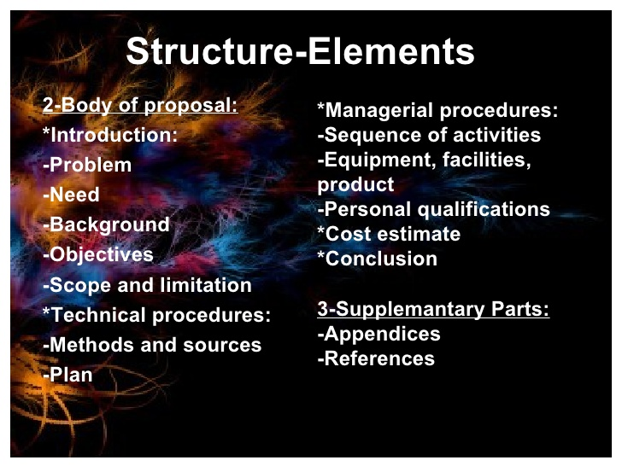

Technical Article
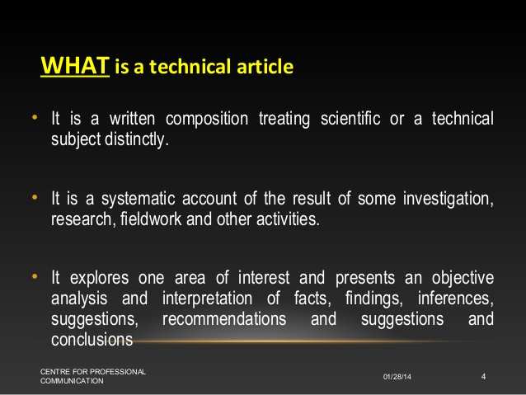

Types of Articles
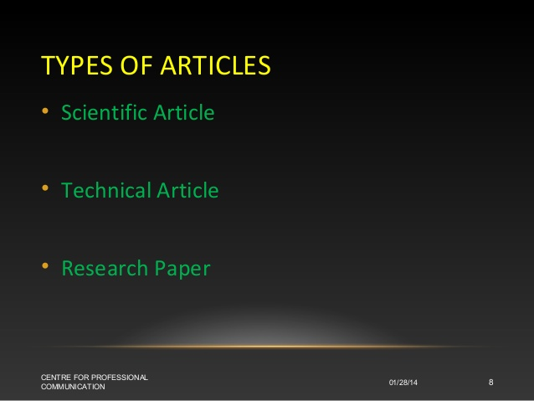

Scientific Article
- A scientific article is a publication that is based on empirical evidence. It can support a hypothesis with original research, describe existing research or comment on current trends in a specific field.
Research Paper
- A research paper is an essay in which you explain what you have learned after exploring your topic in depth. In a research paper, you include information from sources such as books, articles, interviews, and Internet sites. You also use your own ideas, knowledge, and opinions.
- Structure of Technical Article
- 