LECTURE NOTES
ON
MANUFACTURING PROCESSES

B. Tech IVsemester

Prepared By

R.K.Gupta
Assistant Professor

DEPARTMENT OF MECHANICAL ENGINEERING

Jaipur Engineering College and Research
Centre, Jaipur

Affiliated By

(Rajasthan Technical University,Kota)
SYLLABUS
4ME4-06: MANUFACTURING PROCESSES

Credit: 3 Max. Marks: 150 (IA:30, ETE:120)
3L+0T+0P End Term Exam: 3 Hours
SN | Contents | Hours
1 | Introduction: Objective, scope and outcome of the course. | 1
2 | General Classification and Introduction to Manufacturing processes. Foundry Technology: Casting: Definition and major classification; Casting materials, Patterns: types, material and pattern allowances. Moulding sands; composition, preparation, properties and testing; Grain fineness; moisture content, clay content and permeability test. Core & core prints; Gating system: types, pouring basin, sprue,  runner and risers; Melting, pouring and solidification. | 3
 | Principles and method of floor mould casting, shell mould casting, pit mould and loam mould casting; centrifugal casting, investment casting; Permanent mould casting. Die casting; Slush casting. Casting  defects; types, causes and remedy | 5
3 | Forming Processes: Classification; Hot working and cold working; principle, advantages, disadvantages and applications. | 3
 | Forging: Classification, drop forging and press forging methods and use; Forging dies; types, materials. | 4
 | Rolling: Characteristics and applications of hot rolling and cold rolling; | 3
4 | Extrusion; Work materials and products; Press tool works; Basic principles, system, operations and applications. Shearing; Parting,  notching, trimming, nibbling, blanking and piercing, | 4
 | Drawing: wire drawing, tube drawing and deep drawing. | 3
5 | Metal Joining Processes: Welding, Brazing and soldering, classification of welding process, Principle, characteristics and applications of gas welding, thermit welding, electrical arc welding; Submerged arc welding; TIG and MIG welding; Resistance welding;  Spot welding; Butt welding; Seam welding; Projection welding. | 6
 | Principles and process details of Forge welding; Friction welding; Diffusion welding; Ultrasonic welding. Explosive welding. Welding  defects; Types, causes, effects and remedy. Electrodes and Electrode Coatings | 3
6 | Powder Metallurgy: Properties of Powder processed materials, Powder manufacturing, mechanical pulverization, sintering, Electrolytic Process, chemical reduction, atomization, properties of metal powders,  compacting of powders sintering, advantages and applications of Powder metallurgy. | 4
 | TOTAL | 39

Manufacturing Process
4ME4-06
COURSE OUTCOMES

Student will be able-

CO1:To understand basic fundamentals of Casting Processes & its types.

CO2: To memorize different forming & sheet metal operations in manufacturing.

CO3: To understand various fabrication methods used in manufacturing.

CO4: To Acquire the knowledge of Powder Metallurgy Applications and its importance

CO-PO Mapping

Subject Code | Cos | Program Outcomes (POs)
 |  | PO-1 | PO-2 | PO-3 | PO-4 | PO-5 | PO-6 | PO-7 | PO-8 | PO-9 | PO-10 | PO-11 | PO-12
4ME4-06 | CO-1 | 3 | 1 | 1 |  | 2 |  |  |  |  |  |  | 2
 | CO-2 | 2 | 1 | 2 | 1 | 2 | 2 |  |  |  |  |  | 1
 | CO-3 | 2 |  | 1 |  | 2 |  |  |  |  | 2 |  | 1
 | CO-4 | 2 | 1 | 2 |  | 3 |  |  |  |  |  |  | 2

UNIT-2
FOUNDRY TECHNOLOGY
Introduction
Manufacturing is the production of goods through the use of labor, machines, tools, and chemical or biological processing or formulation. It is the essence of secondary sector of the economy. The term may refer to a range of human activity, from handicraft to high-tech, but it is most commonly applied to industrial design, in which raw materials from the primary sector are transformed into finished goods on a large scale. Such goods may be sold to other manufacturers for the production of other more complex products (such as aircraft, household appliances, furniture, sports equipment or automobiles), or distributed via the tertiary industry to end users and consumers (usually through wholesalers, who in turn sell to retailers, who then sell them to individual customers).
Manufacturing engineering, or the manufacturing process, are the steps through which raw materials are transformed into a final product. The manufacturing process begins with the product design, and materials specification from which the product is made. These materials are then modified through manufacturing processes to become the required part.
Modern manufacturing includes all intermediate processes required in the production and integration of a product's components. Some industries, such as semiconductor and steel manufacturers, use the term fabrication instead.

Classification of Manufacturing Process
The manufacturing processes can be classified as:
1. Forming Processes
2. Moulding Processes
3. Machining Processes
4. Assembly Processes
5. Finishing Processes.

1. Forming Processes:
In the metal industry, some of the primary forming operations may take place such as the rolling of basic shapes in steel, aluminium etc. Some of the common shapes so obtained from these processes are bars, sheets, billets, I-beams etc. Which are standard shapes. These shapes can be used for further processing. Other forming processes may be drop-forging, stamping, extrusion, press work, punching, drawing etc.

2. Moulding Processes:
Some products require moulding processes such as sand casting, die-casting etc. to get basic shape or form which may or may not require further processing. The selection of the particular process will depend upon to size of the job, quantity to be produced, accuracy, and complexity desired and economy.

3. Machining Processes:
Metal machining is accomplished through basic machine tool processes which involve the generation of cylindrical surfaces, flat surfaces, complex curves and holes. The machine tools selected to accomplish this task depend on the size and shape of the part to be machined, the quality of finish required and production rate required.
The examples of such processes are: turning, shaping, drilling, boring, grinding etc. In these machining operations metal is removed from the part in the form of small chips by the cutting action of tool. The cutting action is accomplished by either rotating or reciprocating action of the tool relating to the part.

4. Assembly Processes:
These processes assemble the parts and materials using welding, riveting, soldering, brazing, mechanical fastening and adhesive joining etc.

5. Finishing Processes:
These processes are carried out for the aesthetic aspects, to achieve accuracy, surface finish or to increase life of the product. Such processes include cleaning, blasting, deburring, puffing, honing, lapping, polishing, painting etc.
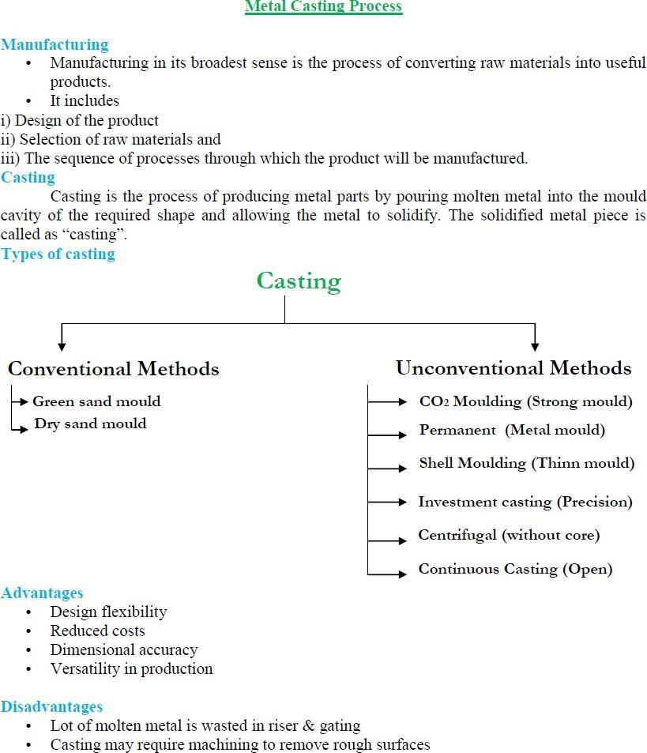
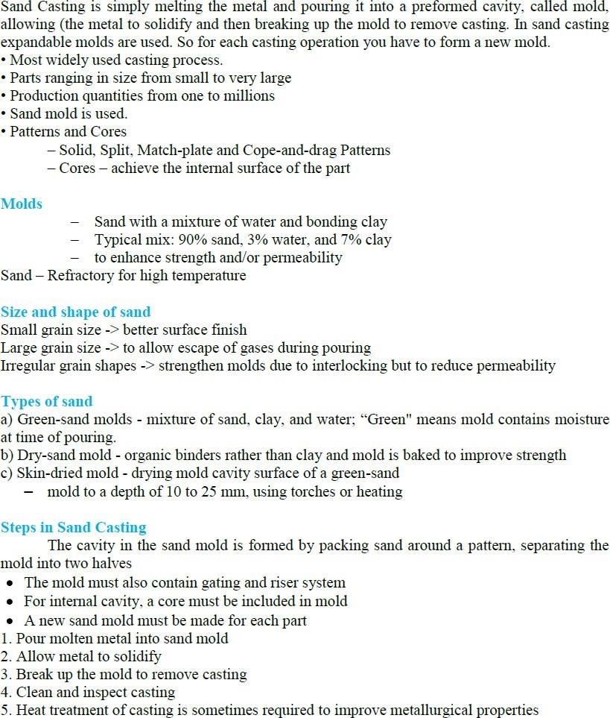

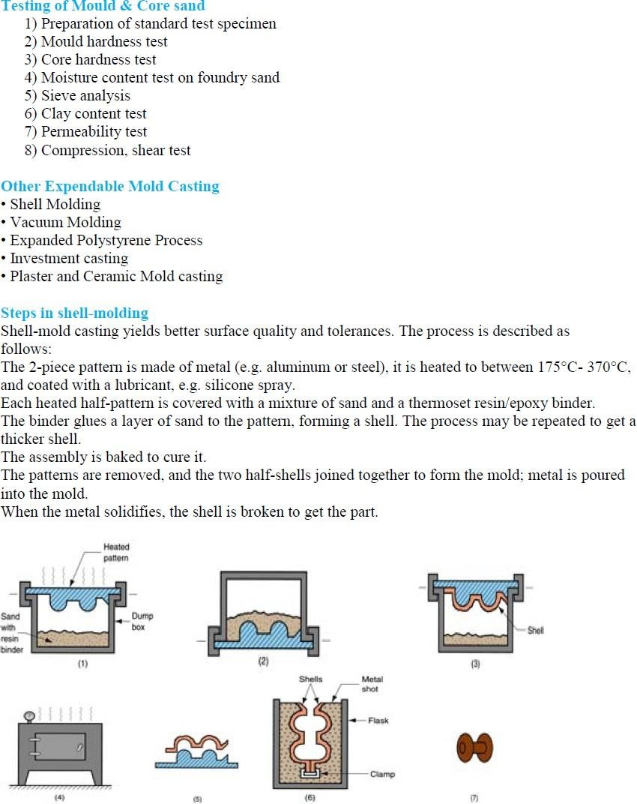

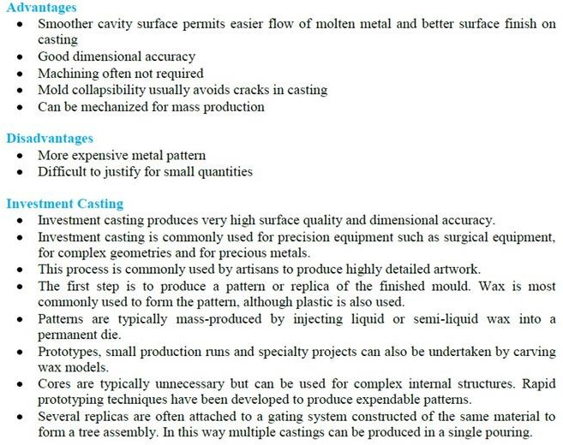
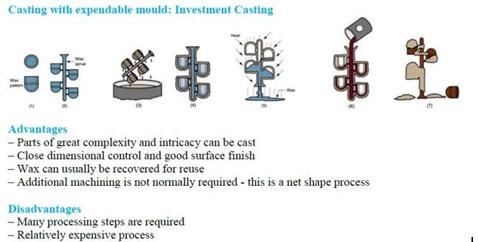

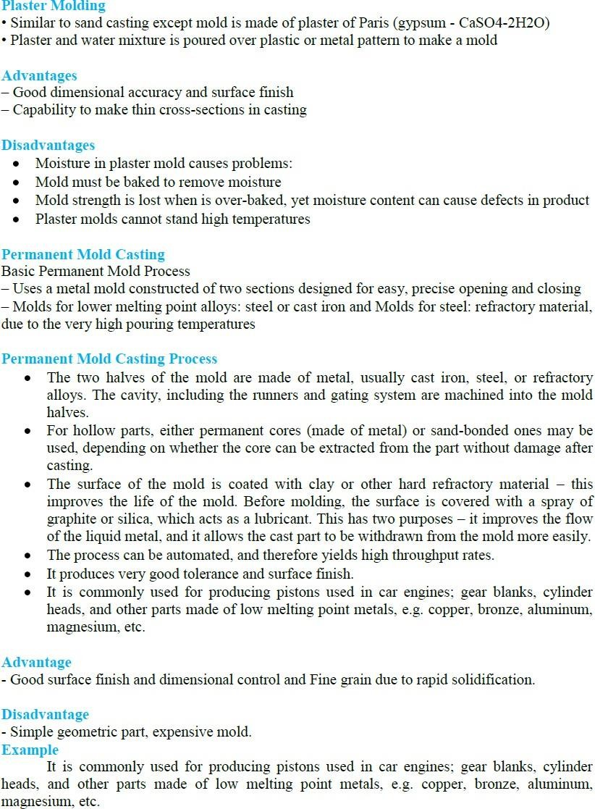

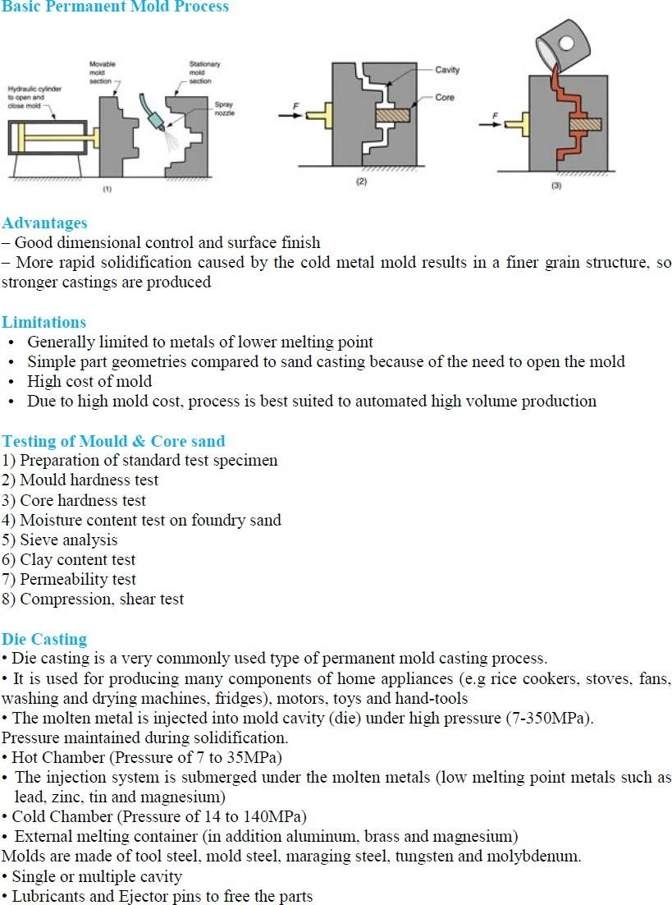

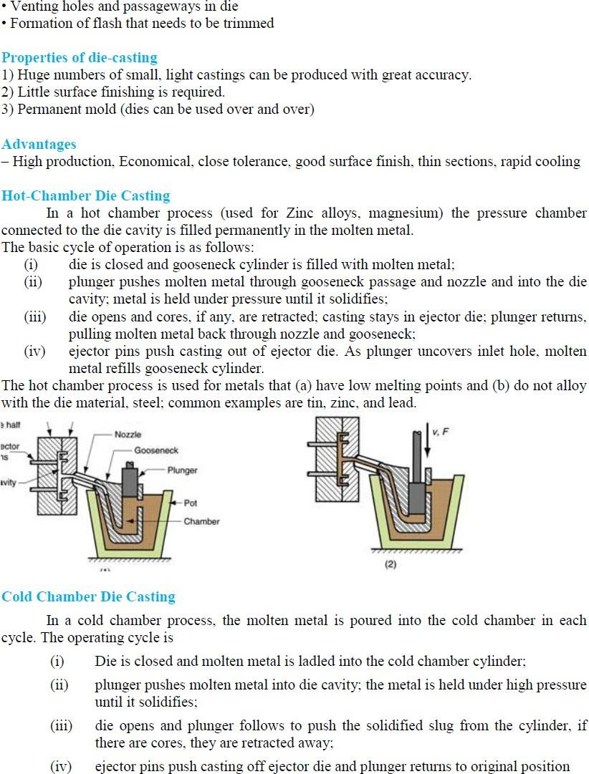

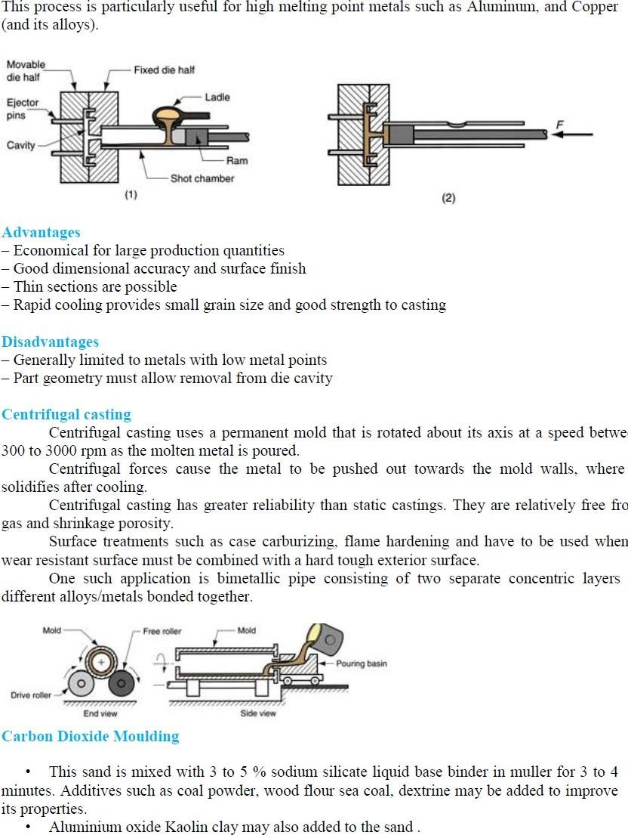

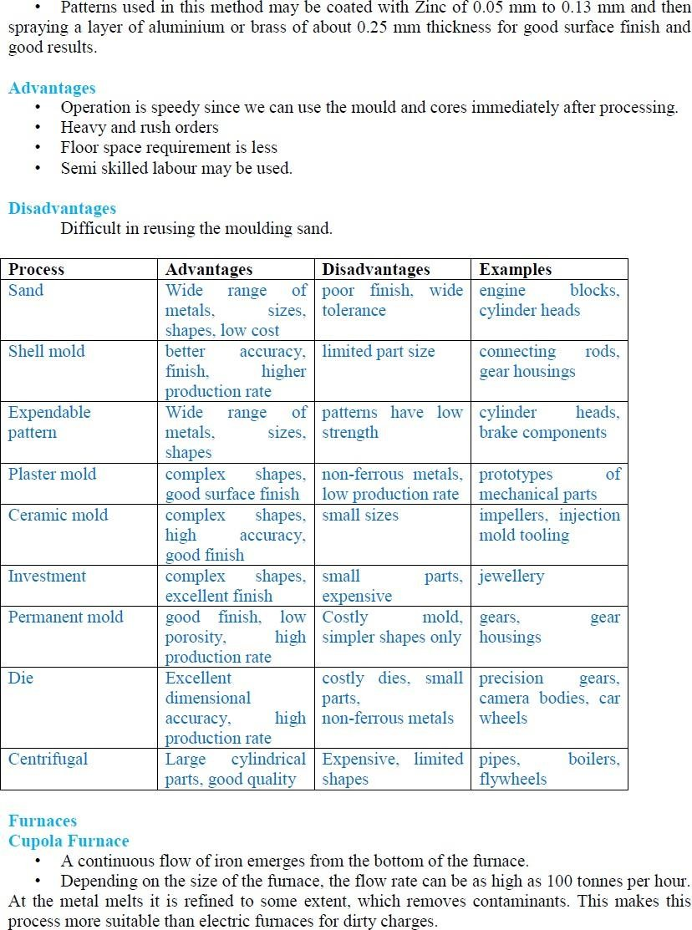

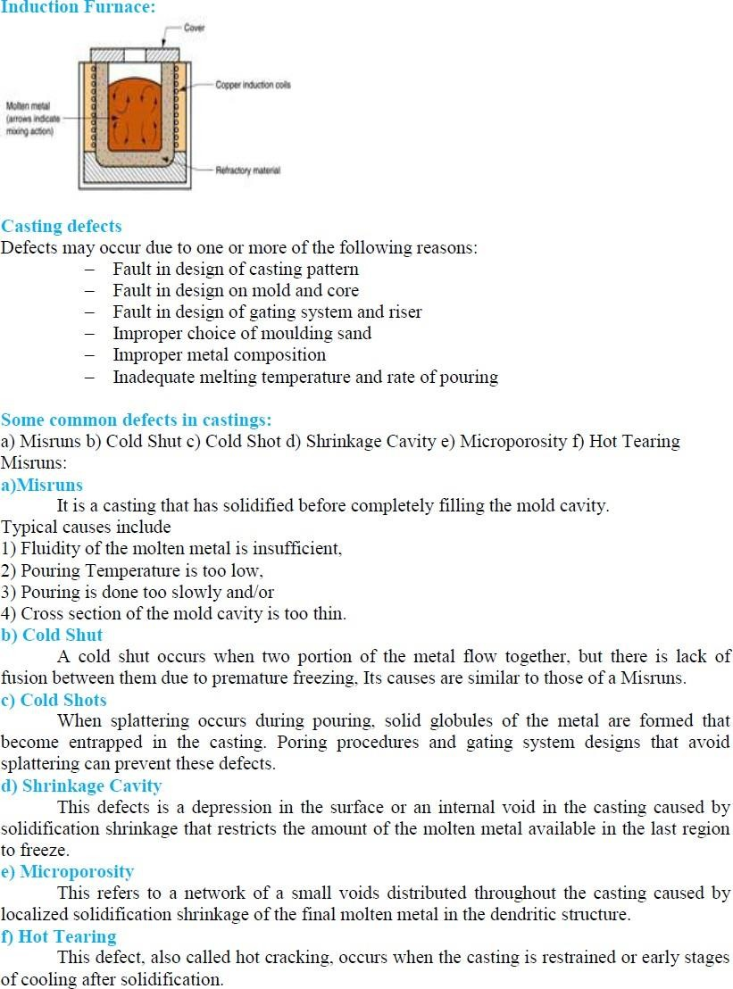

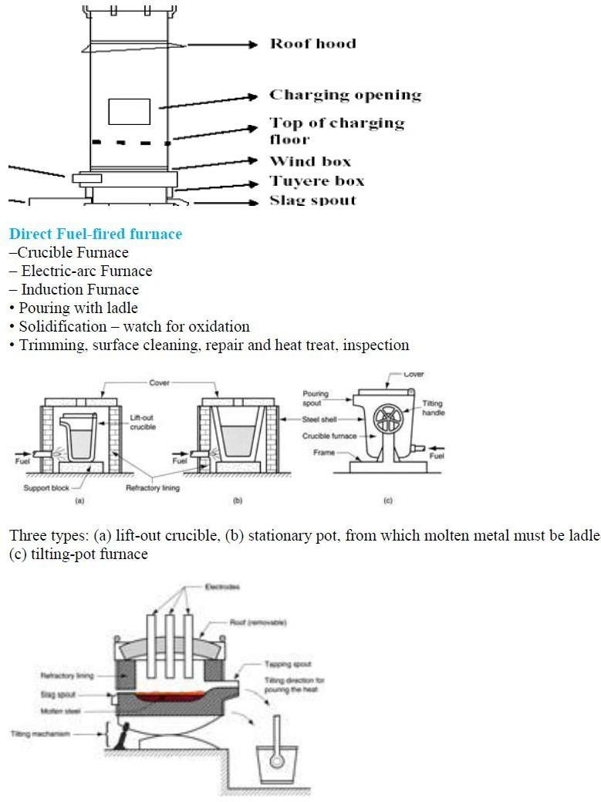

UNIT-3

METAL FORMING

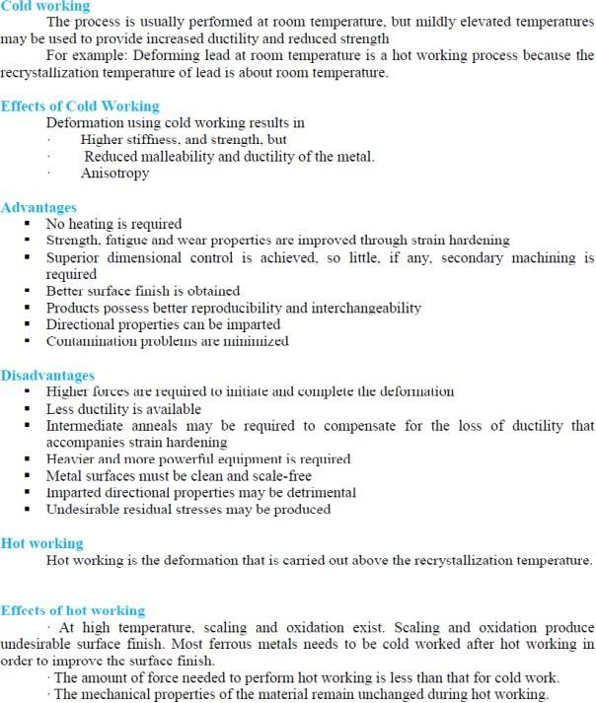

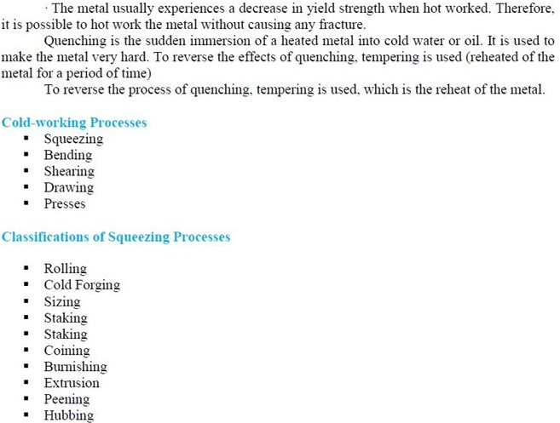
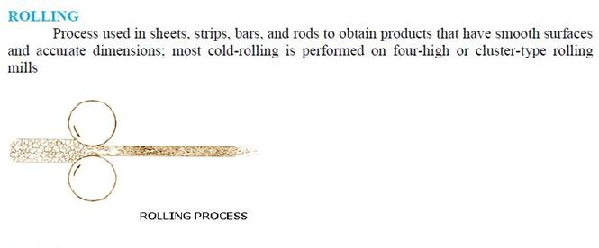

Flat Rolling
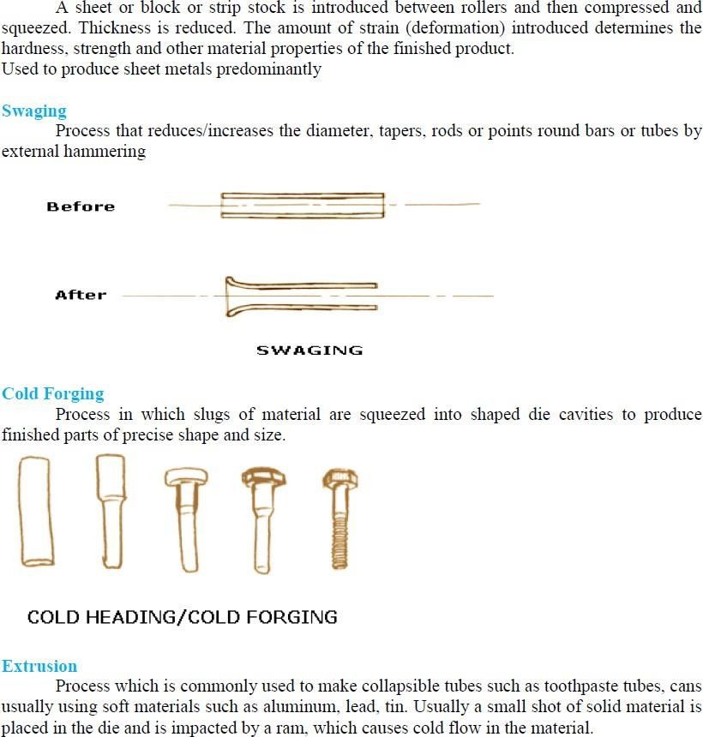

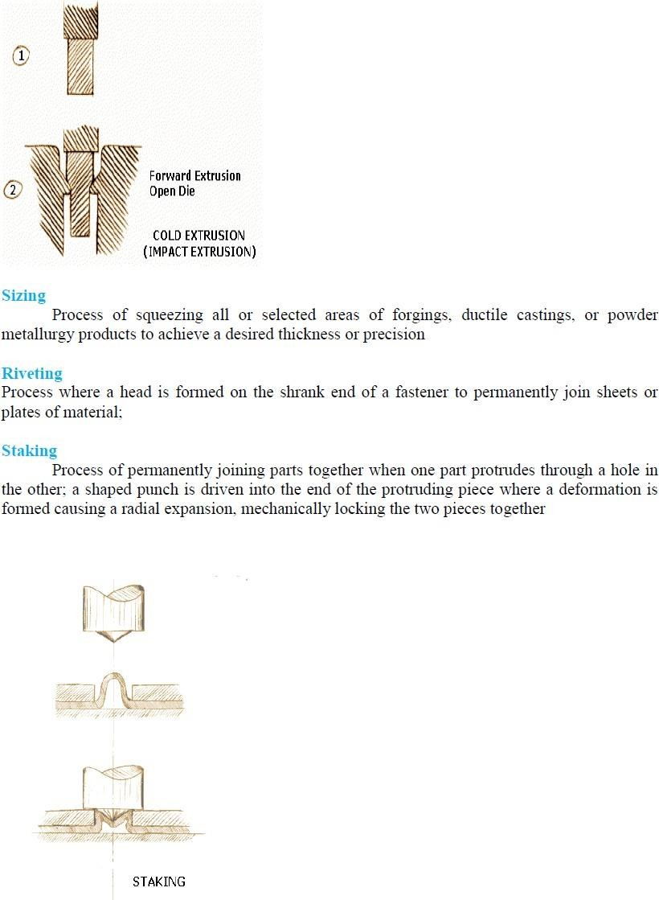

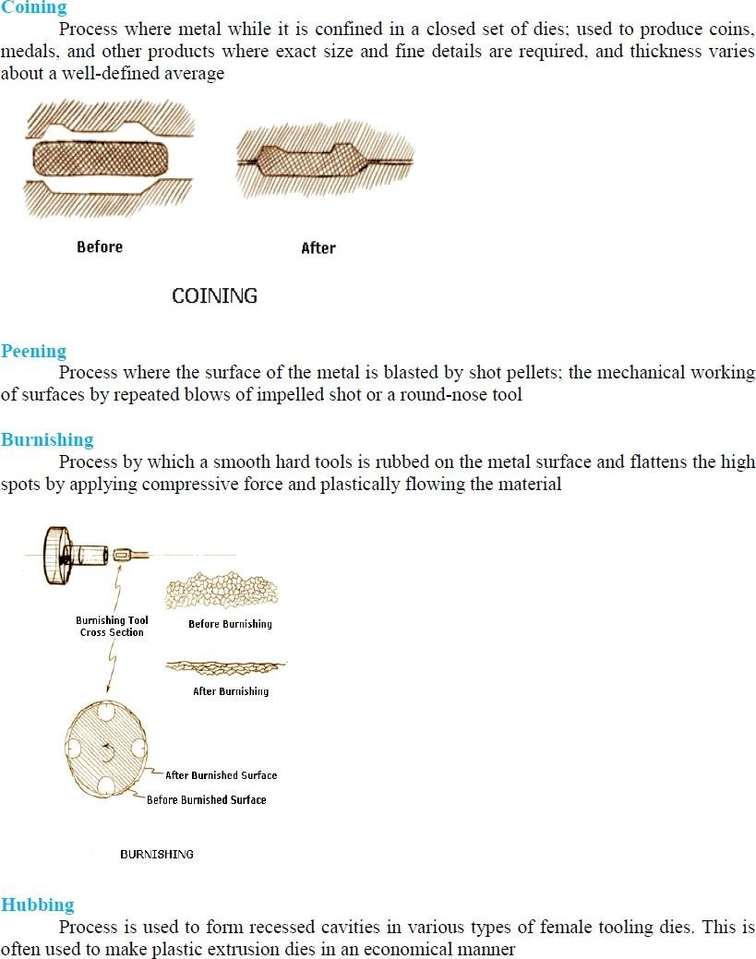

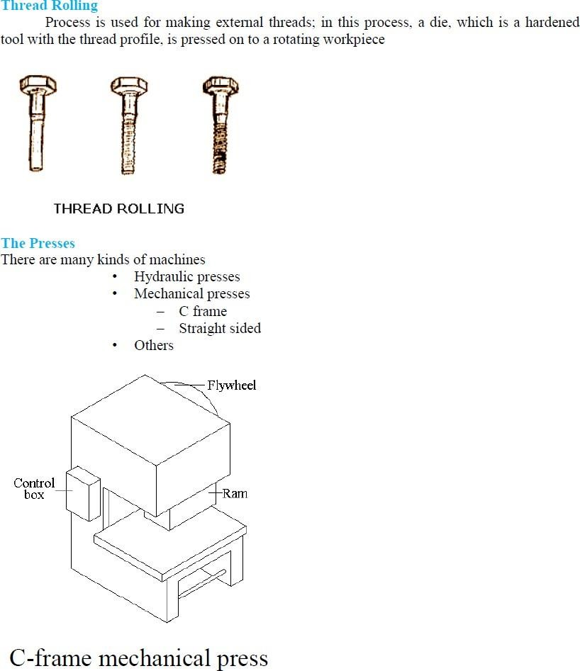

UNIT-4

EXTRUSION
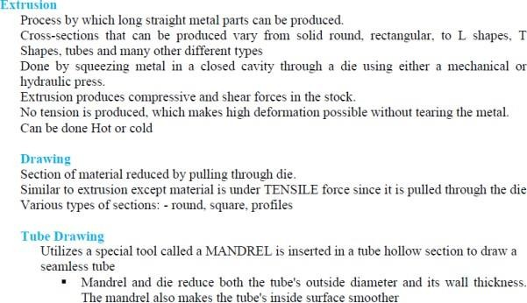

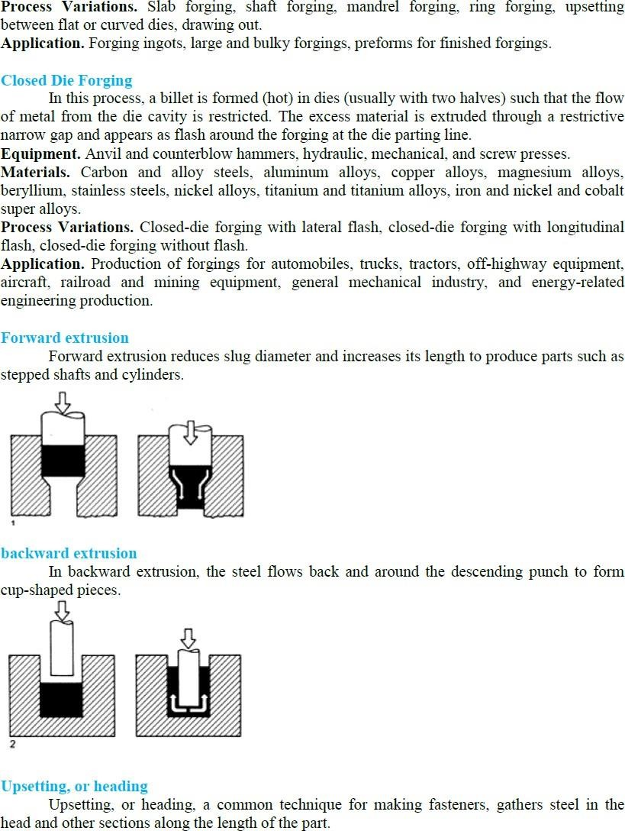

Extrusion is a process in which the metal is subjected to plastic flow by enclosing the metal in a closedchamber in which the only opening provided is through a die. The material is usually treated so that itcan undergo plastic deformation at a sufficiently rapid rate and may be squeezed out of the hole in thedie. In the process the metal assumes the opening provided in the die and comes out as a long strip withthe same cross-section as the die-opening. Incidentally, the metal strip produced will have a longitudinalgrain flow.The process of extrusion is most commonly used for the manufacture of solid and hollow sectionsof nonferrous metals and alloys e.g., aluminium, aluminium-magnesium alloys, magnesium andits alloys, copper, brass and bronze etc. However, some steel products are also made by extrusion.

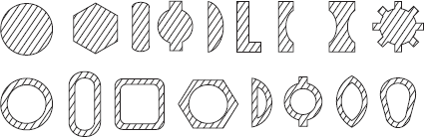

The stock or the material to be extruded is in the shape of cast ingots or billets. Extrusion maybe done hot or cold. The cross-sections of extruded products vary widely. Some of these sections areshown in Figure above

EXTRUSION PROCESSES
Extrusion processes can be classified as followed:

Hot Extrusion
- Forward or Direct extrusion.
- Backward or Indirect extrusion.

Cold Extrusion
- Hooker extrusion.
- Hydrostatic extrusion.
- Impact extrusion.
- Cold extrusion forging.

Forward or direct extrusion process: In this process, the material to be extruded is in the form of a block. It is heated to requisite temperature and then it is transferred inside a chamber as shown in Figure. In the front portion of the chamber, a die with an opening in the shape of the cross-section of the extruded product, is fitted. The block of material is pressed from behind by means of a ram and a follower pad. Since the chamber is closed on all sides, the heated material is forced to squeeze through the die-opening in the form of a long strip of the required cross-section.

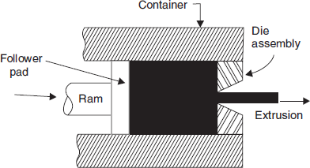

Backward or indirect extrusion: This process is depicted in Figure As shown; the blockof heated metal is inserted into the container/chamber. It is confined on all sides by the container wallsexcept in front; where a ram with the die presses upon the material. As the ram presses backwards, thematerial has to flow forwards through the opening in the die. The ram is made hollow so that the bar ofextruded metal may pass through it unhindered.

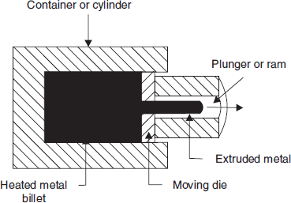

This process is called backward extrusion process as the flow of material is in a direction opposite
to the movement of the ram. In the forward extrusion process the flow of material and ram movement were both in the same direction. The following table compares the forwards (direct) and backwards (Indirect extrusion process).

Hooker extrusion process: This process is also known as extrusion down method. It is used forproducing small thin walled seamless tubes of aluminium and copper. This is done in two stages. In thefirst stage the blank is converted into a cup shaped piece. In the second stage, the walls of the cup onethinned and it is elongated. The process can be understood by referring to Figure. This process is adirect extrusion process.

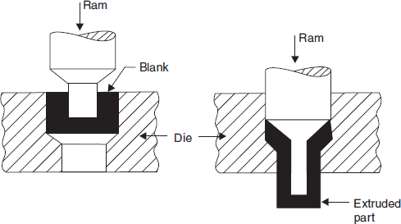

Hydrostatic extrusion: This is a direct extrusion process. But the pressure is applied to the metal blank on all sides through a fluid medium. The fluids commonly used are glycerine, ethyl glycol, mineral oils, castor oil mixed with alcohol etc. Very high pressures are used – 1000 to 3000 MPa. Relatively brittle materials can also be successfully extruded by this method.

Impact extrusion: In this process, which is shown in Figure below the punch descends with high velocity and strikes in the centre of the blank which is placed in a die. The material deforms and fills up the annular space between the die and the punch flowing upwards. Before the use of laminated plastic for manufacturing tooth paste, shaving cream tubes etc., these collapsible tubes containing paste were and are still made by this process. This process is actually a backward extrusion process.

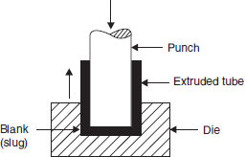

Cold extrusion forging: This process is depicted in Figure below. This is generally similar to the impactextrusion process; but there are two differences:1. In this process the punch descends slowly, and2. The height of extruded product is short and the side walls are much thicker than the thinwalled products produced by the impact extrusion process. In essence, this process is one of backwardextrusion.
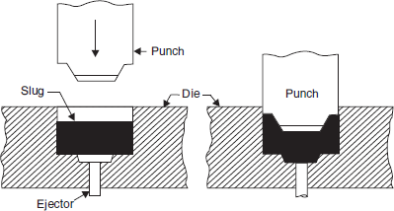

MACHINES FOR EXTRUSION
Both hydraulic and mechanical presses of horizontal and vertical configuration are used for extrusion.They should be capable of exerting high forces and their rams should have long strokes. To reducefriction between metal and extrusion chamber walls, lubricants are used. The dies and punches aremade from good quality alloy steels which are known as hot and cold die steels.Extrusion speed is of the order of 0.5 m/sec for light alloys and 4.5 m/sec for copper alloys.

EXTRUSION DEFECTS
Sometimes the surface of extruded metal/products develop surface cracks. This is due to heat generatedin the extrusion process. These cracks are specially associated with aluminium, magnesium and zincalloy extrusions.The extruded product can develop internal cracks also. These are variously known as centreburst, centre cracking and arrowhead fracture. The tendency for centre cracking increases with increasingdie angles and material impurities.

WIRE DRAWING
Wire drawing is a simple process. In this process, rods made of steel or non ferrous metals and alloys are pulled through conical dies having a hole in the centre. The included angle of the cone is keptbetween 8 to 24°. As the material is pulled through the cone, it undergoes plastic deformation and itgradually undergoes a reduction in its diameter. At the sametime, the length is increased proportionately.
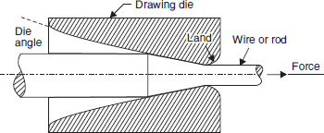

The dies tend to wear out fast due to continuous rubbing of metal being pulled through it. Hence
they are made of very hard material like alloysteel, tungsten carbide or even diamond. In one pass, thereduction in cross-sectional area achieved is about 25–30%. Hence in a wire drawing plant, the wire hasto pass through a number of dies of progressively reducing diameter to achieve the required reduction indiameter. However as the wire passes through dies and undergoes plastic deformation, it gets strainhardened. Its strength increases and capacity to further undergo plastic deformation decreases. Thereforeduring the entire run of the wire, from time to time, it has to be heated (and cooled) to remove theeffect of work-hardening. This process is called “in process annealing”. The aim is to make the materialsoft and ductile again so that the process of drawing may be smoothly carried out.The metal rods to be drawn into wires must be absolutely clean. If necessary, they are pickled inan acid bath to dissolve the oxide layer present on the surface. Its front end is then tapered down so thatit may pass through the hole in the die which is firmly held in the wire drawing machine. The wire isdrawn by means of a number of power driven spools or rotating drums.
During wire drawing, a great deal of heat is generated due to friction between the wire rod andthe die. To reduce friction, dry soap or a synthetic lubricant is used. But despite reducing friction, thedies and drums may have to be water cooled.The preferred material for dies is tungsten carbide but for drawing fine wire, use of ruby ordiamond dies is preferred.
The drawing machines can be arranged in tandem so that the wire drawn by the previous die maybe collected (in coil form) in sufficient quantity before being fed into the next die for further reductionin diameter. As the diameter becomes smaller, the linear speed of wire drawing is increased.
The major variables in wire drawing process are (1) Reduction ratio (2) Die angle and (3) Friction. Improper control of these parameters will cause defects in the drawn material. Defects include centre cracking (as in extrusion and for the same reasons) and formation of longitudinal scratches or folds in the material.

TUBE DRAWING
The ‘drawing’ process can also be used for tube drawing. Tube drawing does not mean manufacturing a tube from solid raw material. It means lengthening a tube reducing its diameter. Variousarrangementsused for tube drawing as shown in figure below

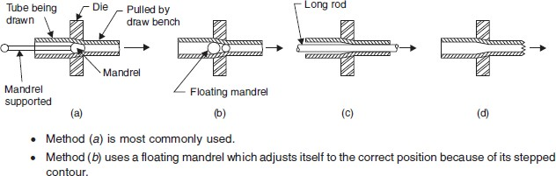

The method shown in Fig. (a) is the most common method used for tube drawing. A conventional tube drawing bench is used. Methodshown in Fig. (b) Employs a floating mandrel. Method shown in Fig. (c) uses a long circular rod to control the size of tube-bore. Method shown inFig.(d) uses neither a mandrel nor a bar and controlling size of bore is difficult.

TUBE MAKING
Tubes and pipes are required in large quantities by industries all over the world. Tubes are basically of two types. They are either seamless (i.e., without any joint) or with joint all along the length of the tube. Seamless tubes are made by processes such as casting, extrusion or rolling. Tubes with joint are made by welding. Usually, the weld joint is made by electric resistance welding process, such tubes are referred to as ERW tubes. The size of a tube or pipe is indicated by the size of its bore in mm. Since the requirement of tubes is so large, a special rolling process called Mannesmann rotary piercing process has been developed. In this process, a heated round billet with its leading end, in the centre of which a short guide hole has been punched or drilled, is pushed longitudinally between two large tapered rolls as shown in Figure below

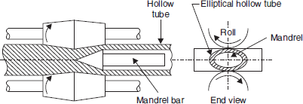

The rolls revolve in the same direction and their axes are inclined at opposite angles of approx 6°from the axis of the billet. As the billet is caught by the rolls and is rotated, their inclination causes the material to be drawn forward. The small clearance between the rolls forces the material to deform into an elliptical shape. Due to compressive forces, secondary tensile stresses start acting in a direction perpendicular to the direction of the compressive stresses. The guide hole drilled/punched at centre of billet tears open. This action is assisted by a suitably placed mandrel.

As the billet mores forward and keeps rotating the tearing action is propagated throughout thelength of the billet. End result is a roughly formed seamless tube of ellipitical cross-section.This roughly formed seamless tube is further rolled in a “plug rolling mill”. The final operationsof “reeling” and “sizing” are further conducted on cooled tube to improves size and finish of tubes.

FORGING
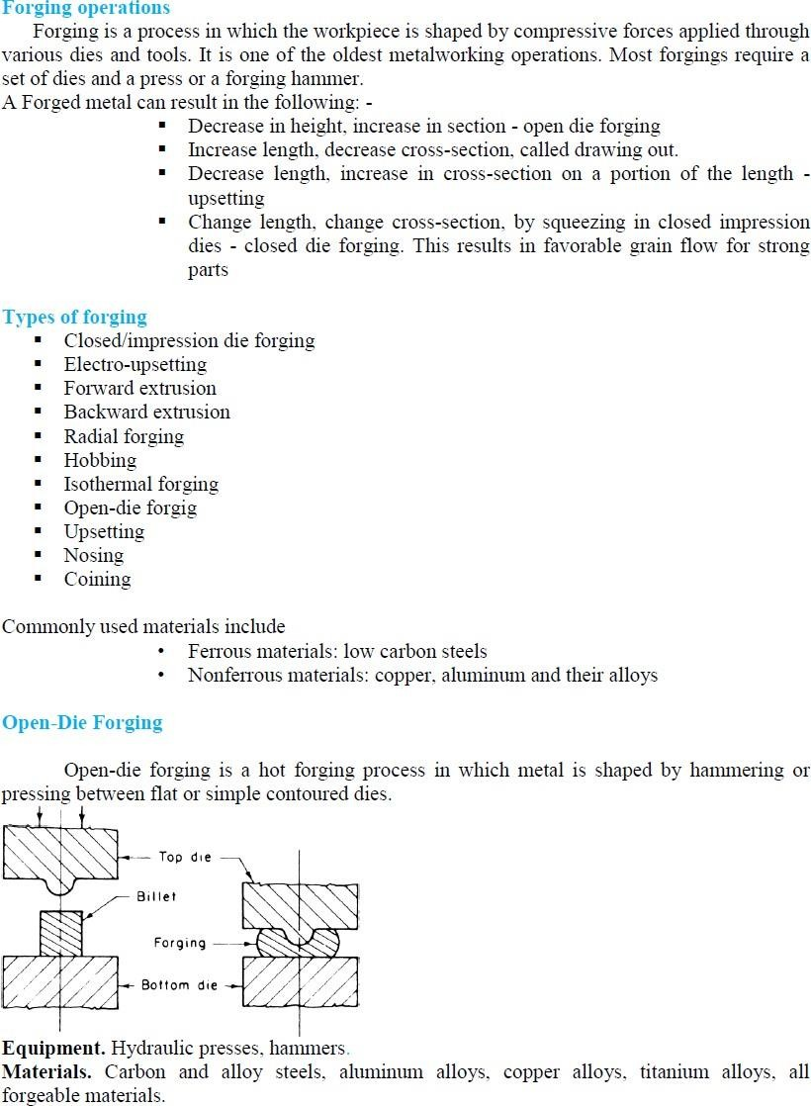

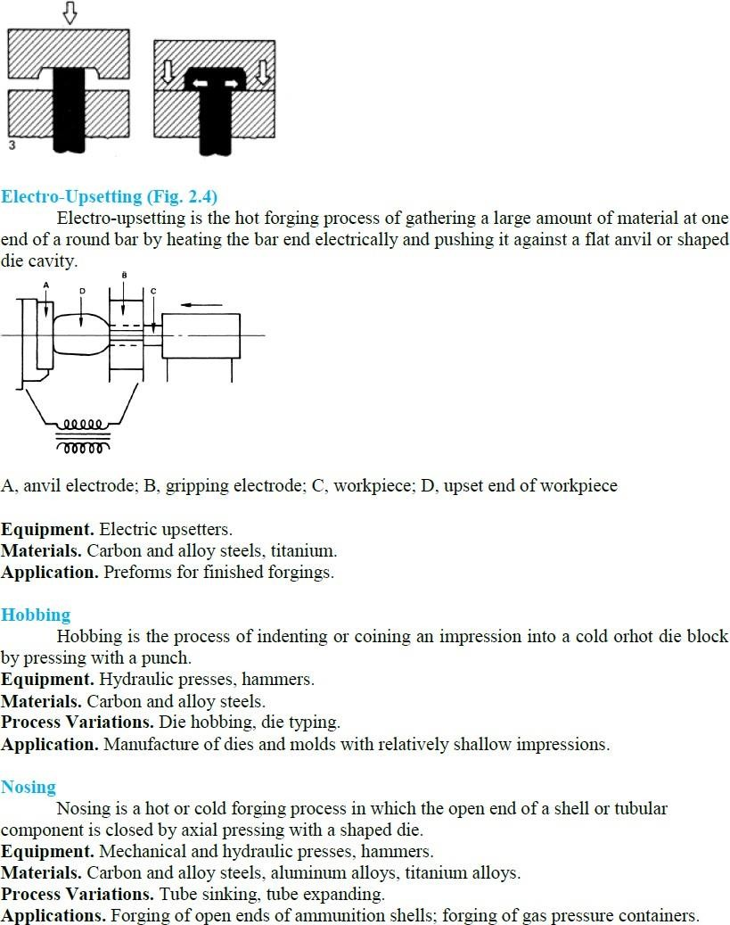

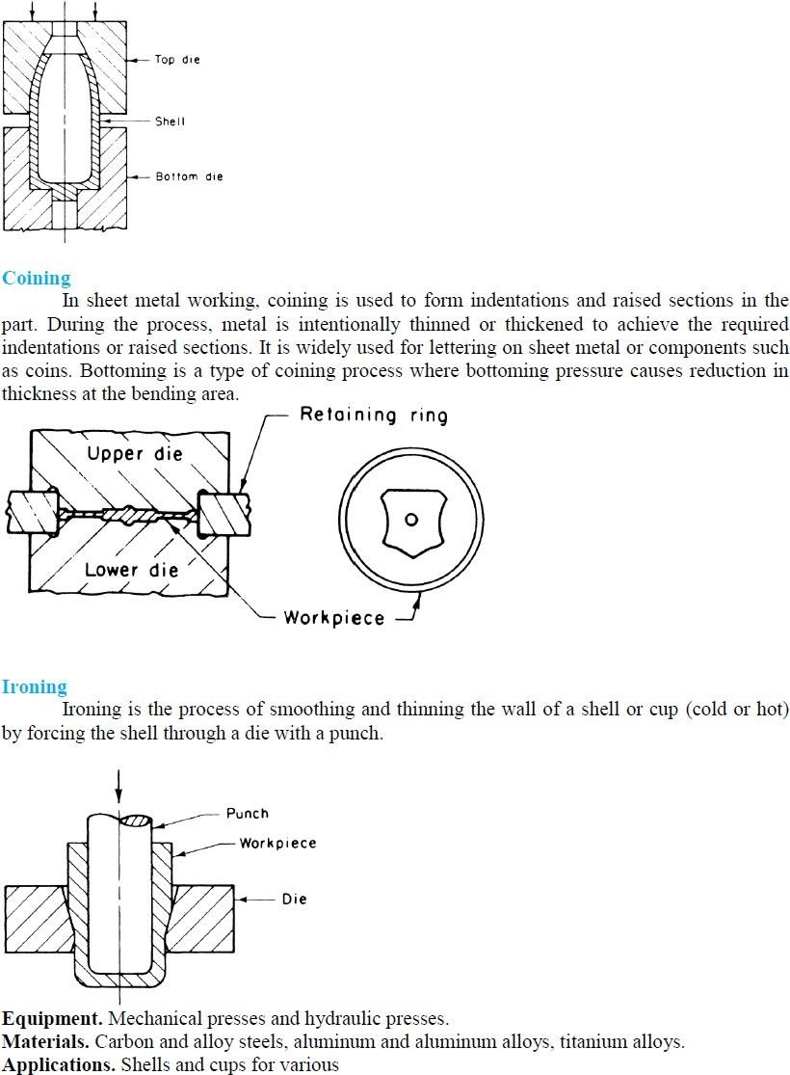

UNIT-5

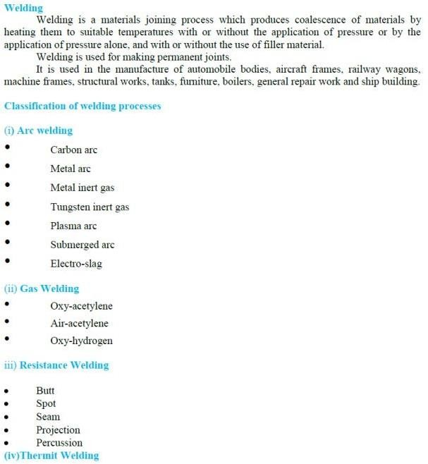
METAL JOINING PROCESS

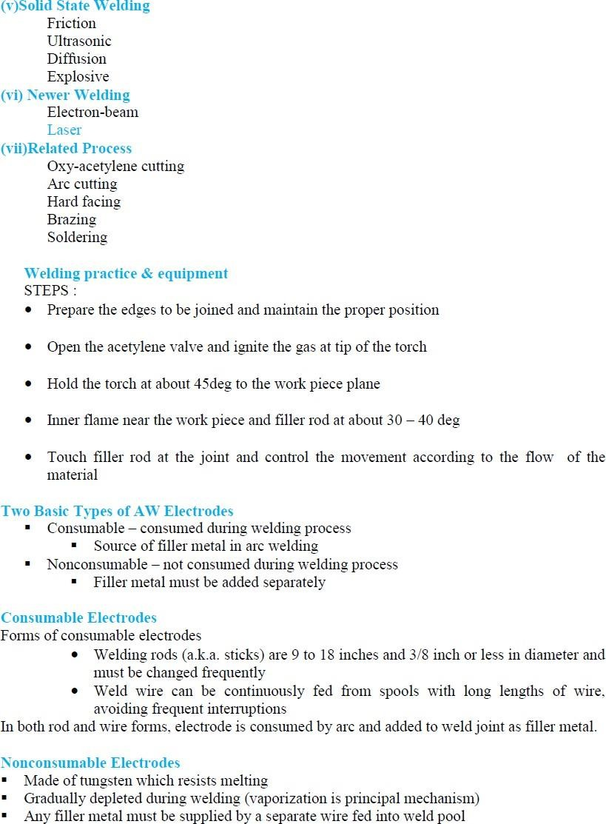

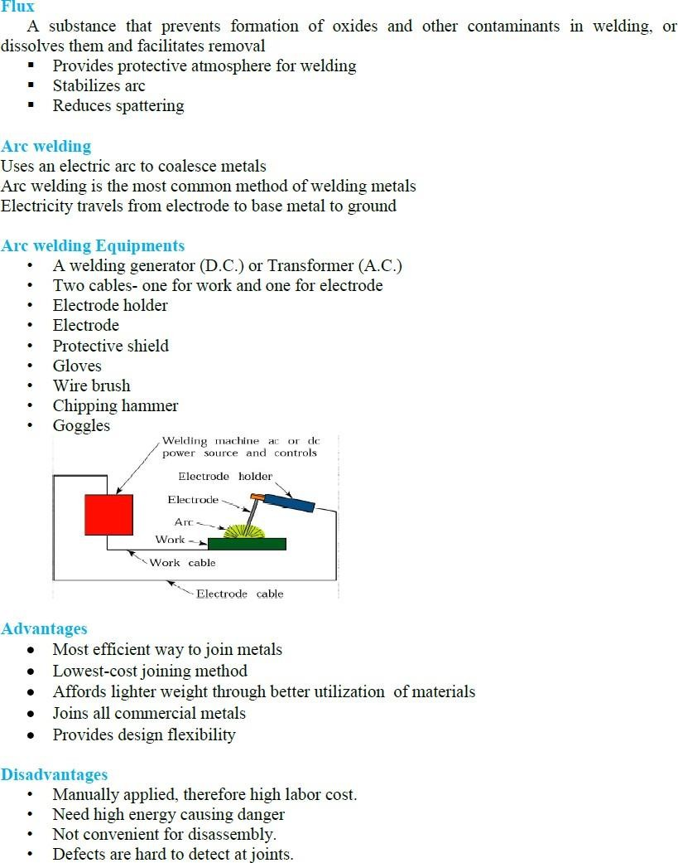

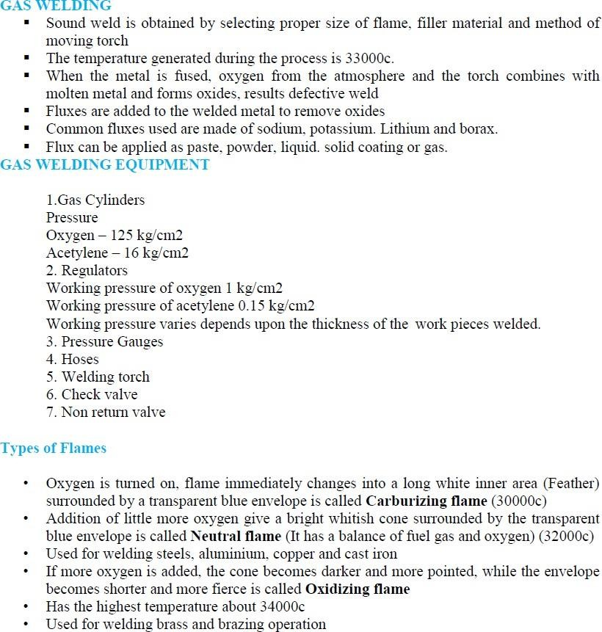

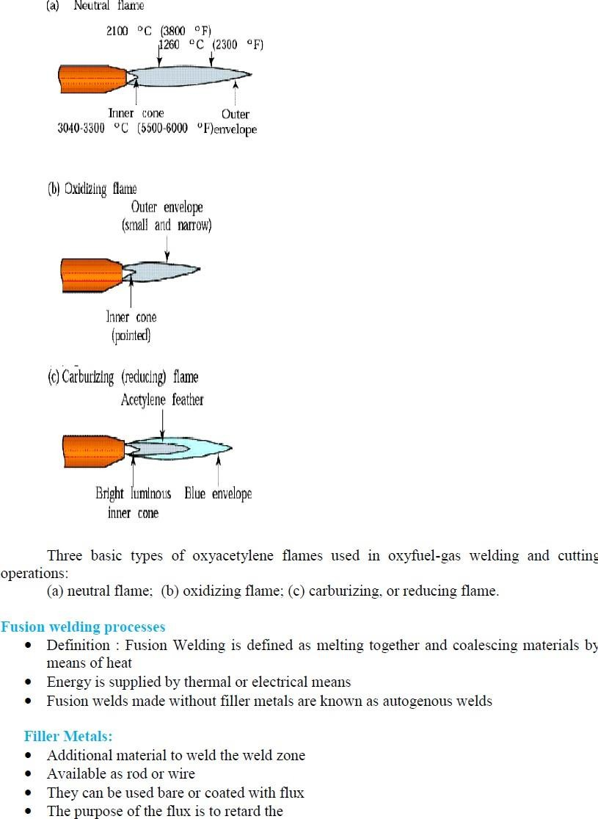

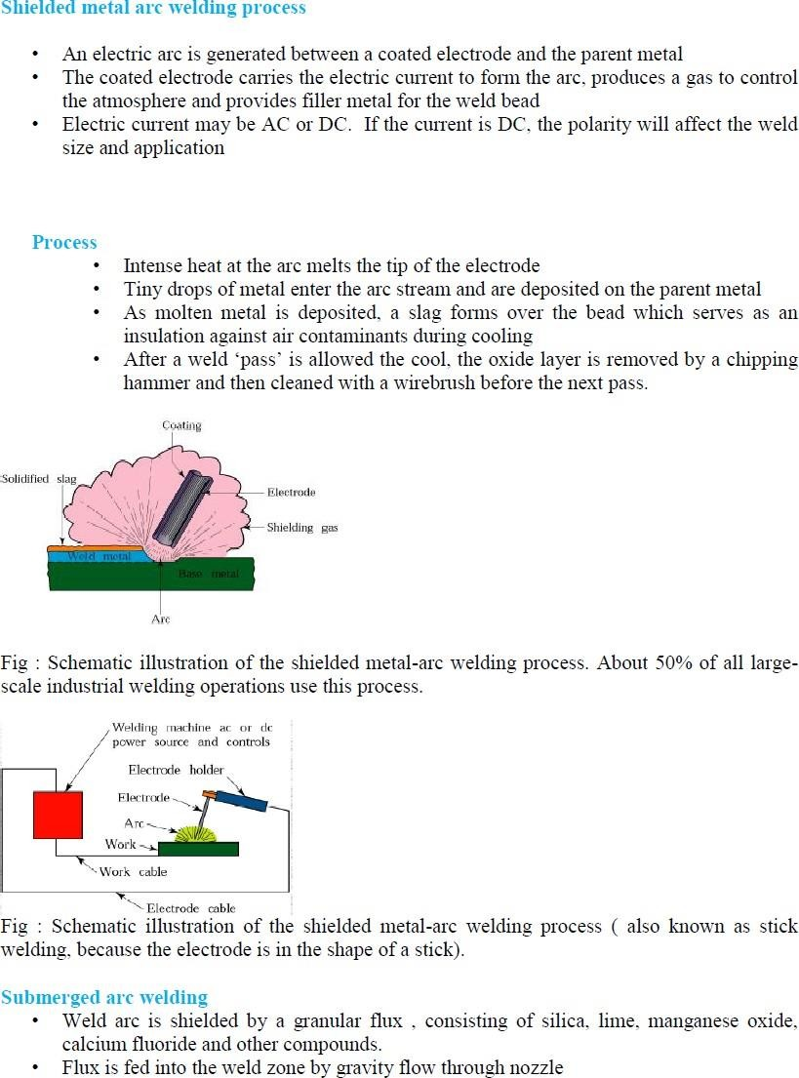

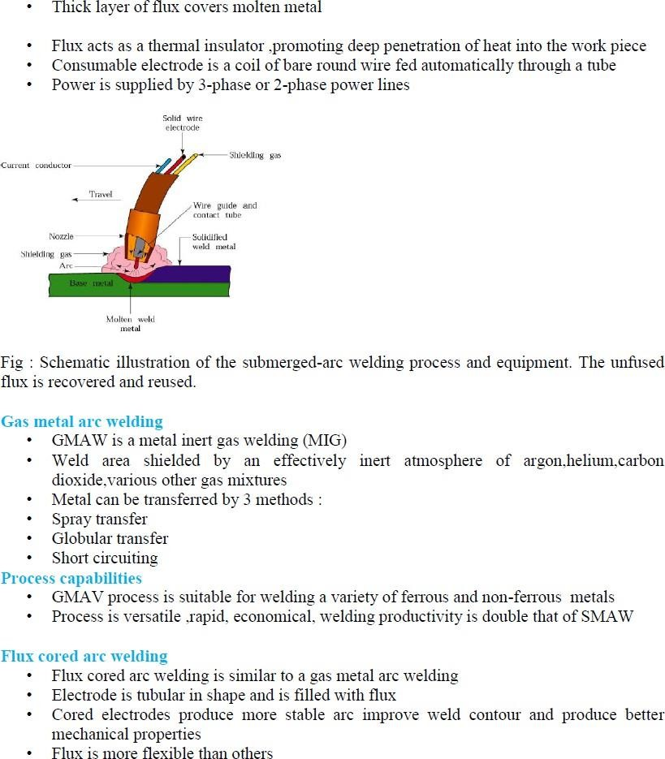

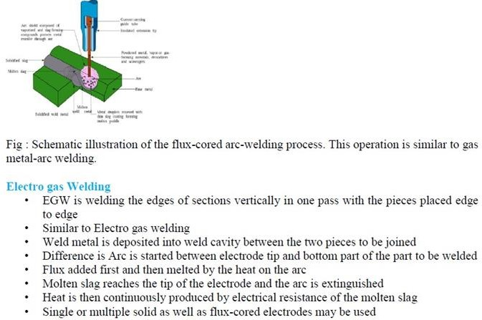
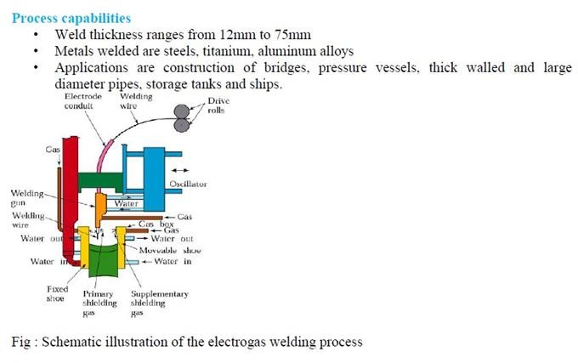

Brazing:
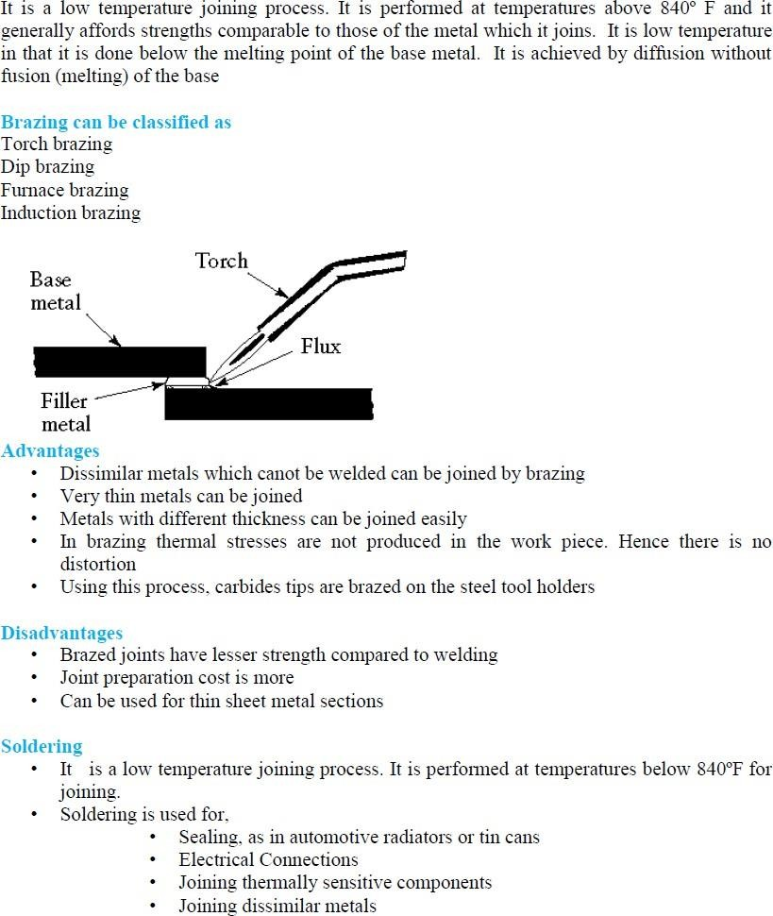

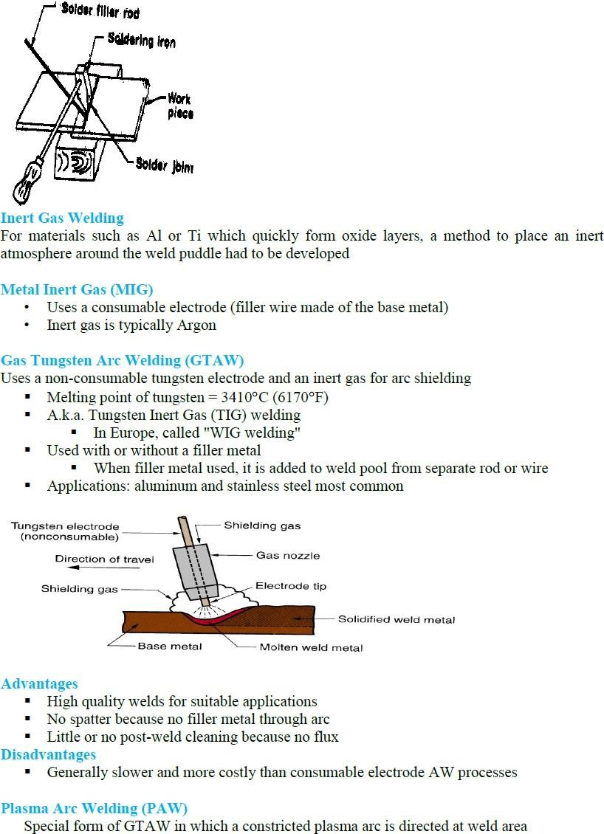

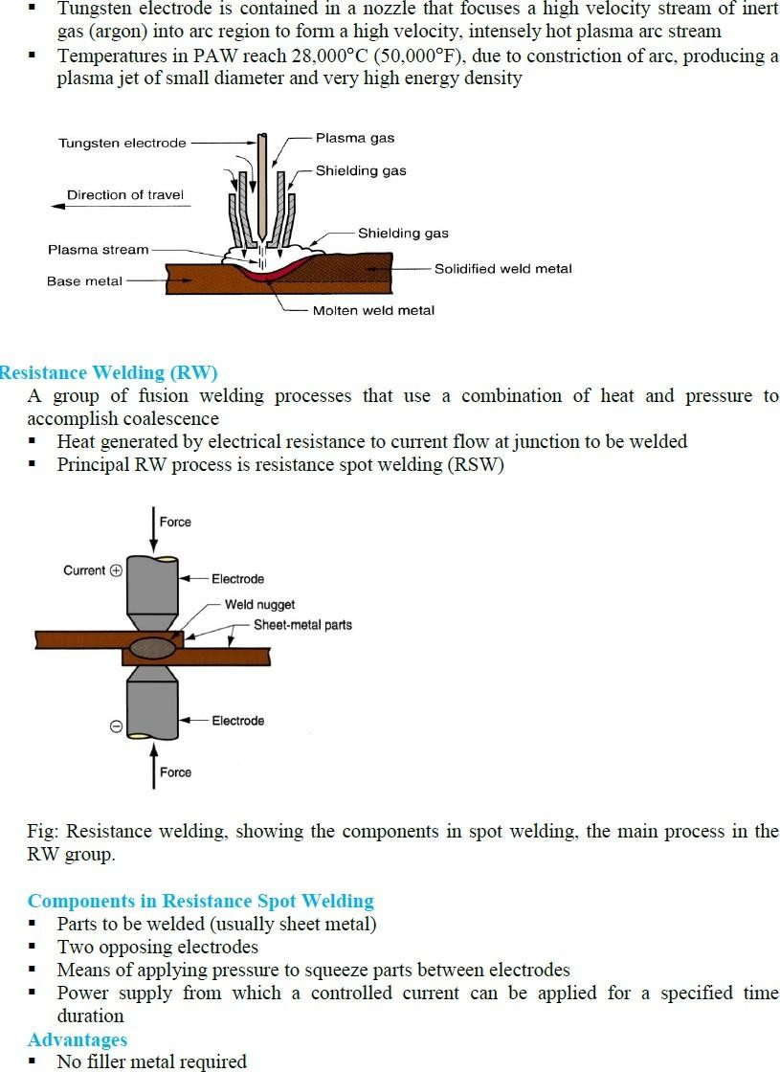

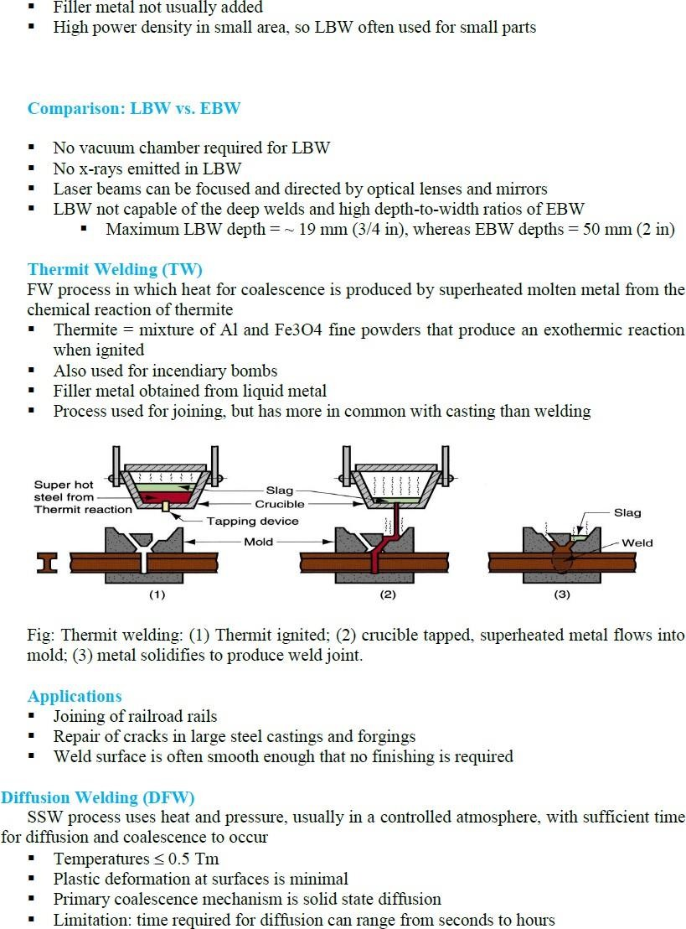

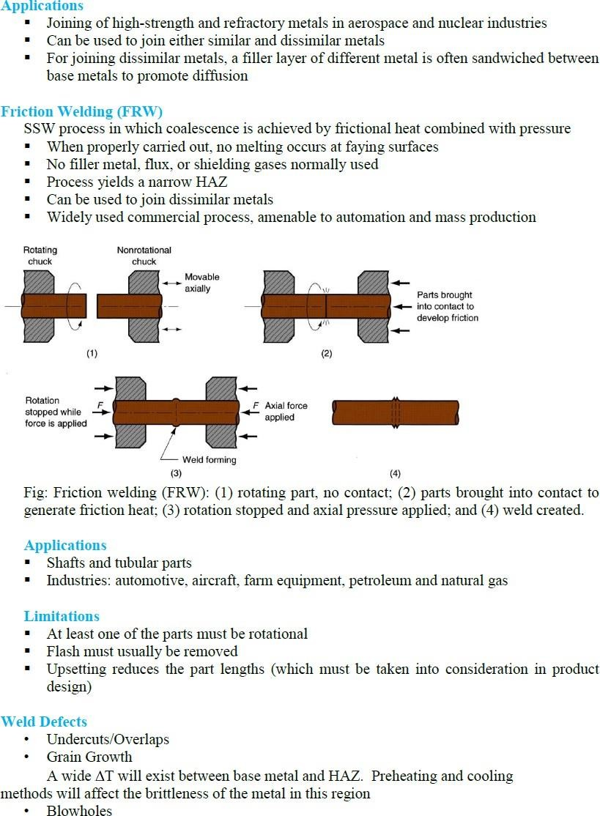

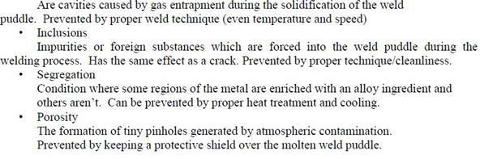

UNIT-6

POWDER METALLURGY

When the goal for a part is the longest possible lifecycle and highest performance while operating under high temperatures, in a corrosive environment, and with the potential for extreme wear, then powder metal manufacturing can offer a very cost-effective option. Not only are the parts strong, robust, and wear-resistant, but the advent of additive manufacturing has made it possible to minimize their weight, maximize their durability, and create parts that are simply impossible to manufacture by conventional manufacturing methods.
What Are Powdered Metals?
Powder metal (PM) parts are created from a very fine metal powder that is compressed and sintered to achieve its final shape. This is quite different from cast parts, which begin their life as a liquefied metal, or from machine or forged parts, which start off as stock metal. The powder metal manufacturing process makes it possible to create parts with an extremely complex geometry. While such parts might be made through casting or machining, the manufacturing costs increase dramatically as the complexity rises. PM parts, however, are cost effective even when the geometry is complicated and can make parts that are impossible to fabricate using any other methods.
Another key benefit of powder metal is that it is a net or near net manufacturing process that results in minimal waste material. Rather than subtracting geometry and materials in order to create a part, PM does not waste any metal, making it a much more efficient and environmentally sustainable process. Because PM is so closely allied with computer-aided manufacturing, parts can be created to simultaneously optimize weight, strength, stiffness, and hardness. This can be vital for applications in industries such as aerospace where weight must be minimized
Where Powder Metal Manufacturing Is Used
Powder metal products can be found in a wide array of industries, including aerospace, automotive, marine, and biomedical. Many everyday products may have been created via PM, such as light bulb filaments, automotive engine components, the lining of friction brakes, medical devices, and lubricant infiltrated bearings. PM can also be used for more exotic purposes, such as heat shields used on spacecraft during re-entry, electrical contacts for extremely high current flows, and gas filters. The parts produced by PM can be used as prototypes or as fully functional parts. As better methods of manufacturing and heat treatment of PM parts are developed, the applications will continue to grow and PM parts will become even more commonplace.

Background on Powder Metal Technology
Powder metallurgy (which forms the basis of modern PM methods and technology) actually dates to the 1940s. Early products made by these methods include porous bearings, electrical contacts, and cemented carbides. Through the intervening years, companies wisely invested in powder metallurgy technology and advances, focusing their research on aspects such as refinement, new alloy development, and atomization techniques for efficiently generating fine powders. Such research and innovation continue to this day. One of the most groundbreaking developments is net shape production of PM parts via additive manufacturing (AM).

Metals Used in Powder Metallurgy Processes
The most commonly used base metals for PM processes include alloyed metals such as:
- Iron
- Steel
- Copper
- Stainless steel
- Titanium
- Aluminum
- Tin
- Molybdenum
- Tungsten
- Tungsten carbide
- Various precious metals
Most industrial PM products are comprised primarily of iron and steel along with other elements, including both metal, semi-metal, and transitional elements. Different alloying elements can be added to the base metals to achieve customized or improved material properties.

Properties of Powder Metallurgy materials

Mechanical properties of structural Powder Metallurgy components
The mechanical properties available from the materials, commonly used for structural or engineering component applications, can be summarised as follows:

Ferrous Powder Metallurgy materials
Ferrous Powder Metallurgy materials, processed by the standard die press and sinter route, can deliver UTS levels up to around 900 N/mm² in the as-sintered condition or up to around 1200 N/mm² after heat treatment or sinter hardening.
These pressed and sintered materials can also deliver tensile yield stress levels up to around 480 N/mm2 as-sintered or around 1200 N/mm² after heat treatment or sinter hardening. Compressive yield stresses are slightly higher at up to around 510 N/mm² as sintered or up to around 1250 N/mm² heat treated.
These very significant levels of strength are, however, accompanied by quite low levels of tensile ductility (Elongation levels below 2% being quite typical). For this reason, PM products at conventional press/sinter density levels (up to 7.1-7.2 g/cm³ maximum) would not be used in applications likely to experience gross plasticity in service.

Powder forged steels
Powder forged steels can deliver high strength levels (UTS up to around 950 N/mm² as forged and 2050 N/mm² heat treated; tensile yield stress up to around 650 N/mm² as forged and 1760 N/mm² heat treated) with higher levels of ductility (5-18% Elongation).

Stainless steels
300 series PM stainless steels, in the Press/Sinter condition, can deliver UTS levels up to around 480 N/mm², tensile yield stress up to around 310 N/mm² and compressive yield strength up to around 320 N/mm², but with much higher ductility levels than their low alloy steel counterparts. (>10% Elongation).
400 series PM stainless steels can deliver similar properties to the 300 series materials in the as-sintered condition. Heat treatment of martensitic grades can increase strength levels to up to around 720 N/mm² UTS and tensile yield stress and 640 N/mm² compressive yield stress, but at the expense of a much reduced ductility (<1% Elongation).

Copper alloys
Press and sintered Cu alloys can deliver relatively modest strength levels (up to around 240 N/mm² UTS, 140 N/mm² tensile yield stress and 170 N/mm² compressive yield stress) but with much higher ductility than their ferrous counterparts (10-20% Elongation).

Aluminium alloys
Pressed and sintered Al alloys can deliver UTS of up to around 200 N/mm2 as sintered or up to around 320 N/mm² after heat treatment and tensile yield stress of up to around 170 N/mm² as sintered or up to around 320 N/mm² after heat treatment, but with quite low ductility levels (0.5-2% Elongation).

Fatigue strength
Both Press/Sinter Powder Metallurgy steels and Powder Forged steels are capable of providing significant levels of fatigue strength:
- In the as-sintered condition, Press/Sinter PM steels can deliver fatigue endurance limits of up to around 320 N/mm² in the rotating bend loading mode and up to around 270 N/mm² in the axial loading mode (R = -1, Kt = 1).
- Heat treatment can raise these values to up to around 540 N/mm² and 460 N/mm² respectively.
- Powder forged steels can deliver fatigue endurance limits of up to around 420 N/mm² in the rotating bend loading mode and up to around 360 N/mm² in the axial loading mode (R = -1, Kt = 1).
- Heat treatment can raise these values to up to around 635 N/mm2 and 560 N/mm² respectively.

Basics of the Powder Metal Manufacturing Process
Typical PM parts are made in three basic steps: the blending of the metal powder (pulverization), die compaction, and sintering of the product. Additional heat treatment steps may be required after sintering in order to achieve the appropriate density, dimensions, and surface finish.
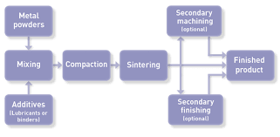
Powder Metallurgy Process
Pulverization and sieving prepare the metal powders for use in PM. The powders can vary in both shape (some are designed to be spherical) and size. Metallic powders can be produced through one of several different processes, including grinding, crushing, electrolytic deposition, chemical reactions, and atomization. The size and shape of the particles is an important factor when designing a part for manufacturing by PM methods.
Die compaction is accomplished using a pre-determined amount of pressure in relation to the part. This pressure is applied at room temperature, while sintering then begins at elevated temperatures conducted at atmospheric pressure. Note that sintering is performed under strict atmosphere-controlled conditions. After sintering, secondary heat processes are often used to enhance mechanical properties and dimensional precision.

How Powdered Metal Parts are Formed
One of the oldest methods to make PM parts is still used today – in fact, it is used to manufacture 1MT/year of iron-based alloy structural components. These components are made by blending a fine iron metal (typically <180 microns) with additives such as carbon, copper, and/or nickel and wax lubricant. The wax lubricant facilitates pressing the powdered metal into a die of the desired part shape.
This “green” part is then heated in a highly controlled atmosphere in a metallurgical furnace. This allows the compacted powdered metal to bond via the sintering process. The part produced after sintering is close to the finished part but still contains between 5-15% porosity and is thus weaker than a finished product resulting in sub wrought steel properties.

Traditional PM Processes
There are many other PM processes that have been successfully developed since the 1940s. The more traditional processes include powder forging, hot isostatic pressing (HIP), metal injection molding, and electric current assisted sintering.
In powder forging, a pre-form is made using the conventional press and sinter methods, but the part is then heated and hot forged. The result is a full-density part with as-wrought properties.
In HIP, the powder is gas atomized and spherical in shape. The mold used is typically a metal can of appropriate shape into which the powder is added. The mold is sealed, vibrated, and then all air is vacuumed out via a pump. The mold is then placed into a hot isostatic press where it is heated to a homologous temperature and its internal pressure is increased via external gas pressure. This particular PM process results in a finished part that has the correct shape and full density. The part has as-wrought or better mechanical properties.
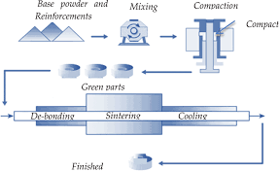
Hot isostatic pressing was developed in the late 1950s and early 1960s and entered tonnage production in the 1970s. In 2015, HIP was used to manufacture approximately 25,000 tons of stainless steel and tools steels annually. This, in turn, lead to the manufacture of super alloys used in aerospace and jet engines.
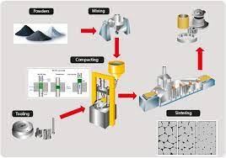
Stages of Powder Metallurgy Process
Another common manufacturing technique for PMs is metal injection molding (MIM). During this process, spherical metal powder that is less than 25 microns in size is mixed with either plastic or wax as a binding agent. Once a near solid part has been formed (65% volume), it is injection-molded. The result is a “green” part that typically has a very complex geometry. The green part is then heated under controlled conditions to remove the binder in a process known as de-bindering. The part at this stage is referred to as a “brown” part, but the process is still not complete. The brown part is then subject to an atmospherically controlled sintering process. The part’s volume is reduced by about 18%, and the final part is extremely dense at 97-99%.
Electric current assisted sintering (ECAS) is a different type of powder metal manufacturing process that makes extensive use of electric currents and does not require the use of binders. Instead of de-binding or sintering after pressing, electric currents are used to increase the density of the powder, which significantly reduces the thermal cycle needed to maintain the strength and density of the final part. This in turn reduces the overall production time for the part. For example, some parts will see a process time reduction from 15 minutes down to just a few microseconds. However, this process only works on relatively simple shapes. Another interesting aspect of the ECAS process is that the molds used are actually designed for the final part shape because the powders achieve final density while filling the mold under pressure and heat. This takes care of both distortion and shape variation.

Iron powder production
In tonnage terms, the production of iron powders for PM structural part production dwarfs the production of all of the non-ferrous metal powders combined. Virtually all iron powders are produced by one of two processes.

The sponge iron process
The longest established of these processes is the sponge iron process, the leading example of a family of processes involving solid state reduction of an oxide. In the process, selected magnetite (Fe3O4) ore is mixed with coke and lime and placed in a silicon carbide retort.
The filled retort is then passed through a long kiln, where the reduction process leaves an iron “cake” and a slag. In subsequent steps, the retort is emptied, the reduced iron sponge is separated from the slag and is crushed and annealed.
The resultant powder is highly irregular in particle shape, therefore ensuring good “green strength” so that die-pressed compacts can be readily handled prior to sintering, and each particle contains internal pores (hence the term “sponge”) so that the good green strength is available at low compacted density levels.
Sponge iron provides the base feedstock for all iron-based, self-lubricating bearings and still accounts for around 30% of iron powder usage in PM structural parts.
Solid state reduction is also used for the production of refractory metal powders, using hydrogen as the reducing agent, and for the production of specialist iron powders by the reduction of mill scale (again using hydrogen).

Water atomisation
Driven by the trend towards higher density levels in PM structural parts as a means of increasing performance levels, sponge iron powders have been increasingly supplanted by powders made by water atomisation.
Atomisation involves the disintegration of a thin stream of molten metal through the impingement of high energy jets of a fluid (liquid or gas). Water is the most commonly used liquid in atomisation.
Water atomised iron powders also have irregular particle shape and therefore good green strength. Unlike sponge iron, the individual powder particles do not contain internal porosity and, because of extensive development of the annealing process, have superior compressibility (see section on Forming processes). Water atomised powders are therefore the material of choice where high green density is sought in PM structural parts.

Non-ferrous metal powder production

Inert gas atomisation
Non-ferrous metal powders are produced by a variety of means. The most significant of these is another atomising process, this time using an inert gas as the atomising fluid. In inert gas atomisation, the particle shape produced is dependent on the time available for surface tension to take effect on the molten droplets prior to solidification and, if a low heat capacity gas is used (nitrogen and argon are most common), this time is extended and spherical powder shapes result.
Spherical powders are particularly useful in hot isostatic pressing (see section on Forming processes), where green strength is not an issue but initial packing density of the powder in the container is significant.

Close-coupled atomisation
The atomising nozzle design can provide either free-fall or close-coupled atomisation. In close-coupled (or confined) atomisation, the design of pouring nozzle and atomising head is adjusted so that impingement of the gas jets and molten stream occurs immediately below the exit of the nozzle with little or no free-fall height. This variant of atomisation technology has proved particularly useful for the production of fine powders for a range of applications, including Metal Injection Moulding.

Plasma atomisation
Developed by PyroGenesis, the plasma atomisation process uses argon plasma torches at > 10,000°C to melt and atomise titanium and other metals into fine droplets. The process has the distinction of producing highly flowable and very pure spherical metallic powders using wire as its feedstock. This method ensures a high level of traceability allowing for applications in the biomedical and aerospace sectors.

Centrifugal atomisation
A further branch of the “atomisation family” comprises a number of centrifugal atomisation processes. There are essentially two types of such processes; in the first type, a cup of molten metal is rotated at high speed or a molten stream of metal is allowed to fall onto a rotating disc or cone; in the second type, the Rotating Electrode Process (REP), a bar of metal is rotated and the free end is progressively melted by an arc from a tungsten electrode. If a plasma arc is involved, the process is known as PREP (Plasma Rotating Electrode Process) and this is a leading candidate for titanium powder production.
There are a few other powder production technologies that have areas of application.

Electrolysis
Electrolysis is a means of producing metal powders and has been most commonly used for the manufacture of copper powders for specialist applications. Electrolytic powders are produced by following the principles used in electroplating, with the conditions changed to produce a loose powdery deposit rather than a smooth adherently solid layer. The formation of powder deposits that adhere loosely to the cathode is favoured by low metal ion concentration in the electrolyte, high acid concentration and high cathode current density. The starting material is a pure metal anode.

Mechanical comminution
Brittle materials can be pulverised in ball mills, hammer mills or attritor mills to form powders. Intermetallics and ferro-alloys are commonly processed this way. As variants on this approach, Hydride-Dehydride (HDH) titanium alloy powders can be produced by reacting the alloy in solid form with hydrogen to form a brittle hydride, which can then be pulverised and dehydrided, and Hydrogen Decrepitation of Nd-Fe-B magnetic alloys, which can cause spontaneous decrepitation of the solid alloy.

Carbonyl and chemical conversion
Finally, there is a range of chemical conversion processes, with the leading example being the carbonyl process for the production of fine nickel or iron powders. In this process, the crude metal is reacted with CO under pressure to form the carbonyl, which is gaseous at reaction temperature, but decomposes to deposit the metal on raising temperature and lowering pressure.
Other chemical conversion processes include:
- The manufacture of Platinum powders from sponge created by thermally decomposing platinum ammonium chloride.
- The Sherritt-Gordon process for the manufacture of nickel powders by hydrogen reduction of a solution of a nickel salt under pressure.
- Chemical precipitation of metals from solution of a soluble salt e.g. silver can be precipitated by adding a reducing agent to a silver nitrate solution.
Sintering
Sintering is a heat treatment applied to a powder compact in order to impart strength and integrity. The temperature used for sintering is below the melting point of the major constituent of the Powder Metallurgy material.
After compaction, neighbouring powder particles are held together by cold welds, which give the compact sufficient “green strength” to be handled. At sintering temperature, diffusion processes cause necks to form and grow at these contact points.
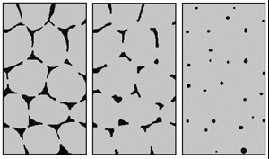
The three stages of solid state sintering: left: initial stage, centre: intermediate stage, right: final stage (Courtesy EPMA)

There are two necessary precursors before this “solid state sintering” mechanism can take place:-
- Removal of the pressing lubricant by evaporation and burning of the vapours
- Reduction of the surface oxides from the powder particles in the compact.
These steps and the sintering process itself are generally achieved in a single, continuous furnace by judicious choice and zoning of the furnace atmosphere and by using an appropriate temperature profile throughout the furnace.

Sinter hardening
Sintering furnaces are available that can apply accelerated cooling rates in the cooling zone and material grades have been developed that can transform to martensitic microstructures at these cooling rates. This process, together with a subsequent tempering treatment, is known as sintering hardening, a process that has emerged, in recent years, has a leading means of enhancing sintered strength.

Liquid Phase Sintering

Transient liquid phase sintering
In a compact that contains only iron powder particles, the solid state sintering process would generate some shrinkage of the compact as the sintering necks grow. However, a common practice with ferrous PM materials is to make an addition of fine copper powder to create a transient liquid phase during sintering.
At sintering temperature, the copper melts and then diffuses into the iron powder particles creating swelling. By careful selection of copper content, it is possible to balance this swelling against the natural shrinkage of the iron powder skeleton and provide a material that does not change in dimensions at all during sintering. The copper addition also provides a useful solid solution strengthening effect.
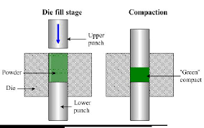
Compaction

Permanent liquid phase sintering
For certain materials, such as cemented carbides or hardmetals, a sintering mechanism involving the generation of a permanent liquid phase is applied. This type of liquid phase sintering involves the use of an additive to the powder, which will melt before the matrix phase and which will often create a so-called binder phase. The process has three stages:
- Rearrangement
As the liquid melts, capillary action will pull the liquid into pores and also cause grains to rearrange into a more favourable packing arrangement
- Solution-precipitation
In areas where capillary pressures are high, atoms will preferentially go into solution and then precipitate in areas of lower chemical potential where particles are not close or in contact. This is called contact flattening and densifies the system in a way similar to grain boundary diffusion in solid state sintering. Ostwald ripening will also occur where smaller particles will go into solution preferentially and precipitate on larger particles leading to densification.
- Final densification
Densification of the solid skeletal network, liquid movement from efficiently packed regions into pores. For permanent liquid phase sintering to be practical, the major phase should be at least slightly soluble in the liquid phase and the “binder” additive should melt before any major sintering of the solid particulate network occurs, otherwise rearrangement of grains will not occur.

Advantages of powder metallurgy
- Products made by P/M generally do not require further finishing
- There is no wastage of raw material
- Reasonably complex shapes can be made
- Different combinations of materials can be used in P/M products, which are otherwise impossible to make. For example, mixing ceramics with metals
- Automation of P/M process is easy as compared to other manufacturing processes
- It provides properties like porosity and self-lubrication to the manufactured parts

Limitations of powder metallurgy
- Tooling cost is generally and can only be justified in mass production
- Raw material cost is very high
- Mechanical properties of the parts are of low quality as compared to cast or machined parts
- In some cases, density of different parts of final product can very due to uneven compression
- Size of product that can be manufactured is generally limited to 2-20 kgs

Applications of powder metallurgy
- P/M parts are generally used as filters due to porous nature
- Making cutting tools and dies
- Used in making machinery parts
- Due to self-lubricating property P/M components are widely used in making bearings and bushes
- P/M process is also used in making magnets

