3ME4-06 : MATERIAL SCIENCE AND ENGINEERING
Credit: 3 Max. Marks: 150 (IA:30, ETE:120) 3L+0T+0P
Subject notes
UT-5
MECHANICAL PROPERTIES OF ENGINEERING MATERIALS
Mechanical properties are the physical properties of the material which describes its behaviour under the action of loads on it.
There are many mechanical properties of materials and some key properties among them are given below.
1. Strength
It is the capacity of the material to withstand the breaking, bowing, or deforming under the action of mechanical loads on it.
2. Elasticity
It is the property of a material to come back to its original size and shape even after the load stops acting on it.
3. Plasticity
It is the property of a material that makes it to be in the deformed size and shape even after the load stops acting on it.
4. Ductility
It is the property of a material that allows it to deform or make into thin wires under the action of tensile loads plastically.
5.Malleability: It is the property due to which it can be deformed into thin sheets. This can be done by rolling or hammering action without fracture. Gold has the highest malleability. Copper, aluminum, silver, and nickel are some other metals that exhibit malleability.

6.Toughness: It is the measure of the amount of energy a material can absorb before failure takes place. Ductile materials are tougher than brittle materials.
7.Weldability: It is the property of the material which indicates the ease with which two similar or dissimilar metals join together. It is the ability of a material to get welded.
8.Machinability: This is the measure of the ease with which a material can be machined or finished.
9.Fatigue: This is a form of failure that occurs in components subjected to dynamic and fluctuating loads.
10.Hardness: It is the property of a material due to which it offers resistance to penetration and scratching. Hard materials resist wear and scratches. Diamond is the hardest material.
11.Brittleness: It is the property of materials due to which it breaks without too much permanent distortion. This property is the opposite of ductility.
12.Creep: This is the slow plastic deformation of metal under constant loads. Usually at high temperatures. Metals generally show creep at high temperatures whereas plastics, rubbers are temperature sensitive to the creep.
Nanomaterials
Nanomaterials can be defined as materials possessing, at minimum, one external dimension measuring 1-100nm. The definition given by the European Commission states that the particle size of at least half of the particles in the number size distribution must measure 100nm or below.
- Conventional material have grain size anywhere from 100 µm to 1mm and more
- Particles with size between 1-100 nm are normally regarded as Nanomaterials
- The average size of an atom is in the order of 1-2 Angstroms in radius.
- 1 nanometer =10 Angstroms
- 1 nm there may be 3-5 atoms
Surface Effects
- As a particle decreases in size, a greater proportion of atoms are found at the surface compared to those inside. For example, a particle of
- Size-30 nm-> 5% of its atoms on its surface
- Size-10 nm->20% of its atoms on its surface
- Size-3 nm-> 50% of its atoms on its surface
- Nanoparticals are more reactive than large particles (Catalyst)

Quantum Effects

The quantum confinement effect can be observed once the diameter of the particle is of the same magnitude as the wavelength of the electron Wave function.
Quantum confinement is responsible for the increase of energy difference between energy states and band gap. A phenomenon tightly related with the optical and electronic properties of the materials.
When materials are this small, their electronic and optical properties deviate substantially from those of bulk materials.(GOLD)
Graphite:
It is also a crystalline form of carbon. In graphite each carbon atom is covalently bonded to three carbon atoms to give trigonal geometry. Bond angle in graphite is 120ºC. Each carbon atom in graphite is sp2 hybridized. Three out of four valence electrons of each carbon atom are used in bond formation with three other carbon atoms while the fourth electron is free to move in the structure of graphite.
Basic trigonal units unite together to give basic hexagonal ring. In hexagonal ring C-C bond length is 1.42Aº.In graphite these rings form flat layers. These layers are arranged in parallel, one above the other. These layers are 3.35Ao apart and are held together by weak van der waals forces only. These layers can slide over one another. Thus it is very soft. Fourth electron of each carbon atom forms delocalized p-bonds which spreads uniformly over all carbon atoms. Due to this reason graphite conducts electricity parallel to the of its plane.
Structure of graphite

Uses :
- Solid lubricants
- Electrodes
- Moderator in nuclear reactors
- Pencil lead

Fullerenes
The 1996 Nobel Prize for Chemistry has been won by Harold W. Kroto, Robert F. Curl and Richard E. Smalley for their discovery in 1985 of a new allotrope of carbon, in which the atoms are arranged in closed shells. The new form was found to have the structure of a truncated icosahedrons, and was named Buckminster fullerene, after the architect Buckminster Fuller who designed geodesic domes in the 1960's. In 1990 physicists W. Krätschmer and D.R. Huffman for the first time produced isolable quantities of C60 by causing an arc between two graphite rods to burn in a helium atmosphere and extracting the carbon condensate.
Professor Sir Harold W. Kroto C 60.

Carbon nanotubes (CNTs) are allotropes of carbon with a cylindrical nanostructure. Nanotubes have been constructed with length-to-diameter ratio of up to 132,000,000:1, significantly larger than for any other material.

Carbon nanotube, also called buckytube, nanoscale hollow tubes composed of carbon atoms. The cylindrical carbon molecules feature high aspect ratios (length-to-diameter values) typically above 10³, with diameters from about 1 nanometer up to tens of nanometers and lengths up to millimeters. This unique one-dimensional structure and concomitant properties endow carbon nanotubes with special natures, rendering them with unlimited potential in nanotechnology-associated applications. Carbon nanotubes are members of the fullerene family. Although the first fullerene molecules were discovered in 1985, it was not until Sumio Iijima reported his findings in 1991 about needlelike carbon tubes in Nature that carbon nanotubes came to public awareness.
This property has special applications in field emission flat-panel displays and cold-cathode electron guns used in microscopes. In nanoelectronics, SWNTs have been used to fabricate transistors that can function at room temperature and are potential candidates for devices operating at tetrahertz (THZ) frequencies. Engineering materials using carbon nanotubes as additives have exhibited capability to make plastic composites with enhanced electrical conductivity and mechanical strength. For biomedical applications, carbon nanotubes show promise as vehicles for targeted drug-delivery and nerve cell regeneration. However, their future success in bio-related applications is highly subject to the toxicity study, which is still in an early stage.
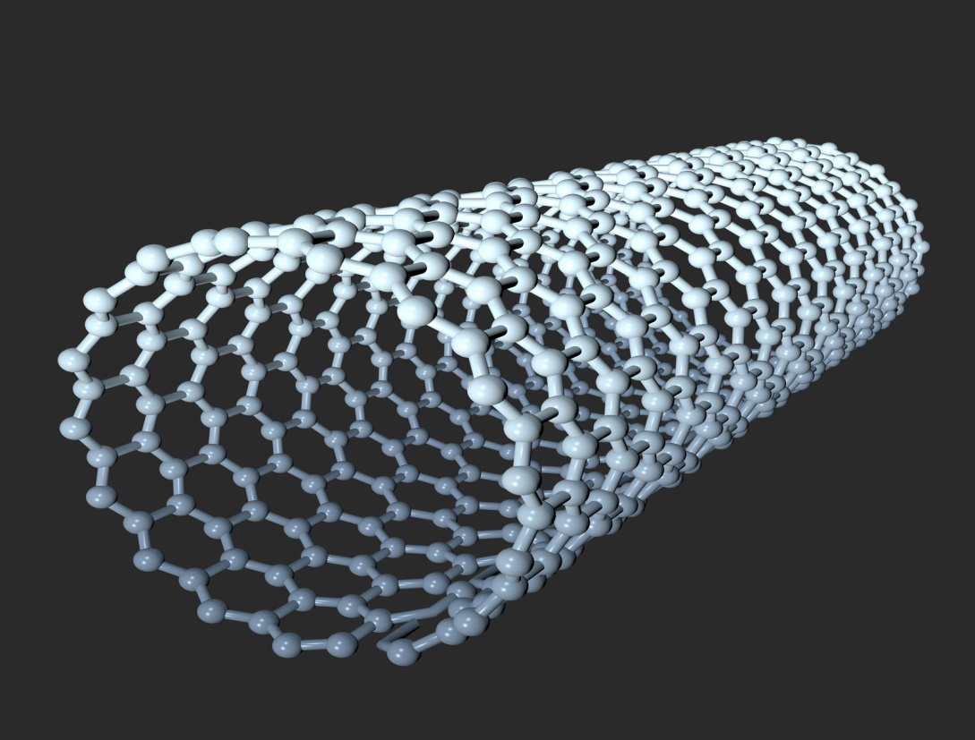

Properties and Applications:-
- The nanotubes are extremely strong and stiff and relatively ductile. For single walled nanotubes tensile strengths range between 50 and 200 Gpa more than carbon fibres. This is strongest known material. Elastic modulus values are of the order of one tera pascal with fracture strains between 5% to 20%.
- They have very low densities. Because of these properties carbon nano tube has been termed as ultimate fibre.
- It has been regarded as 100 times stronger Than steel at the same time six times lighter (weight wise). They find Applications in filling material in composite material.
- They can act as either conductors or semiconductors depending on their chirality so they find their applications in molecular electronics and Computers they are used as ultra sensitive electrochemical sensors. They are used in batteries and fuel cells.
- Field emission results from the tunneling of electrons from a metal tip into Vacuum under application of strong electric field. Small diameter and high aspect ratio (lower loading of CNTs is needed compare to other conductive additives to achieve same electrical conductivity .CNTs are very favourable for field emission.)
- Even for moderate voltages a strong electric field develops at free end of supported CNTs because of their sharpness.
- The large surface area and high absorbency of CNTs make them ideal candidates for use in air gas and water filtration .
Carbon nanocones:
The open carbon cone can be modeled as a wrapped graphene sheet. In order to have strain-free, seamless wrapping, a sector has to be cut out of the sheet. That sector should have an angle of n × 60°, where n = 1, ..., 5 The nanocones are produced by carbon condensation on a Graphite substrates and pyrolysis of heavy oil. The essence of the method is heating the graphite surface with intensive short laser pulse, which evaporates some number of atoms from role as the cut and glue procedure. On the graphene sheet, and other atoms rearrange into the conical surface described above. There is also one special class of nanocones, called nanohorns with exact five defects. These structures with good electron emission properties are easy to get and stable enough. Nano horns show metallic behaviour.

Nanowires:
A nanowire is a nanostructure, with the diameter of the order of a nanometer (10⁻⁹ meters). Alternatively, nanowires can be defined as structures that have athickness or diameter constrained to tens ofnanometers or less and an unconstrained length. At these scales, quantum mechanical effects are important — which coined the term "quantum wires“. Many different types of nanowires exist, including metallic (e.g., Ni, Pt, Au), semiconducting (e.g., Si, InP, GaN, etc.), and insulating (e.g., SiO₂, TiO₂). Molecular nanowires are composed of repeating molecular units either organic (e.g. DNA) or inorganic (e.g. Mo₆S_{9-x}I_{x}).The nanowires could be used, in the near future, to link tiny components into extremely small circuits. using nanotechnology, such components could be created out of chemical compounds.

Methods of preparation of CNT
1.Arc Method
2.Laser Method
3.Chemical vapour Deposition
4.Ball Milling

Laser Method:
In 1996 CNT were first synthesized using a dual pulsed laser and achieved yields of 70% wt. Samples were prepared by laser vaporization of graphite's rods with a 50:50 catalyst mixtures of cobalt and nickel at 12000C in flowing argon followed by heat treatment in vacuum at 1000 oc to remove the C60 and other fullerenes . The initial Laser vaporization pulse was followed by second pulse to vaporizes the target more uniformly .The use of two successive laser pulses minimizes the amount of carbon deposited as sooth. Second pulse breaks up the larger particles ablated by first one and feeds them into the growing nano tube structure. The material produced by this method appears as a mat of ropes 10-20nm in diameter and up to 10 micro meter or more in length.

Chemical vapor deposition method
This Method is useful in production of CNT s on large scale . Both MWCNTs and SWCNTs are obtained by this method . The Method involved decomposing a hydrocarbon gas such as methane acetylene ethylene at temperature of about 1100oc ,in presence of metal nano particle catalyst mostly Ni Co Fe supported on MgO or Al2O3 . Carbon atoms produced by decomposition are condensed on cooler surface containing metal catalyst . The size of the metal nano particle determine the diameter of the nano tube with open ends. It is continuous process used as industrial scale.

Composite materials :
- A composite material can be defined as a combination of two or more materials (having significantly different physical or chemical properties) that results in better properties than those of the individual components.
- The constituents retain their identities in the composite; that is, they do not dissolve or otherwise merge completely into each other, although they act in concert.
- Composites are one of the most widely used materials because of their adaptability to different situations and the relative ease of combination with other materials to serve specific purposes and exhibit desirable properties.
- The main advantages of composite materials are their high strength and stiffness, combined with low density, when compared with bulk materials.

Classification of composite materials:
The composites are classified as mainly two constituents are matrix and a reinforcement

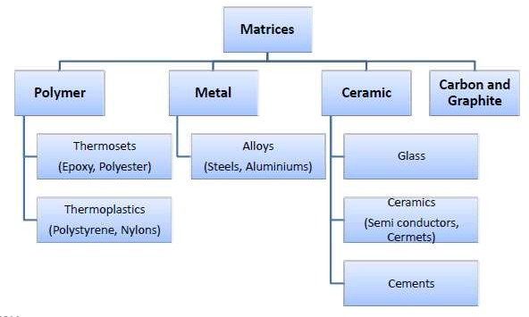ORGANIC/POLYMER MATRIX COMPOSITE (PMCs:
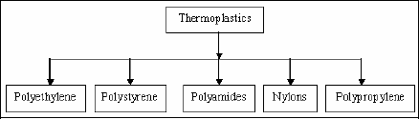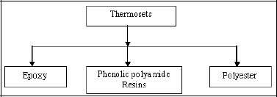
- Thermosets have qualities such as a well-bonded three dimensional molecular structure after curing. They decompose instead of melting on hardening.
- Thermoplastics have one or two dimensional molecular structure and they tend to at an elevated temperature and show exaggerated melting point. Another advantage is that the process of softening at elevated temperatures can reversed to regain its properties during cooling.
METAL MATRIX COMPOSITE (MMCs):
- Metal matrix composites are High strength, fracture toughness and stiffness are offered by metal matrices than those offered by their polymer counterparts. They can withstand elevated temperature in corrosive environment than polymer composites.
- MMCs are widely used in engineering applications where the operating temperature lies in between 250 ºC to 750 ºC.
- Matrix materials: Steel, Aluminum, Titanium, Copper, Magnesium and Super alloys.
CERAMIC MATRIX COMPOSITE (CMCs) :
- Ceramics can be described as solid materials which exhibit very strong ionic bonding in general and in few cases covalent bonding. High melting points, good corrosion resistance, stability at elevated temperatures and high compressive strength
- CMCs are widely used in engineering applications where the operating temperature lies in between 800ºC to 1650ºC

Classification of composite materials:
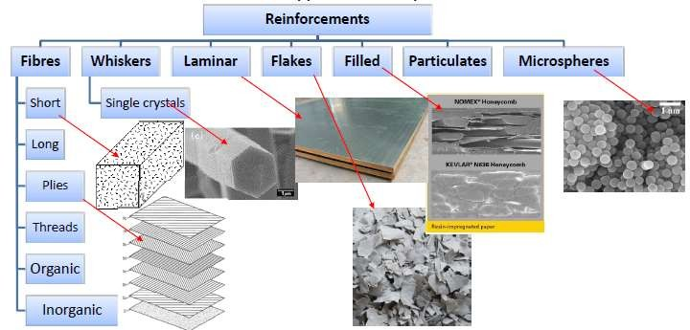

Fiber reinforced composites:
Fibers are the important class of reinforcements, as they satisfy the desired conditions and transfer strength to the matrix constituent influencing and enhancing their properties as desired.
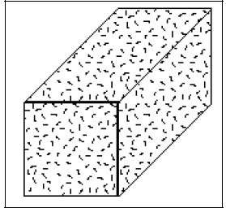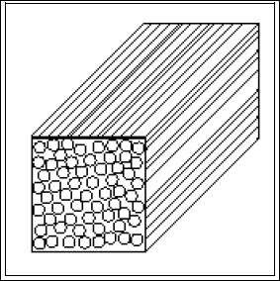
Random fiber (short fiber) reinforced composites
Laminar composites:
Laminar composites are found in as many combinations as the number of materials. They can be described as materials comprising of layers of materials bonded together. These may be of several layers of two or more metal materials occurring alternately or in a determined order more than once, and in as many numbers as required for a specific purpose.
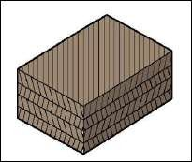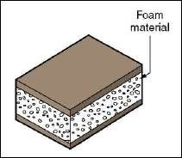
Laminar Composite Sandwich Composite

Particulate reinforced composites:
Microstructures of metal and ceramics composites, which show particles of one phase strewn in the other, are known as particle reinforced composites. Square, triangular and round shapes of reinforcement are known, but the dimensions of all their sides are observed to be more or less equal. The size and volume concentration of the dispersed distinguishes it from dispersion hardened materials.
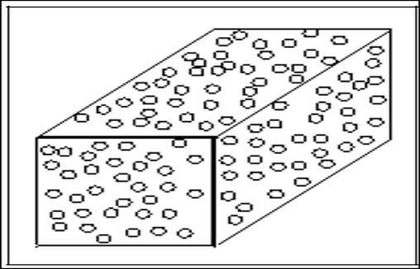
Particulate reinforced composites

Advantages of composite materials :
- Light in weight and Lower density
- High creep resistance
- Strength-to-weight and Stiffness-to-weight are greater than steel or aluminum
- Fatigue properties are better than common engineering metals
- Composites cannot corrode like steel
- Ease of fabrication of large complex structural shapes or modules-Modular construction
- Ability to incorporate sensors in the material to monitor and correct its performance-Smart composites
- High resistance to impact damage.
- Improved corrosion resistance
Limitations :
- High cost of raw materials and fabrication.
- Composites are more brittle than wrought metals and thus are more easily damaged.
- Transverse properties may be weak.
- Matrix is weak, therefore, low toughness.
- Reuse and disposal may be difficult.
- Difficult to attach.
- Difficulty with analysis Cost can fluctuate
Applications of composite materials :
1.SMART CONCRETE
Unlike conventional concrete, the smart concrete has higher potential and enhanced strength. Smart concrete can be prepared by adding carbon fibers for use in electromagnetic shielding and for enhanced electrical conductivity of concrete. Smart concrete under loading and unloading process will loose and regain its conductivity, thus serving as a structural material as well as a sensor. Smart concrete plays a vital role in the construction of road pavements as a traffic-sensing recorder, and also melts ice on highways and airfields during snowfall in winter season by passing low voltage current through it.
2.REHABILITATION AND RETROFIT In these cases the materials are usually bonded externally to the structure in the form of tows (fiber bundles), fabrics, plates, stirrups and jackets. The advantages offered by composites in these forms include their ability to bond well to many substrate materials and to follow complex shapes.
3.ADVANCED COMPOSITE MATERIALS FOR HIGHWAY BRIDGES
- Use of carbon fiber reinforced polymer (CFRP) straight and draped tendons for pre stressing four, 31.2 meter span girders.
- Use of CFRP stirrups for shear reinforcements of two main girders. Use of CFRP for the deck slab.
- Use of glass fiber reinforced polymer (GFRP) reinforcements for the bridge curbs. Use of 64 fiber optic sensors and 16 conventional electric resistance strain gauges to monitor the bridge from a central monitoring station remote from the bridge

Ceramic:
A ceramic is any of the various hard, brittle, heat-resistant and corrosion-resistant materials made by shaping and then firing a nonmetallic mineral, such as clay, at a high temperature. Common examples are earthenware, porcelain, and brick. A composite material of ceramic and metal is known as cermet.
Other ceramic materials, generally requiring greater purity in their make-up than those above, include forms of several chemical compounds, including:
- Barium titanate: (often mixed with strontium titanate) displays ferroelectricity, meaning that its mechanical, electrical, and thermal responses are coupled to one another and also history-dependent. It is widely used in electromechanical transducers, ceramic capacitors, and data storage elements. Grain boundary conditions can create PTC effects in heating elements.
- Bismuth strontium calcium copper oxide, a high-temperature superconductor
- Boron oxide is used in body armor.
- Boron nitride is structurally isoelectronic to carbon and takes on similar physical forms: a graphite-like one used as a lubricant, and a diamond-like one used as an abrasive.
- Earthenware used for domestic ware such as plates and mugs.
- Ferrite is used in the magnetic cores of electrical transformers and magnetic core memory.
- Lead zirconate titanate (PZT) was developed at the United States National Bureau of Standards in 1954. PZT is used as an ultrasonic transducer, as its piezoelectric properties greatly exceed those of Rochelle salt.^{[14]}
- Magnesium diboride (MgB₂) is an unconventional superconductor.
- Porcelain is used for a wide range of household and industrial products.
- Sialon (Silicon Aluminium Oxynitride) has high strength; resistance to thermal shock, chemical and wear resistance, and low density. These ceramics are used in non-ferrous molten metal handling, weld pins, and the chemical industry.
- Silicon carbide (SiC) is used as a susceptor in microwave furnaces, a commonly used abrasive, and as a refractory material.
- Silicon nitride (Si₃N₄) is used as an abrasive powder.
- Steatite (magnesium silicates) is used as an electrical insulator.
- Titanium carbide Used in space shuttle re-entry shields and scratchproof watches.
- Uranium oxide (UO₂), used as fuel in nuclear reactors.
- Zinc oxide (ZnO), which is a semiconductor, and used in the construction of varistors.
- Zirconium dioxide (zirconia), which in pure form undergoes many phase changes between room temperature and practical sintering temperatures, can be chemically "stabilized" in several different forms. Its high oxygen ion conductivity recommends it for use in fuel cells and automotive oxygen sensors. In another variant, metastable structures can impart transformation toughening for mechanical applications; most ceramic knife blades are made of this material. Partially stabilised zirconia (PSZ) is much less brittle than other ceramics and is used for metal forming tools, valves and liners, abrasive slurries, kitchen kn

Applications
- retention of properties at high temperature.
- low coefficient of friction (particularly at high loads and low levels of lubrication)
- low coefficient of expansion.
- corrosion resistance.
- thermal insulation.
- electrical insulation.
- low density.

Mechanical test: Testing of materials are generally classified in two categories.
1.Destructive testing (tensile test, hardness test, fatigue test, creep test and impact test)
2.Non-destructive testing (dye penetrant test, magnetic test, ultrasonic test, radiography, eddy current test etc.)
HARDNESS- Hardness usually implies resistance to deformation, resistance to permanent or plastic deformation or resistance to indentation.
There are three general types of hardness measurements depending upon the manner in which the test is conducted. These are
- Scratch hardness
- Indentation hardness
- Rebound, or dynamic, hardness.
ϕ Only indentation hardness is of major engineering interest for metals.

SCRATCH HARDNESS

With this measure of hardness, various minerals and other materials are rated on their ability to scratch one another.
Hardness is measured according to the Mohs scale.
This consists of 10 standard minerals arranged in the order of their ability to be scratched. The softest mineral in this scale is talc (scratch hardness 1), while diamond has a hardness of 10. A fingernail has a value of about 2, annealed copper has a value of 3, and martensite a hardness of Most hard metals fall in the Mohs hardness range of 4 to 8.
A different type of scratch-hardness test measures the depth or width of a scratch made by drawing a diamond stylus across the surface under a definite load.
Brinell hardness:
- 10-mm-diameter steel ball at a load of 3,000 kg.
- For soft metals the load is reduced to 500 kg to avoid too deep an impression, and for very hard metals a tungsten carbide ball is used to minimize distortion of the indenter.
- The load is applied for a standard time, usually 30 sec.
- The diameter of the indentation is measured with a low-power microscope after removal of the load.
- The average of two readings of the diameter of the impression at right angles should be made.
- The surface on which the indentation is made should be relatively smooth and free from dirt or scale.
- The Brinell hardness number (BHN) is expressed as the load P divided by the surface area of the indentation.
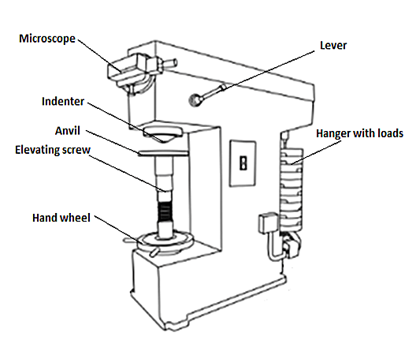
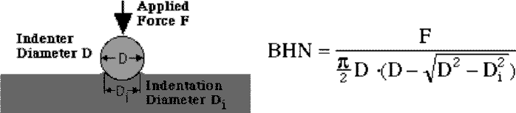

Tensile test
(i) Ultimate tensile stress (UTS)
(ii) Yield stress (YS)
(iii) Breaking stress
(iv) % Elongation
(v) Youngs modulus (E)
(vi) % Reduction in area
Theory:
The tensile test is widely used to provide basic design information on the strength of materials and as acceptance test for specification of materials. In the tensile test, a tensile specimen as per agreed standard is subjected to continually increasing uni-axial tensile force while simultaneous observations are made of the constructed from the load, elongation measurement. The following parameters are found from stress-strain curves.
(i) Elastic limit: The limiting load beyond which the material no longer behaves elastically (recovery of original dimensions when load is removed).
(ii) Ultimate tensile stress: Maximum load divided by the original cross sectional area of specimen.
(iii) Yield stress: Stress required producing a small specified permanent deformation (0.2 % permanent strain)
(iv) % Elongation: It is measured of ductility of material. It is obtained by measuring the difference in length before fracture & after fracture & dividing by the original length.
(v) Modulus of elasticity: It is a measure of stiffness of material. The greater the modulus the smaller the elastic strain from the given application of stress. The slope of the initial position of stress-strain curve is the modulus of elasticity or Youngs modulus.
Equipment required:
(i) Universal testing machine
(ii) Tensile test specimens
(iii) Extensometer dial gauge
(iv) Steel scale, Vernier caliper
(v) Support blocks

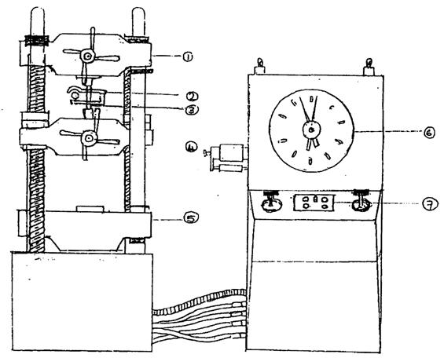

Fig. Universal testing machine
1. Upper cross head
2. Extensometer with dial gauge
3. Tensile specimen
4. Inter mediate cross head
5. Bottom cross head
6. Load dial gauge
7. Speed control valves
Calculation:
Initial diameter of specimen = D₁ mm
Final diameter of specimen = D₂ mm
Initial gauge length = L₁ mm
Final gauge length = L₂ mm
Initial area of specimen (A₁) = πD²₁/4 mm²
Final area of specimen (A₂) = πD²₂/4 mm²
% Elongation = $\frac{ \left(L2 – L1\right)}{L1}$ × 100
% Reduction in area = $\frac{A1-A2}{A1}$ × 100
Yield stress = Yield load / Original area of cross section, N/mm²
Ultimate tensile stress = Maximum load / Original area of cross-section, N/mm²
Breaking stress or Failure stress = Breaking load / Original area of cross-section, N/mm² Torsional Test:
(A) Torsional shear strength (T)
(B) Modulus of rigidity of the material (G)
Apparatus:
1. A torsion testing machine equipped with ‘angle of twist’ measuring system.
2. Torsion testing specimen.
Torsion Test: A torsion testing test commonly measures the following five properties:
(a) Modulus of rigidity which is the ratio of the shear stress to the shear strain, while the material is in the elastic state.
(b) Limit of proportionality which is determined by plotting a torque-twist curve, similar to the stress strain curve in tensile testing.
(c)The maximum torque which is the greatest force used to twist the object before the proportional limit is reached. It occurs well before the fracture point.
(d) The modulus of rapture which is the point at which nominal surface stress occurs. It is calculated from the normal elastic formula as through all the material being tested remained elastic throughout the test.
(e) The total twist for fracture which is formed as the total number of twist or parts of a recorded on a scale?
Torsion test is carried out on a torsion testing machine; the twisting action is applied to one end of the test piece while the other end of the test piece is held stationary.
A turning or twisting movement at the fixed end of the test piece is registered by a system provided along with the machine.
Small, hand operated machine are used for test on small test pieces. When materials in larger sizes are tested, a motor-driven test machine is used.

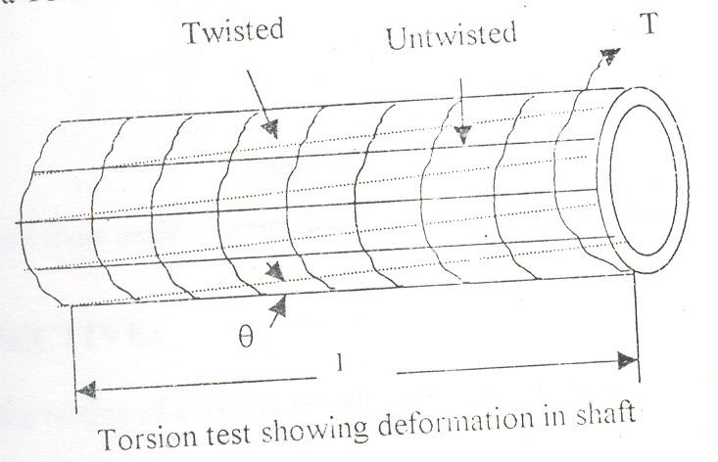
Fig. 1
Theory:
The ability of a material to resist twisting moment (torque) is determined by a torsion test. In torsion test, the specimen of a solid circular section is taken. It is held in a torsion testing machine at one end and the other end is given the torque .this torque causes twist in the specimen. In the fig 1, the twist is shown by deformed dotted lines, which were rectangular grids before application of torque. The torque is increased gradually and the corresponding angle of twist (θ) is measured. The angle of twist is measured by a graduated dial different values of torque.
The shear strain (Y) can be calculated by:
Y = S/L_{u} = rθ
where;
S= the unit shearing displacement in unit length (L_{u})
L_{u}= unit length of rectangular grid,
R= outer radius of a solid shaft,
θ=the angle of twist per unit length.

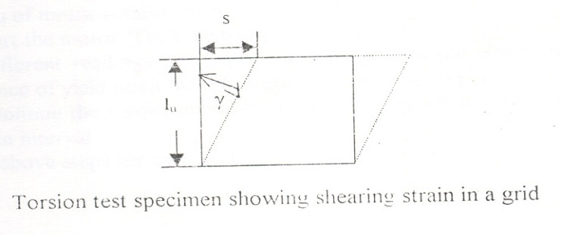
Fig.2
The torque is read on the dial of the machine from the observed data. The torque v/s twist diagram is plotted as shown in fig 3. Its variation is linear up to point A which implies that the elastic limit is A.
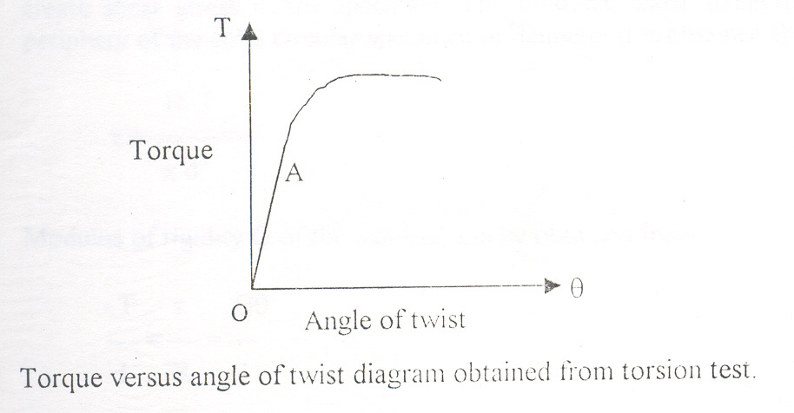
Fig.3
Torsion Testing Machine:
The torsion testing machine is designed for conducting torsion tests on metal and other hard material. The torque applied on the specimen is measured by a pendulum dynamometer and the angle of twist by an angle –measuring disc. The machine is basically consists of two units i.e., driving unit and measuring unit joined together on a frame.
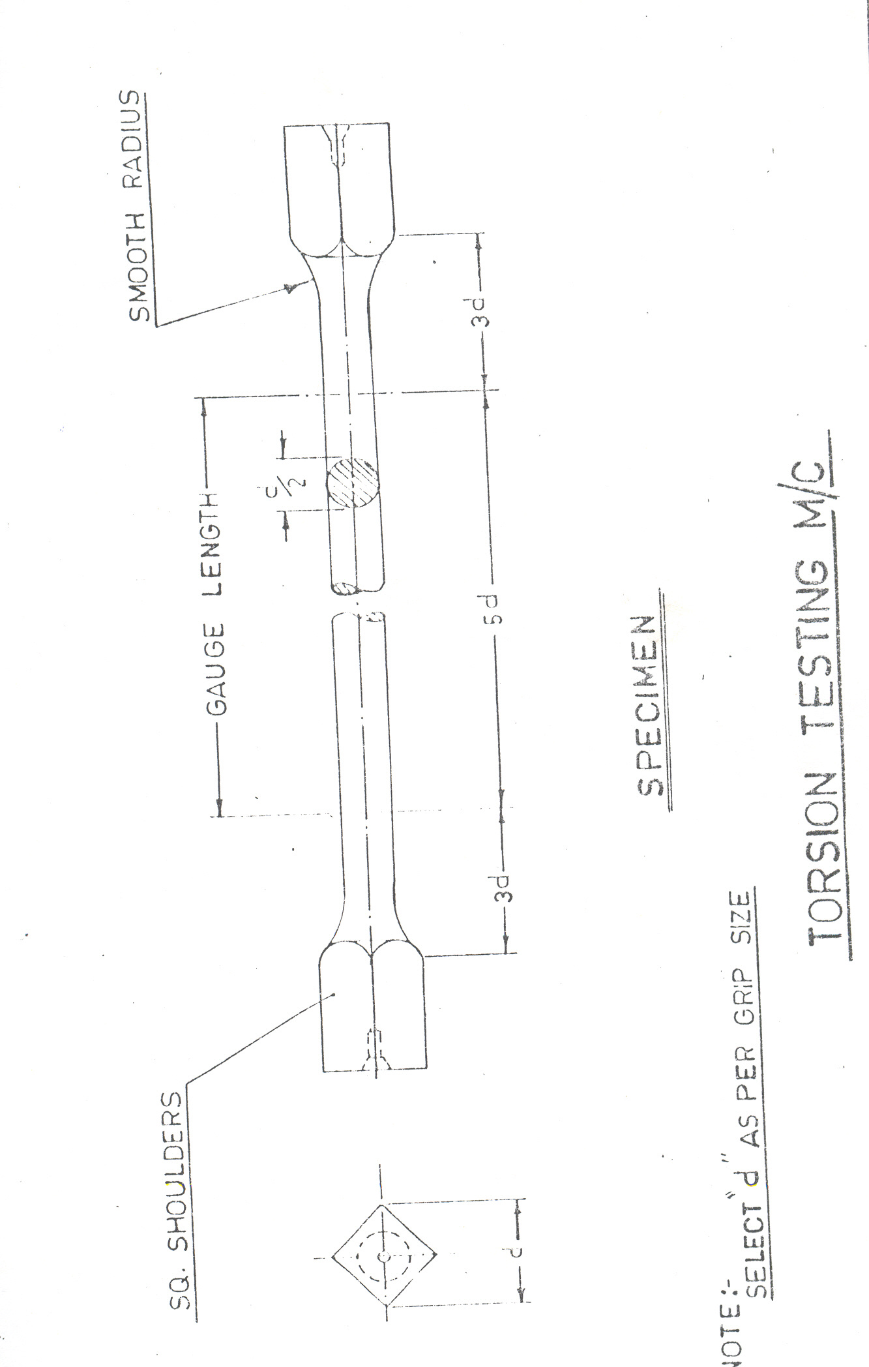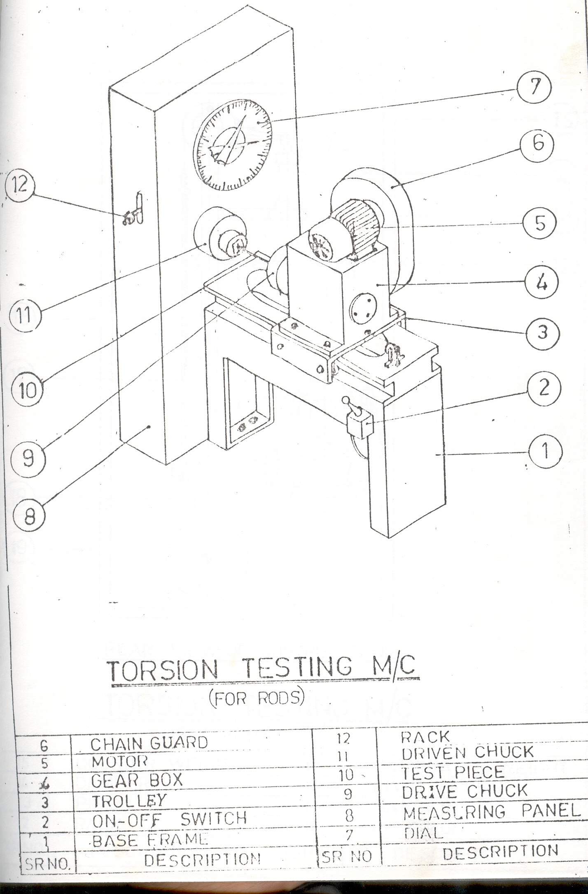

- Driving unit: The unit consists of a gear motor and worms and worm gear reduction gear box. The motor unit is mounted on the top of the gear box and connected through a chain and sprocket assembly. The worm gear shaft carries a spring loaded angel measuring disc and driving chuck. This chuck is suitable for holding test specimen. The assembly of motor and reduction gear is mounted on a trolley, which is supported on four ball bearings, which move in the guides of the machine frame. On the rear side of the reduction gear box, a wire rope is attached which moves down over a pulley and arrives a weight underneath the frame to apply tension load on the specimen during the test. A removable handle is provided to rotate the motor shaft during specimen mounting operation.
(B) Measuring panel: The driven chuck, having a square opening to accommodate the test specimen is mounted on a pivot shaft supported on a ball bearings fixed in a housing clamped to the measuring panel. On the other side of the pivot shaft inside the panel a torque balancing mechanism, consisting a knife edge .V-block, yoke hangers and a lever are mounted. A pendulum dynamometer is connected to this mechanism to measure torque. A set of annular weights (3 parts for a 3 range machine) is provided for this pendulum to select the desired range of the machine. The movement of the pendulum is transmitted to the dialer point through a rack and pinion mechanism to show the torque applied on the specimen. The position of the knife edge etc on the pendulum drive mechanism should never be disturb as till lead to error in calibration of the machine. The damper is provided in the dynamometer mechanism to protect it when sudden shock load caused, because of breakage of test specimen on load. The damper allows the pendulum to return to its normal position slowly. A torque indicating dial is mounted on the front side of the measuring panel. The range setting dial located at the backside of the torque indicating dial is to be adjusted to particular range depending upon the weight placed on the dynamometer pendulum. It is done by moving the range selector lever.
the assumptions made while deriving the above relation are:
- Material is homogenous.
- Circular section remains circular and do not warp.
- A plane section of a material perpendicular to its longitudinal axis remains plane and does not warp after the torque is applied.
- Shaft is loaded by a couple or torque in a plane perpendicular to the longitudinal axis of the plane.
- Shear stress is proportional to shear strain; it means that Hookâ€™s Law is applicable.
- In circular shafts subjected to torque shearing strain varies linearly.

Impact test:
Impact test determines the amount of energy absorbed by a material during fracture. This absorbed energy is a measure of a given material's toughness and acts as a tool to study temperature-dependent brittle-ductile transition. It is to determine whether the material is brittle or ductile in nature.
Impact testing machine consists of a pendulum suspended from a short shaft that rotates in ball bearing and swings midway between two rigid upright stands supported on a rigid base near the bottom of which are the specimen supports anvils. The knife-edge or striking edge is slightly rounded. The pendulum can be raised to any desired height and rested at that position. It is supported in the starting position by a catch and can be released by a trigger. The mechanism is so designed that the pendulum is not disturbed when the catch is released.

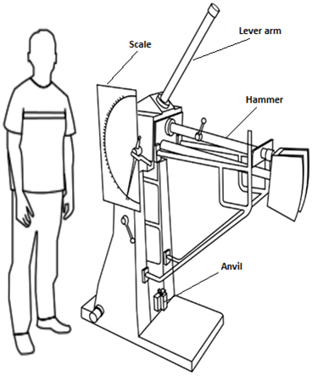

This type of test will detect differences between materials which arc not observable in a tension test. A large number of notched-bar test specimens of different design have been used by investigators of the brittle fracture of metals.
Two classes of specimens have been standardized for notched-impact testing. i.e

1.Charpy
2.Izod

Charpy bar specimens:-

the Charpy specimen may be used with one of three different types of notch, a 'keyhole', a 'U' and a 'V'. The keyhole and U-notch are used for the testing of brittle materials such as cast iron and for the testing of plastics. The V-notch specimen is the specimen of choice for weld testing and is the one discussed here.

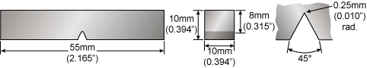
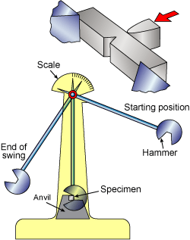

izod test
Impact strengths are generally lower as compared to strengths achieved under slowly applied loads.Indian standard method of izod impact test consists of breaking the specimen by one blow from a swinging hammer under specified condition, a notched test piece is gripped vertically with the bottom of the notch in the same plane as the upper face of the grips.The-blow is struck at a fixed position on the face having the notch. When a striker impacts the specimen, the specimen will absorb energy till it yields. At this point the specimen will begin to undergo plastic deformation at the notch. The specimen continues to absorb energy and work harden at the plastic zone, when the specimen can absorb no more energy fracture takes place.
Generally notch type specimens are used for impact tests. The notch in the test specimen serves to concentrate the stress, minimize plastic deformation, and direct the fracture to the part of the specimen behind the notch. Thus scatter in energy-to-break is reduced. The stress-concentration at the notch decreases with increase in notch radius. Also the use of notched specimen increases the sensitivity and reproducibility of the measurement.
TEST SPECIMEN:
The standard test piece of overall length of 75mm and a square cross-section of 10mm side with a standard 45° notch, 2mm deep is employed for the test. The notch is at 28mm from one end. In case of round specimen 11.4mm diameter with a standard 45° notch, 3.3mm deep is employed.
