3ME4-06 : MATERIAL SCIENCE AND ENGINEERING
Credit: 3 Max. Marks: 150 (IA:30, ETE:120) 3L+0T+0P
Subject notes
UT-3
Isothermal Transformation or Time-Temperature-Transformation Curves
When steel is austenitized, and then held at a constant temperature below the austenite region (A_{f}), it will transform to some transformation product like pearlite or bainite. There is an incubation time for nucleation, followed by nucleation and growth. Finally, the reaction will complete, and transformation will end. The course of this transformation can be understood by plotting the amount of austenite transformed against the corresponding elapsed time at constant temperature.For a given steel, the information given by a series of such curves, each curve determined at a different temperature, can be summarized by a single diagram called a Time-Temperature-Transformation (TTT) curve. This is shown in Figure 5. This diagram shows the time, at a particular temperature, to start to transform and finish transforming to a transformation product such as ferrite, pearlite or bainite. This diagram can be thought of as a map which plots the transformations of austenite as a function of constant temperature and time. This allows estimates to be made regarding how the steel will respond to any mode of cooling from austenite.
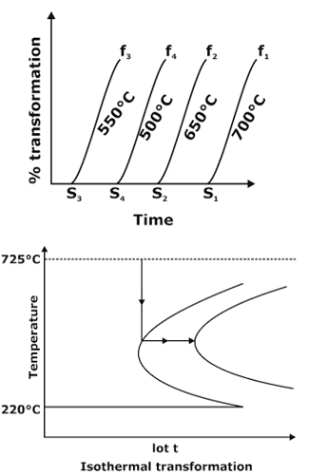
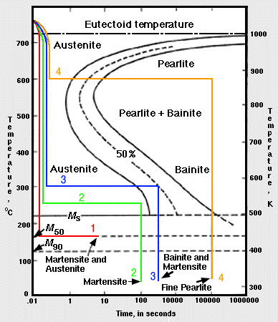
Figure Diagram showing how measurements of the isothermal transformations of austenite as a function of time and temperature are used to create Isothermal TTT diagrams.
Diagrams that describe the transformation of austenite as a function of constant temperature are called Time-Temperature Transformation diagrams. These diagrams are created empirically by taking hundreds of very thin samples and austenitizing the samples. These samples are then quenched into a medium (usually molten salt) at specific temperatures of interest. The samples are individually held isothermally at the desired temperature for various lengths of time. The samples are then quenched in water. Once cool, the samples are metallographically examined and the volume fractions of the microstructure constituents are determined. The results are plotted on a graph showing the progression of transformation as a function of time and temperature.
Factors affecting TTT diagram
1- Composition of steel-
(a) carbon wt%,
(b) alloying element wt%
2- Grain size of austenite
3- Heterogeneity of austenite.
Example (1) Using the isothermal transformation diagram for an iron-carbon alloy of eutectoid composition, specify the nature of the final microstructure of a small specimen that has been subjected to the following time-temperature treatments. The specimen begins at 760°C and that it has been held at this temperature long enough to have achieved a complete and homogeneous austenitic structure.
(a) Rapidly cool to 250°C, hold for 100s, and quench to room temperature
(b) Rapidly cool to 600°C, hold for 104 s, and quench to room temperature.
Ans :- 1- At 760°C: in the austenite region (g) — 100% austenite
2-Rapidly cool from 760°C to 250°C: 100% austenite
3-Hold for 100 seconds at 250°C: 100% austenite
4-Quench to room temp.: 100% martensite B /
1-At 760°C: in the austenite region — 100% austenite
2-Rapidly cool from 760°C to 600°C: 100% austenite
3-Hold for 104 s at 250°C: 100% pearlite
4-Quench to room temp.: 100% pearlite
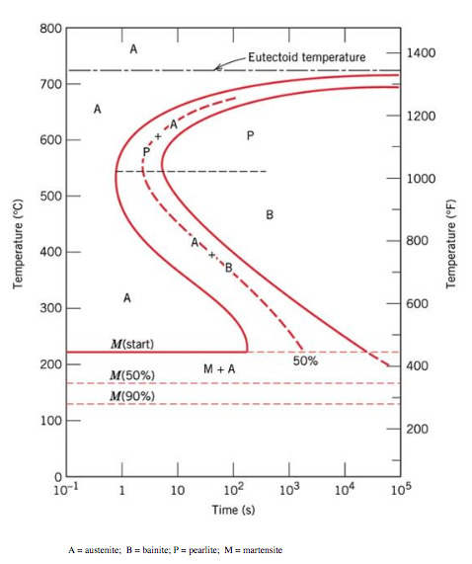

Heat Treatment Process: heat treatment is the process of heating the metal, holding it at that temperature, and then cooling it back. During the process, the metal part will undergo changes in its mechanical properties. This is because the high temperature alters the microstructure of the metal.
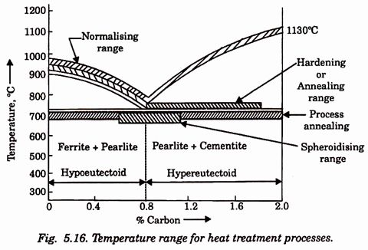

Classification of heat treatment processes.

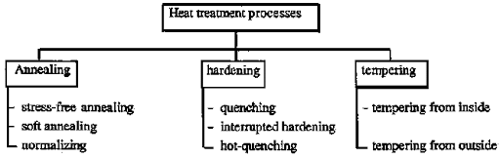
- Annealing:
Annealing is a heat treatment process which alters the microstructure of a material to change its mechanical or electrical properties. Typically, in steels, annealing is used to reduce hardness, increase ductility and help eliminate internal stresses.
The Steel parts produced by mechanical operation process such as casting, rolling or drawing, extruding, etc. develop internal stresses and change their internal structure. This renders them hard and brittle.Annealing is carried out for such parts to remove the internal stresses and make them more ductile and less brittle.Annealing consists of heating of steel parts to a temperature at or near the critical temperature 900 degree Celsius hold it at that temperature for a suitable time and when allowed to cool slowly in the Furnace itself.
The heating done during annealing affects the metal in two stages of recovery and recrystallization.
Recovery occurs as the temperature of the metal is gradually raised.Internal stresses are relieved as the atom in the metal rearrange themselves into the position that there occupied before subjected to mechanical operation.Recrystallization occurs as the temperature of the metal is rise further and nuclei for the growth of new stress-free crystal begin to form.As these nuclei form, the Express free crystals exhibit most of the original properties of the metal. Gradual slow cooling ensures the retaining of restored properties of the metal.
Annealing is carried out for accomplishing one or more of the following:
- Softening of a metal or alloy. This may be done due to improving machinability.
- Relieving internal residual stresses caused by the various manufacturing process.
- Refining the grain size of the metal or alloy.
- Increasing the ductility and reducing brittleness.
- Homogenizing the distribution of constituents.
Two types of annealing carried out are:
1. Process annealing.
2. Full annealing.
1. Process annealing:
It consists of heating the Steel to a temperature little below the critical range and then cooling it slowly. This causes complete recrystallization in steel to form New grain structure. This will release the internal stresses previously the strip in the steel and improve the machinability.
2. Full annealing:
It consists of heating the Steel temperature at or near the critical point holding there for a suitable time and then allowing it cools slowly in the Furnace itself. This courses wipes out all traces of the previous structure and define the crystalline structure in addition to the softening of the metal. It also removes internal stresses. Now,

The Steel parts produced by mechanical operation process such as casting, rolling or drawing, extruding, etc. develop internal stresses and change their internal structure. This renders them hard and brittle.Annealing is carried out for such parts to remove the internal stresses and make them more ductile and less brittle.Annealing consists of heating of steel parts to a temperature at or near the critical temperature 900 degree Celsius hold it at that temperature for a suitable time and when allowed to cool slowly in the Furnace itself.The heating done during annealing affects the metal in two stages of recovery and recrystallization.
Recovery occurs as the temperature of the metal is gradually raised.
Internal stresses are relieved as the atom in the metal rearrange themselves into the position that there occupied before subjected to mechanical operation.
Recrystallization occurs as the temperature of the metal is rise further and nuclei for the growth of new stress-free crystal begin to form.As these nuclei form, the Express free crystals exhibit most of the original properties of the metal. Gradual slow cooling ensures the retaining of restored properties of the metal.
Annealing is carried out for accomplishing one or more of the following:
- Softening of a metal or alloy. This may be done due to improving machinability.
- Relieving internal residual stresses caused by the various manufacturing process.
- Refining the grain size of the metal or alloy.
- Increasing the ductility and reducing brittleness.
- Homogenizing the distribution of constituents.

2. Normalizing:
Normalizing is a heat treatment process similar to annealing in which the Steel is heated to about 50 degree Celsius above the upper critical temperature followed by air cooling.
This results in a softer state which will be lesser soft than that produced by annealing.
This heat treatment process is usually carried for low and medium carbon steel as well as alloy steel to make the grain structure more uniform and relieve the internal stresses.
Normalizing carried for accomplishing one or more of the following:
- To refine the grain size.
- Reduce or remove internal stresses.
- Improve the machinability of low carbon steel.
- Increase the strength of medium carbon steel.
- And also To improve the mechanical properties of the medium Carbon Steel.
3. Hardening:
Hardening is a heat treatment process carried out to increase the hardness of Steel.
It consists of heating Steel components to the temperature within or above its critical range. Held at this temperature for a considerable time to ensure thorough penetration of heat at this temperature well inside the component and then allowed to cool separately by quenching in water oil or brine solution.
This kind of heat treatment produced a small grain size in the metal.The strength and hardness of the Steel are increased but makes it more brittle since ductility is reduced.
Hardening is carried to accomplish the following:
- To reduce the grain size.
- Obtain maximum hardness.
- Reduce ductility to the minimum.
- To increase the wear resistance of Steel.
- Improve the magnetizing properties.

4. Tempering:
This heat treatment process carried out for steel parts which have been already hardened, in order to reduce bitterness and unequal stress develop as a result of hardening.This process reduces brittleness and hardness but improves the tensile strength of Steel.It increases the toughness of Steel at the expenses of loss of some hardness.
5. Nitriding:
Nitriding is a process of surface hardening in which nitrogen gas is used to obtain a hard surface for the Steel. In this process, the Steel parts are heated in an atmosphere of ammonia (NH₃ ) for a prolonged period and then cooled slowly.
The heating temperature for nitriding Ranges from 480 degree Celsius to 550 degree Celsius.
During this process, when Ammonia comes in contact with steel is diffuses into nascent hydrogen and nascent nitrogen.This nascent nitrogen so produced diffuses into the surface of the workpiece forming hard nitrites which increase surface hardness.Beside increasing surface hardness and wear resistance nitriding provides good resistance to corrosion due to water, air, and steam.Nitriding is generally employed to Steel parts which are moving like engine parts such a cylinder, crankshaft, etc.
6. Cyaniding:
Cyaniding is also a surface hardening process in which the heated parts to be surface hardened are immersed in a bath of molten sodium or potassium cyanide.The immersed Steel parts are left in the molten cyanide bath for about 15 to 20 minutes.Then the parts are taken out of the bath and Queens in lime water to neutralize the particles of Cyanide salt sticking to the surface of the steel parts.The cyanide yield carbon monoxide and nitrogen both of which behaves as active carburizing agents in hardening the surface of the Steel.This surface hardening is particularly suitable for small parts like a small gear, Bush pins, screws pins, and small hand tool which required thin and Hard-wear resisting surface.
Hardenability: ¬ It is an index of the depth to which the martensite can be formed in a given steel as a result of a given hardening treatment.
- The term Hardenability is used to measure the depth of hardness achieved i.e. martensite introduced into the steel section by quenching the steel from austenite state.
- The responsibility of a steel to a given hardening treatment is indicated by the property known as Hardenability.
- Greater the depth of hardness below the surface, higher will be the hardenabillity of steel.
Jominy End Quench Test for hardenabillity measurements:
The Jominy end quench test is used to measure the hardenability of a steel. Hardenability The Jominy end quench test measures the hardenability of steel. This is the ability of the steel to partially or to completely transform from austenite to some fraction of martensite at a given depth below the surface, when cooled under a given condition from high temperature. The quench and temper heat treatment uses this phase transformation to harden steels. After tempering, the martensite microstructure gives the steel a good combination of strength and toughness. Without tempering, martensite is hard, but brittle. To select steels for a heat treated component, it is important to know their hardenability. Alloying and microstructure both affect the hardenability, allowing the correct steel and quenching rate to be selected. The prior processing of the steel also affects the microstructure, and should also be considered. The hardening of steels can be understood by considering that on cooling from high temperature, the austenite microstructure of the steel can transform to either martensite or a mixture of ferrite and pearlite (figure 1). The ferrite/pearlite reaction involves diffusion, which takes time. However, the martensite transformation does not involve diffusion and is essentially instantaneous. These two reactions are competitive, and martensite is obtained if the cooling rate is fast enough to avoid the slower formation of ferrite and pearlite. In alloyed steels, the ferrite/pearlite reaction is further slowed down, which allows martensite to be obtained with slower cooling rates. The transformation to another possible phase, bainite, can be understood in a similar way. The hardenability describes the capacity of the steel to harden in depth under a given set of conditions. For example, a steel of a high hardenability can transform to a high fraction of martensite to depths of several millimetres under relatively slow cooling, such as an oil quench, whereas a steel of low hardenability may only form a high fraction of martensite to a depth of less than a millimetre, even under quite rapid cooling such as a water quench. Steels with high hardenability are needed for large high strength components, such as large extruder screws for injection moulding of polymers, pistons for rock breakers, mine shaft supports, aircraft undercarriages, and also for small high precision components such as die-casting moulds, drills and presses for stamping coins. The slower cooling rates that can be used for high hardenability steels can reduce thermal stresses and distortion.
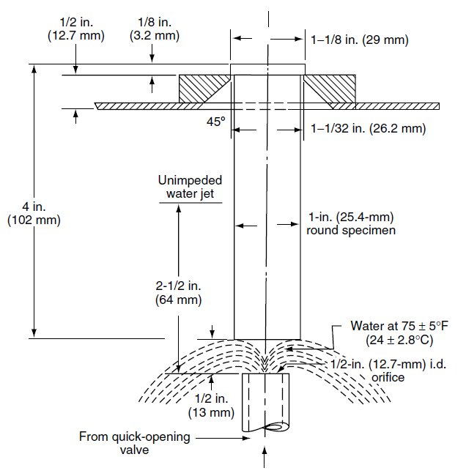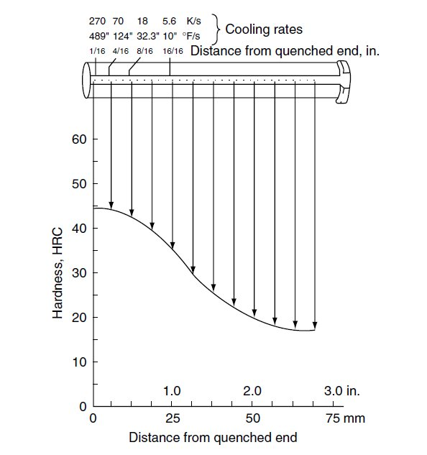
Austempering& Martempering :
Austempering :
It is quenching from a temperature above the transformation range to some temperature above the upper limit of martensite formation, and holding at this temperature until the austenite is completely transformed to the desired intermediate structure, for the purpose of conferring certain mechanical properties. It is carried out in a medium having a rate of heat abstraction high enough to prevent the formation of high temperature transformation products.
Martempering :
It is quenching from a temperature above the transformation range to some temperature above the upper limit of martensite formation, holding at that temperature long enough to permit equalisation of temperature without transformation of the austenite followed by cooling in air. This results into the formation of martensite which may be tempered as desired.
It is a hardening procedure in which an austenitized steel object is quenched into an appropriate medium whose temperature is maintained substantially at the Ms temperature of the steel object, held in the medium until its temperature is uniform throughout but not long enough to permit bainite to form, and then cooled in air. The treatment is followed by tempering.

Case Hardening:Case hardening is a technique in which the metal surface is reinforced by the adding of a fine layer at the top of another metal alloy that is generally more durable. Case hardening steel is normally used to increase the object life. This is particularly significant for the manufacture of machine parts, carbon steel forgings, and carbon steel pinions. Case hardening is also utilized for other applications. Case hardening is also called surface hardening. Case hardening has been in use for many centuries, and was frequently used for producing horseshoes and different kinds of cooking utensils that were subjected to substantial wear and tear. Case hardening is essentially a group of processes that are used to increase the surface hardness to an extent that is higher than that of the bulk material. Case hardening is performed normally locally on the top surface, and for a limited depth. Greater hardness is usually related with better wear and fatigue resistance.
Applications
Components that are subjected to severe impacts and high pressures are generally case hardened. The surfaces that need special hardness may be selectively hardened, without performing case hardening of the remaining object. Firearms are a usual item that is case hardened, as they need accuracy in machining and higher hardness for performing the desired functions. Another general application of the case hardening is on camshafts and special purpose screws, mainly the self drilling screws. Case hardening is less complex for fasteners and screws since it is performed simply by heating and quenching. Case hardening of smaller items is performed by repetitive heat application.

Induction Hardening / Flame Hardening
Induction hardening is a process used for the surface hardening of steel and other alloy components. The parts to be heat treated are placed inside a water cooled copper coil and then heated above their transformation temperature by applying an alternating current to the coil. The alternating current in the coil induces an alternating magnetic field within the work piece, which if made from steel, caused the outer surface of the part to heat to a temperature above the transformation range. Parts are held at that temperature until the appropriate depth of hardening has been achieved, and then quenched in oil, or another media, depending upon the steel type and hardness desired. The core of the component remains unaffected by the treatment and its physical properties are those of the bar from which it was machined or preheat treated. The hardness of the case can be HRC 37 - 58. Carbon and alloy steels with a carbon content in the range 0.40 - 0.45% are most suitable for this process. In some cases, parts made from alloy steels such as 4320, 8620 or 9310, like steel and paper mill rolls, are first carburized to a required case depth and slow cooled, and then induction hardened. This is to realize the benefit of relatively high core mechanical properties, and surface hardness greater than HRC 60, which provides excellent protection.
While induction hardening is most commonly used for steel parts, other alloys such as copper alloys, which are solution treated and tempered, may be induction hardened as well. Applications include hardening bearing races, gears, pinion shafts, crane (and other) wheels and treads, and threaded pipe used for oil patch drilling.
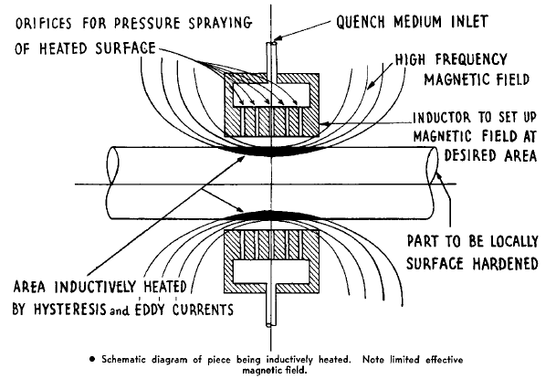
Flame Hardening
Flame hardening is similar to induction hardening, in that it is a surface hardening process. Heat is applied to the part being hardened, using an oxy- acetylene (or similar gas) flame on the surface of the steel being hardened and heating the surface above the upper critical temperature before quenching the steel in a spray of water. The result is a hard surface layer ranging from 0.050" to 0.250" deep. As with induction hardening, the steel component must have sufficient carbon (greater than 0.35%). The composition of the steel is not changed; therefore core mechanical properties are unaffected. Flame hardening produces results similar to conventional hardening processes but with less hardness penetration. Applications for flame hardening are similar to those for induction hardening, although an advantage of flame hardening is the ability to harden flat surfaces. Flat wear plates, and knives can be selectively hardened using this process.
