Jaipur Engineering College & Research Centre, Jaipur
Department of Electronics & Communication Engineering

Session (2019-20)

Notes File
POWER ELECTRONICS (6EC3-01)

Prepared By:
Deepak sankhala,Mrs.Yogita Taluja
(AP, Dept. of ECE)

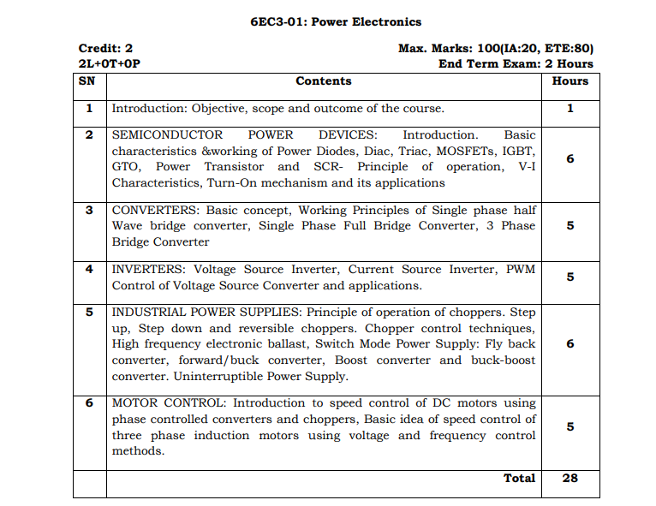

Power Electronics
1 | Introduction: Objective, scope and outcome of the course.
2 | SEMICONDUCTOR POWER DEVICES: Introduction. Basic characteristics &working of Power Diodes, Diac, Triac, MOSFETs, IGBT, GTO, Power Transistor and SCR- Principle of operation, V-I Characteristics, Turn-On mechanism and its applications
3 | CONVERTERS: Basic concept, Working Principles of Single phase half Wave bridge converter, Single Phase Full Bridge Converter, 3 Phase Bridge Converter
4 | INVERTERS: Voltage Source Inverter, Current Source Inverter, PWM Control of Voltage Source Converter and applications.
5 | INDUSTRIAL POWER SUPPLIES: Principle of operation of choppers. Step up, Step down and reversible choppers. Chopper control techniques, High frequency electronic ballast, Switch Mode Power Supply: Fly back converter, forward/buck converter, Boost converter and buck-boost converter. Uninterruptible Power Supply.
6 | MOTOR CONTROL: Introduction to speed control of DC motors using phase controlled converters and choppers, Basic idea of speed control of three phase induction motors using voltage and frequency control methods.

Unit 1
SEMICONDUCTOR POWER DEVICES:
Introduction. Basic characteristics &working of Power Diodes, Diac, Triac, MOSFETs, IGBT, GTO, Power Transistor and SCR- Principle of operation, V-I Characteristics, Turn-On mechanism and its applications

POWER ELECTRONICS
The control of electric motor drives requires control of electric power. Power electronics have eased the concept of power control. Power electronics signifies the word power electronics and control or we can say the electronic that deal with power equipment for power control.

Ref signal
Main power source
Power
Electronic
circuit
Load
Control
Circuit
Feedback Signal
Digital Circuit
Power electronics based on the switching of power semiconductor devices. With the development of power semiconductor technology, the power handling capabilities and switching speed of power devices have been improved tremendously.
Power Semiconductor Devices

The first SCR was developed in late 1957. Power semiconductor devices are broadly categorized into 3 types:
  - Power diodes (600V,4500A)
  - Transistors
  - Thyristors (10KV,300A,30MW)

Thyristor is a four layer three junction pnpn semiconductor switching device. It has 3 terminals these are anode, cathode and gate. SCRs are solid state device, so they are compact, possess high reliability and have low loss.
Power diodes

The diode is a simple semiconductor device that includes two layers, two terminals & a single junction. The junction of normal diodes can be formed through semiconductors like p-type and n-type. The terminal at p-type is known as anode whereas the terminal at the n-type is known as the cathode. There are different kinds of diodes are available in the market. Each type has its application. This article discusses an overview of the power diode. Ideally, a diode must have no reverse recovery time. But, the deigning cost of such diode may change. In various applications, the reverse recovery time effect is not important so low-cost diodes can also be used.

What is a Power Diode?
Definition: A diode that has two terminals like anode & cathode and two layers like P & N, used in the power electronics circuits is known as power diode. This diode is more complex in construction as well as in operation because low power device has to change to make them appropriate in high power applications.
In power electronic circuits, this diode plays an essential role. It can be used as a rectifier in converter circuits, voltage regulation circuits, flyback / freewheeling diode, reverse voltage protection, etc.
These diodes are related to signal diodes except for a slight disparity in its construction. The doping level in signal diode for both P-layer & N-layer is the same whereas, in power diodes, the junction can be formed among a heavily doped P+ layer & lightly doped N– layer.

Construction
The construction of this diode includes three layers like the P+ layer, n– layer and n+ layer. Here the top layer is the P+ layer, it is heavily doped. The middle layer is n– layer, it is lightly doped and the last layer is n+ layer, and it is heavily doped.
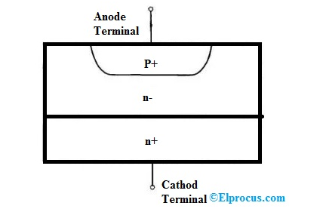
Here p+ layer acts as an anode, the thickness of this layer is 10 μm & the level of doping is 10¹⁹ cm⁻³.
The n+ layer acts as a cathode, the thickness of this layer is 250-300 μm & the level of doping is 10¹⁹ cm⁻³.
The n- layer acts as a middle layer/drift layer, the thickness of this layer mainly depends on the breakdown voltage & the level of doping is 10¹⁴ cm⁻³. Once this layer width increases then breakdown voltage will be increased.

Working Principle of Power Diode
The working principle of this diode is similar to the normal PN junction diode. When the voltage of the anode terminal is high than the voltage of the cathode terminal, the diode conducts. The range of forwarding voltage drop in this diode is very small approximately 0.5V – 1.2V. In this mode, the diode works as a forward characteristic.
If the voltage of the cathode is high than the voltage of anode, the diode performs as blocking mode. In this mode, the diode performs like the reverse characteristic.

Types of Power Diode
The classification of these diodes can be done based on the reverse recovery time, the process of manufacturing & the depletion region penetration in reversed bias condition.
The power diodes depending on the reverse recovery time as well as the process of manufacturing are classified into three types such as
- General Purpose Diodes
- Fast Recovery Diodes
- Schottky Diodes

V-I Characteristics
The V-I characteristics of a power diode are shown below. Once the forward voltage increases then the forward current will be increased linearly.
An extremely less amount of current leakage will supply in the reverse bias condition. This current is independent of the applied reverse voltage.
The leakage current mainly supplies because of the minority charge carriers in the diode. As the reverse voltage gets the reverse breakdown voltage, then the breakdown of an avalanche will occur. When the reverse breakdown arises, the reverse current will also be raised drastically with less increase in reverse voltage. The reverse current can be controlled by an external circuit.

Advantages and Disadvantages of Power Diode
The advantages and disadvantages of power diode include the following.
- The PN-junction region of this diode is large & can supply huge current, however, the capacitance of this junction can also be large, which works at a lower frequency & it is generally used for rectification only.
- It will resolve AC at high current and a high voltage.
- The main disadvantage is its size & probably needs to be fixed to a heat sink while conducting a high current.
- It needs specialized hardware for installing and insulating from the metal frames which are available in the surrounding.

Applications
The applications of power diode include the following.
- This diode provides uncontrolled power rectification
- It is used in different applications like DC power supplies, for charging the battery, inverters and AC rectifiers.
- These are used like snubber networks and free-wheeling diodes due to their characteristics like voltage & high-current.
- These diodes are used as feedback, freewheeling diodes, and high-voltage rectifier.
- In reverse breakdown condition, when the current and voltage of this diode are huge, the power dissipation can be high so the device can be destroyed.

TRIAC.
The word TRIAC can be expanded as a TRIode for Alternating Current. While other power electronic switches like MOSFET, IGBT, etc are used for switching/controlling DC power, the TRIAC is used to control AC power because once turned on TRIAC can conduct in both the direction allowing AC voltage to passes completely in both the positive and negative cycle.
The TRIAC is a three-terminal semiconductor switching device that is used for controlling current flow in a circuit. It is one of the most important members of the thyristor family; it is a bidirectional device that can pass the current in both forward and reverse direction, which means that they can conduct in both the conditions of the gate signal, positive and negative.

TRIAC Symbol
A TRIACs can be formed by connecting two equivalent SCRs in inverse parallel to one another and the gates of the two SCR are connected together to form a single gate. If you are new to DIACs as well then you can read the DIAC Introduction Article to know more about it. The Symbol of the TRIAC will be like the image below, it has three terminals Main Terminal 1 (MT1), Main Terminal 2 (MT2) and Gate (G).
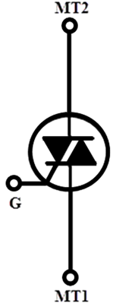
The MT1 and MT 2 are also called as Anode 1 and Anode 2. The TRIAC can be included in a circuit in a way that the current is flowing from either MT1 to MT2 or MT2 to MT1, there will not be any current until we inject a gate current pulse at G.

TRIAC Construction
The below shows the structure of the TRIAC, it is a four-layer device that consists of six doping regions. The gate terminal is designed in a way to have ohmic contact with both N and P regions, which helps the device to get triggered with both positive and negative polarities.
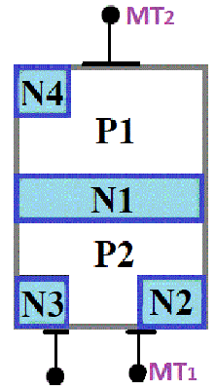
Although TRIAC is a bidirectional device, everyone prefers to specify voltage and current using MT1 as the reference in order to reduce confusion.
TRIAC Working Principle and Operation
TRIAC can go to conduction state if the applied voltage is equal to the breakdown voltage, but the most preferred way of turning on a TRIAC is by providing a gate pulse, either positive or negative. If the gate current is high, a very small amount of voltage is enough to turn on the TRIAC. As the TRIAC is bidirectional and has an ability to get turned on with both the polarities to the gate pulse it can operate in four different types of modes of operation as listed below
1. MT2 is positive with respect to MT1 with a gate polarity positive with respect to MT1.
2. MT2 is positive with respect to MT1 with a gate polarity negative with respect to MT1.
3. MT2 is negative with respect to MT1 with a gate polarity negative with respect to MT1.
4. MT2 is negative with respect to MT1 with a gate polarity positive with respect to MT1.

MT2 is positive with respect to MT1 with a gate polarity positive with respect to MT1
When the terminal MT2 is positive with respect to the Terminal MT1 the current will be flowing in the path of P1-N1-P2-N2. During this operation, the junction between the layers P1-N1 and P2-N2 are forward biased whereas the Junction between N1-P2 is reverse biased. When the positive signal is applied to the gate the junction between P2-N2 is forward biased and breakdown occurs.
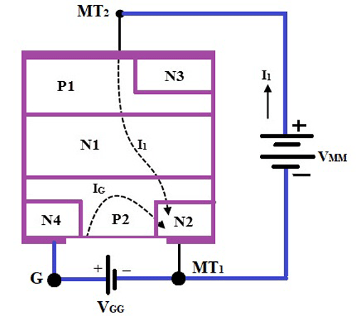

MT2 is positive with respect to MT1 with a gate polarity negative with respect to MT1
When the MT2 is positive and the gate pulse is negative, the current flow will be in the same path as the first mode which is P1-N1-P2-N2, but here the junction between the P2-N2 is forward biased and the current carriers are injected into the P2 layer.

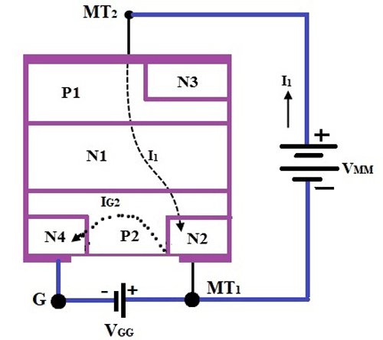

MT2 is negative with respect to MT1 with a gate polarity negative with respect to MT1
When the terminal MT2 is positive and negative pulse is provided to the gate terminal the current will be flowing in the path of P2-N1-P2-N2. During the operation the junction between the layers P2-N1 and P1-N4 are forward biased whereas the junction between the layers N1-P1 is reverse biased, hence the TRIAC is said to operate in the negatively biased region.

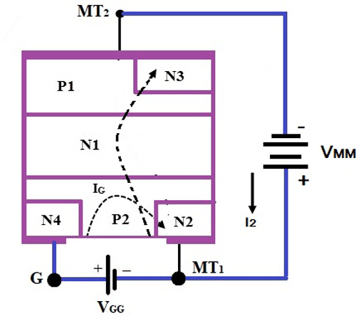

MT2 is negative with respect to MT1 with a gate polarity positive with respect to MT1
When the terminal MT2 is negative and the gate is triggered with a positive pulse the junction between P2-N2 is forward biased and the current carriers are injected, hence the TRIAC is turned on.

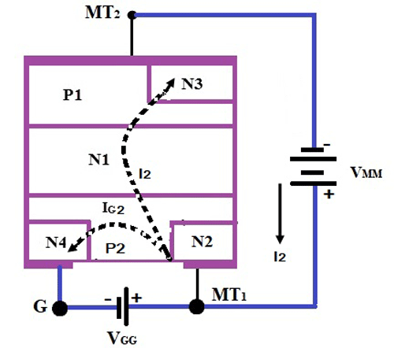
The TRIAC doesn’t usually operate in mode 4 because it carries a disadvantage that it should not be used for circuits with high di/dt. The sensitivity of triggering of TRIAC with mode 2 and 3 is high and negative gate pulse is used in case of a marginal triggering capability. The triggering of mode 1 is even more sensitive than mode 2 and 3 triggering but it requires a positive gate pulse for triggering. In most of the cases, the triggering mode 2 and 3 are preferred.

VI characteristics of TRIAC
Since the TRIAC is a bidirectional device it’s the VI characteristics curve of TRIAC will be on the first and third quadrant of the graph, which is similar to the VI characteristics of a Thyristor. If you are completely news to Thyristors like SCR you can check the Introduction to SCR article. When the terminal MT2 is set to be positive with respect to the terminal MT1 the TRIAC will be operating in the forward blocking mode.
During the initial stage due to the resistance of the TRIAC, there will be a small leakage current flowing through the device as the applied voltage is less than the breakdown voltage. When the voltage is increased and it reaches the breakdown voltage the TRIAC is turned on and high current starts flowing through the device.
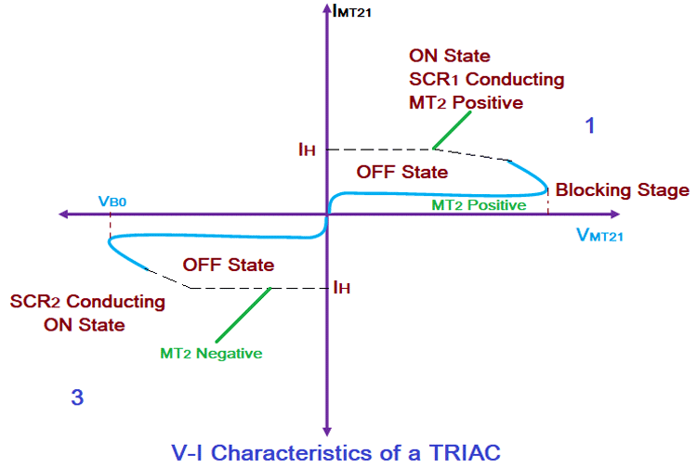

Apart from increasing the voltage of the device the TRIAC can be turned ON by applying the gate pulse, even if the applied voltage is less than the breakdown voltage. The same operation can be carried out in the negative direction of the TRIAC which can leave us with a mirror image of the same curve on the negative quadrant. The supply voltage at which the TRIAC starts conduction will depend on the gate current applied to the TRIAC. If the gate current is higher, then the voltage required to turn ON the TRIAC can be less. The characteristic curve that is given above shows the operation of TRIAC in mode 1 on the first quadrant and mode 3 on the third quadrant.

TRIAC Application:
As mentioned earlier, TRIACs are commonly used to switch AC voltages. A sample application TRIAC circuit for AC switching is shown below.

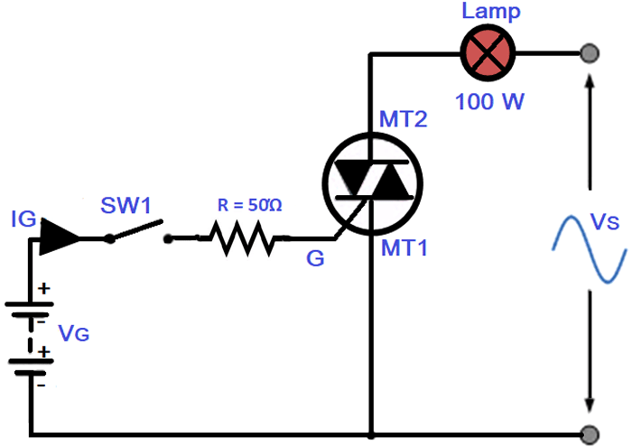
The above circuit shows the typical set up of a switching system using a TRIAC. Initially, when the switch SW1 is open there will not be any supply to the gate circuit and the current flow will be zero through the lamp. If the switch is turned ON the current starts flowing through the resistor R and there will be a pulse provided to the Gate terminal G. The given gate pulse will help in breaking down the junctions of the TRIAC and help it conduct, hence the AC voltage Vs will be allowed to flow through the circuit and lights up the Lamp.
TRIACs can be used in various applications such as
- Control circuits like electric fan speed control and smaller motor controls
- High Power lamp switching and light dimmers
- AC power control domestic appliances

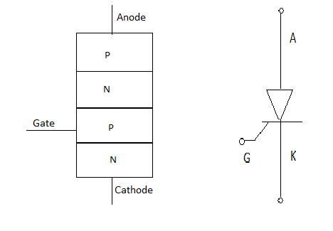

SCR is made up of silicon, it act as a rectifier; it has very low resistance in the forward direction and high resistance in the reverse direction. It is a unidirectional device.

Static V-I characteristics of a Thyristor

The circuit diagram for obtaining static V-I characteristics is as shown

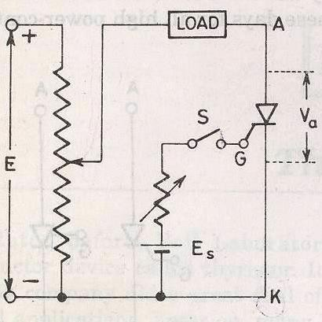
Anode and cathode are connected to main source voltage through the load. The gate and cathode are fed from source Es.
A typical SCR V-I characteristic is as shown below:

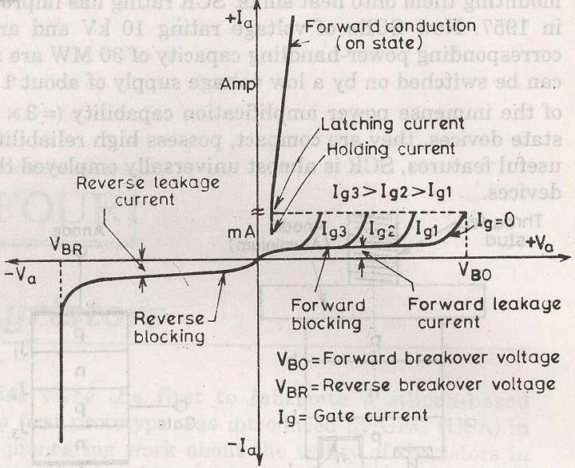

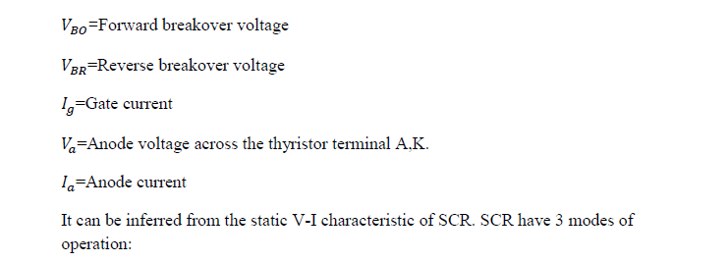

    - Reverse blocking mode
    - Forward blocking mode ( off state)
    - Forward conduction mode (on state)

Reverse Blocking Mode

When cathode of the thyristor is made positive with respect to anode with switch open thyristor is reverse biased. Junctions J₁ and J₂ are reverse biased where junction J₂ is forward biased. The device behaves as if two diodes are connected in series with reverse voltage applied across them.
  - A small leakage current of the order of few mA only flows. As the thyristor is reverse biased and in blocking mode. It is called as acting in reverse blocking mode of operation.
  - Now if the reverse voltage is increased, at a critical breakdown level called reverse breakdown voltage Vbr ,an avalanche occurs at J₁ and J₃ and the reverse

current increases rapidly. As a large current associated with Vbr and hence more losses to the SCR.
This results in Thyristor damage as junction temperature may exceed its maximum temperature rise.

Forward Blocking Mode

When anode is positive with respect to cathode, with gate circuit open, thyristor is said to be forward biased.
Thus junction J₁ and J₃ are forward biased and J₂ is reverse biased. As the forward voltage is increases junction J₂ will have an avalanche breakdown at a voltage called forward breakover voltageVbr. When forward voltage is less then VBR thyristor offers high impedance. Thus a thyristor acts as an open switch in forward blocking mode.

Forward Conduction Mode

Here thyristor conducts current from anode to cathode with a very small voltage drop across it. So a thyristor can be brought from forward blocking mode to forward conducting mode:
- By exceeding the forward breakover voltage.
- By applying a gate pulse between gate and cathode.

During forward conduction mode of operation thyristor is in on state and behave like a close switch. Voltage drop is of the order of 1 to 2mV. This small voltage drop is due to ohmic drop across the four layers of the device.
Different turn ON methods for SCR
- Forward voltage triggering
- Gate triggering
- DV/DTtriggering
- Light triggering
- Temperature triggering

Forward voltage triggering
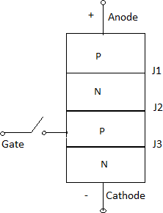

A forward voltage is applied between anode and cathode with gate circuit open.

  - Junction J₁ and J₃ is forward biased.
  - Juntion J₂ is reverse biased.
  - As the anode to cathode voltage is increased breakdown of the reverse biased junction
_{J2} occurs. This is known as avalanche breakdown and the voltage at which this phenomena occurs is called forward breakover voltage.

The conduction of current continues even if the anode cathode voltage reduces below 𝑉𝐵𝑂till 𝐼𝑎 will not go below𝐼ℎ. Where 𝐼ℎ is the holding current for the thyristor

Gate triggering

This is the simplest, reliable and efficient method of firing the forward biased SCRs. First SCR is forward biased. Then a positive gate voltage is applied between gate and cathode. In practice the transition from OFF state to ON state by exceeding 𝑉𝐵𝑂 is never employed as it may destroy the device. The magnitude of 𝑉𝐵𝑂, so forward breakover voltage is taken as final voltage rating of the device during the design of SCR application.
First step is to choose a thyristor with forward breakover voltage (say 800V) higher than the normal working voltage. The benefit is that the thyristor will be in blocking state with normal working voltage applied across the anode and cathode with gate open. When we require the turning ON of a SCR a positive gate voltage between gate and cathode is applied. The point to be noted that cathode n- layer is heavily doped as compared to gate p-layer. So when gate supply is given between gate and cathode gate p-layer is flooded with electron from cathode n-layer. Now the thyristor is forward biased, so some of these electron reach junction 𝐽2 .As a result width of 𝐽2 breaks down or conduction at 𝐽2 occur at a voltage less than 𝑉𝐵𝑂.As 𝐼𝑔 increases 𝑉𝐵𝑂 reduces which decreases then turn ON time. Another important point is duration for which the gate current is applied should be more then that if the gate current is reduced to zero before the anode current reaches a minimum value known as holding current, SCR can’t turn ON.
In this process power loss is less and also low applied voltage is required for triggering.

dv/dt triggering

This is a turning ON method but it may lead to destruction of SCR and so it must be avoided.
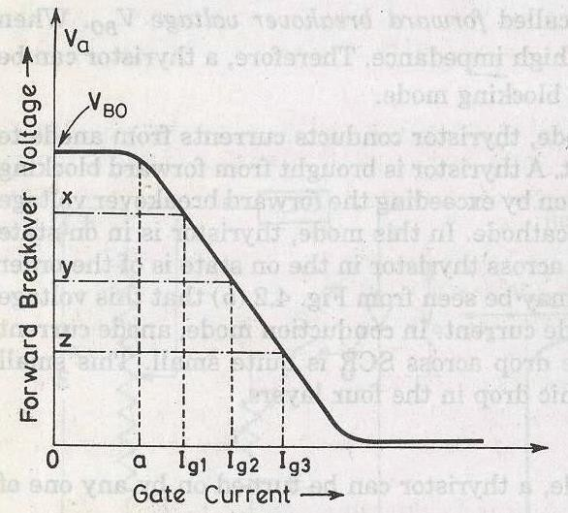

When SCR is forward biased, junction 𝐽1 and 𝐽3 are forward biased and junction 𝐽2 is reversed biased so it behaves as if an insulator is place between two conducting plate. Here 𝐽1 and 𝐽3 acts as a conducting plate and 𝐽2 acts as an insulator. 𝐽2 is known as junction capacitor. So if we increase the rate of change of forward voltage instead of increasing the magnitude of voltage. Junction 𝐽2 breaks and starts conducting. A high value changing current may damage the SCR. So SCR may be protected from high𝑑𝑣𝑑𝑡.

𝑞=𝑐𝑣
𝐼𝑎=𝑐𝑑𝑣/𝑑𝑡
𝐼𝑎 𝛼 𝑑𝑣/𝑑𝑡

Temperature triggering

During forward biased, 𝐽₂ is reverse biased so a leakage forward current always associated with SCR. Now as we know the leakage current is temperature dependant, so if we increase the temperature the leakage current will also increase and heat dissipitation of junction
_{j2}occurs. When this heat reaches a sufficient value j₂ will break and conduction starts. Disadvantages
type of triggering causes local hot spot and may cause thermal run away of the device. This triggering cannot be controlled easily.
It is very costly as protection is costly.

Light triggering

First a new recess niche is made in the inner p-layer. When this recess is irradiated, then free charge carriers (electron and hole) are generated. Now if the intensity is increased above a certain value then it leads to turn ON of SCR. Such SCR are known as Light activated SCR (LASCR).

Some definitions:

Latching current

The latching current may be defined as the minimum value of anode current which at must attain during turn ON process to maintain conduction even if gate signal is removed.
Holding current

It is the minimum value of anode current below which if it falls, the SCR will turn OFF.

Switching characteristics of thyristors
The time variation of voltage across the thyristor and current through it during turn on and turn off process gives the dynamic or switching characteristic of SCR.

Switching characteristic during turn on Turn on time
It is the time during which it changes from forward blocking state to ON state. Total turn on time is divided into 3 intervals:
- Delay time
- Rise time
- Spread time

Delay time

If 𝐼𝑔and 𝐼𝑎 represent the final value of gate current and anode current. Then the delay time can be explained as time during which the gate current attains 0.9 𝐼𝑔 to the instant anode current reaches 0.1 𝐼𝑔 or the anode current rises from forward leakage current to 0.1 𝐼𝑎.
1. Gate current 0.9 𝐼𝑔 to 0.1 𝐼𝑎.
2. Anode voltage falls from 𝑉𝑎 to 0.9𝑉𝑎.
3. Anode current rises from forward leakage current to 0.1 𝐼𝑎.
Rise time (𝒕𝒓)
Time during which
1. Anode current rises from 0.1 𝐼𝑎 to 0.9 𝐼𝑎
2. Forward blocking voltage falls from 0.9𝑉𝑎 to 0.1𝑉𝑎. 𝑉𝑎 is the initial forward blocking voltage.

Spread time (𝒕𝒑)
1. Time taken by the anode current to rise from 0.9𝐼𝑎 to𝐼𝑎.
2. Time for the forward voltage to fall from 0.1𝑉𝑜 to on state voltage drop of 1 to 1.5V. During turn on, SCR is considered to be a charge controlled device. A certain amount of charge is injected in the gate region to begin conduction. So higher the magnitude of gate current it requires less time to inject the charges. Thus turn on time is reduced by using large magnitude of gate current.

How the distribution of charge occurs?
As the gate current begins to flow from gate to cathode with the application of gate signal. Gate current has a non uniform distribution of current density over the cathode surface. Distribution of current density is much higher near the gate. The density decrease as the distance from the gate increases. So anode current flows in a narrow region near gate where gate current densities are highest. From the beginning of rise time the anode current starts spreading itself. The anode current spread at a rate of 0.1mm/sec. The spreading anode current requires some time if the rise time is not sufficient then the anode current cannot spread over the entire region of cathode. Now a large anode current is applied and also a large anode current flowing through the SCR. As a result turn on losses is high. As these losses occur over a small conducting region so local hot spots may form and it may damage the device.
Switching Characteristics During Turn Off
Thyristor turn off means it changed from ON to OFF state. Once thyristor is oON there is no role of gate. As we know thyristor can be made turn OFF by reducing the anode current below the latching current. Here we assume the latching current to be zero ampere. If a forward voltage is applied across the SCR at the moment it reaches zero then SCR will not be able to block this forward voltage. Because the charges trapped in the 4-layer are still favourable for conduction and it may turn on the device. So to avoid such a case, SCR is reverse biased for some time even if the anode current has reached to zero.
So now the turn off time can be different as the instant anode current becomes zero to the instant when SCR regains its forward blocking capability.
𝑡𝑞=𝑡𝑟𝑟+𝑡𝑞𝑟
Where,
𝑡𝑞 is the turn off time, is the reverse recovery time, 𝑡𝑞𝑟 is the gate recovery time
At 𝑡1 anode current is zero. Now anode current builds up in reverse direction with same 𝑑𝑣𝑑𝑡 slope. This is due to the presence of charge carriers in the four layers. The reverse recovery current removes the excess carriers from 𝐽1 and 𝐽3 between the instants 𝑡1 and𝑡3. At instant 𝑡3 the end junction 𝐽1 and 𝐽3 is recovered. But 𝐽2 still has trapped charges which decay due to recombination only so the reverse voltage has to be maintained for some more time. The time taken for the recombination of charges between 𝑡3 and 𝑡4 is called gate recovery time 𝑡𝑞𝑟. Junction 𝐽2 recovered and now a forward voltage can be applied across SCR.
The turn off time is affected by:
1. Junction temperature
2. Magnitude of forward current 𝑑𝑖𝑑𝑡 during commutation.

Turn off time decreases with the increase of magnitude of reverse applied voltage.
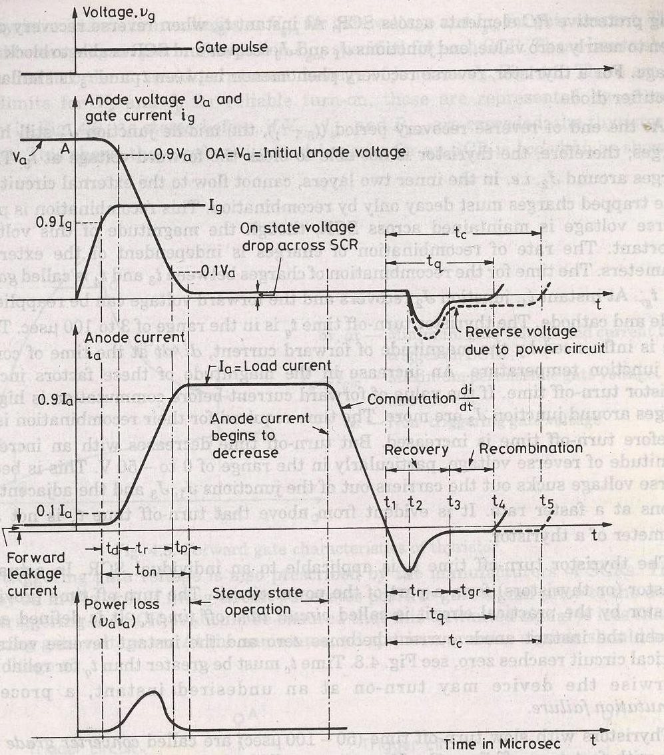

GTO(Gate turn off thyristor)
A gate turn off thyristor is a pnpn device. In which it can be turned ON like an ordinary SCR by a positive gate current. However it can be easily turned off by a negative gate pulse of appropriate magnitude.

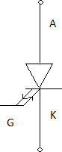
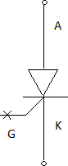
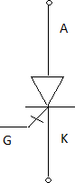

Conventional SCR are turned on by a positive gate signal but once the SCR is turned on gate loses control over it. So to turn it off we require external commutation circuit. These commutation circuits are bulky and costly. So due to these drawbacks GTO comes into existence.
The salient features of GTO are:

  - GTO turned on like conventional SCR and is turned off by a negative gate signal of sufficient magnitude.
  - It is a non latching device.
  - GTO reduces acoustic and electromagnetic noise. It has high switching frequency and efficiency.
A gate turn off thyristor can turn on like an ordinary thyristor but it is turn off by negative gate pulse of appropriate magnitude.
Disadvantage

The negative gate current required to turn off a GTO is quite large that is 20% to 30 % of anode current
Advantage

It is compact and cost less

Switching performance
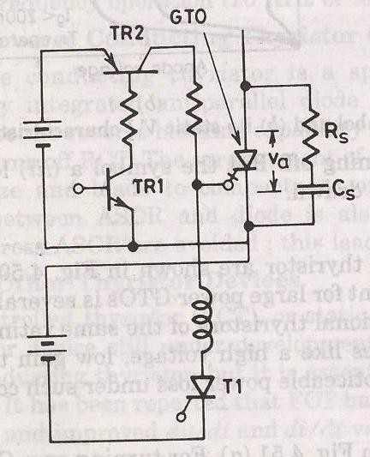

- For turning ON a GTO first TR1is turned on.
- This in turn switches on TR2 so that a positive gate current pulse is applied to turn on the GTO.
- Thyristor 𝑇₁ is used to apply a high peak negative gate current pulse.

Gate turn-on characteristics

- The gate turn on characteristics is similar to a thyristor. Total turn on time consists of delay time, rise time, spread time.
- The turn on time can be reduced by increasing its forward gate current.

GATE TURN OFF

Turn off time is different for SCR.Turn off characteristics is divied into 3 pd

  - Storage time
  - Fall time
  - Tail time
Tq=ts+tf+tt
At normal operating condition gto carries a steady state current.The turn off process starts as soon as negative current is applied after t=0.
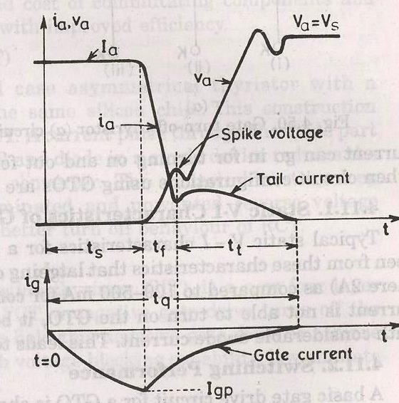

STORAGE TIME

During the storagepd the anode voltage and current remains constant.The gate current rises depending upon the gate circuit impedance and gate applied voltage.The beginning of pd is as soon as negative gate current is applied.The end of storage pd is marked by fall in anode current and rise in voltage,what we have to do is remove the excess carriers.the excess carriers are removed by negative carriers.
FALL TIME

After ts, anode current begins to fall rapidly and anode voltage starts rising.After falling to a certain value,then anode current changes its rate to fall.this time is called fall time.
SPIKE IN VOLTAGE

During the time of storage and fall timethere is achange in voltage due to abrupt current change. TAIL TIME
During this time ,the anode current and voltage continues towards the turn off values.The transient overshoot is due to the snubber parameter and voltage stabilizes to steady state value.
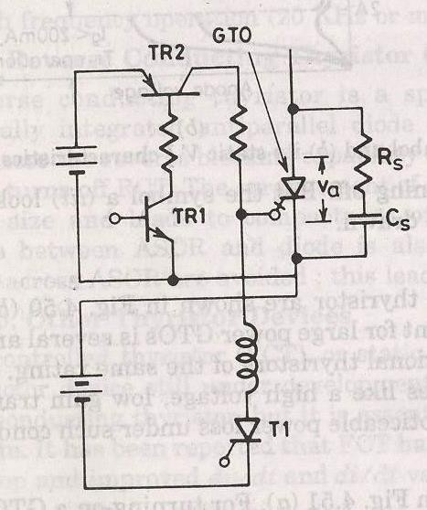

THE TRIAC

As SCR is a unidirectional device,the conduction is from anode to cathode and not from cathode to anode. It conducts in both direction.It is a bidirectional SCR with three terminal.
TRIAC=TRIODE+AC

Here it is considered to be two SCRS connected in anti parallel.As it conducts in both direction so it is named as MT1,MT2 and gate G.
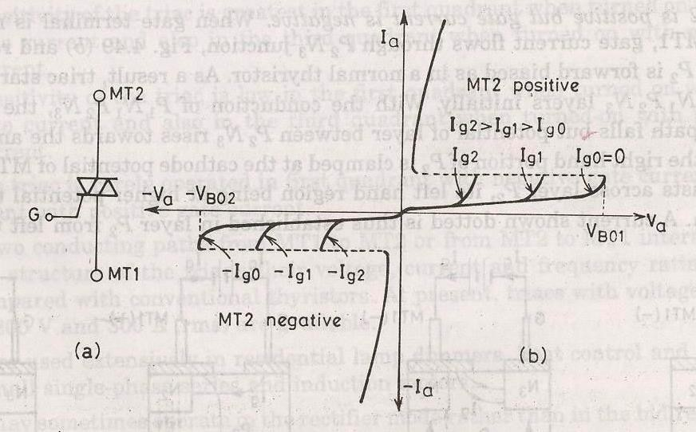

SALIENT FEATURES

1.Bi directional triode thyristor 2.TRIAC means triode that works on ac 3.It conduct in both direction
- It is a controlled device

- Its operation is similar to two devices connected in anti parallel with common gate connection.
- It has 3 terminals MT1,MT2 and gate G Its use is control of power in ac.
POWER BJT

Power BJT means a large voltage blocking in the OFF state and high current carrying capability in the ON state. In most power application, base is the input terminal. Emitter is the common terminal.
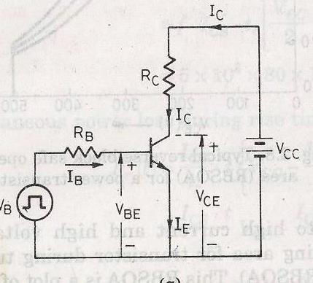
Collector is the output terminal.
SIGNAL LEVEL OF BJT

n+ doped emitter layer ,doping of base is more than collector.Depletion layer exists more towards the collector than emitter

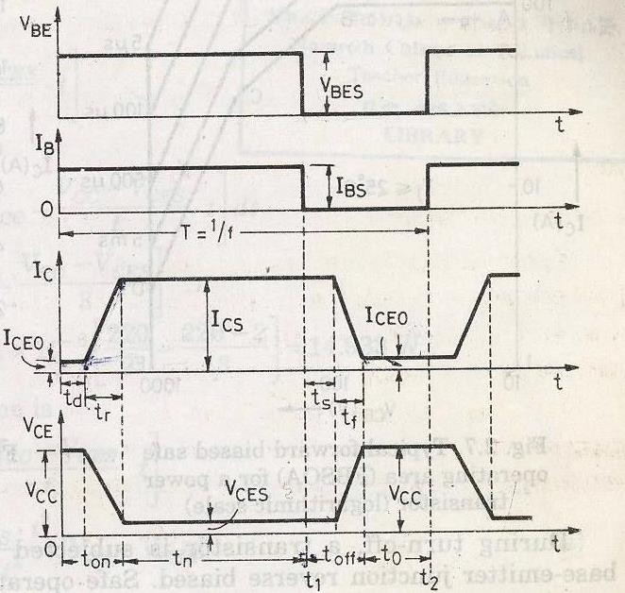

POWER BJT CONSTRUCTION

The maxium collector emitter voltage that can be sustained across the junction, when it is carrying substantial collector current.
Vceo=maxium collectorand emitter voltage that can be sustain by the device. Vcbo=collector base breakdown voltage with emitter open
PRIMARY BREAKDOWN

It is due to convention avalanche breakdown of the C-B junction and its associated large flow of current.The thickness of the depletion region determines the breakdown voltage of the transistor.The base thickness is made as small as possible,in order to have good amplification capability. If the thickness is too small, the breakdown voltage is compromised.So a compromise has to be made between the two.

THE DOPING LEVELS-

1.The doping of the emitter layer is quite large. 2.The base doping is moderate.
3.n- region is lightly doped.

4.n+ region doping level is similar to emitter. 1.THICKNESS OF DRIFT REGION-
It determines the breakdown length of the transistor. 2.THE BASE THICKNES –
Small base thickness- good amplification capability

Too small base thickness- the breakdown voltage of the transistor has ti be compromised.

For a relatively thick base,the current gain will be relatively small.so it is increase the gain.Monolithicesigns for darlington connected BJT pair have been deveploed.
SECONDARY BREAKDOWN

Secondary breakdown is due to large power disspation at localized site within the semi conductor.
PHYSICS OF BJT OPERATION-

The transistor is assumed to operate in active region. There is no doped collector drift region. It has importance only in switching operation, in active region of operation.
  - junction is forward biased and C-B junction is reverse biased. Electrons are injected into base from the emitter. Holes are injected from base into the emitter.
QUASI SATURATION-

Intially we assume that, the transistor is in active region. Base current is allowed to increase then lets see what happens.first collector rises in response to base current.So there is a increase voltage drop across the collector load.So C-E voltage drops.
Because of increase in collector current, there is a increase in voltage in drift region. This eventually reduces the reverse biased across the C-B junction.so n-p junction get smaller, at some point the junction become forward bised. So now injection of holes from base into collector drift region occurs. Charge neutrality requires the electron to be injected in the drift region of the holes. From where these electron came. Since a large no of electron is supplied to the C-B junction via injection from emitter and subsequent diffusion across the base. As excess carrier build up in the drift region begins to occur quasi saturation region is entered. As the injected carrires increase in the drift region is

gradually shotred out and the voltage across the drift region drops. In quasi saturation the drift region is not completely shorted out by high level injection.Hard saturation obtained when excess carrier density reaches the n+ side.

During quasi saturation, the rate of the collector fall.Hard saturation occurs when excess carriers have completely swept across the drift region .

Gate Turn Off Thyristor:
Thyristor called the Gate Turn Off Thyristor. We will learn its construction, circuit symbol, the V-I Characteristics, the principle of operation and some of the commonly known applications of Gate Turn Off Thyristor.

Introduction
Although the thyristor is extensively used in high power applications, it always suffered from being a semi-controlled device. Even though it could be switched ON by applying a gate signal, it has to be turned OFF by interrupting the main current using a commutation circuit.
In case of DC to DC and DC to AC conversion circuits, this becomes a serious deficiency with thyristor due to the absence of natural current zero (as in case of AC circuits). Hence, the development of Gate Turn off Thyristor (GTO) addresses the major problem of the thyristor by ensuring the turn OFF mechanism through the gate terminal.

Basics of Gate Turn-Off Thyristor
A Gate Turn off Thyristor or GTO is a three terminal, bipolar (current controlled minority carrier) semiconductor switching device. Similar to conventional thyristor, the terminals are anode, cathode and gate as shown in figure below. As the name indicates, it has gate turn off capability.
These are capable not only to turn ON the main current with a gate drive circuit, but also to turn it OFF. A small positive gate current triggers the GTO into conduction mode and also by a negative pulse on the gate, it is capable of being turned off. Observe in below figure that the gate has double arrows on it which distinguish the GTO from normal thyristor. This indicates the bidirectional current flow through the gate terminal.
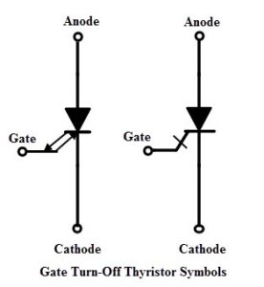
The gate current required to turn off the GTO is relatively high. For example, a GTO rated with 4000V and 3000A may need -750A gate current to switch it off. So the typical turn off gain of GTO is low and is in the range of 4 to 5. Due to this large negative current, GTOs are used in low power applications.
On the other hand, during the conduction state GTO behaves just like a thyristor with a small ON state voltage drop. The GTO has faster switching speed than the thyristor and has higher voltage and current ratings than the power transistors.
Several varieties of GTOs are available in today’s market with asymmetric and symmetric voltage capabilities. GTOs with identical forward and reverse blocking capabilities are called as symmetric GTOs (S-GTOs). These are used in current source inverters, but these are somewhat slower. Mostly asymmetric GTOs (A-GTOs) are used due to its lower ON state voltage drop and stable temperature characteristics.
These asymmetrical GTOs have an appreciable reverse voltage capability (typically 20 to 25 V). These are used where either the reverse voltage across it would never occur or a reverse conducting diode is connected across the circuit. This article describes only about asymmetric GTOs.

Construction
Consider the below structure of GTO, which is almost similar to the thyristor. It is also a four layer, three junction P-N-P-N device like a standard thyristor. In this, the n+ layer at the cathode end is highly doped to obtain high emitter efficiency. This result the breakdown voltage of the junction J3 is low which is typically in the range of 20 to 40 volts.
The doping level of the p type gate is highly graded because the doping level should be low to maintain high emitter efficiency, whereas for having a good turn OFF properties, doping of this region should be high. In addition, gate and cathodes should be highly interdigited with various geometric forms to optimize the current turn off capability.
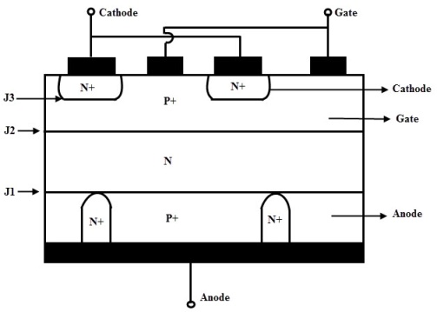
The junction between the P+ anode and N base is called anode junction. A heavily doped P+ anode region is required to obtain the higher efficiency anode junction so that a good turn ON properties is achieved. However, the turn OFF capabilities are affected with such GTOs.
This problem can be solved by introducing heavily doped N+ layers at regular intervals in P+ anode layer as shown in figure. So this N+ layer makes a direct contact with N layer at junction J1. This cause the electrons to travel from base N region directly to anode metal contact without causing hole injection from P+ anode. This is called as a anode shorted GTO structure.
Due to these anode shorts, the reverse blocking capacity of the GTO is reduced to the reverse breakdown voltage of junction j3 and hence speeds up the turn OFF mechanism.
However, with a large number of anode shorts, the efficiency of the anode junction reduces and hence the turn ON performance of the GTO degrades. Therefore, careful considerations have to be taken about the density of these anode shorts for a good turn ON and OFF performance.

Principle of Operation
The turn ON operation of GTO is similar to a conventional thyristor. When the anode terminal is made positive with respect to cathode by applying a positive gate current, the hole current injection from gate forward bias the cathode p-base junction.
This results in the emission of electrons from the cathode towards the anode terminal. This induces the hole injection from the anode terminal into the base region. This injection of holes and electrons continuous till the GTO comes into the conduction state.
In case of thyristor, the conduction starts initially by turning ON the area of cathode adjacent to the gate terminal. And thus, by plasma spreading the remaining area comes into the conduction.
Unlike a thyristor, GTO consists of narrow cathode elements which are heavily interdigitated with gate terminal, thereby initial turned ON area is very large and plasma spreading is small. Hence the GTO comes into the conduction state very quickly.
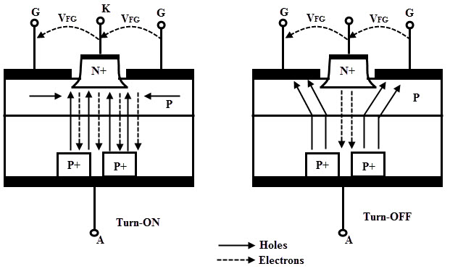
To turn OFF a conducting GTO, a reverse bias is applied at the gate by making the gate negative with respect to cathode. A part of the holes from the P base layer is extracted through the gate which suppress the injection of electrons from the cathode.
In response to this, more hole current is extracted through the gate results more suppression of electrons from the cathode. Eventually, the voltage drop across the p base junction causes to reverse bias the gate cathode junction and hence the GTO is turned OFF.
During the hole extraction process, the p-base region is gradually depleted so that the conduction area squeezed. As this process continuous, the anode current flows through remote areas forming high current density filaments. This causes local hot spots which can damage the device unless these filaments are extinguished quickly.
By the application of high negative gate voltage these filaments are extinguished rapidly. Due to the N base region stored charge, the anode to gate current continues to flow even though the cathode current is ceased. This is called a tail current which decays exponentially as the excess charge carriers are reduced by the recombination process. Once the tail current reduced to a leakage current level, the device retains its forward blocking characteristics.

V-I Characteristics
During the turn ON, GTO is similar to thyristor in its operates.So the first quadrant characteristics are similar to the thyristor. When the anode is made positive with respect to cathode, the device operates in forward blocking mode. By the application of positive gate signal triggers the GTO into conduction state.
The latching current and forward leakage currents are considerably higher in GTO compared to the thyristor as shown in figure. The gate drive can be removed if the anode current is above the holding current level.
But it is recommended not to remove the positive gate drive during conduction and to hold at value more than the maximum critical gate current. This is because the cathode is subdivided into small finger elements as discussed above to assist the turn OFF process.
This causes the anode current dips below the holding current level transiently, which forces a high anode current at a high rate back into the GTO. This can be potentially destructive. Therefore, some manufacturers recommend the continuous gate signal during the conduction state.
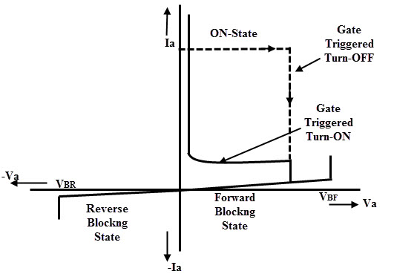
The GTO can be turned OFF by the application of reverse gate current which can be either step or ramp drive. The GTO can be turned OFF without reversing anode voltage. The dashed line in the figure shows i-v trajectory during the turn OFF for an inductive load. It should be noted that during the turn OFF, GTO can block a rated forward voltage only.
To avoid dv/dt triggering and protect the device during turn OFF, either a recommended value of resistance must be connected between the gate and cathode or a small reverse bias voltage (typically -2V) must be maintained on the gate terminal. This prevents the gate cathode junction to become forward biased and hence the GTO sustains during the turn OFF state.
In reverse biased condition of GTO, the blocking capability is depends on the type of GTO. A symmetric GTO has a high reverse blocking capability while asymmetric GTO has a small reverse blocking capability as shown in figure.
It is observed that, during reverse biased condition, after a small reverse voltage (20 to 30 V) GTO starts conducting in reverse direction due to the anode short structure. This mode of operation does not destroy the device provided that the gate is negatively biased and the time of this operation should be small.

IGBT
The Insulated Gate Bipolar Transistor also called an IGBT for short, is something of a cross between a conventional Bipolar Junction Transistor, (BJT) and a Field Effect Transistor, (MOSFET) making it ideal as a semiconductor switching device.
The IGBT Transistor takes the best parts of these two types of common transistors, the high input impedance and high switching speeds of a MOSFET with the low saturation voltage of a bipolar transistor, and combines them together to produce another type of transistor switching device that is capable of handling large collector-emitter currents with virtually zero gate current drive.

The Insulated Gate Bipolar Transistor, (IGBT) combines the insulated gate (hence the first part of its name) technology of the MOSFET with the output performance characteristics of a conventional bipolar transistor, (hence the second part of its name).
The result of this hybrid combination is that the “IGBT Transistor” has the output switching and conduction characteristics of a bipolar transistor but is voltage-controlled like a MOSFET.
IGBTs are mainly used in power electronics applications, such as inverters, converters and power supplies, were the demands of the solid state switching device are not fully met by power bipolars and power MOSFETs. High-current and high-voltage bipolars are available, but their switching speeds are slow, while power MOSFETs may have higher switching speeds, but high-voltage and high-current devices are expensive and hard to achieve.
The advantage gained by the insulated gate bipolar transistor device over a BJT or MOSFET is that it offers greater power gain than the standard bipolar type transistor combined with the higher voltage operation and lower input losses of the MOSFET. In effect it is an FET integrated with a bipolar transistor in a form of Darlington type configuration as shown.

Insulated Gate Bipolar Transistor
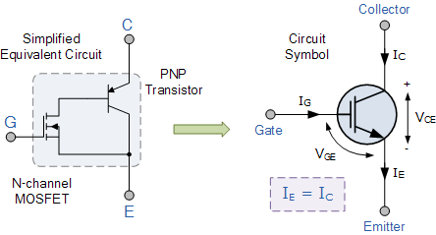
We can see that the insulated gate bipolar transistor is a three terminal, trans conductance device that combines an insulated gate N-channel MOSFET input with a PNP bipolar transistor output connected in a type of Darlington configuration.
As a result the terminals are labeled as: Collector, Emitter and Gate. Two of its terminals (C-E) are associated with the conductance path which passes current, while its third terminal (G) controls the device.
The amount of amplification achieved by the insulated gate bipolar transistor is a ratio between its output signal and its input signal. For a conventional bipolar junction transistor, (BJT) the amount of gain is approximately equal to the ratio of the output current to the input current, called Beta.
For a metal oxide semiconductor field effect transistor or MOSFET, there is no input current as the gate is isolated from the main current carrying channel. Therefore, an FET’s gain is equal to the ratio of output current change to input voltage change, making it a transconductance device and this is also true of the IGBT. Then we can treat the IGBT as a power BJT whose base current is provided by a MOSFET.
The Insulated Gate Bipolar Transistor can be used in small signal amplifier circuits in much the same way as the BJT or MOSFET type transistors. But as the IGBT combines the low conduction loss of a BJT with the high switching speed of a power MOSFET an optimal solid state switch exists which is ideal for use in power electronics applications.
Also, the IGBT has a much lower “on-state” resistance, R_{ON} than an equivalent MOSFET. This means that the I²R drop across the bipolar output structure for a given switching current is much lower. The forward blocking operation of the IGBT transistor is identical to a power MOSFET.
When used as static controlled switch, the insulated gate bipolar transistor has voltage and current ratings similar to that of the bipolar transistor. However, the presence of an isolated gate in an IGBT makes it a lot simpler to drive than the BJT as much less drive power is needed.
An insulated gate bipolar transistor is simply turned “ON” or “OFF” by activating and deactivating its Gate terminal. Applying a positive input voltage signal across the Gate and the Emitter will keep the device in its “ON” state, while making the input gate signal zero or slightly negative will cause it to turn “OFF” in much the same way as a bipolar transistor or eMOSFET. Another advantage of the IGBT is that it has a much lower on-state channel resistance than a standard MOSFET.

IGBT Characteristics
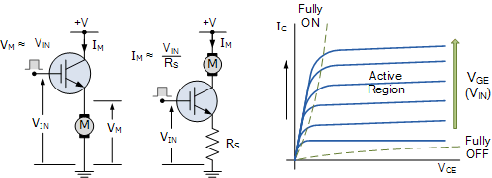
Because the IGBT is a voltage-controlled device, it only requires a small voltage on the Gate to maintain conduction through the device unlike BJT’s which require that the Base current is continuously supplied in a sufficient enough quantity to maintain saturation.
Also the IGBT is a unidirectional device, meaning it can only switch current in the “forward direction”, that is from Collector to Emitter unlike MOSFET’s which have bi-directional current switching capabilities (controlled in the forward direction and uncontrolled in the reverse direction).
The principal of operation and Gate drive circuits for the insulated gate bipolar transistor are very similar to that of the N-channel power MOSFET. The basic difference is that the resistance offered by the main conducting channel when current flows through the device in its “ON” state is very much smaller in the IGBT. Because of this, the current ratings are much higher when compared with an equivalent power MOSFET.
The main advantages of using the Insulated Gate Bipolar Transistor over other types of transistor devices are its high voltage capability, low ON-resistance, ease of drive, relatively fast switching speeds and combined with zero gate drive current makes it a good choice for moderate speed, high voltage applications such as in pulse-width modulated (PWM), variable speed control, switch-mode power supplies or solar powered DC-AC inverter and frequency converter applications operating in the hundreds of kilohertz range.

Unit 2

CONVERTERS: Basic concept, Working Principles of Single phase half Wave bridge converter, Single Phase Full Bridge Converter, 3 Phase Bridge Converter

RECTIFIER
Rectifier are used to convert A.C to D.C supply.

Rectifiers can be classified as single phase rectifier and three phase rectifier. Single phase rectifier are classified as 1-Փ half wave and 1-Փ full wave rectifier. Three phase rectifier are classified as 3-Փ half wave rectifier and 3-Փ full wave rectifier. 1-Փ Full wave rectifier are classified as1-Փ mid point type and 1-Փ bridge type rectifier. 1-Փ bridge type rectifier are classified as 1-Փ half controlled and 1-Փ full controlled rectifier. 3-Փ full wave rectifier are again classified as 3-Փ mid point type and 3-Փ bridge type rectifier. 3-Փ bridge type rectifier are again divided as 3-Փ half controlled rectifier and 3-Փ full controlled rectifier.

Single phase half wave circuit with R-L load
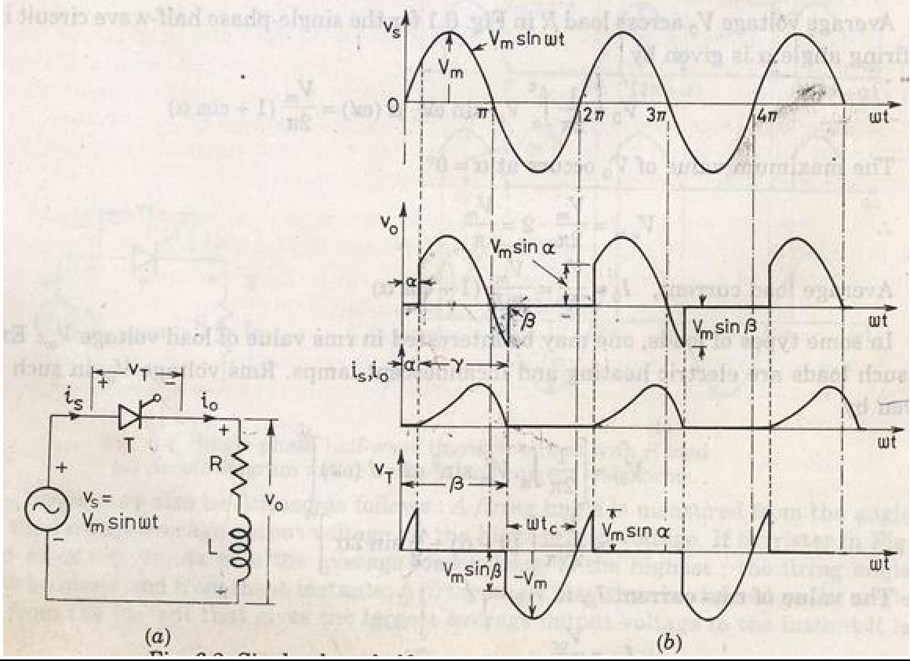
Output current 𝑖𝑜rises gradually. After some time 𝑖𝑜 reaches a maximum value and then begins to decrease.
At π, 𝑣𝑜=0 but 𝑖𝑜 is not zero because of the load inductance L. After π interval SCR is reverse biased but load current is not less then the holding current.
At β>π, 𝑖𝑜 reduces to zero and SCR is turned off.
At 2π+β SCR triggers again
α is the firing angle.
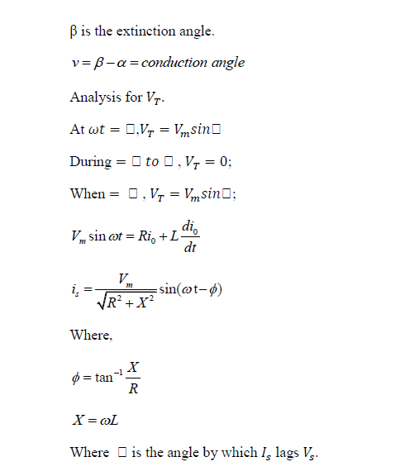
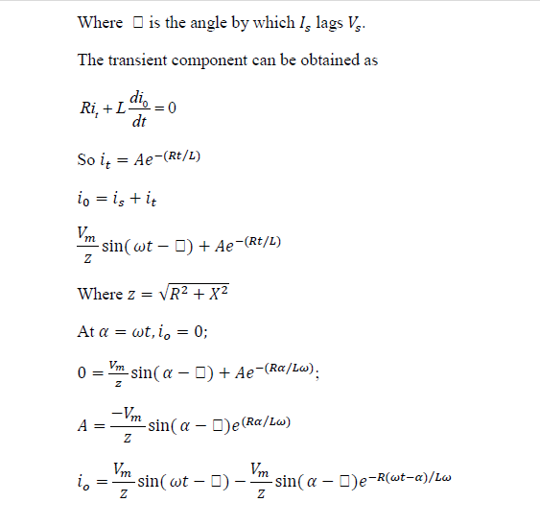
Single phase full converter
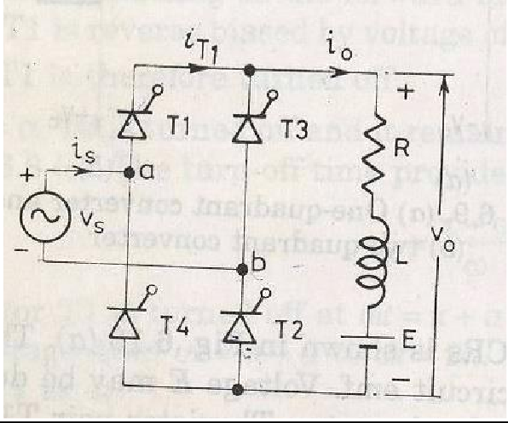

T₁,T₂ triggered at α and π radian latter T₃, T₄ are triggered.

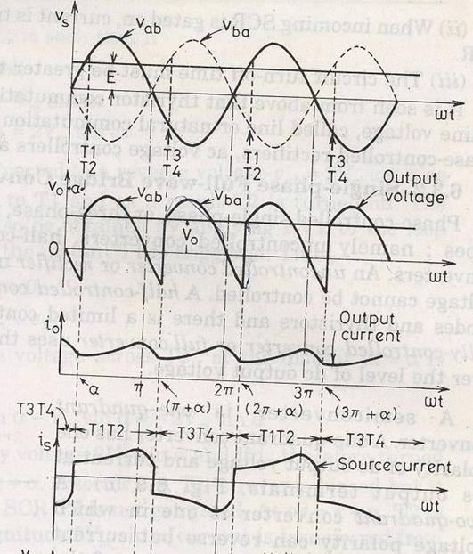

Single phase half wave circuit with RLE load
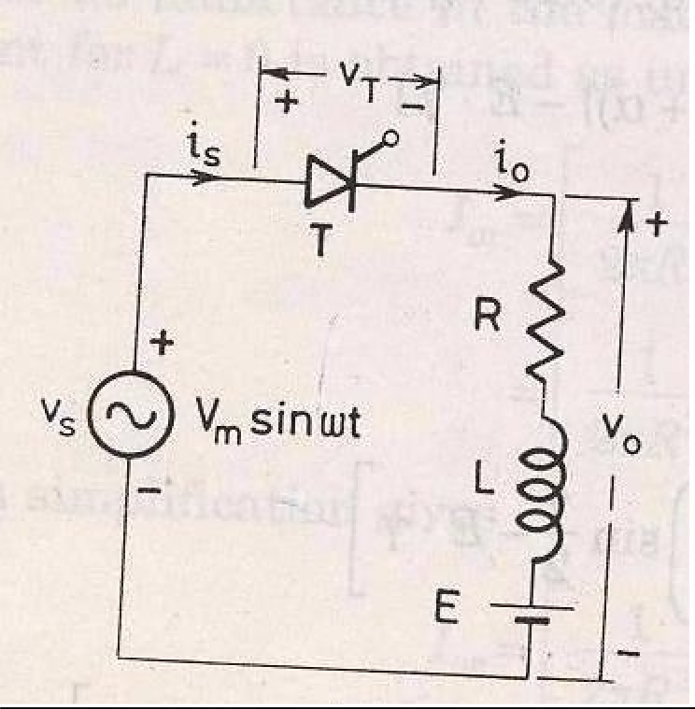

The minimum value of firing angle is

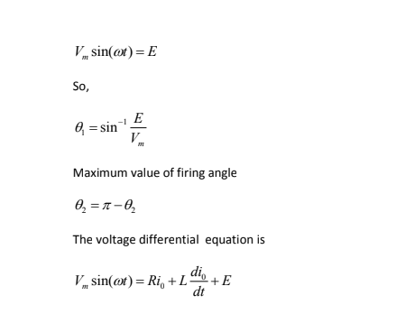

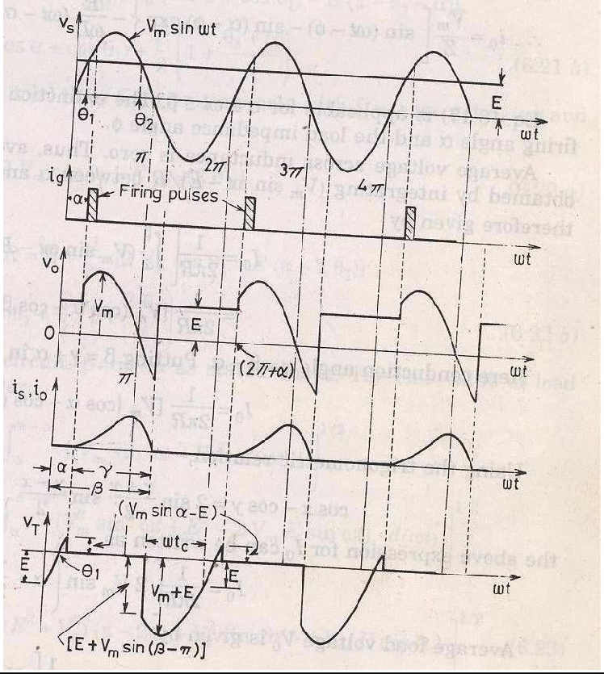

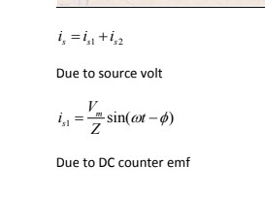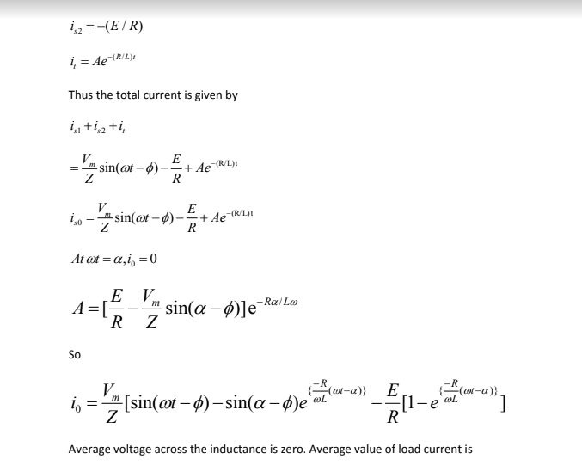

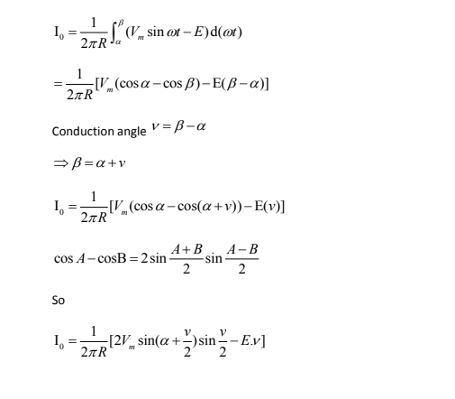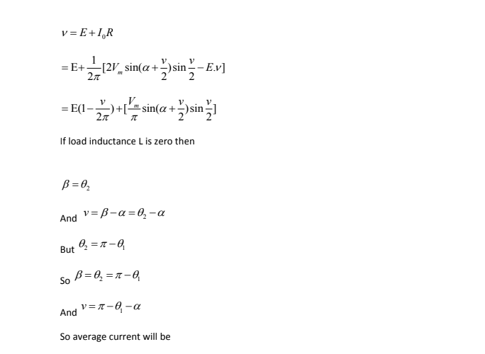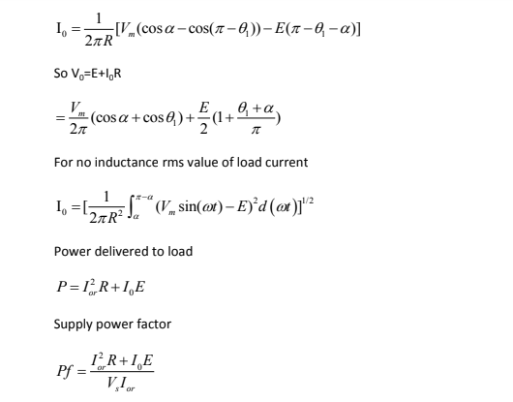
(Vm sin( t)  E) d t ]

Single phase full wave converter:

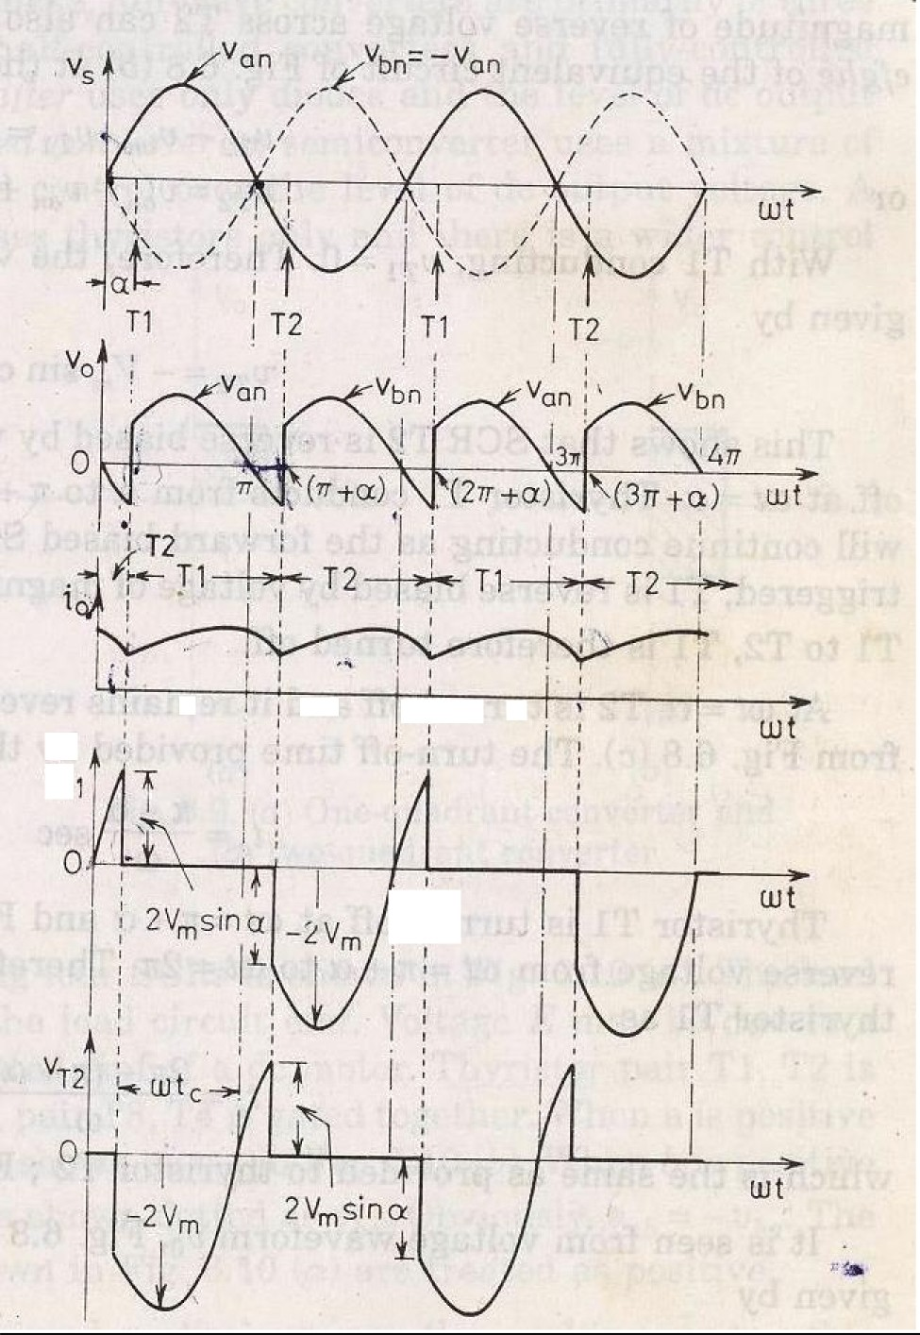

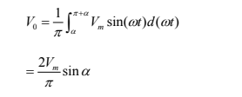

Single phase semi converter:

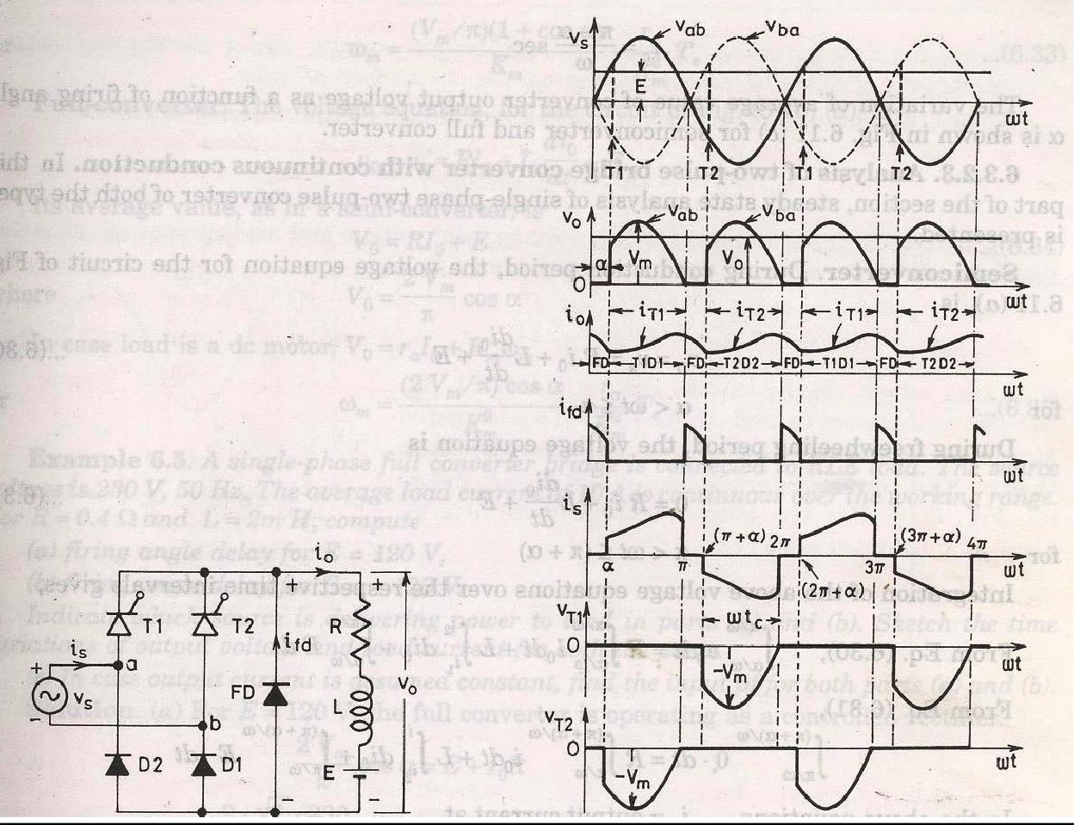

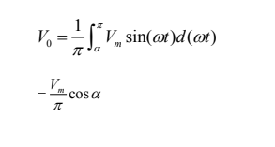

full converter:
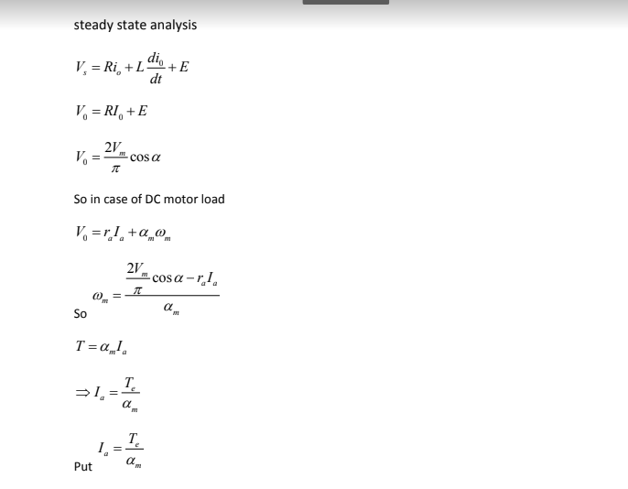
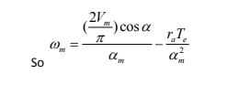
Self Notes Converter

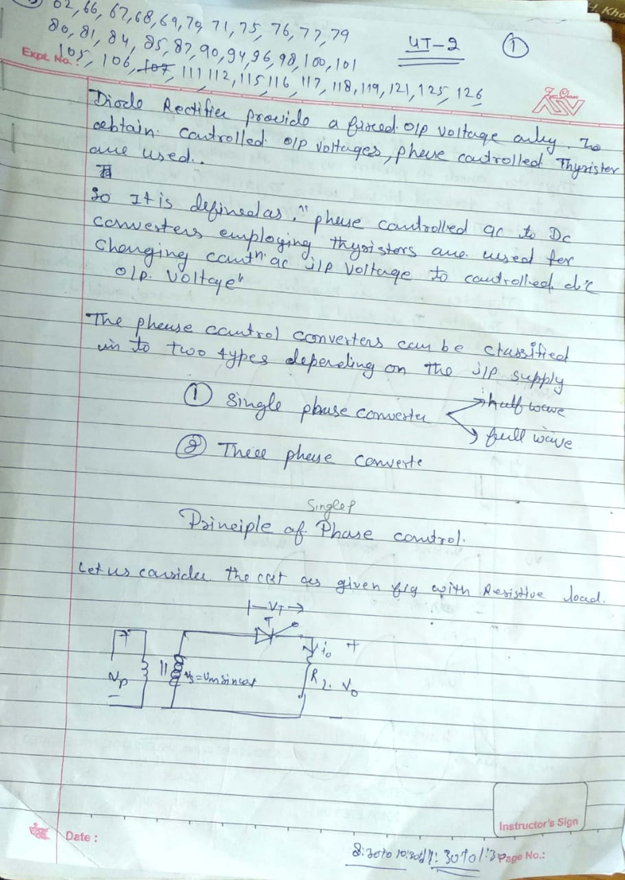
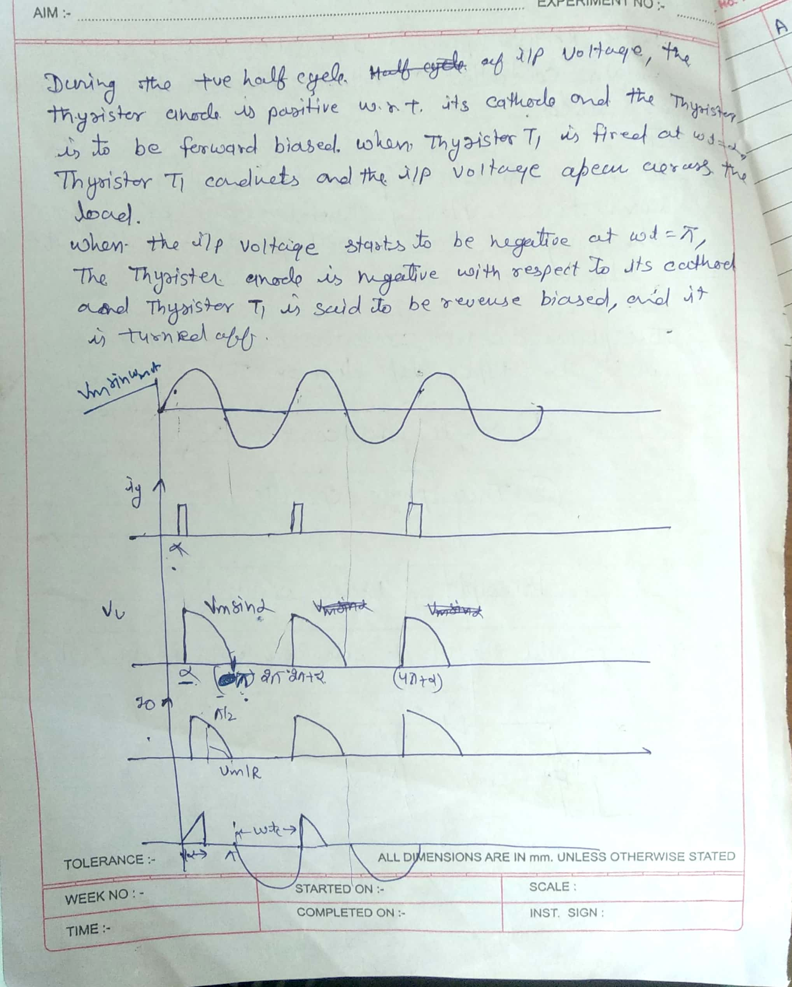

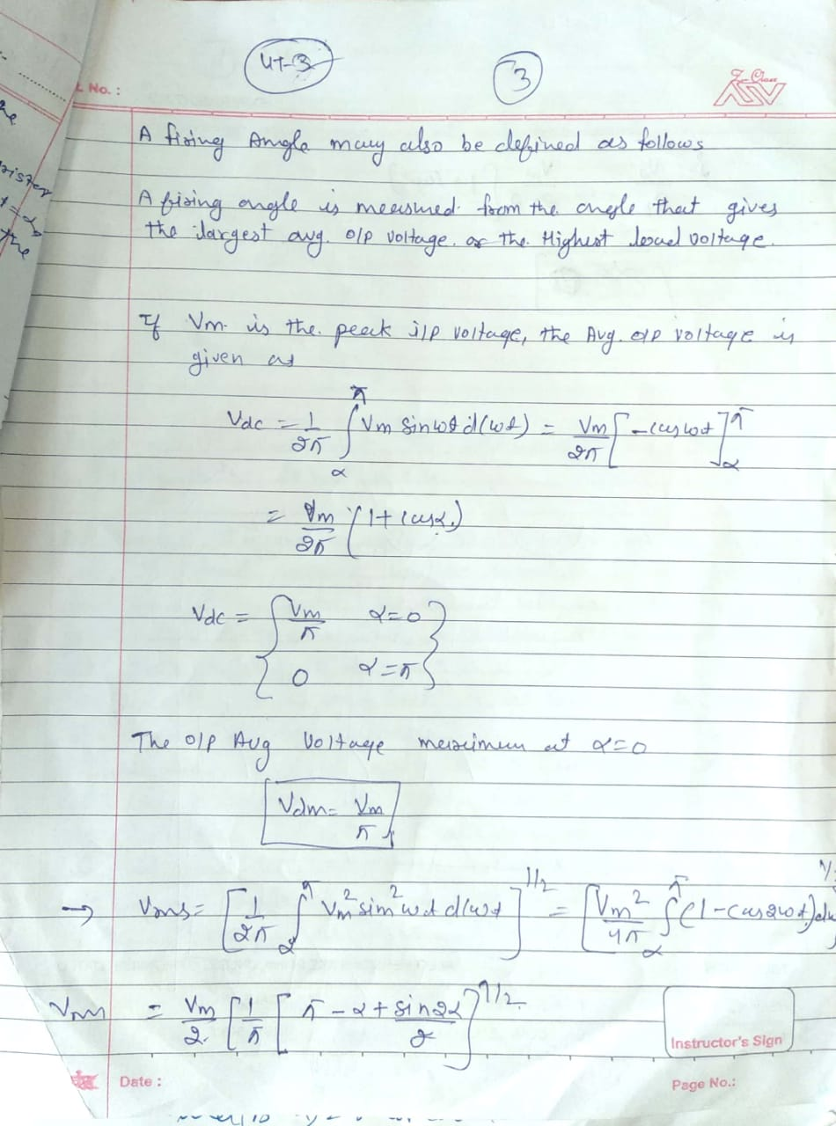

1- ¢ full wave bridge converter with RL load through a waveform of power supply ,load voltage and load current

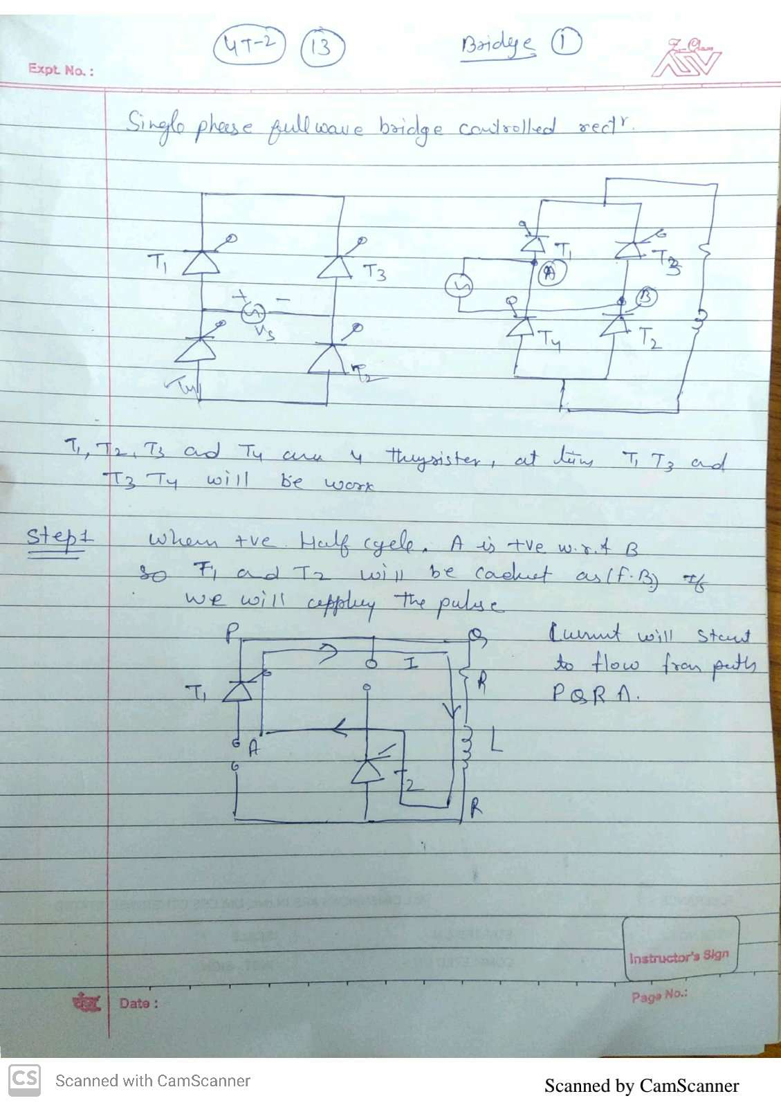

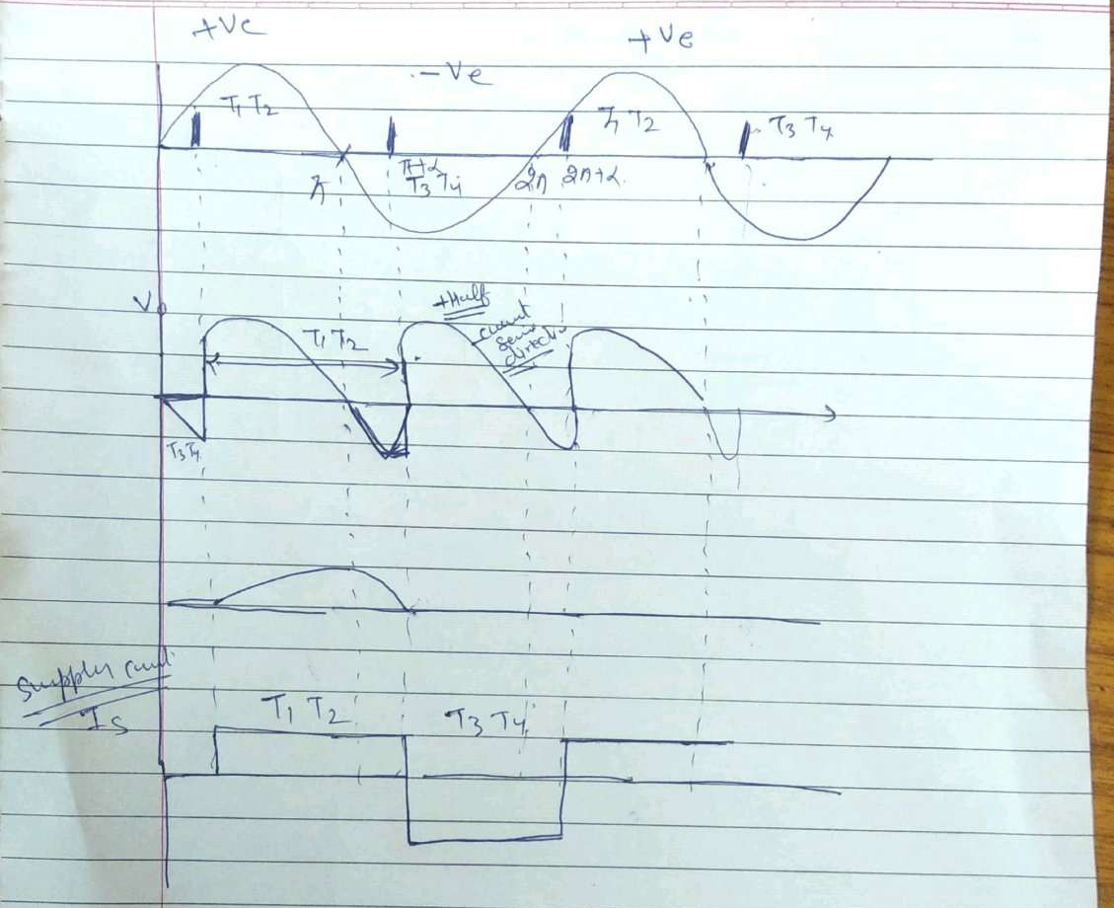

1- ¢ full wave bridge converter with RL

Single phase uncontrolled rectifiers are extensively used in a number of power electronic based converters. In most cases they are used to provide an intermediate unregulated dc voltage source which is further processed to obtain a regulated dc or ac output. They have, in general, been proved to be efficient and robust power stages. However, they suffer from a few disadvantages. The main among them is their inability to control the output dc voltage / current magnitude when the input ac voltage and load parameters remain fixed.
They are also unidirectional in the sense that they allow electrical power to flow from the ac side to the dc side only. These two disadvantages are the direct consequences of using power diodes in these converters which can block voltage only in one direction. As will be shown in this module, these two disadvantages are overcome if the diodes are replaced by thyristors, the resulting converters are called fully controlled converters. Thyristors are semicontrolled devices which can be turned ON by applying a current pulse at its gate terminal at a desired instance.
However, they cannot be turned off from the gate terminals. Therefore, the fully controlled converter continues to exhibit load dependent output voltage / current waveforms as in the case of their uncontrolled counterpart. However, since the thyristor can block forward voltage, the output voltage / current magnitude can be controlled by controlling the turn on instants of the thyristors. Working principle of thyristors based single phase fully controlled converters will be explained first in the case of a single thyristor halfwave rectifier circuit supplying an R or R-L load. However, such converters are rarely used in practice.
Full bridge is the most popular configuration used with single phase fully controlled rectifiers. Analysis and performance of this rectifier supplying an R-L-E load (which may represent a dc motor) will be studied in detail in this lesson.
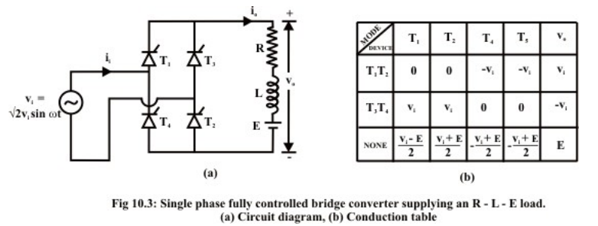

Fig 10.3 (a) shows the circuit diagram of a single phase fully controlled bridge converter. It is one of the most popular converter circuits and is widely used in the speed control of separately excited dc machines. Indeed, the R–L–E load shown in this figure may represent the electrical equivalent circuit of a separately excited dc motor. The single phase fully controlled bridge converter is obtained by replacing all the diode of the corresponding uncontrolled converter by thyristors. Thyristors T1 and T2 are fired together while T3 and T4 are fired 180º after T1 and T2. From the circuit diagram of Fig 10.3(a) it is clear that for any load current to flow at least one thyristor from the top group (T1, T3) and one thyristor from the bottom group (T2, T4) must conduct.

It can also be argued that neither T1T3 nor T2T4 can conduct simultaneously. For example whenever T3 and T4 are in the forward blocking state and a gate pulse is applied to them, they turn ON and at the same time a negative voltage is applied across T1 and T2 commutating them immediately. Similar argument holds for T1 and T2. For the same reason T1T4 or T2T3 can not conduct simultaneously. Therefore, the only possible conduction modes when the current i0 can flow are T1T2 and T3T4. Of coarse it is possible that at a given moment none of the thyristors conduct. This situation will typically occur when the load current becomes zero in between the firings of T1T2 and T3T4. Once the load current becomes zero all thyristors remain off. In this mode the load current remains zero. Consequently the converter is said to be operating in the discontinuous conduction mode. Fig 10.3(b) shows the voltage across different devices and the dc output voltage during each of these conduction modes. It is to be noted that whenever T1 and T2 conducts, the voltage across T3 and T4 becomes –vi. Therefore T3 and T4 can be fired only when vi is negative i.e, over the negative half cycle of the input supply voltage. Similarly T1 and T2 can be fired only over the positive half cycle of the input supply.

The voltage across the devices when none of the thyristors conduct depends on the off state impedance of each device. The values listed in Fig 10.3 (b) assume identical devices. Under normal operating condition of the converter the load current may or may not remain zero over some interval of the input voltage cycle. If i0 is always greater than zero then the converter is said to be operating in the continuous conduction mode. In this mode of operation of the converter T1T2 and T3T4 conducts for alternate half cycle of the input supply.

However, in the discontinuous conduction mode none of the thyristors conduct over some portion of the input cycle. The load current remains zero during that period. 10.3.1 Operation in the continuous conduction mode As has been explained earlier in the continuous conduction mode of operation i0 never becomes zero, therefore, either T1T2 or T3T4 conducts. Fig 10.4 shows the waveforms of different variables in the steady state. The firing angle of the converter is α. The angle θ is given by 1 E sinθ = 2V (10.15) It is assumed that at t = 0- T3T4 was conducting. As T1T2 are fired at ωt = α they turn on commutating T3T4 immediately. T3T4 are again fired at ωt = π + α. Till this point T1T2 conducts.
The period of conduction of different thyristors are pictorially depicted in the second waveform (also called the conduction diagram) of Fig 10.4.
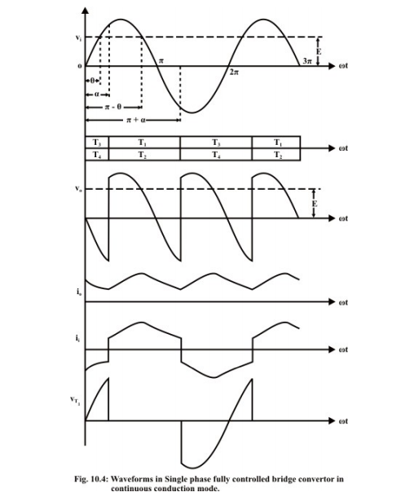
The dc link voltage waveform shown next follows from this conduction diagram and the conduction table shown in Fig 10.3(b). It is observed that the emf source E is greater than the dc link voltage till ωt = α. Therefore, the load current i0 continues to fall till this point. However, as T1T2 are fired at this point v0 becomes greater than E and i0 starts increasing through R-L and E. At ωt = π – θ v0 again equals E. Depending upon the load circuit parameters io reaches its maximum at around this point and starts falling afterwards. Continuous conduction mode will be possible only if i0 remains greater than zero till T3T4 are fired at ωt = π + α where upon the same process repeats.
The resulting i0 waveform is shown below v0. The input ac current waveform ii is obtained from i0 by noting that whenever T1T2 conducts ii = i0 and ii = - i0 whenever T3T4 conducts. The last waveform shows the typical voltage waveform across the thyristor T1. It is to be noted that when the thyristor turns off at ωt = π + α a negative voltage is applied across it for a duration of π – α. The thyristor must turn off during this interval for successful operation of the converter.
It is noted that the dc voltage waveform is periodic over half the input cycle. Therefore, it can be expressed in a Fourier series as follows. [ α = OAV an bn n=1 v = V + v cos2n ∑ ωt + v sin2nωt] (10.16) Where π+α OAV 0 i α 1 2 2 V = v dωt = V cosα π π ∫ (10.17) π an 0 i 0 2 2 2 cos(2n +1)α cos(2n -1)α v = v cos2nωt dωt= V - π π 2n +1 2n -1 ⎡ ⎤ ⎢ ⎥ ⎣ ⎦ ∫ (10.18) π bn 0 i 0 2 2 2 sin(2n +1)α sin(2n -1)α v = v sin2nωt dωt= V - π π 2n +1 2n -1 ⎡ ⎤ ⎢ ⎥ ⎣ ⎦ ∫ (10.19) Therefore the RMS value of the nth harmonic 2 2 OnRMS an bn 1 V = v +v 2 (10.20) RMS value of v0 can of course be completed directly from. π+α 2 ORMS 0 i α 1 V = vdωt=V π ∫ (10.21) Fourier series expression of v0 is important because it provides a simple method of estimating individual and total RMS harmonic current injected into the load as follows: The impedance offered by the load at nth harmonic frequency is given by 2 Z = R + (2n n ωL)2 (10.22) 1 α 2 onRMS 2 onRMS OHRMS on RMS n n=1 V I = ; I = I Z ⎡ ⎤ ⎢ ⎥ ⎣ ⎦ ∑ (10.23) From (10.18) – (10.23) it can be argued that in an inductive circuit IonRMS → 0 as fast as 1/n2 . So in practice it will be sufficient to consider only first few harmonics to obtain a reasonably accurate estimate of IOHRMS form equation 10.23. This method will be useful, for example, while calculating the required current derating of a dc motor to be used with such a converter.
However to obtain the current rating of the device to be used it is necessary to find out a closed form expression of i0. This will also help to establish the condition under which the converter will operate in the continuous conduction mode. To begin with we observe that the voltage waveform and hence the current waveform is periodic over an interval π. Therefore, finding out an expression for i0 over any interval of length π will be sufficient. We choose the interval α ≤ ωt ≤ π + α. In this interval 0 0 i di L + Ri + E = 2V sinωt dt (10.24) The general solution of which is given by ( ) ωt-α - tanφ i 0 2V sinθ i = Ie + sin(ωt -φ) - Z cosφ⎦ Where, 2 22 i ωL Z= R +ω L ; tanφ = ; E = 2V sinθ; R = Zcosφ R Now at steady state 0 0 ωt=α ωt=π+α i =i since i0 is periodic over the chosen interval. Using this boundary condition we obtain ( ) ωt-α - tanφ i 0 π - tanφ 2V 2sin(φ - α) s θ e + sin(ωt -φ) - i = Z cosφ 1-e ⎡ ⎤ ⎢ ⎥ ⎣ ⎦ in (10.26) The input current ii is related to i0 as follows: i 0 i = i for α ω≤ ≤t π +α (10.27) ii = - i0 otherwise. Fig 10.5 shows the waveform of ii in relation to the vi waveform.

pulse width modulation control scheme for power factor

Power factor is the ratio of real power (kilo Watt) which is actually consumed by the equipment, to apparent power (kilo Volt Ampere) which is what must be supplied by the network. Power Factor is a measure of how effectively your system uses its electricity supply. A system with poor power factor draws more apparent power than real power. A low power factor is classed as less than 0.9. Certain loads such as inductive loads and capacitive loads reduce the value of this factor. A power factor of anything less than 1 means you may be paying more than you need for electricity supplied. You are charged more for this supply if you have a tariff with a (Kilo volt ampere) demand chargeinstead of Kilo Watt. The efficiency of (Alternating Current-Direct Current) and Direct Current-Direct Current) power converters that are used in many applications like Interruptible Power Supplies (UPS), inverter depends on power factor. Rectifiers used for (Alternating Current-Direct Current) conversion have high harmonic content, low power factor, low efficiency and large size of inductors and filters. Performance and efficiency of converters is increased by high power factor and low line current distortion. This requirement is usually satisfied by incorporating some form of PFC circuits to shape the input phase currents.

Need for Power Factor Correction Power factor correction is a technique used to increase the power factor of a system to minimize the input current waveform distortion and make it in phase with the voltage one increasing the power factor of an electrical system is desirable because it reduces the reactive current and thus increases efficiency. Apparent power delivered to the load is greater than the real power which the load consumes when an electric load has a power factor lower than 1. Most of the research on PFC for nonlinear loads is related to the reduction of the harmonic content of the line current. We need to correct PF because most electronic equipment being connected to the electricity distribution network, the non-sinusoidal input line current drawn by these equipment’s due to input line rectification generates current harmonics that causes severe problems. These include increased magnitudes of neutral currents in three-phase systems, overheating of transformers and induction motors. This creates the need for some kind of power conditioning. Thus, the need to limit the harmonic content of line currents drawn by electronic equipment connected to the electricity distribution networks, results in the need for Power Factor Correction.

3 phase full wave converter
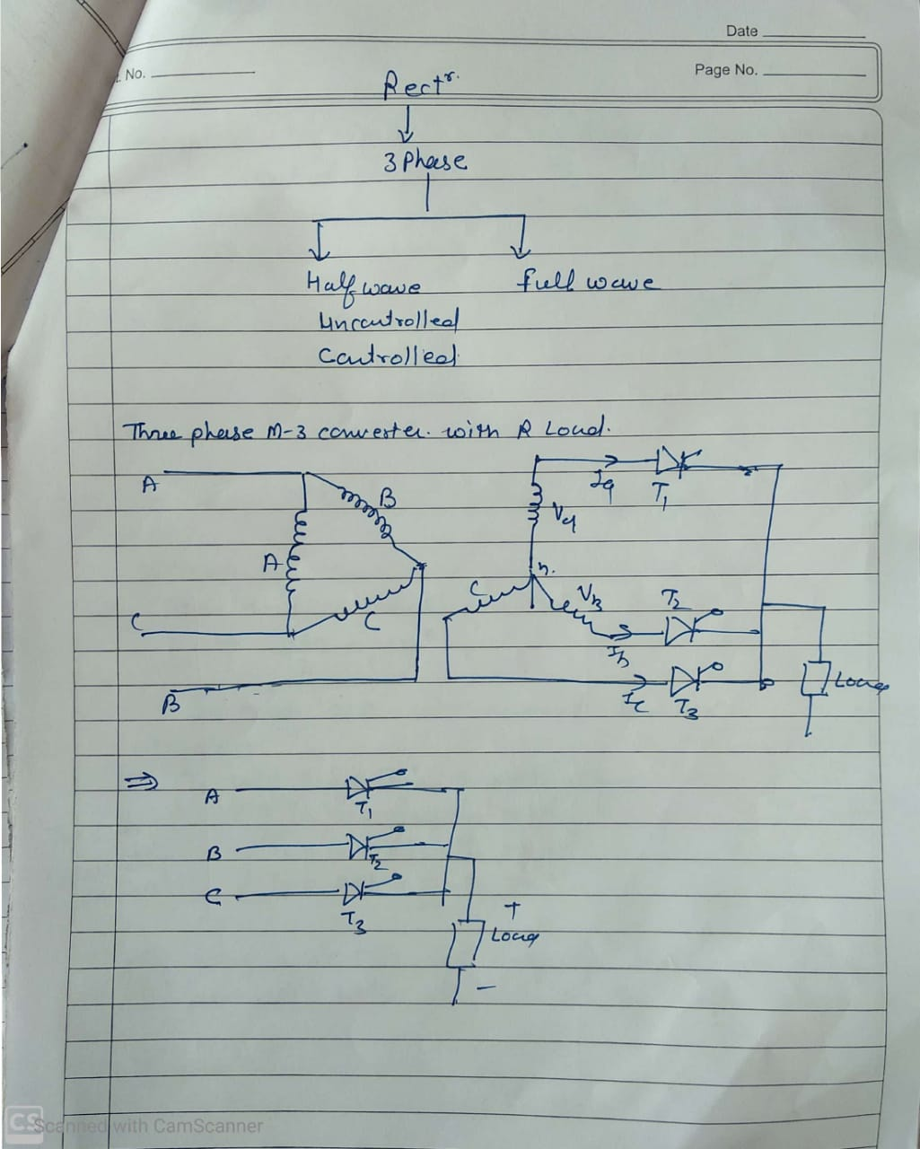

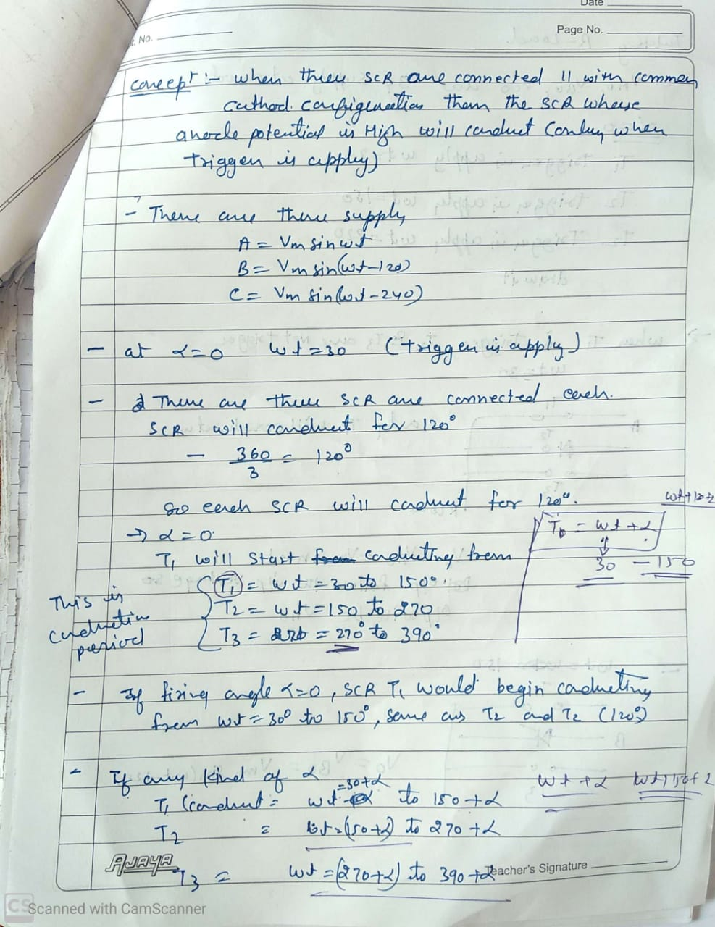

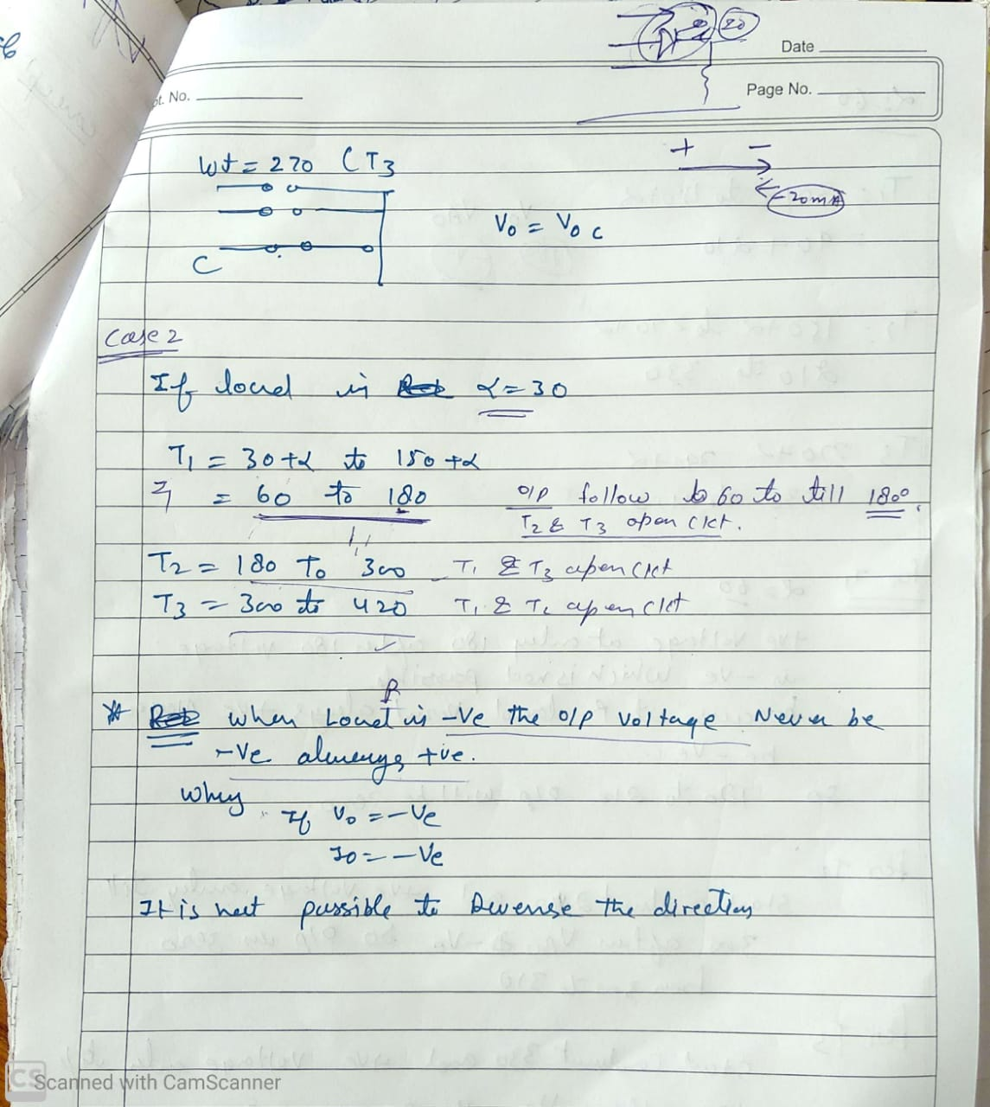

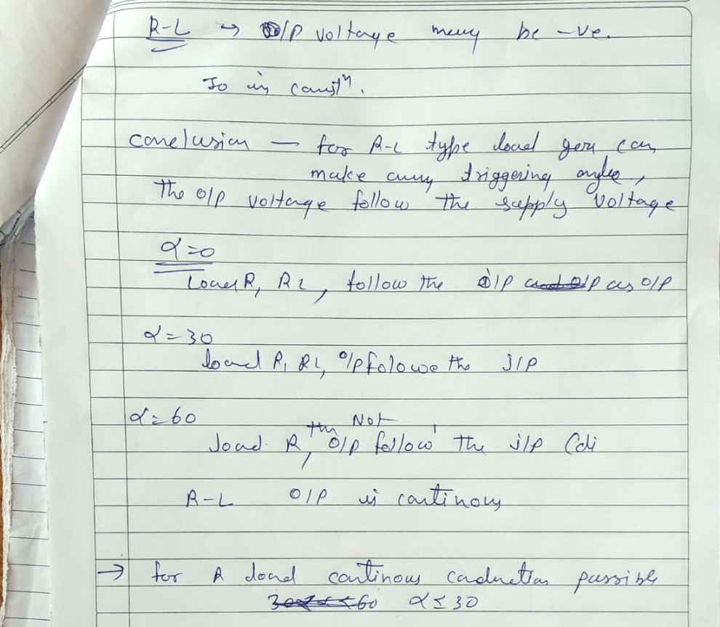

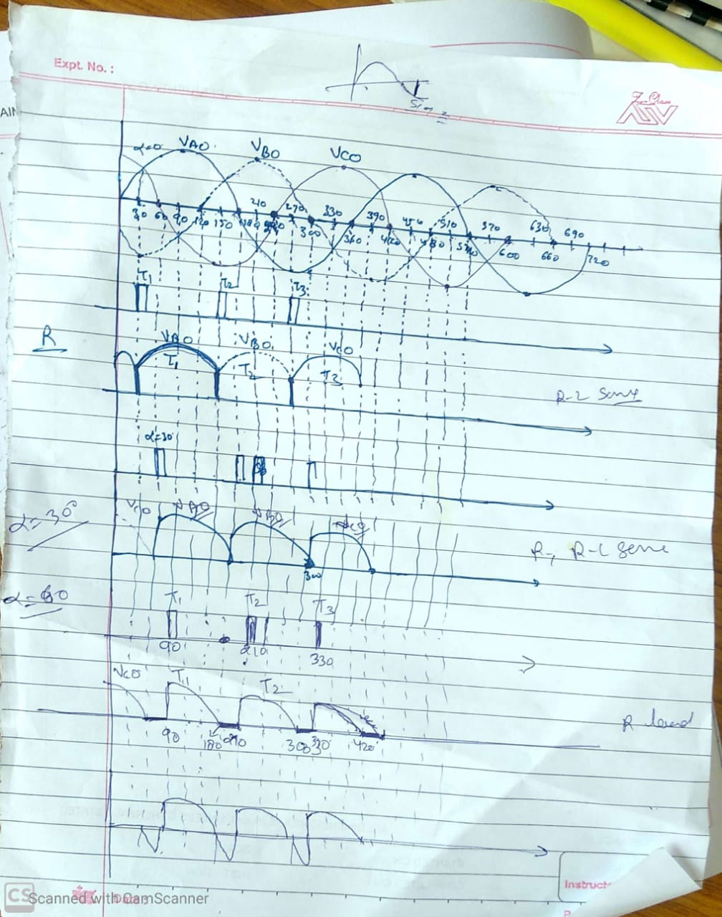

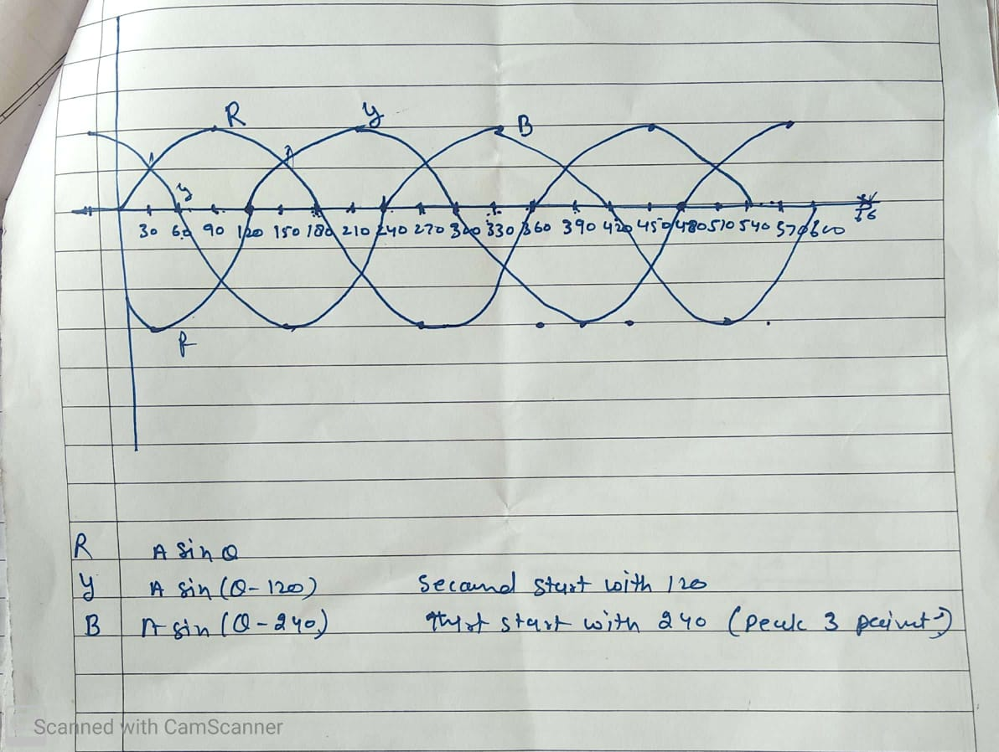

Unit 3
INVERTERS: Voltage Source Inverter, Current Source Inverter, PWM Control of Voltage Source Converter and applications.

INVERTERS

The device that converts dc power into ac power at desired output voltage and frequency is called an inverter.
Single phase voltage source inverters
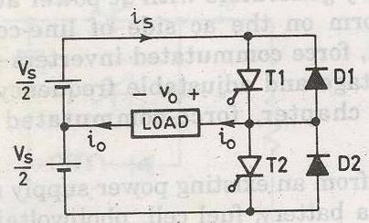
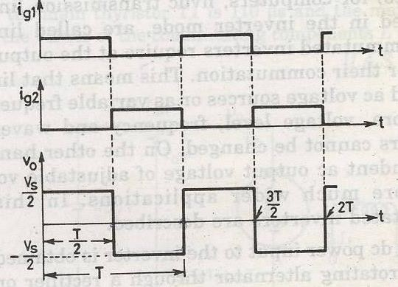

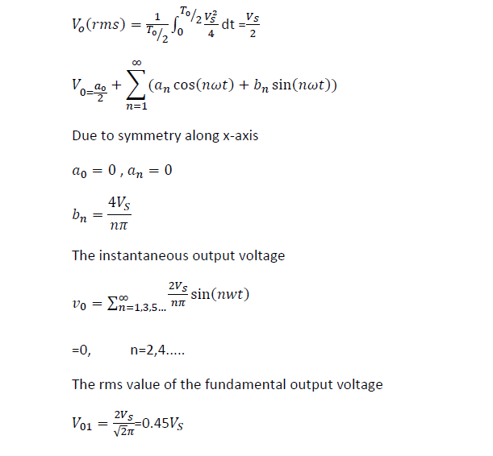

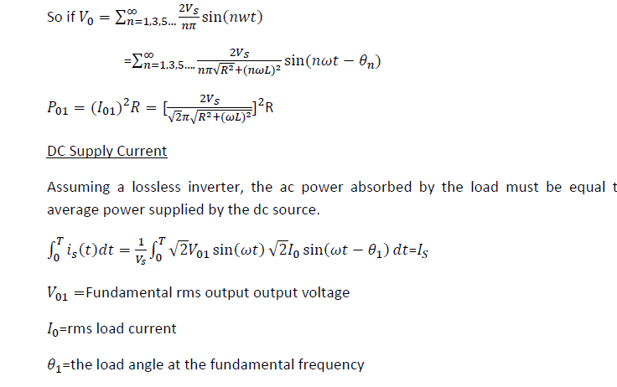

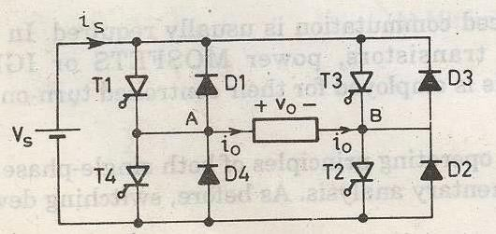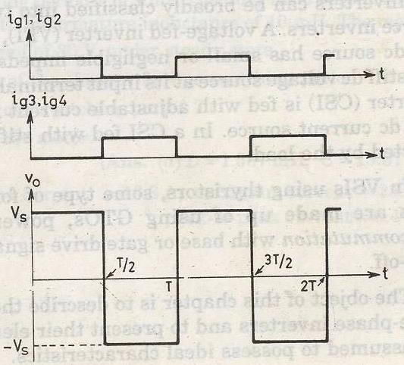

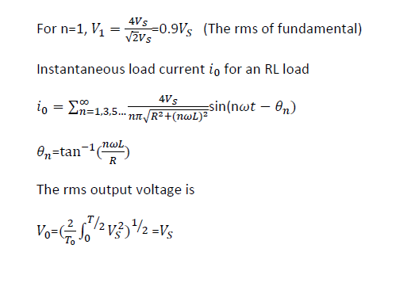
1 𝑆

The instantaneous output voltage in a fourier series

_{V0}
∞
= ∑ 4𝑉𝑆 sin(𝑛𝜔𝑡)
𝑛𝜋
𝑛=1,3,5…

Single phase bridge inverter
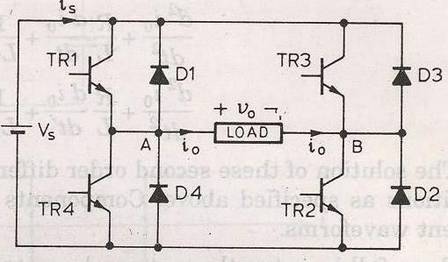

INVERTER

Inverters are of the two types

- VSI
- CSI

The Inverter is the power electronic circuit, which converts the DC voltage into AC voltage. The DC source is normally a battery or output of the controlled rectifier.
- The output voltage waveform of the inverter can be square wave, quasi-square wave or low distorted sine wave.
- The output voltage can be controlled with the help of drives of the switches.
- The pulse width modulation techniques are most commonly used to control the output voltage of inverters. Such inverters are called as PWM inverters.
- The output voltage of the inverter contain harmonics whenever it is not sinusoidal.
- These harmonics can be reduced by using proper control schemes.
Inverters can be broadly classified into two types. They are
- Voltage Source Inverter (VSI)
- Current Source Inverter (CSI)
When the DC voltage remains constant, then it is called Voltage Source Inverter(VSI) or Voltage Fed Inverter (VFI).
When input current is maintained constant, then it is called Current Source Inverter (CSI) or Current Fed Inverter (CFI).
Some times, the DC input voltage to the inverter is controlled to adjust the output. Such inverters are called Variable DC Link Inverters. The inverters can have single phase or three-phase output.
- A voltage source inverter(VSI) is fed by a stiff DC voltage, whereas a current source inverter is fed by a stiff current source.
- A voltage source can be converted to a current source by connecting a series inductance and then varying the voltage to obtain the desired current.
- A VSI can also be operated in current-controlled mode, and similarly a CSI can also be operated in the voltage control mode.
- The inverters are used in variable frequency ac motor drives, uninterrupted power supplies, induction heating, static VAR compensators, etc.
The following table gives us the comparative study between VSI and CSI
VSI | CSI
VSI is fed from a DC voltage source having small or negligible impedance. | CSI is fed with adjustable current from a DC voltage source of high impedance.
Input voltage is maintained constant | The input current is constant but adjustable.
Output voltage does not dependent on the load | The amplitude of output current is independent of the load.
The waveform of the load current as well as its magnitude depends upon the nature of load impedance. | The magnitude of output voltage and its waveform depends upon the nature of the load impedance.
VSI requires feedback diodes | The CSI does not require any feedback diodes.
The commutation circuit is complicated | Commutation circuit is simple as it contains only capacitors.
Power BJT, Power MOSFET, IGBT, GTO with self commutation can be used in the circuit. | They cannot be used as these devices have to withstand reverse voltage.

half wave converter with RL load through a waveform
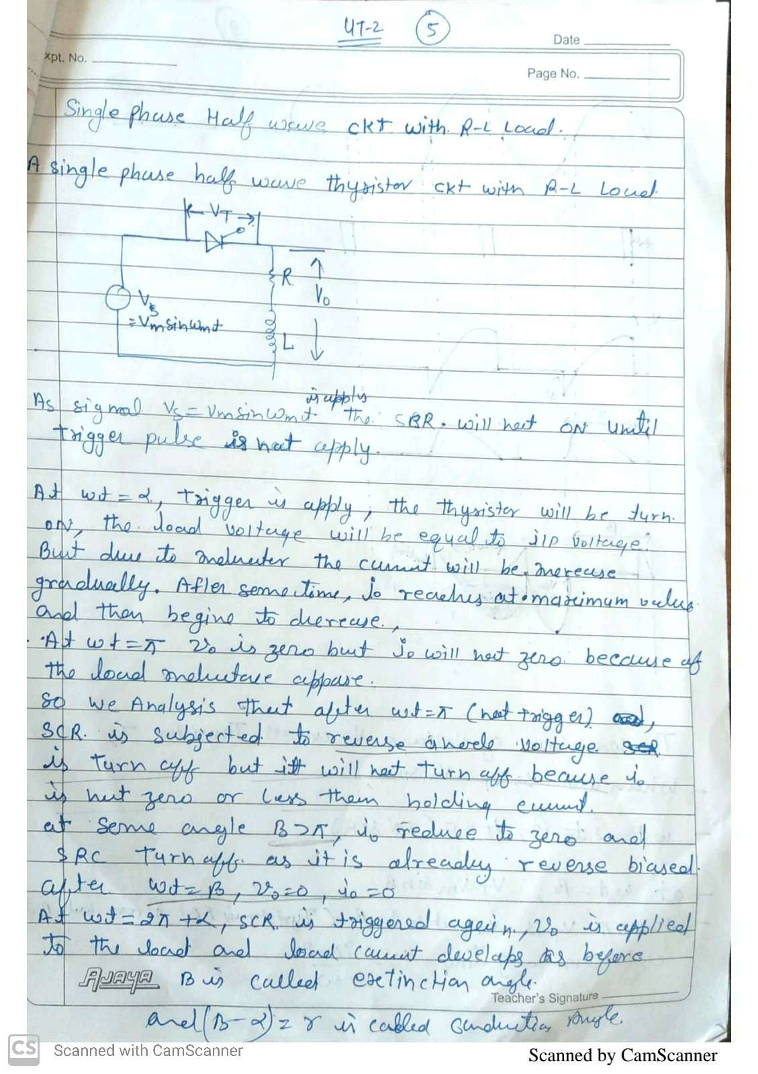

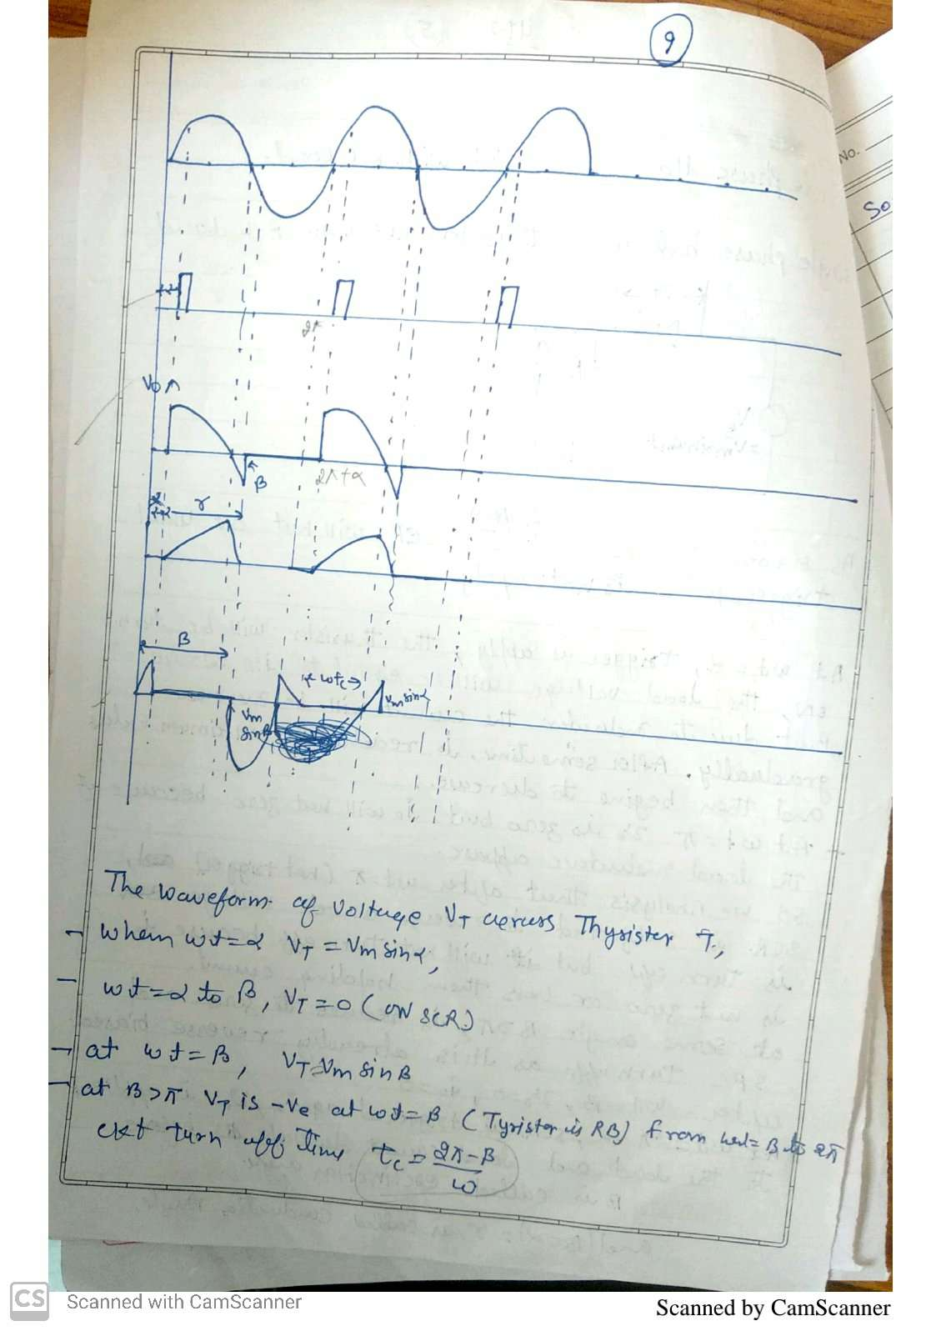

3 phase full wave converter

Pulse width model

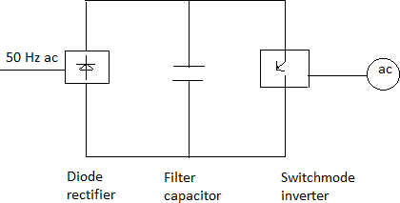

The VSI can be further divided into general 3 categories: 1.Pulse width modulated inverters
- Square wave inverters
- Single phase inverter with voltage cancellation

Pulse width modulated inverters

The input dc voltage is of constant magnitude . The diode rectifier is used to rectify the line voltage.The inverter control the magnitude and frequency of the ac output voltage.
This is achieved by PWM technique of inverter switches and this is called PWM inverters.

The sinusoidal PWM technique is one of the PWM technique to shape the output voltage to as close as sinusoidal output.
Basic concepts of switch mode inverter

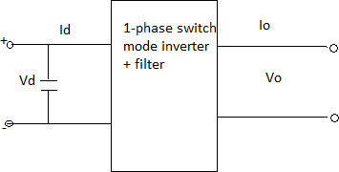

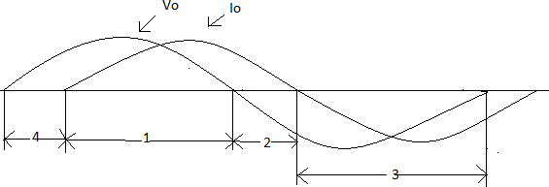

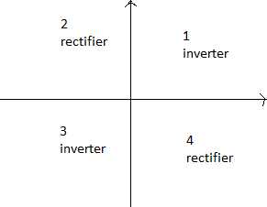

During interval 1 i₀and v₀ both are positive During interval 3i₀ and v₀ both are negative
Therefore during 1 and 3 the instantaneous power flow is from dc side to corresponding to inverter mode of operation.
In contrast during interval 2 and 4 v₀ and i₀ are of opposite sign i.e. power flows from ac side to dc side corresponding to rectifier mode of operation.

Pulse width modulated switching scheme

We require the inverter output to be sinusoidal with magnitude and frequency controllable.

In order to produce sinusoidal output voltage at desired frequency a sinusoidal control signal at desired frequency is compared with a triangular waveform as show.
The frequency of the triangular waveform established the inverter switching frequency.

The triangular waveform is called carrier waveform. The triangular waveform establishes switching frequency , which establishes with which the inverter switches are applied.
The control signal has frequency 𝑓_{𝑠} and is used to modulate the switch duty ratio.
𝑓₁ is the desired fundamental frequency of the output voltage.

The amplitude modulation ratio 𝑚_{𝑎} is defined as

m 𝑉𝑐𝑜𝑛𝑡𝑟𝑜𝑙

a= 𝑉𝑡𝑟𝑖

𝑉_{𝑐𝑜𝑛𝑡𝑟𝑜𝑙} is the peak amplitude of control signal.
𝑉_{𝑡𝑟𝑖} peak amplitude of triangular signal. The frequency modulation ratio 𝑚_{𝑓}

m = 𝑓𝑠
f
𝑓1
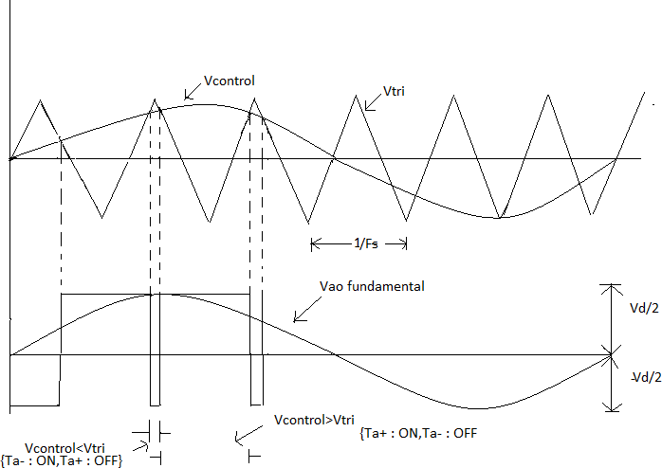

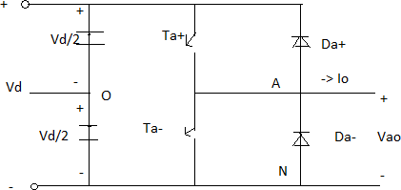

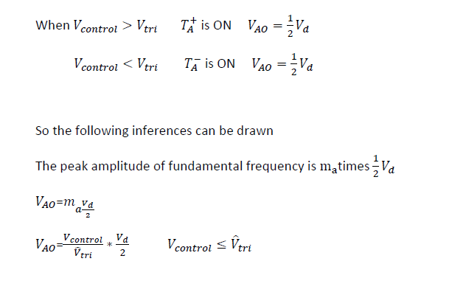
So the following inferences can be drawn

The peak amplitude of fundamental frequency is m_{a}times 2 𝑉_{𝑑}
1
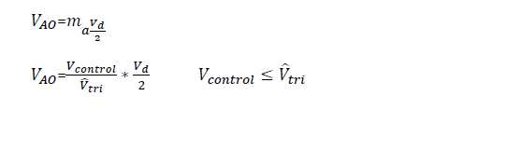

The foregoing arguments shown why V_{control}is chosen to be sinusoidal to provide sinusoidal output voltage with fewer harmonics
Let the V_{control} vary sinusoidal with frequency f₁,which is the desired frequency of the inverter output voltage.
Let Vcontrol=V̂controlsin𝜔1t
V̂control ≤ V̂tri

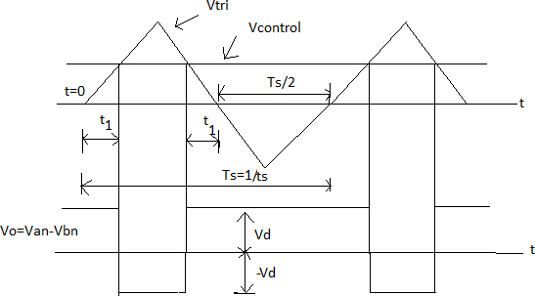

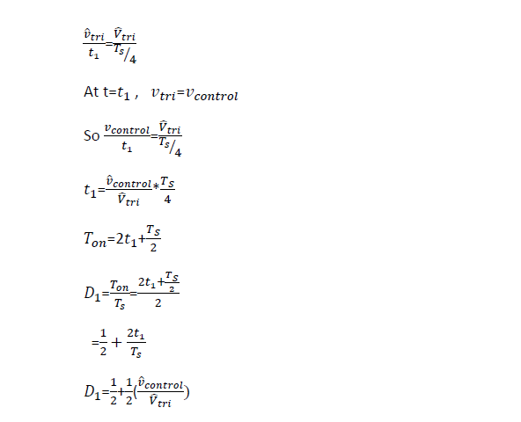

Three phase inverter

When three single-phase inverters are connected in parallel a three phase inverter is formed.
The gating signal has to be displaced by 120⁰ with respect to each other so as achieve three phase balanced voltages.
A 3-phase output can be achieved from a configuration of six transistors and six diodes.

Two type of control signal can be applied to transistors, they are such as 180⁰ or 120⁰ conduction.
180-degree conduction

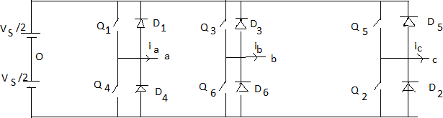

When 𝑄₁ is switched on, terminal a is connected to the positive terminal of dc input voltage. When 𝑄₄ is switched on terminal a is brought to negative terminal of the dc source.
There are 6 modes of operation is a cycle and the duration of each mode is 60⁰.
The conduction sequence of transistors is 123,234,345,456,561,612. The gating signals are shifted from each other by 60⁰ to get 3-𝜑 balanced voltages.

Switching states for the three phase voltage inverters
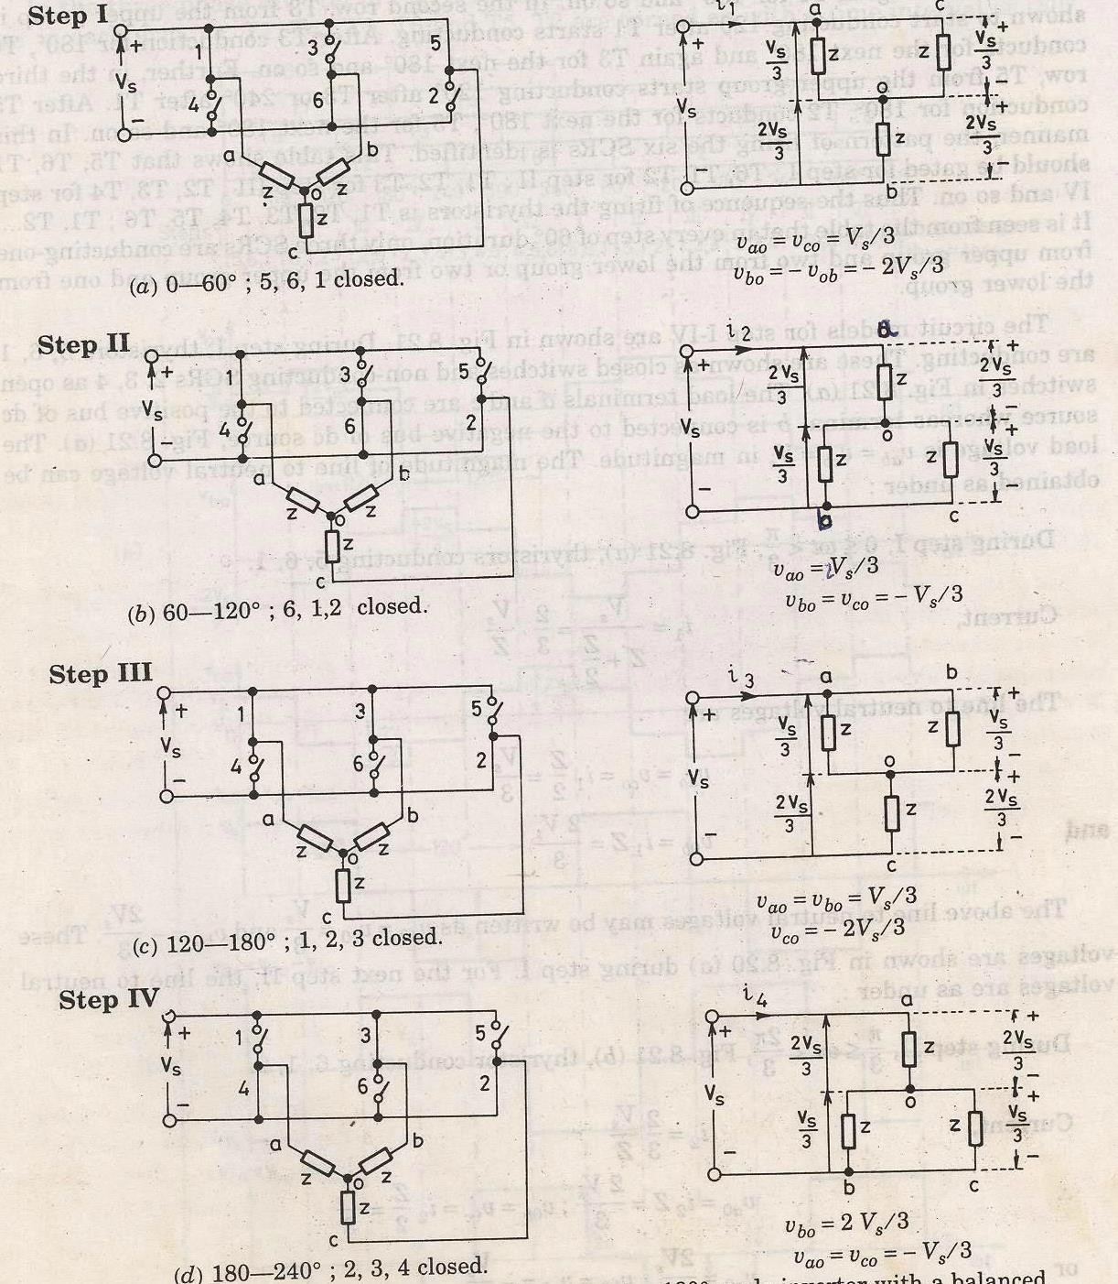
4,5,6 5,6,1
3,4,5 6,1,2

2,3,4 1,2,3

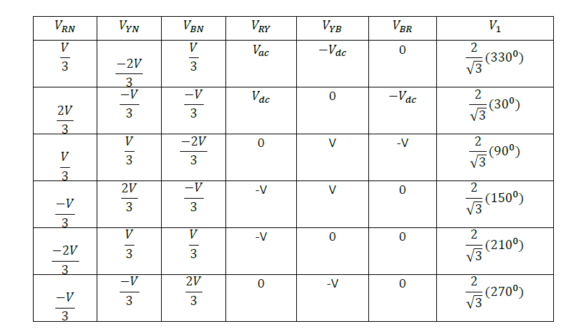

Fourier analysis

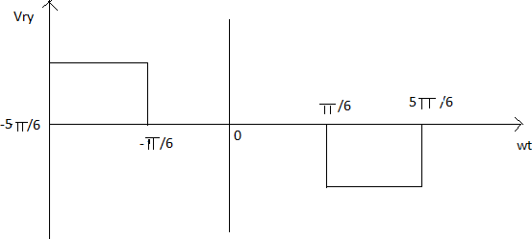

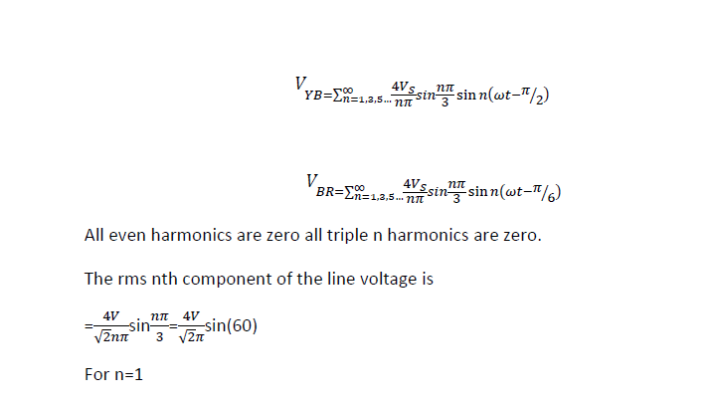

Three phase 120⁰mode VSI
The circuit diagram is same as that for 180⁰ mode of conduction.
Here each thyristor conducts for 120⁰.There are 6 steps each of 60⁰ duration, for completing one cycle of ac output voltage.

5,6 6,1

4,5 1,2
3,4 2,3

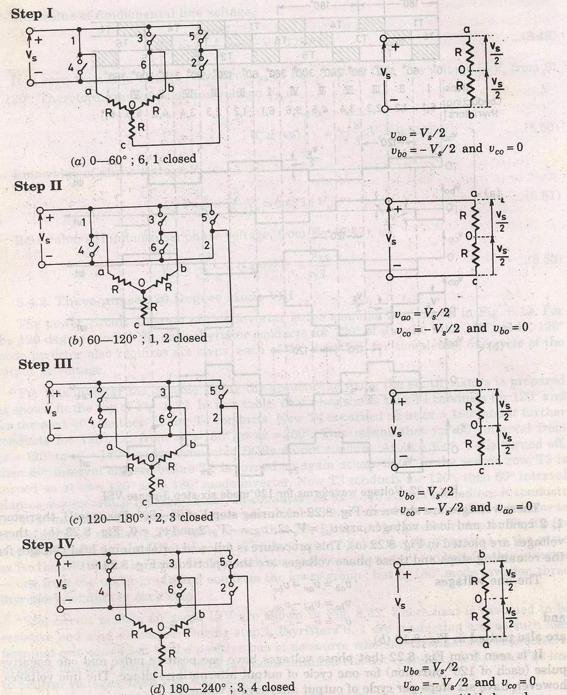

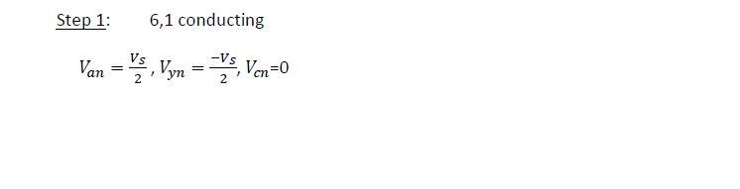

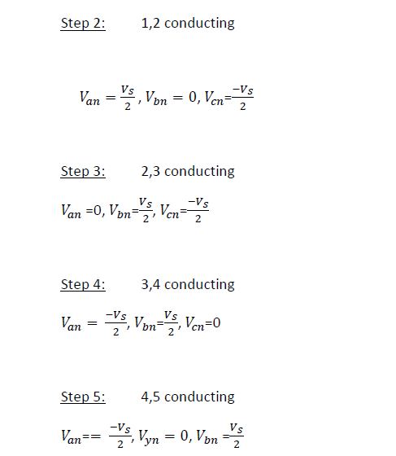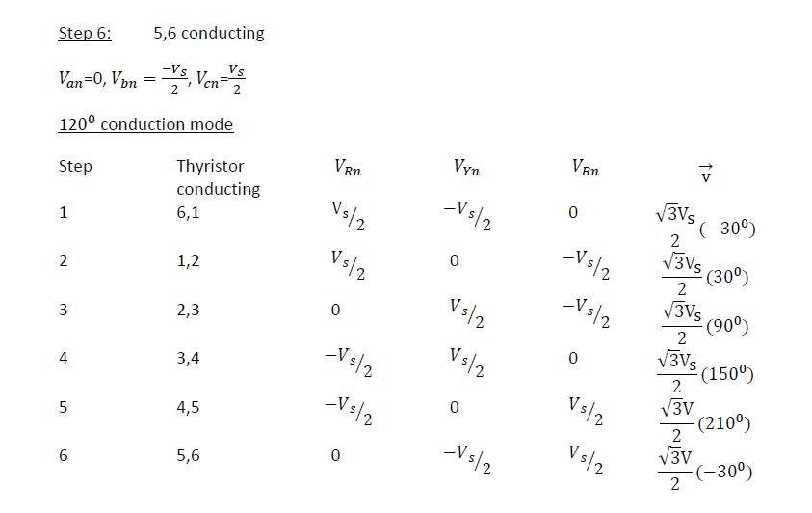
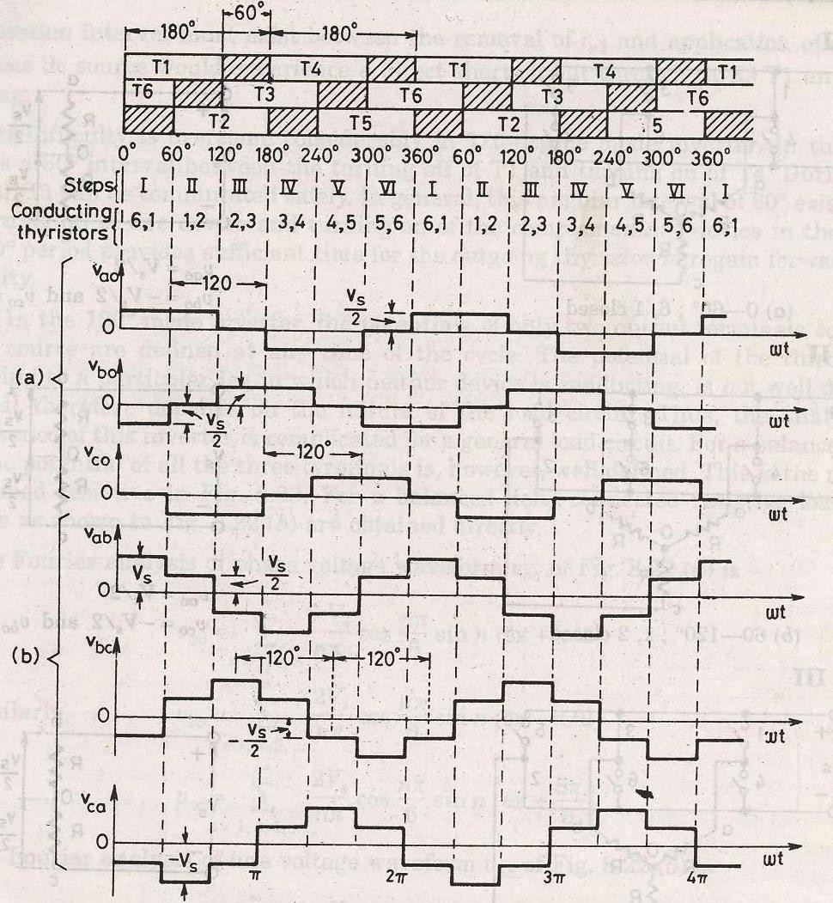

UNIT 4
INDUSTRIAL POWER SUPPLIES: Principle of operation of choppers. Step up, Step down and reversible choppers. Chopper control techniques, High frequency electronic ballast, Switch Mode Power Supply: Fly back converter, forward/buck converter, Boost converter and buck-boost converter. Uninterruptible Power Supply.

CHOPPER

A chopper is a static device that converts fixed DC input voltage to variable output voltage directly. Chopper are mostly used in electric vehicle, mini haulers.
Chopper are used for speed control and braking. The systems employing chopper offer smooth control, high efficiency and have fast response.
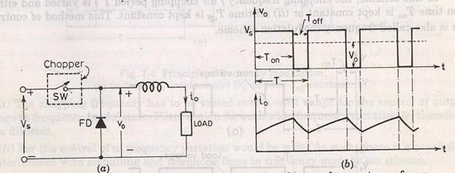
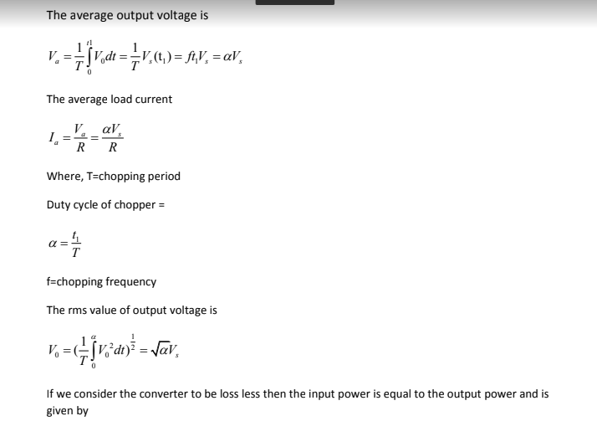

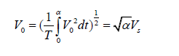
If we consider the converter to be loss less then the input power is equal to the output power and is given by

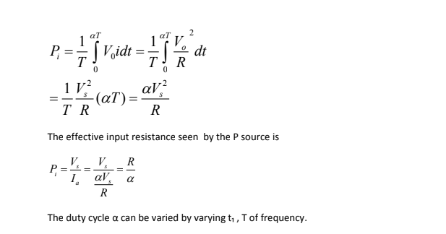

The duty cycle α can be varied by varying t₁ , T of frequency.

Constant frequency operation:

- The chopping period T is kept constant and on time is varied. The pulse width modulation ,the width of the pulse is varied.
- Variable frequency operation, the chopping frequency f is varied. Frequency modulation, either on time or off time is kept constant.
This type of control generate harmonics at unpredictable frequency and filter design is often difficult.

TYPES OF CHOPPER:

FIRST QUADRANT OR TYPE A CHOPPER:
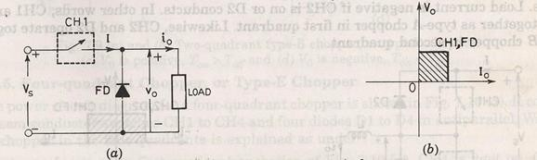
When switch ON

V0  Vs .
Current i₀ flows in the same direction when switch off. V₀=0, i₀=0
So, average value of both the load and the current are positive.

SECOND QUADRANT OR TYPE B CHOPPER:

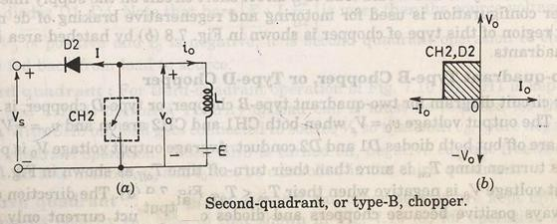

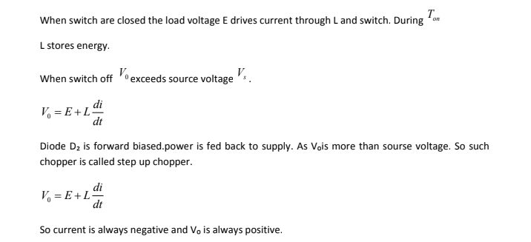

TWO QUADRANT TYPE A CHOPPER OR, TYPE C CHOPPER:
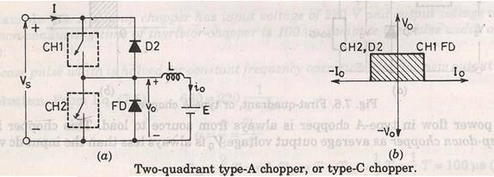

Both the switches never switch ON simultaneously as it lead direct short circuit of the supply.
Now when sw2 is closed or FD is on the output voltage V₀ is zero. When sw1 is ON or diode D conducts output voltage is V₀ is +V_{s}’ CURRENT ANANLYSIS:
When CH1 is ON current flows along i_{0.} When CH1 is off current continues to flow along i₀ as FD is forward biased. So i₀ is positive.
Now when CH2 is ON current direction will be opposite to i₀. When sw2 is off D2 turns ON.

Load current is –i_{0.} So average load voltage is always positive. Average load current may be positive or negative.

TWO QUADRANT TYPE B CHOPPER, OR TYPE D CHOPPER:
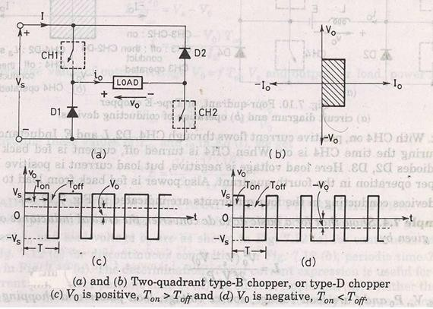

When CH1 and CH2 both are on then V₀=V_{s.}

When CH1 and CH2 are off and D1 and D2 are on V ₀=-V_{s.}

The direction of current is always positive because chopper and diode can only conduct in the direction of arrow shown in fig.
Average voltage is positive when T_{on}>T_{off}

FOUR QUADRANT CHOPPER, OR TYPE E CHOPPER
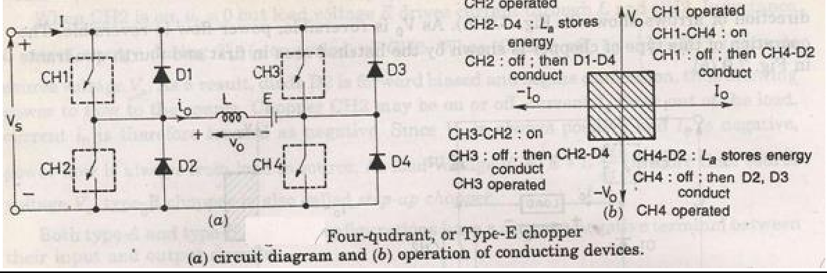

FIRST QUADRANT:

CH4 is kept ON CH3 is off
CH1 is operarted V₀=V_{s}
i₀ = positive

when CH1 is off positive current free wheels through CH4,D2 so V₀ and I₂ is in first quadrant.
SECOND QUADRANT:

CH1,CH3,CH4 are off. CH2 is operated.
Reverse current flows and I is negative through L CH2 D4 and E. When CH2 off D1 and D4 is ON and current id fed back to source. So
E  L di
dt is more than source voltage V_{s.}

As i₀ is negative and V₀ is positive, so second quadrant operation. THIRD QUADRANT:
CH1 OFF, CH2 ON

CH3 operated. So both V₀ and i₀ is negative.

When CH3 turned off negative current freewheels through CH2 and D4. FOURTH QUADRANT:
CH4 is operated other are off.

Positive current flows through CH4 E L D2.

Inductance L stores energy when current fed to source through D3 and D2.V₀ is negative.

STEADY STATE ANALYSIS OF PRACTICAL BUCK CHOPPER:
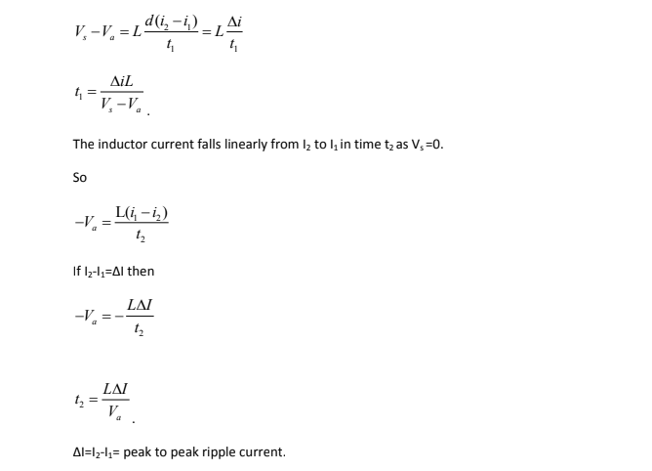
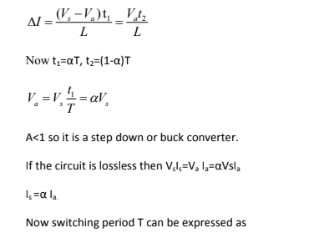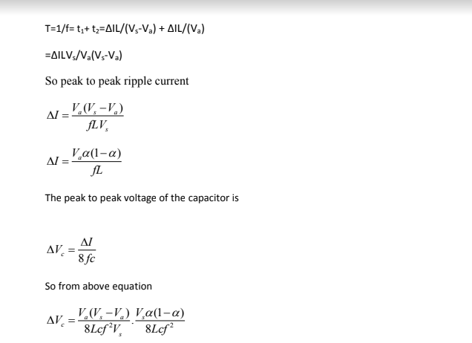

Condition for continuous inductor current and capacitor voltage :
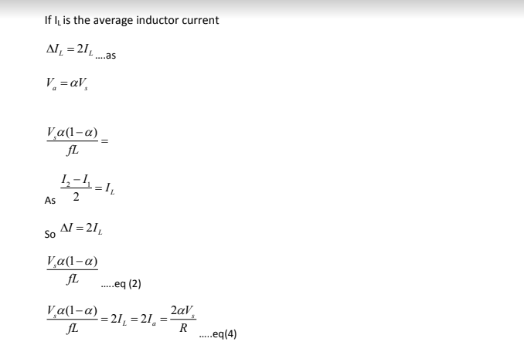

Switch Mode Power Supply
Linear voltage regulators are generally much more efficient and easier to use than equivalent voltage regulator circuits made from discrete components such a zener diode and a resistor, or transistors and even op-amps.
The most popular linear and fixed output voltage regulator types are by far the 78… positive output voltage series, and the 79… negative output voltage series. These two types of complementary voltage regulators produce a precise and stable voltage output ranging from about 5 volts up to about 24 volts for use in many electronic circuits.
There is a wide range of these three-terminal fixed voltage regulators available each with its own built-in voltage regulation and current limiting circuits. This allows us to create a whole host of different power supply rails and outputs, either single or dual supply, suitable for most electronic circuits and applications. There are even variable voltage linear regulators available as well providing an output voltage which is continually variable from just above zero to a few volts below its maximum voltage output.
Most d.c. power supplies comprise of a large and heavy step-down mains transformer, diode rectification, either full-wave or half-wave, a filter circuit to remove any ripple content from the rectified d.c. producing a suitably smooth d.c. voltage, and some form of voltage regulator or stabiliser circuit, either linear or switching to ensure the correct regulation of the power supplies output voltage under varying load conditions. Then a typical d.c. power supply would look something like this:

Typical DC Power Supply
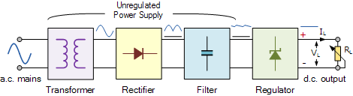

These typical power supply designs contain a large mains transformer (which also provides isolation between the input and output) and a dissipative series regulator circuit. The regulator circuit could consist of a single zener diode or a three-terminal linear series regulator to produce the required output voltage. The advantage of a linear regulator is that the power supply circuit only needs an input capacitor, output capacitor and some feedback resistors to set the output voltage.
Linear voltage regulators produce a regulated DC output by placing a continuously conducting transistor in series between the input and the output operating it in its linear region (hence the name) of its current-voltage (i-v) characteristics. Thus the transistor acts more like a variable resistance which continually adjusts itself to whatever value is needed to maintain the correct output voltage. Consider this simple series pass transistor regulator circuit below:

Series Transistor Regulator Circuit
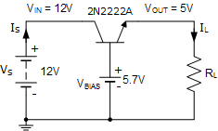
Here this simple emitter-follower regulator circuit consists of a single NPN transistor and a DC biasing voltage to set the required output voltage. As an emitter follower circuit has unity voltage gain, applying a suitable biasing voltage to the transistors base, a stabilised output is obtained from the emitter terminal.
Since a transistor provides current gain, the output load current will be much higher than the base current and higher still if a Darlington transistor arrangement is used.
Also, providing that the input voltage is sufficiently high enough to get the desired output voltage, the output voltage is controlled by the transistors base voltage and in this example is given as 5.7 volts to produce a 5 volt output to the load as approximately 0.7 volts is dropped across the transistor between the base and emitter terminals. Then depending upon the value of the base voltage, any value of emitter output voltage can be obtained.
While this simple series regulator circuit will work, the downside to this is that the series transistor is continually biased in its linear region dissipating power in the form of heat as a result of its V*I product, since all the load current must pass through the series transistor, resulting in poor efficiency, wasted power and continuous heat generation.
Also, one of the disadvantages that series voltage regulators have is that, their maximum continuous output current rating is limited to just a few amperes or so, so are generally used in applications where low power outputs are required. When higher output voltage or current power supplies are required, the normal practice is to use a switching regulator commonly known as a switch-mode power supply to convert the mains voltage into whatever higher power output is required.
Switch Mode Power Supplies, or SMPS, are becoming common place and have replaced in most cases the traditional linear ac-to-dc power supplies as a way to cut power consumption, reduce heat dissipation, as well as size and weight. Switch-mode power supplies can now be found in most PC’s, power amplifiers, TV’s, dc motor drives, etc., and just about anything that requires a highly efficient supply as switch-mode power supplies are increasingly becoming a much more mature technology.
By definition, a switch mode power supply (SMPS) is a type of power supply that uses semiconductor switching techniques, rather than standard linear methods to provide the required output voltage. The basic switching converter consists of a power switching stage and a control circuit. The power switching stage performs the power conversion from the circuits input voltage, V_{IN} to its output voltage, V_{OUT} which includes output filtering.
The major advantage of the switch mode power supply is its higher efficiency, compared to standard linear regulators, and this is achieved by internally switching a transistor (or power MOSFET) between its “ON” state (saturated) and its “OFF” state (cut-off), both of which produces lower power dissipation. This means that when the switching transistor is fully “ON” and conducting current, the voltage drop across it is at its minimal value, and when the transistor is fully “OFF” there is no current flow through it. So the transistor is acting like an ideal switch.
As a result, unlike linear regulators which only offer step-down voltage regulation, a switch mode power supply, can offer step-down, step-up and negation of the input voltage using one or more of the three basic switch mode circuit topologies: Buck, Boost and Buck-Boost. This refers to how the transistor switch, inductor, and smoothing capacitor are connected within the basic circuit.

Buck Switch Mode Power Supply
The Buck switching regulator is a type of switch mode power supply circuit that is designed to efficiently reduce DC voltage from a higher voltage to a lower one, that is it subtracts or “Bucks” the supply voltage, thereby reducing the voltage available at the output terminals without changing the polarity. In other words, the buck switching regulator is a step-down regulator circuit, so for example a buck converter can convert say, +12 volts to +5 volts.
The buck switching regulator is a DC-to-DC converter and one of the simplest and most popular type of switching regulator. When used within a switch mode power supply configuration, the buck switching regulator uses a series transistor or power MOSFET (ideally an insulated gate bipolar transistor, or IGBT) as its main switching device as shown below.

The Buck Switching Regulator
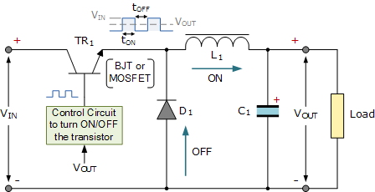

We can see that the basic circuit configuration for a buck converter is a series transistor switch, TR₁ with an associated drive circuit that keeps the output voltage as close to the desired level as possible, a diode, D₁, an inductor, L₁ and a smoothing capacitor, C₁. The buck converter has two operating modes, depending on if the switching transistor TR₁ is turned “ON” or “OFF”.
When the transistor is biased “ON” (switch closed), diode D₁ becomes reverse biased and the input voltage, V_{IN} causes a current to flow through the inductor to the connected load at the output, charging up the capacitor, C₁. As a changing current flows through the inductor coil, it produces a back-emf which opposes the flow of current, according to Faraday’s law, until it reaches a steady state creating a magnetic field around the inductor, L₁. This situation continues indefinitely as long as TR₁ is closed.
When transistor TR₁ is turned “OFF” (switch open) by the controlling circuitry, the input voltage is instantly disconnected from the emitter circuit causing the magnetic field around the inductor to collapse inducing a reverse voltage across the inductor. This reverse voltage causes the diode to become forward biased, so the stored energy in the inductors magnetic field forces current to continue to flow through the load in the same direction, and return back through diode.
Then the inductor, L₁ returns its stored energy back to the load acting like a source and supplying current until all the inductor’s energy is returned to the circuit or until the transistor switch closes again, whichever comes first. At the same time the capacitor also discharges supplying current to the load. The combination of the inductor and capacitor forms an LC filter smoothing out any ripple created by the switching action of the transistor.
Therefore, when the transistor solid state switch is closed, current is supplied from the supply, and when the transistor switch is open, current is supplied by the inductor. Note that the current flowing through the inductor is always in the same direction, either directly from the supply or via the diode but obviously at different times within the switching cycle.
As the transistor switch is being continuously closed and opened, the average output voltage value will therefore be related to the duty cycle, D which is defined as the conduction time of the transistor switch during one full switching cycle. If V_{IN} is the supply voltage, and the “ON” and “OFF” times for the transistor switch are defined as: t_{ON} and t_{OFF}, then the output voltage V_{OUT} is given as:

Buck Converter Duty Cycle
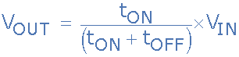

The buck converters duty cycle can also be defined as:
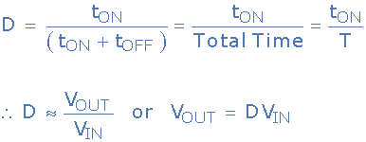

So the larger the duty cycle, the higher the average DC output voltage from the switch mode power supply. From this we can also see that the output voltage will always be lower than the input voltage since the duty cycle, D can never reach one (unity) resulting in a step-down voltage regulator. Voltage regulation is obtained by varying the duty cycle and with high switching speeds, up to 200kHz, smaller components can be used thereby greatly reducing a switch mode power supply’s size and weight.
Another advantage of the buck converter is that the inductor-capacitor (LC) arrangement provides very good filtering of the inductor current. Ideally the buck converter should be operated in a continuous switching mode so that the inductor current never falls to zero. With ideal components, that is zero voltage drop and switching losses in the “ON” state, the ideal buck converter could have efficiencies as high as 100%.
As well as the step-down buck switching regulator for the basic design of a switch mode power supply, there is another operation of the fundamental switching regulator that acts as a step-up voltage regulator called the Boost Converter.

Boost Switch Mode Power Supply
The Boost switching regulator is another type of switch mode power supply circuit. It has the same types of components as the previous buck converter, but this time in different positions. The boost converter is designed to increase a DC voltage from a lower voltage to a higher one, that is it adds too or “Boosts” the supply voltage, thereby increasing the available voltage at the output terminals without changing the polarity. In other words, the boost switching regulator is a step-up regulator circuit, so for example a boost converter can convert say, +5 volts to +12 volts.
We saw previously that the buck switching regulator uses a series switching transistor within its basic design. The difference with the design of the boost switching regulator is that it uses a parallel connected switching transistor to control the output voltage from the switch mode power supply. As the transistor switch is effectively connected in parallel with the output, electrical energy only passes through the inductor to the load when the transistor is biased “OFF” (switch open) as shown.

The Boost Switching Regulator
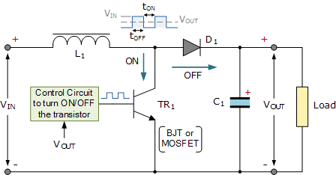

In the Boost Converter circuit, when the transistor switch is fully-on, electrical energy from the supply, V_{IN} passes through the inductor and transistor switch and back to the supply. As a result, none of it passes to the output as the saturated transistor switch effectively creates a short-circuit to the output. This increases the current flowing through the inductor as it has a shorter inner path to travel back to the supply. Meanwhile, diode D₁ becomes reverse biased as its anode is connected to ground via the transistor switch with the voltage level on the output remaining fairly constant as the capacitor starts to discharge through the load.
When the transistor is switched fully-off, the input supply is now connected to the output via the series connected inductor and diode. As the inductor field decreases the induced energy stored in the inductor is pushed to the output by V_{IN}, through the now forward biased diode. The result of all this is that the induced voltage across the inductor L₁ reverses and adds to the voltage of the input supply increasing the total output voltage as it now becomes, V_{IN} + V_{L}.
Current from the smoothing capacitor, C₁ which was used to supply the load when the transistor switch was closed, is now returned to the capacitor by the input supply via the diode. Then the current supplied to the capacitor is the diode current, which will always be ON or OFF as the diode is continually switched between forward and reverse status by the switching actions of transistor. Then the smoothing capacitor must be sufficiently large enough to produce a smooth steady output.
As the induced voltage across the inductor L₁ is negative, it adds to the source voltage, V_{IN} forcing the inductor current into the load. The boost converters steady state output voltage is given by:
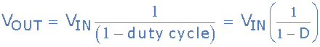

As with the previous buck converter, the output voltage from the boost converter depends upon the input voltage and duty cycle. Therefore, by controlling the duty cycle, output regulation is achieved. Not also that this equation is independent of the value of the inductor, the load current, and the output capacitor.
We have seen above that the basic operation of a non-isolated switch mode power supply circuit can use either a buck converter or boost converter configuration depending upon whether we require a step-down (buck) or step-up (boost) output voltage. While buck converters may be the more common SMPS switching configuration, boost converters are commonly used in capacitive circuit applications such as battery chargers, photo-flashes, strobe flashes, etc, because the capacitor supplies all of the load current while the switch is closed.
But we can also combine these two basic switching topologies into a single non-isolating switching regulator circuit called unsurprisingly, a Buck-Boost Converter.

Buck-Boost Switching Regulator
The Buck-Boost switching regulator is a combination of the buck converter and the boost converter that produces an inverted (negative) output voltage which can be greater or less than the input voltage based on the duty cycle. The buck-boost converter is a variation of the boost converter circuit in which the inverting converter only delivers the energy stored by the inductor, L₁, into the load. The basic buck-boost switch mode power supply circuit is given below.

The Buck-Boost Switching Regulator
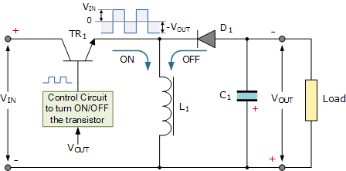

When the transistor switch, TR₁, is switched fully-on (closed), the voltage across the inductor is equal to the supply voltage so the inductor stores energy from the input supply. No current is delivered to the connected load at the output because diode, D₁, is reverse biased. When the transistor switch is fully-off (open), the diode becomes forward biased and the energy previously stored in the inductor is transferred to the load.
In other words, when the switch is “ON”, energy is delivered into the inductor by the DC supply (via the switch), and none to the output, and when the switch is “OFF”, the voltage across the inductor reverses as the inductor now becomes a source of energy so the energy stored previously in the inductor is switched to the output (through the diode), and none comes directly from the input DC source. So the voltage dropped across the load when the switching transistor is “OFF” is equal to the inductor voltage.
The result is that the magnitude of the inverted output voltage can be greater or smaller (or equal to) the magnitude of the input voltage based on the duty cycle. For example, a positive-to-negative buck-boost converter can convert 5 volts to 12 volts (step-up) or 12 volts to 5 volts (step-down).
The buck-boost switching regulators steady state output voltage, V_{OUT} is given as:
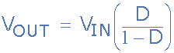

Then the buck-boost regulator gets its name from producing an output voltage that can be higher (like a boost power stage) or lower (like a buck power stage) in magnitude than the input voltage. However, the output voltage is opposite in polarity from the input voltage.

Switch Mode Power Supply Summary
The modern switch mode power supply, or SMPS, uses solid-state switches to convert an unregulated DC input voltage to a regulated and smooth DC output voltage at different voltage levels. The input supply can be a true DC voltage from a battery or solar panel, or a rectified DC voltage from an AC supply using a diode bridge along with some additional capacitive filtering.
In many power control applications, the power transistor, MOSFET or IGFET, is operated in its switching mode were it is repeatedly turned “ON” and “OFF” at high speed. The main advantage of this is that the power efficiency of the regulator can be quite high because the transistor is either fully-on and conducting (saturated) or full-off (cut-off).
There are several types of DC-to-DC converter (as opposed to a DC-to-AC converter which is an inverter) configurations available, with the three basic switching power supply topologies looked at here being the Buck, Boost, and the Buck-Boost switching regulators. All three of these topologies are non-isolated, that is their input and output voltages share a common ground line.
Each switching regulator design has its own unique properties with regards to the steady-state duty cycles, relationship between the input and output current, and the output voltage ripple produced by the solid-state switch action. Another important property of these switch mode power supply topologies is the frequency response of the switching action to the output voltage.
Regulation of the output voltage is achieved by the percentage control of the time that the switching transistor is in the “ON” state compared to the total ON/OFF time. This ratio is called the duty cycle and by varying the duty cycle, (D the magnitude of the output voltage, V_{OUT} can be controlled.
The use of a single inductor and diode as well as fast switching solid-state switches capable of operating at switching frequencies in the kilohertz range, within the switch mode power supply design, allows for the size and weight of the power supply to be greatly reduced. This is because there would be no large and heavy step-down (or step-up) voltage mains transformers within their design. However, if isolation is required between the input and output terminals, a transformer must be included before the converter.
The two most popular non-isolated switching configurations are the buck (subtractive) and the boost (additive) converters.
The buck converter is a type of switch-mode power supply that is designed to convert electrical energy from one voltage to a lower one. The buck converter operates with a series connected switching transistor. As the duty cycle, D < 1, the output voltage of the buck is always smaller than the input voltage, V_{IN}.
The boost converter is a type of switch-mode power supply that is designed to convert electrical energy from one voltage to a higher one. The boost converter operates with a parallel connected switching transistor which results in a direct current path between V_{IN} and V_{OUT} via the inductor, L₁ and diode, D₁. This means there is no protection against short-circuits on the output.
By varying the duty cycle, (D) of a boost converter, the output voltage can be controlled and with D < 1, the DC output from the boost converter is greater than input voltage V_{IN} as a consequence of the inductors self-induced voltage.
Also, the output smoothing capacitors in Switch-mode Power Supplies is assumed to be very large, which results in a constant output voltage from the switch mode supply during the transistors switching action.

interruptible Power Supply, UPS

Uninterruptible power supplies are used in many areas like critical computer centres, data centres and the like to ensure that power is maintained even during a short power interruption.
An uninterruptible power supply, UPS, sometimes also called an uninterruptible power source is a form of power supply that utilises the main power source such as the line supply, but is also able to maintain power to the equipment being powered when the main source fails or is interrupted.
The key feature of an uninterruptible power supply, UPS is that it provides instantaneous, or near instantaneous protection from power interruptions.
Uninterruptible power supplies are used in applications where maintaining power is of paramount importance. Typically UPS systems are used for data centres, computer systems and for some medical applications where continuity of power is crucial.
For many businesses, a power cut, even if very short can be catastrophic. Servers and files could become unreachable requiring to be rebooted. A worse scenario may be that data becomes corrupted by a sudden and disorderly shutdown.
The use of a UPS system can prevent disaster striking if the power is fails for a short time. The UPS seamlessly switches to some form of battery power to continue to power any devices until either the main power is restored, or possibly a backup generator can be activated or the devices can be short down properly.

ssues with line power systems
Before looking at what a UPS system is and how UPS backup can help, it is first necessary to understand the problems so that it is possible to see what can be done.
The power obtained from the mains or line power systems is not totally perfect. Issues arise that can cause problems with electronic systems. The various issues vary according to country, locations, etc.
The main power problems that can occur are:
- Surge: A surge is brief spike in incoming voltage on the power line. It is commonly caused by lightning hitting a line on the network. It can also arise when large inductive loads are switched and a back EMF propagates along the line. Surges can damage and destroy electronics, as it can enter the electronic device and cause damage to the electronic components that are not designed to withstand the high voltage spikes.
- Blackout: A blackout is a term used to describe a power outage. It can last anywhere from a few seconds upwards. They can be caused by faults on the power system, as a result of general usage, or as a result of severe weather: gales, snow, flooding, etc.
- Brownout: A brownout is another form of reduction of service. It is a drop in the voltage being supplied. These can occur intentionally or unintentionally. Although power companies in many countries have strict limits for voltage they need to maintain, this is not so in all areas of the globe and power companies may reduce the voltage for a short or long period to reduce strained resources and prevent a complete blackout.
- Under voltage: An under-voltage condition or voltage 'sag' is could be described as a short brownout. It is a short lived reduction in voltage.
- Over Voltage: An over-voltage condition exists when the voltage provided by the power line is higher than it should be over an extended period, i.e. it is not a spike or a surge. Typically the voltage increase is not high enough for it to be defined as a surge or spike.
- Power line noise: Power line noise is also known as frequency noise and it can disrupt or degrade the performance of a circuit by injecting unwanted signals into the system.
- Frequency Variation: It is possible on some power systems for the frequency to vary. Normally national power systems are accurately timed so that the different power generation sources work in synchronism. However frequency variations could occur on a locally generated supply, e.g. a local diesel generator, etc.
- Harmonic Distortion: Normally it is anticipated that the waveform from the power supply line will be a sine wave. On occasions it may have a high harmonic content, and this can disrupt the way that the internal equipment power supplies like switch mode power supplies, etc operate, causing issues with the equipment being used.
These different issues with power systems can give rise to problems in electronic equipment when powered from a mains line.
Computers, servers, and other IT related equipment can be particularly susceptible to issues with the power line and it is often necessary to protect them, otherwise costly interruptions to the service or damage can occur. This makes UPS backup systems worth considering.

Uninterruptible power supply basics
The aim of a UPS uninterruptible power supply is to provide AC power from the normal line or mains connection when it is available, but in the case of power failures, the uninterruptible power supply will use back-up alternatives, often in the form of batteries. Using techniques such as inverters, they will provide a simulated AC supply to maintain the power to the equipment.
There are several different types of uninterruptible power supply, and it is necessary to choose the correct type for the particular application in mind.
A UPS uninterruptible power supply differs from an auxiliary power supply in that the UPS provides instantaneous or virtually instantaneous protection from power interruptions. An auxiliary power supply may need some time to replace the power.
Often a UPS will provide the replacement power from batteries. These will only have a limited run time - often between 5 and 20 minutes, but this should be sufficient to allow for an orderly shutdown of the system to prevent data loss, or to allow an auxiliary power supply to be started up. It is possible to extend the power capacity in many instances to provide protection for longer periods of time. This is normally achieved by using larger batteries, or adopting other strategies that will be able to provide power over longer periods.
Uninterruptible power supplies, UPS range in their power ratings from small systems that may protect a single computer to much larger ones used to protect complete data centres, etc.

Uninterruptible power supply technologies
There are several different uninterruptible power supply technologies that are available and can be used.
Different types of these power supplies are used in different applications, some for higher power and other for lower power applications. The approach adopted depends upon the requirements.
<li
Stand-by or Off-line UPS technology: This form of uninterruptible power supply technology often referred to as an SPS - standby power supply - is used to provide a low cost solution to overcome the risk of data loss, etc from power failures. It is one of the most basics types. It provides surge protection along with battery back-up.
The equipment being protected is normally connected directly to incoming line or mains power. To provide the transient or surge protection, voltage transient clamping devices like those used in a common surge protected plug strip are employed - these are connected across the power line.
When the incoming utility voltage falls below a predetermined level the uninterruptible power supply detects the low voltage condition and activates its internal DC-AC inverter circuitry, which is powered from an internal storage battery. The UPS will normally use mechanical switches or relays to change the equipment to be powered to the new supply. The switchover time can be as long as 25 milliseconds depending on the amount of time it takes the Standby UPS to detect the lost utility voltage and for the switches to change over.
It is also worth remembering that the power provided from this form of uninterruptible power supply technology is a square wave form factor rather than a sine wave as supplied by the normal line supply.
- Line-interactive UPS technology: This form of UPS, uninterruptible power supply technology is aimed at the mid-range cost bracket. It builds on the technology of the Standby UPS, adding a multi-tap variable voltage transformer to provide protection against sustained low or over-voltage situations.
This form of uninterruptible power supply technology uses the autotransformer with selectable taps to compensate for any long term fluctuations in voltage. By altering the tap on the transformer the correct output voltage can be maintained. By doing this battery power in conserved as the UPS is able to operate from the mains or line power supply even when the
<li
- input power does not conform fully to the normal specified voltages.
This form of UPS technology is particularly valuable in areas where the line or mains supply is not particularly reliable and may exhibit considerable fluctuations and occasional drop-outs. It provides the protection against all situations, although for extended failures, an auxiliary power supply may be needed to be incorporated as battery power is unlikely to be able to support long periods without mains power.
- On-line or double conversion UPS technology: This form of uninterruptible power supply technology provide a greater level of protection. Initially this type of uninterruptible power supply technology was normally used for large installations, however costs and technology improvements have enabled them to be viable for smaller installations.
The On-Line or Double conversion UPS system uses the same building blocks as the other forms of uninterruptible power supply technology. However the big difference with an online UPS is that the batteries are in circuit all the time, and this means that no power switches are required, and the problems with drop-outs during switch-over are removed.
In essence the incoming line or mains power is transformed and rectified and applied to the batteries. The power for the load equipment is then taken from the batteries / rectified and through an inverter which brings the voltage back up to the required line input voltage. This form of UPS gains its name of a double conversion, because the power is converted from AC to DC to float charge the batteries and also power a DC to AC inverter.
In this way it can be seen that the batteries are always in circuit and this means that no switches are required. When power loss occurs, the input rectifier receives no supply, and as a result power is drawn from the batteries. Once line power is resumed, the rectifier will supply the equipment and also re-charge the batteries.
</li
These different uninterruptible power supply technologies represent the major ones that are used. Other UPS technologies exist and are used, but not as widely as those described.

Buying an uninterruptible power supply, UPS
A good UPS, uninterruptible power supply is an essential purchase for many businesses that rely on PCs, servers and other electronics devices that are required to be powered on 24 hours a day, seven days a week.
However, the thought of buying an uninterruptible power supply may appear to be a very costly activity.
Surprisingly small UPS systems for home and small business use are very much less costly than many may consider.
When considering to buy a UPS system, it is worth stopping to consider what is needed and which UPS system meets the needs the best for the given cost
- Type of UPS backup required: It is important to select the correct type of UPS system for the particular application, and the expected issues. The different UPS system types provide different levels of protection. I is worth analysing what is needed and hence being able to select the required type of US backup system..
POWER LINE ISSUE | STANDBY UPS | LINE INTERACTIVE UPS | DOUBLE CONVERSION UPS
Harmonic distortion | ✘ | ✘ | ✔
Frequency variation | ✘ | ✘ | ✔
Power line noise | ✘ | ✘ | ✔
Over voltage | ✘ | ✔ | ✔
Under voltage | ✘ | ✔ | ✔
Brown-out | ✔ | ✔ | ✔
Blackout | ✔ | ✔ | ✔
Surge | ✔ | ✔ | ✔
- UPS power capability: It is necessary to select a UPS system that will provide the power required to supply the electronic devices that need to be protected and powered in the case of a line power failure. It is necessary to add up the power consumption of all the devices. As a rough guide a PC consumes about 120watts, a monitor around 50watts, an external drive around 20 watts, and a wireless router around 10 watts. For commercial systems, a server could consume about 1kW, although some will consume much less, a switch in a server room could consume up to 250 watts and storage devices up to 500 watts.
It is necessary to add up all of the power requirements and then add a margin on top. Sometimes there may be issues with VA ratings - these take account of the phase of the current and voltage. If this is the case, then add a margin for this.

Unit 5
MOTOR CONTROL: Introduction to speed control of DC motors using phase controlled converters and choppers, Basic idea of speed control of three phase induction motors using voltage and frequency control methods.

MOTOR CONTROL

- Introduction Variable speed applications are gradually increases in industrial sector. Therefore it is important to create high performance, high flexible electrical drives. Electrical motor, Power controller and energy transmitting medium are the main Parts of Electrical drives. Nowadays, power electronics converter are cast instates of power controller. High performance motor drive system has special features such as good dynamic speed command and load regulating reaction. Electric drives are groups as: DC drives system and AC drives system. DC drives are usually used than AC drives, in applications such as, good speed regulation adjustable speed control, braking and reversing frequent starting. Some important applications are mine winders, paper mills, hoists, rolling mills, printing presses, traction, machine tools, textile mills, cranes, excavators. DC motors are used widely in position control system and variable speed drives. There are number of methods of speed control of DC drives – armature voltage control, armature resistance control and field flux control. In this paper, the motor speed under and up to the rated speed can be achieved by Changing the Armature voltage. The Armature voltage can be controlled by Using IGBT based chopper. Chopper as power converter and PI as speed and current controller, controlling of DC motor speed is examined. The use of controller is to decrease the error and the error is calculated by Equaling output value with the set point. A chopper is a static power electronic device used to converts stable dc input voltage to a adjustable dc voltage as output. Here we use IGBT Chopper systems which have fast in response, smooth control capability and are very efficient. A IGBT chopper is used to step down or step up the stable dc input voltage.

- DC Motor

When the wide speed range of control is needed, the DC motors are employed.The major use of DC motors are in position control and variable-speed applications. The techniques of speed control for DC motors are less expensive and simpler than the AC motors. Separately excited dc motor has armature and field winding. It requires separate supply voltage. Field flux is supplied by field winding to armature. The current immediately flows to the armature winding, when the supply is applied to the motor, through the brushes and commutator. The rotor is positioned in magnetic field and it is also carrying current. The back EMF and a torque are produced by motor, a torque stabilizes the load torque at specific speed. When the field current and armature current flows in circuit, it excites the DC motor, thus develops the back EMF and torque. The armature current is independent of The field current. The field and armature winding are supplied separately. Any variation in the armature current has no influence on the field current. The field current are generally minimum than armature current. Suppose, Ia is the armature current in ampere, Va is the armature voltage in volt, Eg is the motor back emf in volt, Ra is the armature resistance in ohm, La is the armature inductance in Henry.

. Chopper

A chopper is a static power electronic device which changes stable dc input voltage to a adjustable dc voltage. chopper is used to step down or step up the stable dc input voltage. Chopper systems offer high efficiency, regeneration facility, smooth control, and faster response. There are some power semiconductor devices used in a chopper circuit. They are force commutated thyristor, MOSFET, BJT, GTO and IGBT But from the above switching devices, GTO and IGBT are broadly used. These semiconductor devices are generally denoted by a switch. No current will flow, when the switch is OFF, and when switch is ON, the Current will flows through the load. In this paper, we cast the IGBT as switch in chopper circuit. IGBT employed chopper gives fast Switching, more efficiency, less switching losses. The ON and OFF state of semiconductor switch i.e. IGBT switch which is high in speed. It connects and disconnect, the source to load and the load from source respectively, at a fast speed. As shown in Fig1. When the switch is turning ON state i.e. Ton, chopper is turn ON and Output voltage and source voltage are equal. When the switch is turn OFF i.e. Toff, chopper is off and load voltage is zero. In this way, we obtaind the chopped dc voltage at the load terminals.

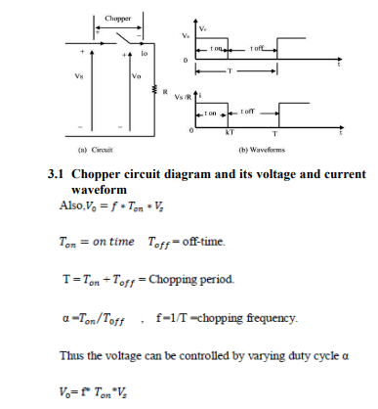

SEPARATELY EXCITED DC MOTOR
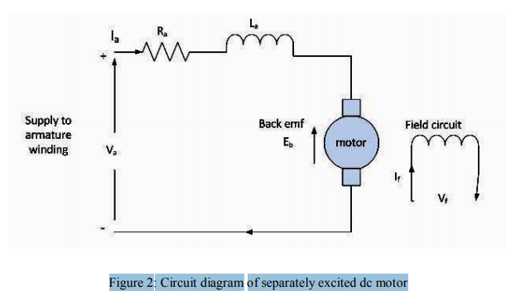

Circuit diagram of separately excited dc motor Separately excited dc motor has field and armature winding with separate supply voltage. Field winding supplies field flux to armature. When DC voltage is applied to motor, current is fed to the armature winding through brushes and commutator. Since rotor is placed in magnetic field and it is carrying current also. So motor will develops a back emf and a torque to balance load torque at particular speed. 3.2 Mathematical analysis of separately Excited DC Motor When a separately excited dc motor is excited by a field current of and an armature current of flows in the circuit, the motor develops a back EMF and a torque to balance the load torque at a particular speed. The field current If is independent of the armature current Ia. Each winding is supplied separately. Any change in the armature current has no effect on the field current.The is generally much less than the .Ia.

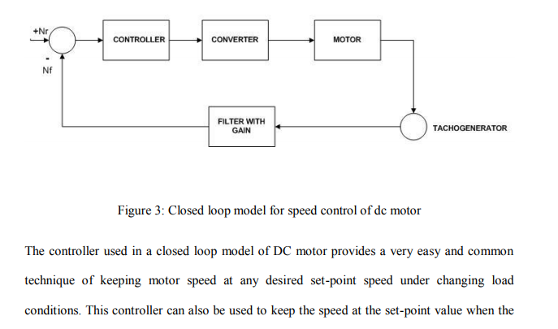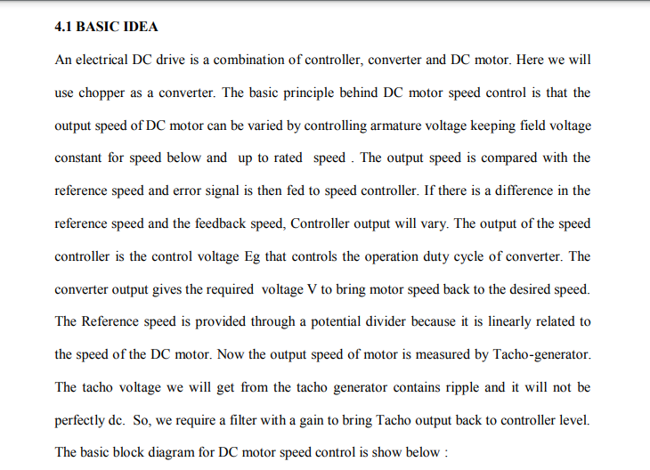

The speed control of separately excited dc motor is carried out by varying the armature voltage for below rated speed and by varying field flux to achieve speed above the rated speed. This thesis presents the speed control methodology by varying armature voltage using chopper by providing control signal to the switches. Speed can be controlled from below and up to rated speed .The firing circuit of chopper receives signal from controller and variable voltage is given to the armature of dc motor according to the desired speed .There are two controllers we are using here one is speed controller and other is current controller. Both controllers are of proportional -integral type .The reason behind using PI type controller is it removes the delay and provide fast control. Now the simulation of model is done and analyzed in MATLAB (Simulink) under varying speed and torque condition.

n many different applications it is required to control speed of DC motor. Some of the examples are
· In treadmill machine it is required to vary the speed of motor that used to roll the belt
· The speed of DC motor used in railway engines (traction) has to be varied
· E-bikes, e-bicycles, e-scooters also runs on DC motor and to vary their speed it is required to control speed of DC motor
· DC motors are also used in portable sewing machine, drill machine etc, in which speed control of motor is provided for different operation
One of the popular methods of speed control of DC motor is using chopper. Chopper is a device that gives variable DC output from applied fixed DC input. It simply chops fixed DC and generates variable DC. Let us first understand how it generates variable DC.
n many different applications it is required to control speed of DC motor. Some of the examples are
· In treadmill machine it is required to vary the speed of motor that used to roll the belt
· The speed of DC motor used in railway engines (traction) has to be varied
· E-bikes, e-bicycles, e-scooters also runs on DC motor and to vary their speed it is required to control speed of DC motor
· DC motors are also used in portable sewing machine, drill machine etc, in which speed control of motor is provided for different operation
One of the popular methods of speed control of DC motor is using chopper. Chopper is a device that gives variable DC output from applied fixed DC input. It simply chops fixed DC and generates variable DC. Let us first understand how it generates variable DC.
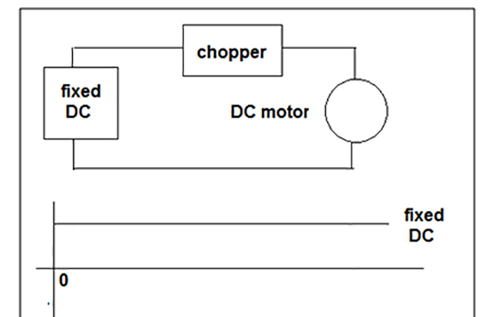
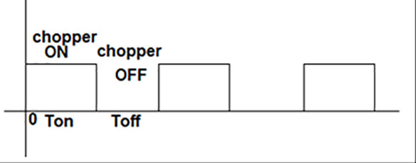
Block Representation of Chopper circuit used to control rotation of DC Motor

As shown in figure the chopper supplies fixed DC voltage to motor. When chopper is ON motor gets supply but when chopper is off motor does not get the supply. So as shown in figure let us say chopper is on for Ton time and it is off for Toff time. So depending upon the Ton and Toff time the DC voltage applied to motor is
Vdc = [T_{on} / (T_{on} + T_{off})] × V_{fixed}
But T_{on} + T_{off} = T_{total}
So Vdc = [T_{on} / T_{total}] × V_{fixed}
Here T_{on} / T_{total} is called duty cycle. So as duty cycle is more the average DC voltage supplied to motor is more and so speed of motor is increased. So as duty cycle is varied by varying on and off time of chopper, the speed of motor can be varied.
The given circuit demonstrates one of such chopper circuit using Zero Cross Detector (ZCD), timer IC NE555 and darlington amplifier TIP122 used as chopper device. The circuit chops rectified DC output and varies the speed of DC motor.

Circuit Description
· 230V @ 50 Hz AC is applied at the primary of transformer T1 (0-12 VAC, 500 mA). It’s secondary is connected with AC input terminals of bridge rectifier BR1.
· Rectified output is given to base of transistor Q1 through voltage divider formed by resistors R1 (1K) & R2 (1K).
· Collector output of Q1 is fed to base of transistor Q2 through R4 (470Ω). Q1 and Q2 both are connected in switch configuration as shown.
· The output of Q2 is applied at the trigger input of NE555 chip U1. It is configured in monostable mode. Timing components RV1 (10K pot) and C1 (1 µF) decides width of output pulse
· Output of U1 is applied to base of darlington transistor TIP122 through current limiting resistor R6
· The DC motor is connected between rectified output and collector of TIP122. The emitter of TIP122 is connected to ground

Circuit Operation
Let us understand the circuit operation with the help of waveforms at different points A, B, C, D, E and F
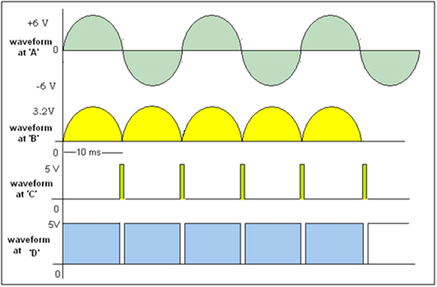
Fig. 2: Timing Diagram of Signals at various stages of the chopper circuit
· Step down transformer T1 steps down 230 VAC into 12 VAC as shown as waveform 1 above figure at point A
· This AC input is given to bridge rectifier. Bridge rectifier will produce rectified DC output as shown in second waveform if above figure at point B
· This rectified output is given to base of transistor Q1. Because transistor Q1 is connected in switch configuration, when the input at the base becomes lower than 0.7 V it comes into cutoff and produces very short duration positive pulse at point ‘C’. That is shown as 3rd waveform in figure
· As this positive pulses are given to Q2 which is again connected in switch configuration, it will produce negative pulse at point ‘D’ of same width of positive pulse. This is shown as 4th waveform
· These negative pulses are applied to trigger input of NE555 chip connected in monostable mode. So it will generate high output every time when it gets this negative pulse. Its time period can be varied from 0 milisecond to max 10 milisecond using 10 K pot
· As per the waveforms given in below figure let us understand 2 different cases with pulse width of NE555 3 ms and 8 ms
· As shown a second waveform in above figure, the NE555 will generate high output when gets negative pulse at its trigger input. For first case the width of pulse is 3 ms
· Because this pulse is given to base input of TIP122, it is turned ON till pulse is high. When TIP122 is ON the motor gets chopped rectified output as shown in 3rd waveform in figure. Out of total 10 ms time, the motor gets DC waveform for 3 ms only
· So average voltage applied to DC motor is less (as shown in waveform) and its speed is also less
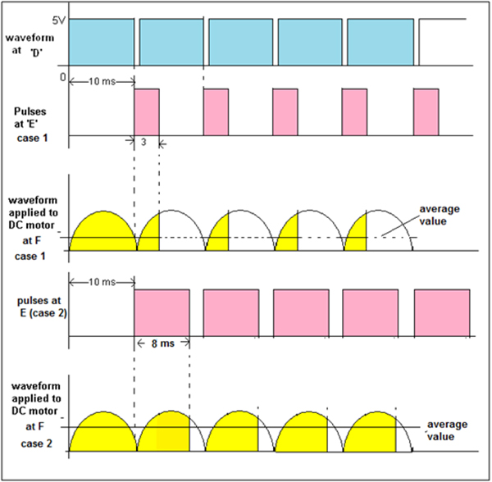
Fig. 3: Timing Diagram of Output Waveforms from the Chopper Circuit
· As shown in 4th and 5th waveforms, now the time period (pulse width) of NE555 is increased to 8 ms. So the rectified output applied to DC motor is also more – means average voltage applied to motor is more and its speed is more
· Thus as time period (width of output pulse) of NE555 is varied from 0 ms to 10 ms, it gives chopped rectified DC wave to motor that will vary its speed from min to max.

Answer 5 (ii)

Speed Control of Induction Motor by Variable Frequency Control
Variable Frequency Control is a method which is used to control the speed of an induction motor. The synchronous speed and therefore, the speed of the motor can be controlled by varying the supply frequency.The synchronous speed of an induction motor is given by the relation shown below.
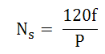
The EMF induced in the stator of the induction motor is given by the equation shown below.
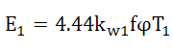
Therefore, if the supply frequency is changed induced EMF will also change to maintain the same air gap flux. The terminal voltage V₁ is equal to the induced EMF E₁ if the stator voltage drop is neglected.
In order to minimise the losses and to avoid the saturation, the motor is operated at rated air gap flux. This condition is obtained by varying the terminal voltage with frequency so as to maintain (V/f) ratio constant at the rate value. This type of control is known as Constant Volts Per Hertz.
Thus, the speed control of an induction motor using variable frequency supply requires a variable voltage power source. The variable frequency supply is obtained by the following converters.
- Voltage source inverter
- Current source inverter
- Cyclo converter
An inverter converts a fixed voltage DC to a fixed or variable voltage AC with variable frequency. Cyclo converter converts a fixed voltage and fixed frequency AC to a variable voltage and variable AC frequency.
The variable frequency control allows good running and transient performance to be obtained from a cage induction motor. Cyclo converter controlled induction motor drive is suitable only for large power drives and to get lower speeds.

