WDM

WDM (Wavelength-division Multiplexing) is the technology of combing a number of wavelengths onto the same fiber simultaneously. A powerful aspect of WDM is that each optical channel can carry any transmission format. WDW increases the capacity of a fiber network dramatically. Thus it is recognized as the Layer 1 transport technology in all tiers of the network. The purpose of this article is to give a brief overview of WDM technology and its applications.

NEED OF WDM
Due to the rapid growth in telecommunication links, high capacity and faster data transmission rates over farther distances are required. To meet these demands, network managers are relying more and more on fiber optics. Typically, there are three methods for expanding capacity: installing more cables, increasing system bitrate to multiplex more signals and wavelength division multiplexing.

The first method, installing more cables, will be preferred in many cases, especially in metropolitan areas, since fiber has become incredibly inexpensive and installation methods more efficient. But when conduit space is not available or major construction is necessary, this may not be the most cost-effective.

Another way for capacity expansion is to increase system bitrate to multiplex more signals. But increasing system bitrate may not prove cost effective either. Since many systems are already running at SONET OC-48 rates (2.5 GB/s) and upgrading to OC-192 (10 GB/s) is expensive, requires changing out all the electronics in a network, and adds 4 times the capacity, may not be necessary.

Thirdly, the WDM has been proved to be the more cost-effective technology. It does not only support current electronics and fibers but also can share fibers by transmitting channels at different wavelengths (colors) of light. Besides, systems are already using fiber optic amplifiers as repeaters also do not require upgrading for most WDM.

From the above comparison of three methods for expanding capacity, we can easily draw a conclusion that WDM is the best solution to meet the demand for more capacity and faster data transmission rates.

Actually, it is not difficult to understand the operating principle of WDM. Consider the fact that you can see many different colors of light: red, green, yellow, blue, etc. The colors are transmitted through the air together and may mix, but they can be easily separated by using a simple device like a prism.

It’s like we separate the “white” light from the sun into a spectrum of colors with the prism. WDM is equivalent to the prism in the operating principle. A WDM system uses a multiplexer at the transmitter to joint the several signals together. At the same time, it uses a demultiplexer at the receiver to split them apart, as shown in the following diagram. With the right type of fiber, it is possible to function as an optical add-drop multiplexer.

This technique was originally demonstrated with optical fiber in the early 80s. The first WDM systems combined only two signals. Modern systems can handle up to 160 signals and can thus expand a basic 10 Gbit/s system over a single fiber pair to over 1.6 Tbit/s. Because WDM systems can expand the capacity of the network and accommodate several generations of technology development in optical infrastructure without having to overhaul the backbone network, they are popular with telecommunications companies.

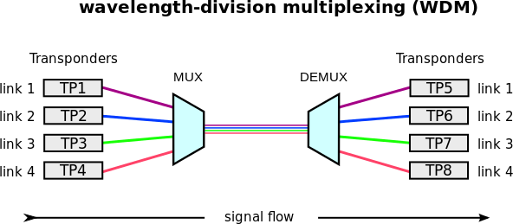

CWDM VS DWDM

WDM systems are divided into different wavelength patterns: CWDM (Coarse Wavelength Division Multiplexing) and DWDM (Dense Wavelength Division Multiplexing). There are many differences between CWDM and DWDM: spacings, DFB lasers, and transmission distances.

The channel spacings between individual wavelengths transmitted through the same fiber serve as the basis for defining CWDM and DWDM. Typically, the spacing in CWDM systems is 20 nm, while most DWDM systems today offer 0.8 nm (100 GHz) wavelength separation according to the ITU standard.

Due to wider CWDM channel spacing, the number of channels (lambdas) available on the same link is significantly reduced, but the optical interface components do not have to be as precise as DWDM components. CWDM equipment is thus significantly cheaper than DWDM equipment.
Both CWDM and DWDM architectures utilize the DFB (Distributed Feedback Lasers). However, CWDM systems use DFB lasers that are not cooled. These systems typically operate from 0 to 70℃ with the laser wavelength drifting about 6 nm over this range. Coupled with the laser wavelength of up to ±3 nm, the wavelength drift yields a total wavelength variation of about ±12 nm.

DWDM systems, on the other hand, require the larger cooled DFB lasers, because a semiconductor laser wavelength drifts about 0.08 nm/℃ with temperature. DFB lasers are cooled to stabilize the wavelength from outside the passband of the multiplexer and demultiplexer filters as the temperature fluctuates in DWDM systems.

Due to the unique attributes of CWDM and DWDM, they are deployed for different transmission distances. Typically, CWDM can travel anywhere up to about 160 km. If we need to transmit the data over a long range, the DWDM system is the best choice. DWDM supports 1550 nm wavelength size, which can be amplified to extend transmission distance to hundreds of kilometers.

OPERATIONAL PRINCIPLES OF WDM

Since the spectral width of a high-quality source occupies only a narrow slice of optical bandwidth, there are many independent operating regions across the spectrum, ranging from the a-band through the L-band, that can be used simultaneously.The original use of WDM was to upgrade the capacity of installed point-to-point transmission links.

This was achieved with wavelengths that were separated from several tens up to 200 nm in order not to impose strict wavelength-tolerance requirements on the different laser sources and the receiving wavelength splitters. Subsequently, the development of lasers that have extremely narrow spectraJemission widths allowed wavelengths to be spaced less than a nanometer apart. This is the basis of wavelength-division multiplexing, which simultaneously uses a number of light sources, each emitting at a slightly different peak wavelength.

Each wavelength carries an independent signal, so that the link capacity is increased greatly. The main trick is to ensure that the peak wavelength of a source is spaced sufficiently far from its neighbor so as not to create interference between their spectral extents. Equally important is the requirement that during the operation of a system these peak wavelengths do not drift into the spectral territory occupied by adjacent channels. In addition to maintaining strict control of the wavelength, system designers include an empty guardband between the channels as an operations safety factor.

Thereby the fidelities of the independent messages from each source are maintained for subsequent conversion to electrical signals at the receiving end.

WDM Operating Regions

The possibility of having an extremely high-capacity link by means of WDM can be seen by examining the characteristics of a high-quality optical source. As an example, a distributed- feedback (DFB) laser has a frequency spectrum on the order of I MHz, which is equivalent to a spectral linewidth of 10-5 nm. With such spectral widths, simplex systems make use of only a tiny portion of the transmission bandwidth capability of a fiber. This can be seen from Figure 3.1, which depicts the attenuation of light in a silica fiber as a function of wavelength. The curve shows that the two low-loss regions of a standard G.652 single-mode fiber extend over the O- band wavelengths ranging from about 1270 to 1350 nm (originally called the second window) and from 1480 to 1600nm (originally called the third window). We can view these regions either in terms of spectral width (the wavelength band occupied by the light signal) or by means of optical bandwidth (the frequency band occupied by the light signal).

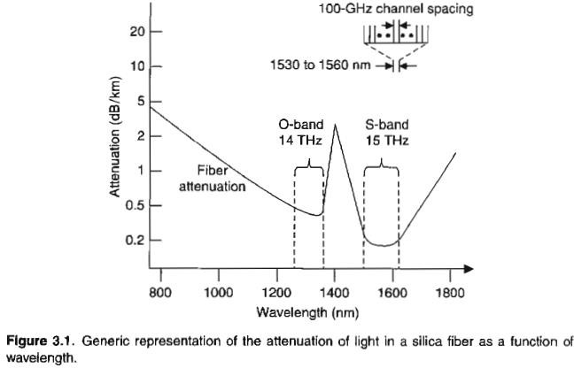

To find the optical bandwidth corresponding to a particular spectral width in these regions, we use the fundamental relationship c=Lamda*v, which relates the wavelength Laamda. to the carrier frequency v, where c is the speed of light. Differentiating this, we have
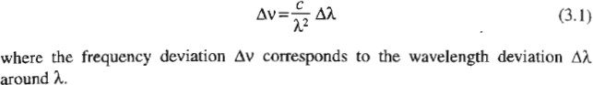

Now suppose we have a fiber that has the attenuation characteristic shown in Figure 3.1. From Eq. (3.1) the optical bandwidth is .Deltav= 14THz for a usable spectral band .DeltaLamda= 80 nm in the center of the O-band. Similarly, .Deltav= 15 THz for a usable spectral band DeltaLamda= 120 nm in the low-loss region running from near the beginning of the S-band to almost the end of the L-band. This yields a total available fiber bandwidth of about 30THz in the two low-loss windows.

Prior to about 2000, the peak wavelengths of adjacent light sources typically were restricted to be separated by 0.8 to 1.6 nm (100 to 200 GHz) in a WDM system. This was done to take into account possible drifts of the peak wavelength due to aging or temperature effects, and to give both the manufacturer and the user some leeway in specifying and choosing the precise peak emission wavelength. The next generation of WDM systems specified both narrower and much wider channel spacings depending on the application and on the wavelength region being used. The much narrower spacings thus require strict wavelength control of the optical source. On the other hand, the wider wavelength separations offer inexpensive WDM implementations since wavelength control requirements are relaxed significantly.

Generic WDM Link

The implementation of WDM networks requires a variety of passive and/or active devices to combine, distribute, isolate, add, drop, attenuate, and amplify optical power at different wavelengths. Passive devices require no external electric power or control for their operation, so they have a fixed application in WDM networks. These passive components are used to separate and combine wavelength channels, to divide optical power onto a number of fiber lines, or to tap off part of an optical signal for monitoring purposes.

The performance of active devices can be controlled electronically, thereby providing a large degree of network flexibility, Active WDM components include tunable optical filters, tunable light sources, configurable add/drop multiplexers, dynamic gain equalizers, and optical amplifiers.

Figure 3.2 shows the implementation of a simple WDM link. The transmitting side has a series of independently modulated fixed-wavelength light sources, each of which emits signals at a unique wavelength. Here a multiplexer (popularly called a mux) is needed to combine these optical outputs into a continuous spectrum of signals and couple them onto a single fiber. Within a standard telecommunication link there may be various types of optical amplifiers, a variety of specialized active components (not shown), and passive optical power splitters. The operations and maintenance benefits of PONs are that no active devices are used between the transmitting and receiving endpoints.

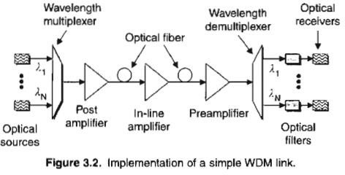

At the receiving end a demultiplexer is required to separate the individual wavelengths of the independent optical signals into appropriate detection channels for signal processing. At the transmitter the basic design challenge is to have the multiplexer provide a low-loss path from each optical source to the multiplexer output. A different requirement exists for the demultiplexer, since photodetectors usually are sensitive over a broad range of wavelengths, which could include all the WDM channels.

To prevent spurious signals from entering a receiving channel, that is, to give good channel isolation of the different wavelengths being used, the demultiplexer must exhibit narrow spectral operation or very stable optical filters with sharp wavelength cutoffs must be used.

The tolerable crosstalk levels between channels can vary widely depending on the application. In general, a -lOdB level is not sufficient, whereas a level of - 30 dB is acceptable. In principle, any optical demultiplexer can also be used as a multiplexer. For simplicity, the word multiplexer is used as a general term to refer to both combining and separating functions, except when it is necessary to distinguish the two devices or functions.

Wavelength Division Multiplexing (WDM)
- Optical signals of different wavelength (1300-1600 nm) can propagate without interfering with each other. The scheme of combining a number of wavelengths over a single fiber is called wavelength division multiplexing (WDM).

- Each input is generated by a separate optical source with a unique wavelength. An optical multiplexer couples light from individual sources to the transmitting fiber. At the receiving station, an optical demultiplexer is required to separate the different carriers before photodetection of individual signals. Fig. 7.1.1 shows simple SDM scheme.
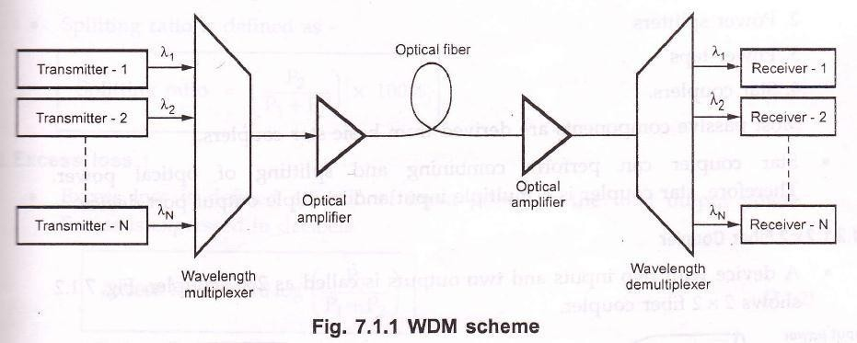
  - To prevent spurious signals to enter into receiving channel, the demultiplexer must have narrow spectral operation with sharp wavelength cut-offs. The acceptable limit of crosstalk is – 30 dB.

Features of WDM
- Important advantages or features of WDM are as mentioned below –
- Capacity upgrade : Since each wavelength supports independent data rate in Gbps.
- Transparency : WDM can carry fast asynchronous, slow synchronous, synchronous analog and digital data.
- Wavelength routing : Link capacity and flexibility can be increased by using multiple wavelength.
- Wavelength switching : WDM can add or drop multiplexers, cross connects and wavelength converters.

Passive Components
For implementing WDM various passive and active components are required to combine, distribute, isolate and to amplify optical power at different wavelength.

Passive components are mainly used to split or combine optical signals. These components operates in optical domains. Passive components don’t need external control for their operation. Passive components are fabricated by using optical fibers by planar optical waveguides. Commonly required passive components are –

- N x N couplers
- Power splitters
- Power taps
- Star couplers.

Most passive components are derived from basic stat couplers.

Stat coupler can person combining and splitting of optical power. Therefore, star coupler is a multiple input and multiple output port device.

Dense Wavelength Division Multiplexing (DWDM)
DWDM:
- DWDM (Dense wavelength – division multiplexing) is a data transmission technology having very large capacity and efficiency.
- Multiple data channels of optical signals are assigned different wavelengths, and are multiplexed onto one fiber.
- DWDM system consist of transmitters, multiplexers, optical amplifer and demultiplexer. Fig. 7.2.1 shows typical application of DWDM system.

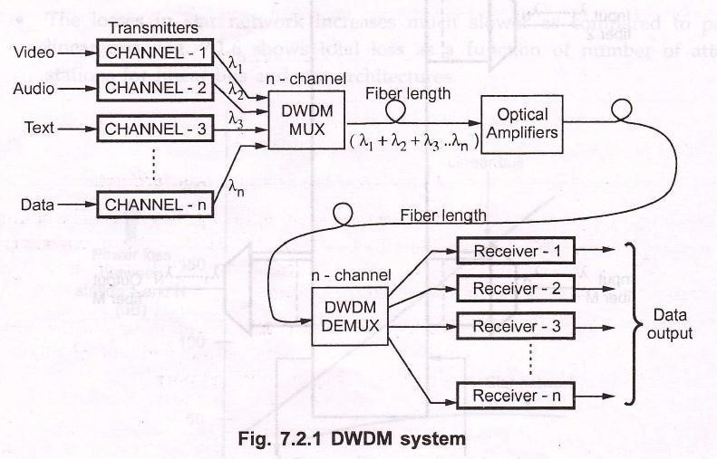
- DWDM used single mode fiber to carry multiple light waves of different frequencies.
- DWDM systemuses Erbium – Doped Fiber Amplifers (EDFA) for its long haul applications, and to overcome the effects of dispersion and attenuation channel spacing of 100 GHz is used.

DWDW is short for dense wavelength division multiplexing. It is an optical multiplexing technology used to increase bandwidth over existing fiber networks. DWDM works by combining and transmitting multiple signals simultaneously at different wavelengths on the same fiber. It has revolutionized the transmission of information over long distances. DWDM can be divided into passive DWDM and active DWDM. This article will detail these two DWDM systems.

Passive DWDM
Passive DWDM systems have no active components. The line functions only due to the optical budget of transceivers used. No optical signal amplifiers and dispersion compensators are used. Passive DWDM systems have a high channel capacity and potential for expansion, but the transmission distance is limited to the optical budget of transceivers used. The main application of passive DWDM system is metro networks and high speed communication lines with a high channel capacity.
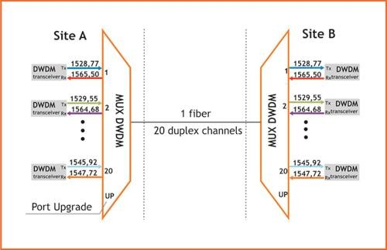

Active DWDM

Active DWDM systems commonly refer to as a transponder-based system. They offer a way to transport large amounts of data between sites in a data center interconnect setting. The transponder takes the outputs of the SAN or IP switch format, usually in a short wave 850nm or long wave 1310nm format, and converts them through an optical-electrical-optical (OEO) DWDM conversion. When creating long-haul DWDM networks, several EDFA amplifiers are installed sequentially in the line. The number of amplifiers in one section is limited and depends on the optical cable type, channel count, data transmission rate of each channel, and permissible OSNR value.

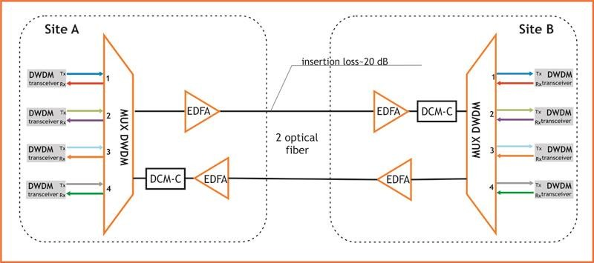

The possible length of lines when using active DWDM system is determined not only with installed optical amplifiers and the OSNR value, but also with the influence of chromatic dispersion—the distortion of transmitted signal impulses, on transmitted signals. At the design stage of the DWDM network project, permissible values of chromatic dispersion for the transceivers are taken into account, and, if necessary, chromatic dispersion compensation modules (DCM) are included in the line. DCM introduces additional attenuation into the line, which leads to a reduction of the amplified section length.

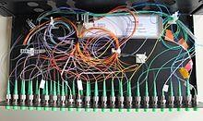At this stage, a basic DWDM system contains several main components:

WDM multiplexer for DWDM communications

- A DWDM terminal multiplexer. The terminal multiplexer contains a wavelength- converting transponder for each data signal, an optical multiplexer and where necessary an optical amplifier (EDFA). Each wavelength-converting transponder receives an optical data signal from the client-layer, such as Synchronous optical networking [SONET /SDH] or another type of data signal, converts this signal into the electrical domain and re- transmits the signal at a specific wavelength using a 1,550 nm band laser. These data signals are then combined together into a multi-wavelength optical signal using an optical multiplexer, for transmission over a single fiber (e.g., SMF-28 fiber). The terminal multiplexer may or may not also include a local transmit EDFA for power amplification of the multi-wavelength optical signal. In the mid-1990s DWDM systems contained 4 or 8 wavelength-converting transponders; by 2000 or so, commercial systems capable of carrying 128 signals were available.

- An intermediate line repeater is placed approximately every 80–100 km to compensate for the loss of optical power as the signal travels along the fiber. The 'multi-wavelength optical signal' is amplified by an EDFA, which usually consists of several amplifier stages.
- An intermediate optical terminal, or optical add-drop multiplexer. This is a remote amplification site that amplifies the multi-wavelength signal that may have traversed up to 140 km or more before reaching the remote site. Optical diagnostics and telemetry are often extracted or inserted at such a site, to allow for localization of any fiber breaks or signal impairments. In more sophisticated systems (which are no longer point-to-point), several signals out of the multi-wavelength optical signal may be removed and dropped locally.
- A DWDM terminal demultiplexer. At the remote site, the terminal de-multiplexer consisting of an optical de-multiplexer and one or more wavelength-converting transponders separates the multi-wavelength optical signal back into individual data signals and outputs them on separate fibers for client-layer systems (such as SONET/SDH). Originally, this de-multiplexing was performed entirely passively, except for some telemetry, as most SONET systems can receive 1,550 nm signals. However, in order to allow for transmission to remote client-layer systems (and to allow for digital domain signal integrity determination) such de-multiplexed signals are usually sent to O/E/O output transponders prior to being relayed to their client-layer systems. Often, the functionality of output transponder has been integrated into that of input transponder, so that most commercial systems have transponders that support bi-directional interfaces on both their 1,550 nm (i.e., internal) side, and external (i.e., client-facing) side. Transponders in some systems supporting 40 GHz nominal operation may also perform forward error correction (FEC) via digital wrapper technology, as described in the ITU-T G.709 standard.
- Optical Supervisory Channel (OSC). This is data channel which uses an additional wavelength usually outside the EDFA amplification band (at 1,510 nm, 1,620 nm, 1,310 nm or another proprietary wavelength). The OSC carries information about the multi-wavelength optical signal as well as remote conditions at the optical terminal or EDFA site. It is also normally used for remote software upgrades and user (i.e., network operator) Network Management information. It is the multi-wavelength analogue to SONET's DCC (or supervisory channel). ITU standards suggest that the OSC should utilize an OC-3 signal structure, though some vendors have opted to use 100 megabit Ethernet or another signal format. Unlike the 1550 nm multi-wavelength signal containing client data, the OSC is always terminated at intermediate amplifier sites, where it receives local information before re-transmission.

