|  |  |  |  |  |  |  |
| --- | --- | --- | --- | --- | --- | --- |
| |  | | --- | |  | | **Notes**  Network Theory. | |  | |  | |  | |  |   **.** |
| **Learning Objectives**  **Students will learn basic concepts of different type of signals and transients response.** |
|  |

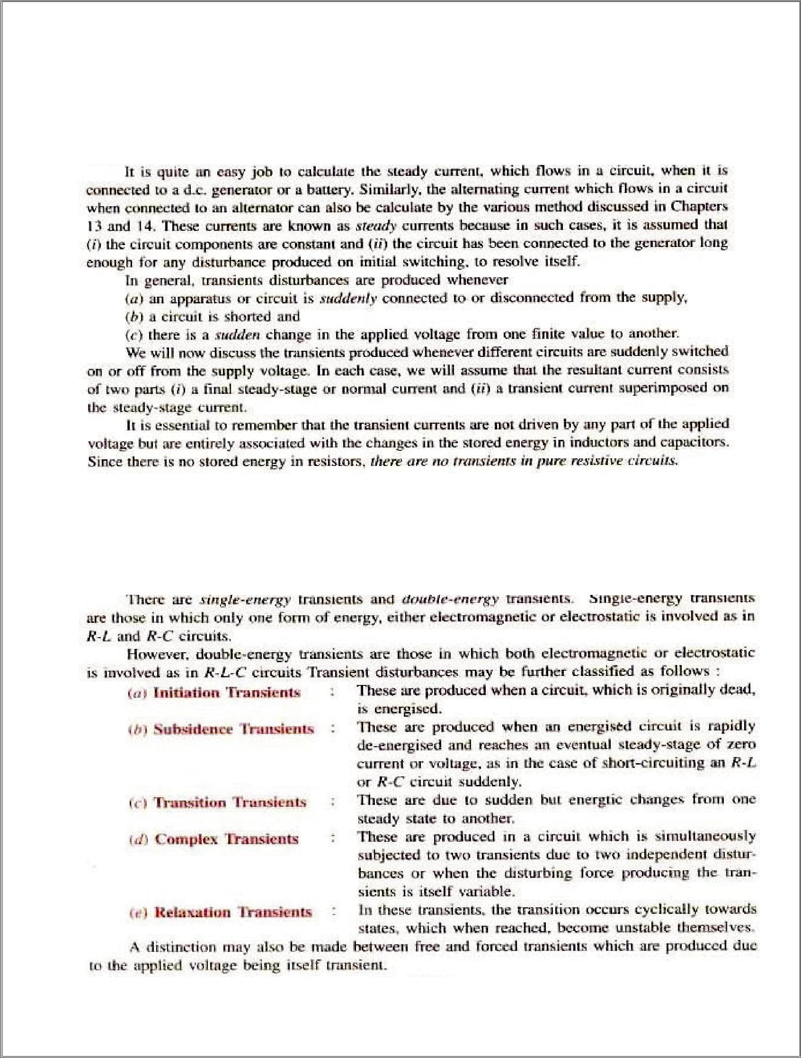2

**UNIT-2**

**TRANSIENTS**

**INTRODUCTION:-**

**TYPES OF TRANSIENTS-**

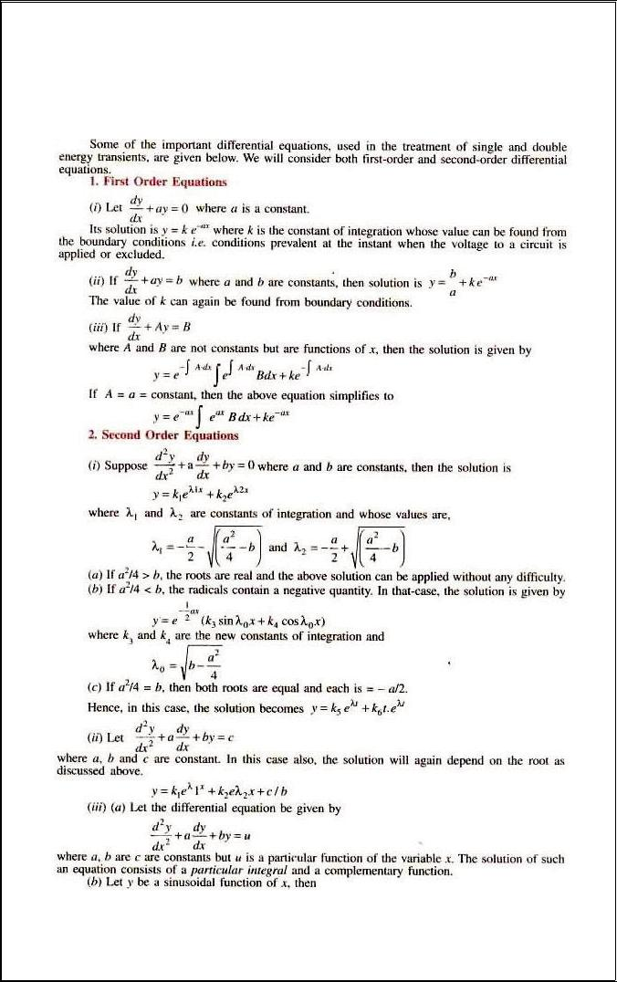3

**IMPORTANT EQUATIONS:-**

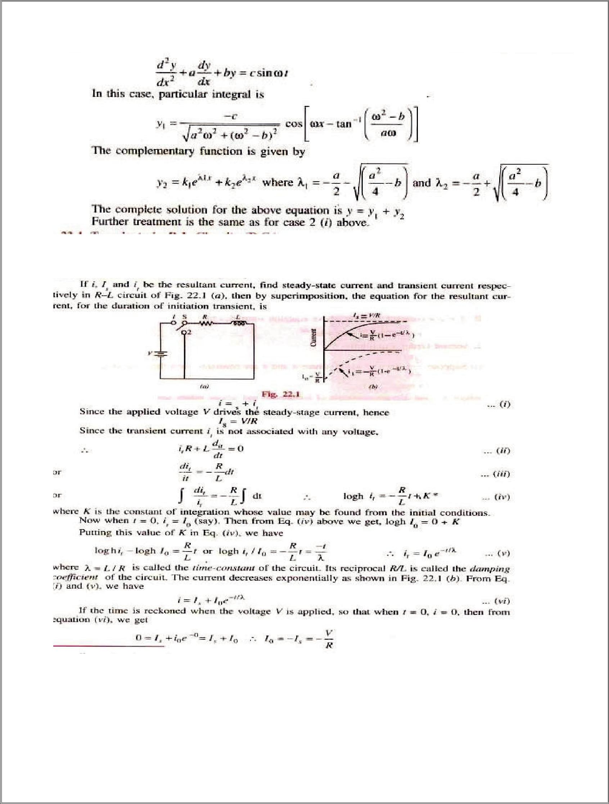4

**TRANSIENTS IN RL CIRCUITS(DC):-**

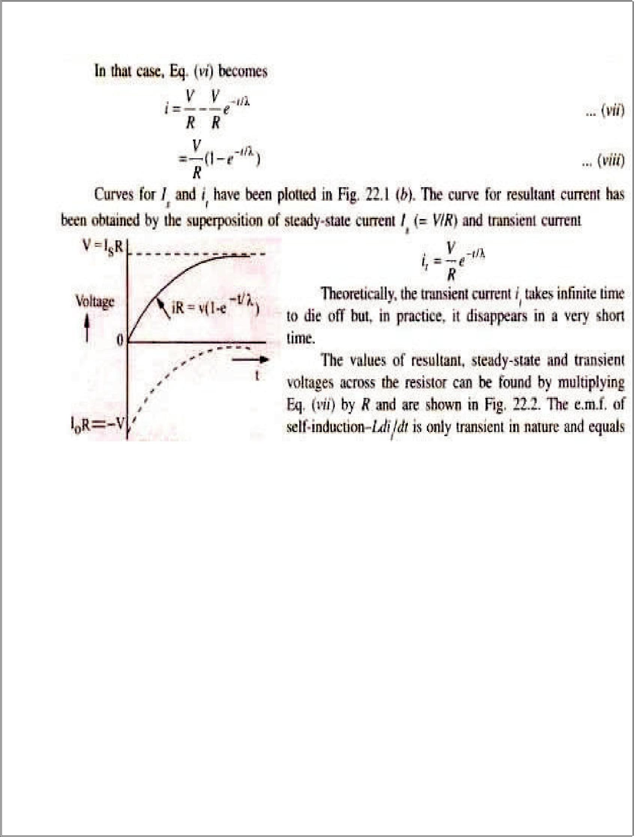5

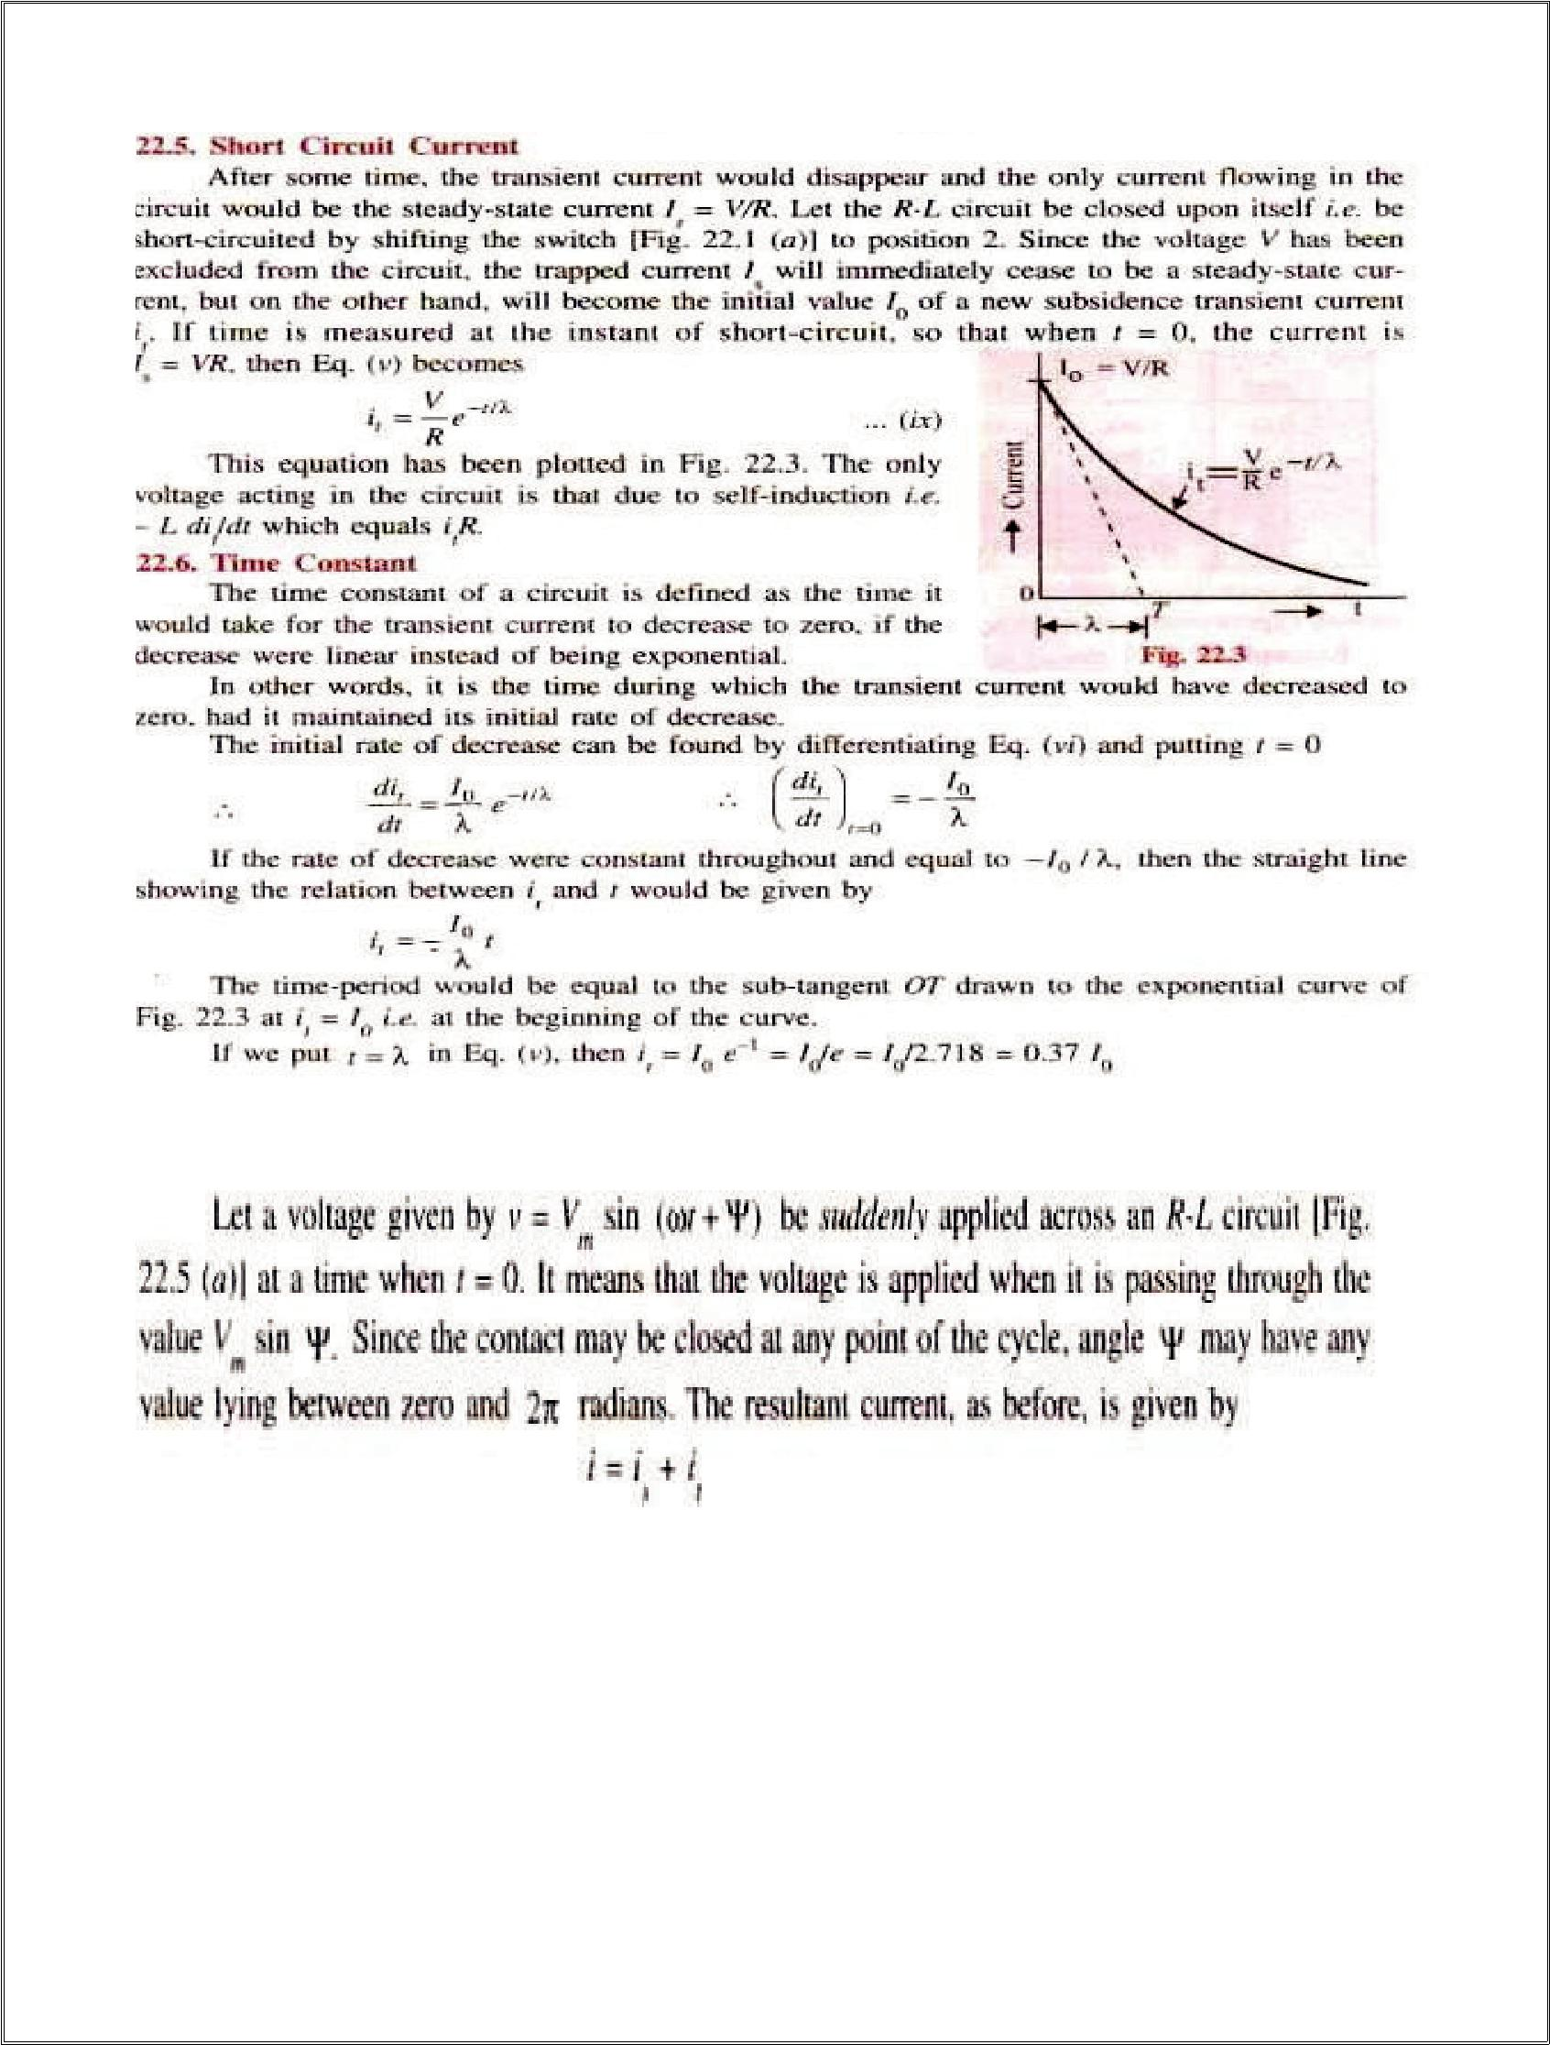6

**TRANSIENTS IN RL CIRCUITS(AC):-**

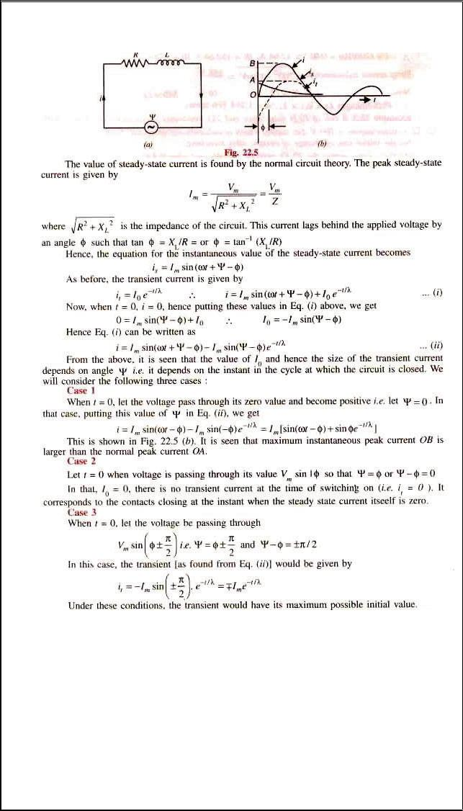7

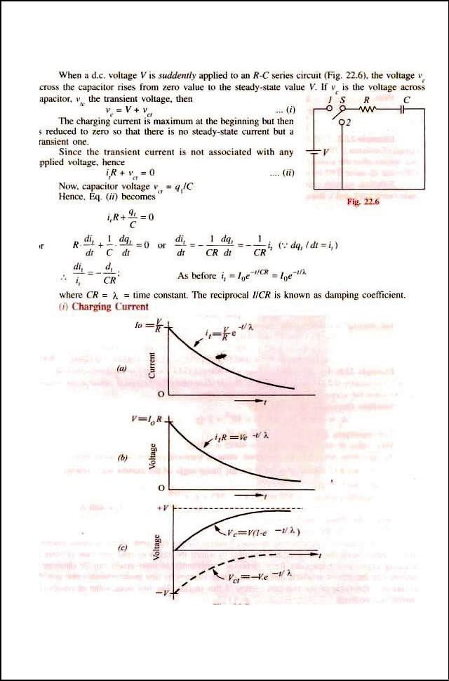8

**TRANSIENTS IN RC CIRCUITS(dc):-**

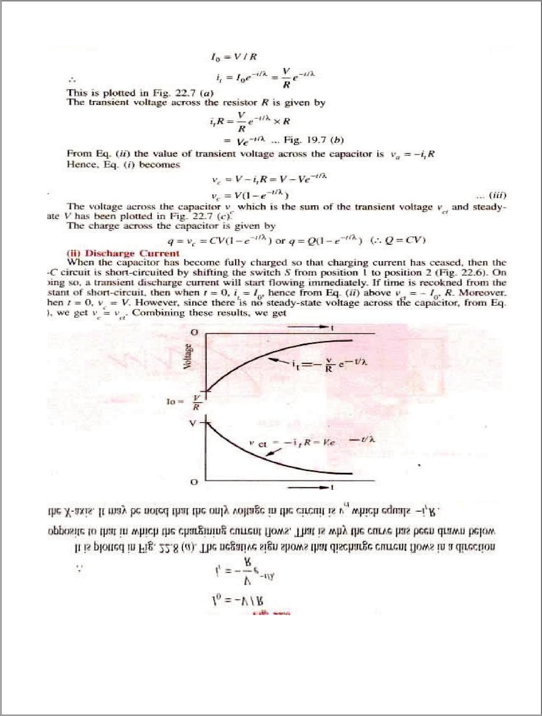9

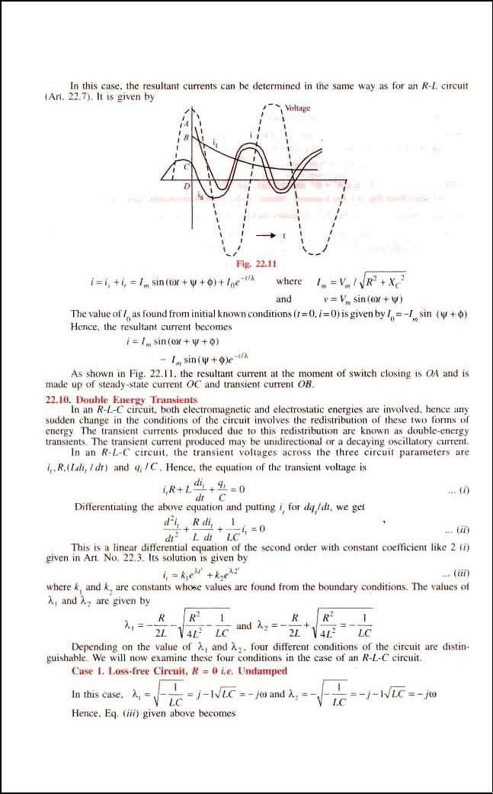10

**TRANSIENTS IN RC CIRCUITS(ac):-**

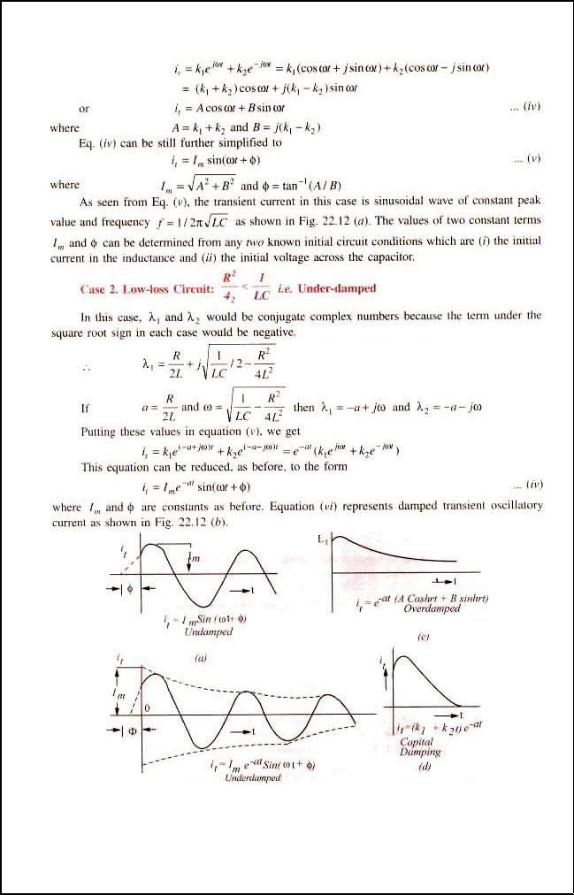11

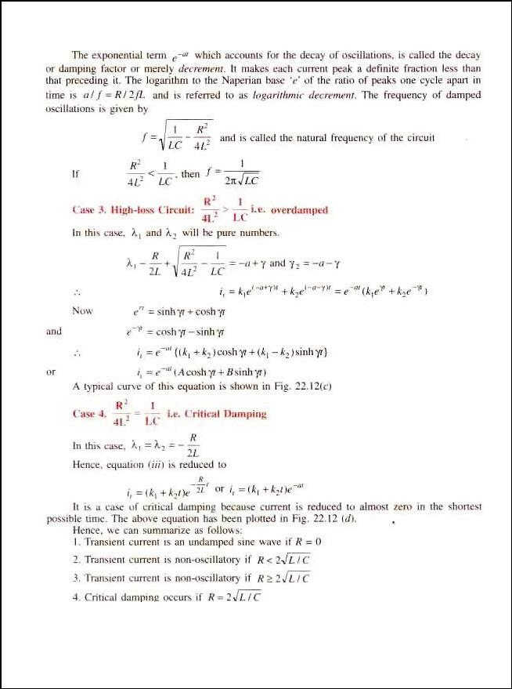12

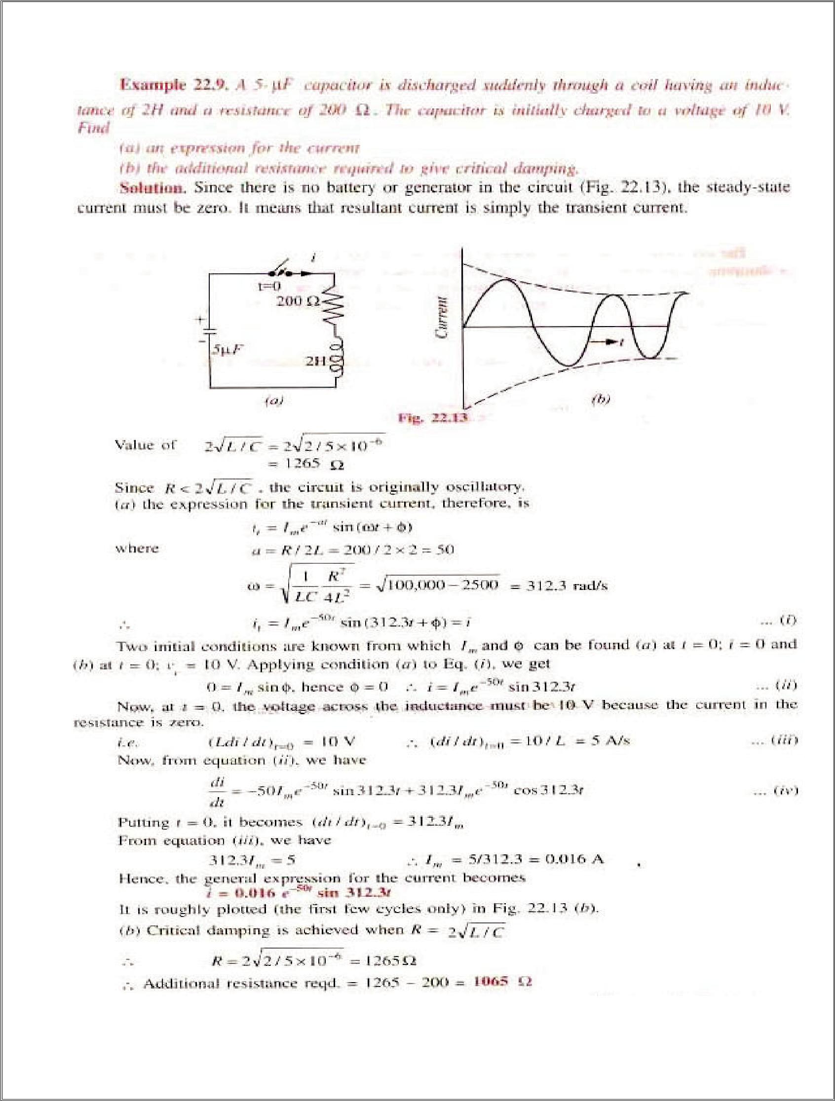13

**Beyond syllabus**

**Steps, Impulses and Ramps**

# The ***unit step function u[n]*** is defined as:

# **u[n] = 0, n < 0**

# **u[n] = 1, n ≥ 0**

This signal plays a valuable role in the analysis and testing of digital signals and processors.

Another basic signal which is even more important than the unit step, is the ***unit impulse function*** δ***[n]***, and is defined as:

δ**[n] = 0, n ≠ 0**

δ**[n] = 1, n = 0**



the unit step function the unit impulse function

One further signal is the digital ramp which rises or falls linearly with the variable ***n***. The ***unit ramp function r[n]*** is defined as:

**r[n] = n u[n]**



The unit ramp function

Since u[n] is zero for n<0, so is the ramp function

**The Unit Impulse Response**

The unit impulse was described above as:

δ**[n] = 0, n ≠ 0**

δ**[n] = 1, n = 0**

This is also sometimes known as the Kronecker ***delta function***

|  |  |  |  |  |  |  |  |  |  |  |  |  |  |  |  |  |  |  |  |
| --- | --- | --- | --- | --- | --- | --- | --- | --- | --- | --- | --- | --- | --- | --- | --- | --- | --- | --- | --- |
| ***n*** | | -2 | | -1 | | 0 | | 1 | | 2 | | 3 | | 4 | | 5 | | 6 | |
| δ***[n]*** | 0 | | 0 | | 0 | | **1** | | 0 | 0 | 0 | | 0 | | 0 | | 0 | | 0 |
| δ***[n-2]*** | 0 | | 0 | | 0 | | 0 | | 0 | **1** | 0 | | 0 | | 0 | | 0 | | 0 |



Shifted impulse sequence, δ[n – 2]

A shifted impulse such as δ[n – 2] is non-zero when its argument is zero, i.e. n – 2 = 0, or equivalently n = 2.

2

The third row of table 1 gives the values of the shifted impulse δ[n – 2] and Figure shows a plot of the sequence.

Now consider the following signal:

**x[n] = 2**δ**[n ] + 4**δ**[n – 1] + 6**δ**[n – 2] + 4**δ**[n – 3] + 2**δ**[n – 4]**

shows the individual sequences and their sum

|  |  |  |  |  |  |  |  |  |  |  |  |  |  |  |  |  |  |  |  |  |  |  |  |  |  |  |  |  |  |
| --- | --- | --- | --- | --- | --- | --- | --- | --- | --- | --- | --- | --- | --- | --- | --- | --- | --- | --- | --- | --- | --- | --- | --- | --- | --- | --- | --- | --- | --- |
| ***n*** | | | -2 | | | -1 | | | 0 | | | 1 | | | 2 | | | 3 | | | 4 | | | 5 | | | 6 | | |
| 2δ***[n]*** | 0 | | | 0 | | | 0 | | | **2** | | | 0 | | 0 | | 0 | | | 0 | | | 0 | | | 0 | | | 0 |
| 4δ***[n-1]*** | 0 | | | 0 | | | 0 | | | 0 | | | **4** | | 0 | | 0 | | | 0 | | | 0 | | | 0 | | | 0 |
| 6δ***[n-2]*** | | 0 | | | 0 | | | 0 | | | 0 | | | **6** | | 0 | | | 0 | | | 0 | | | 0 | | | 0 | |
| 4δ***[n-3]*** | 0 | | | 0 | | | 0 | | | 0 | | | 0 | | 0 | | **4** | | | 0 | | | 0 | | | 0 | | | 0 |
| 2δ***[n-4]*** | 0 | | | 0 | | | 0 | | | 0 | | | 0 | | 0 | | 0 | | | **2** | | | 0 | | | 0 | | | 0 |
| ***x***[***n***] | 0 | | | 0 | | | 0 | | | **2** | | | **4** | | **6** | | **4** | | | **2** | | | 0 | | | 0 | | | 0 |

Hence any sequence can be represented by the equation:

Σ−=*kknkxnx*][][][δ

**= + *x[-1]***δ***[n + 1]* + *x[0]***δ***[n]* + *x[1]***δ***[n - 1]* + *x[2]***δ***[n - 2] +……****.*

When the input to an FIR filter is a unit impulse sequence, ***x[n] =*** δ***[n]***, the output is known as the **unit impulse response**, which is normally donated as ***h[n]***.



Substituting *x[n] =* δ*[n]* gives the output *y[n] = h[n]*.