Notes

Network Theory

Learning Objectives
Students will learn basic concepts of different types of two port networks.
1

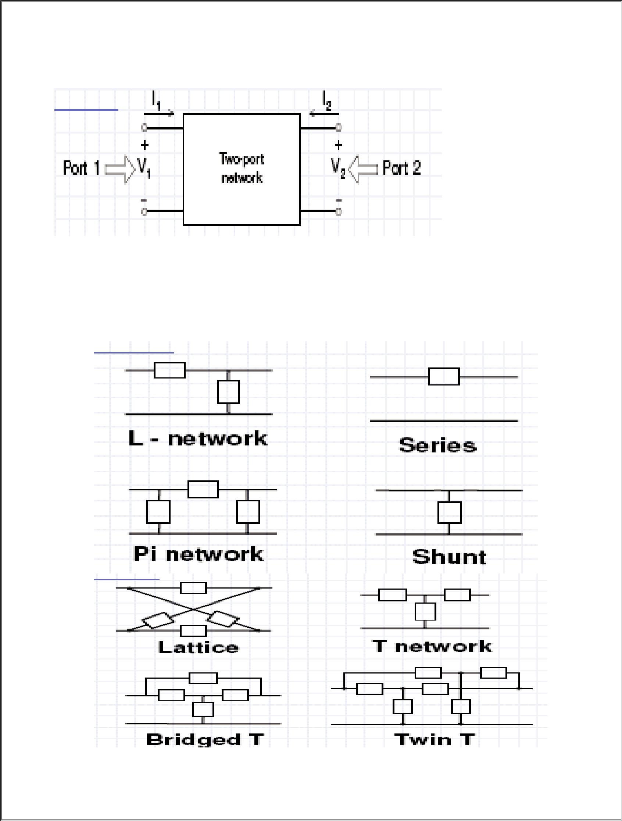
2

Definition of Two-Port Networks

- In general, we describe a two-port network as a network consisting of R, L, and C elements, op amps, transformers, and dependent sources, but no independent sources.

- Only two of the four variables are independent, and the specification of any

two of them determines the remaining two
Examples of Two-Port Networks

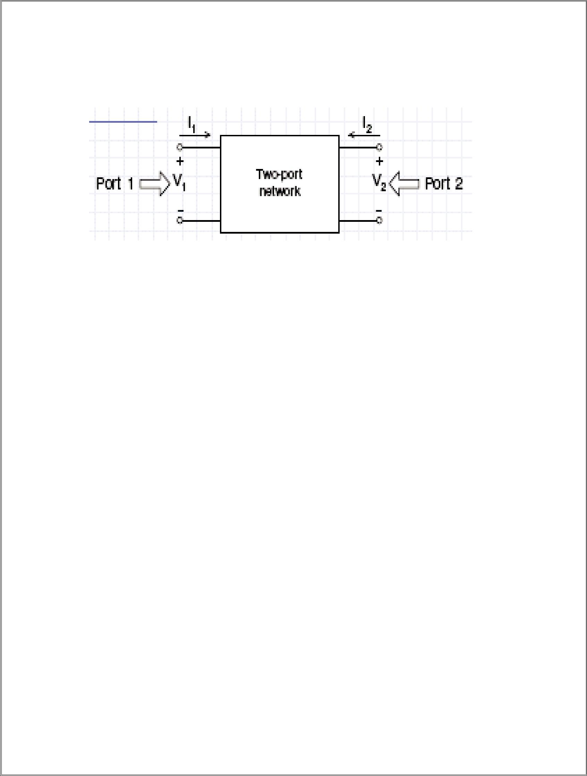
3

Two-Port Network Parameters Parameters of the two-port

completely describe its behavior in terms of the voltage and current at each port.

- Permits us to describe its operation when it is connected to a larger network.

- Important in modeling electronic devices and system components

Two-Port Parameters

- Admittance Parameters (yjk)
- Impedance Parameters (zjk)
- Hybrid Parameters (hjk)
- Transmission Parameters (tjk)

Admittance Parameters

- V1 and V2 are the independent variables
- Express I1 and I2 in terms of V1 and V2
^{I}1 ^{= Y}11^{V}1 ^{+ Y}12^{V}2
^{I}2 ^{= Y}21^{V}1 ^{+ Y}22^{V}2
• The coefficients yjk are also called the short-circuit admittance parameters or the

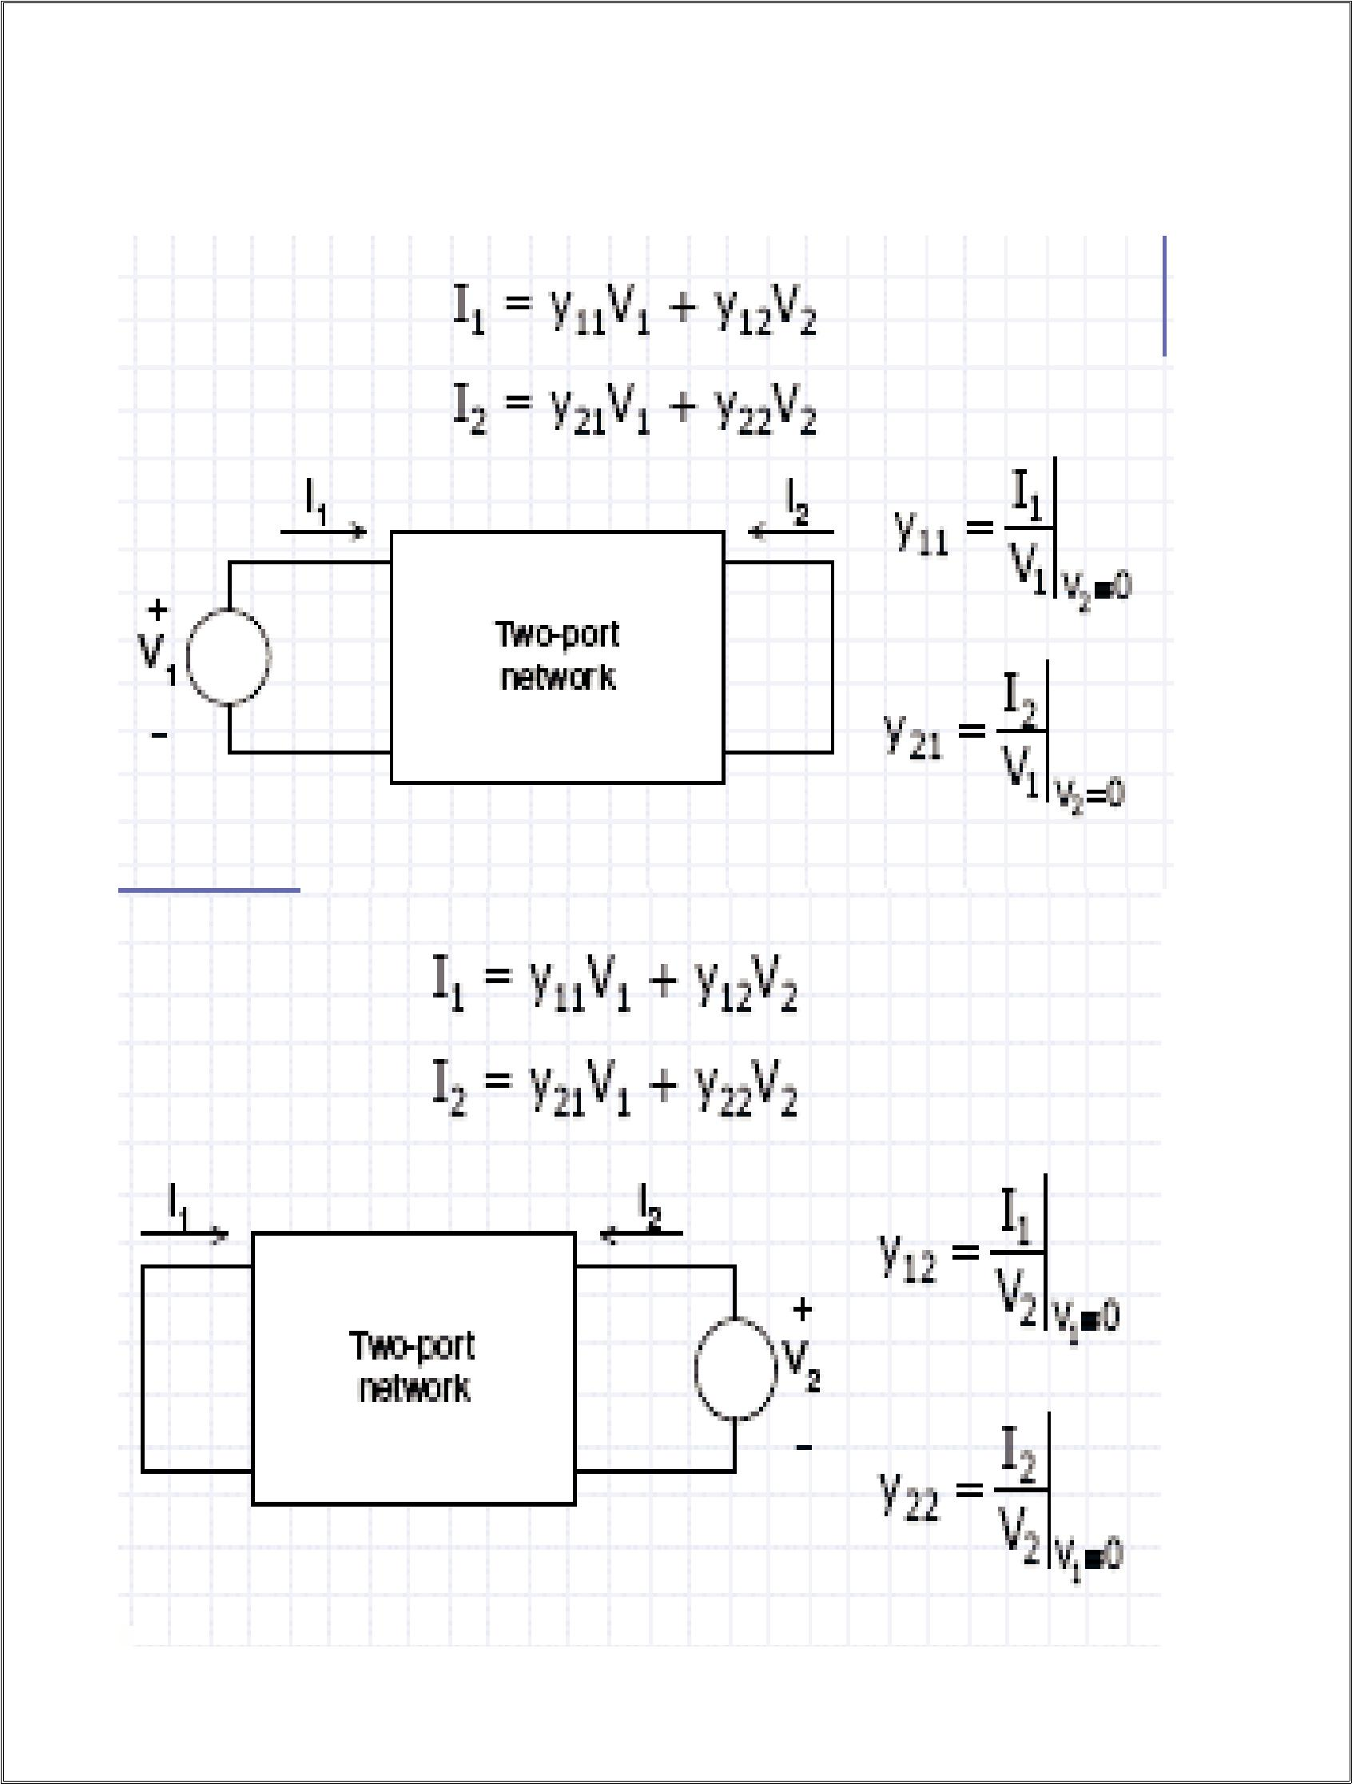
4

y-parameters
• The coefficients yjk are dimensionally admittance

Getting the Short-Circuit Admittance Parameters (y-parameters)

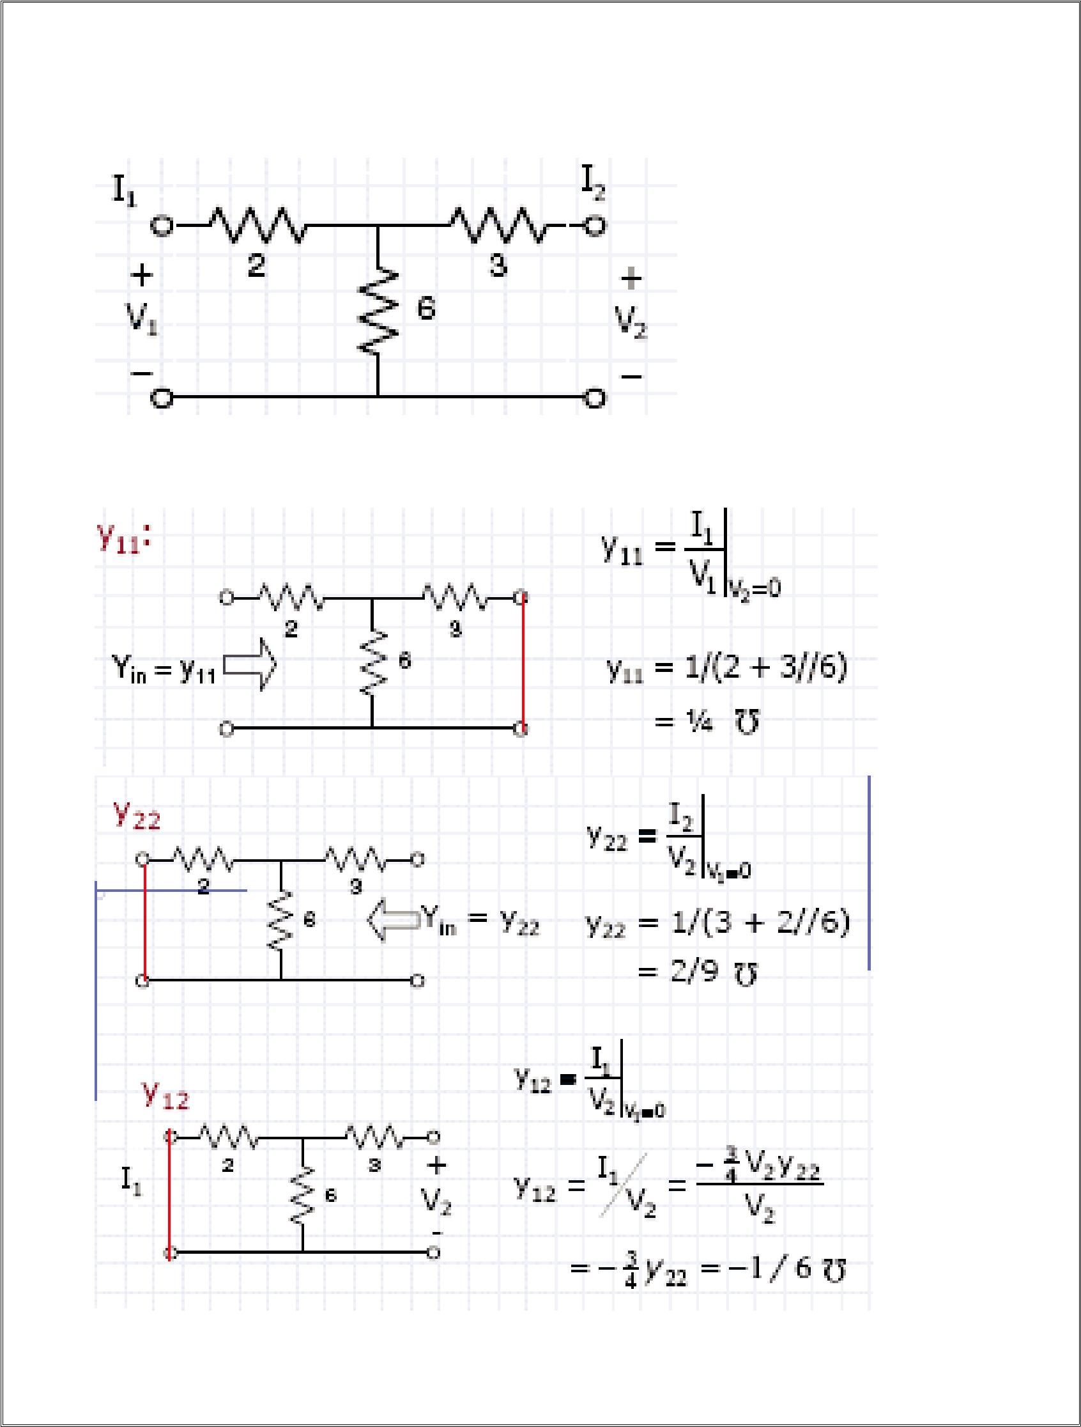
5

Example: Find the Y-parameters of the two-port network on the

Get the y-parameters one by one.

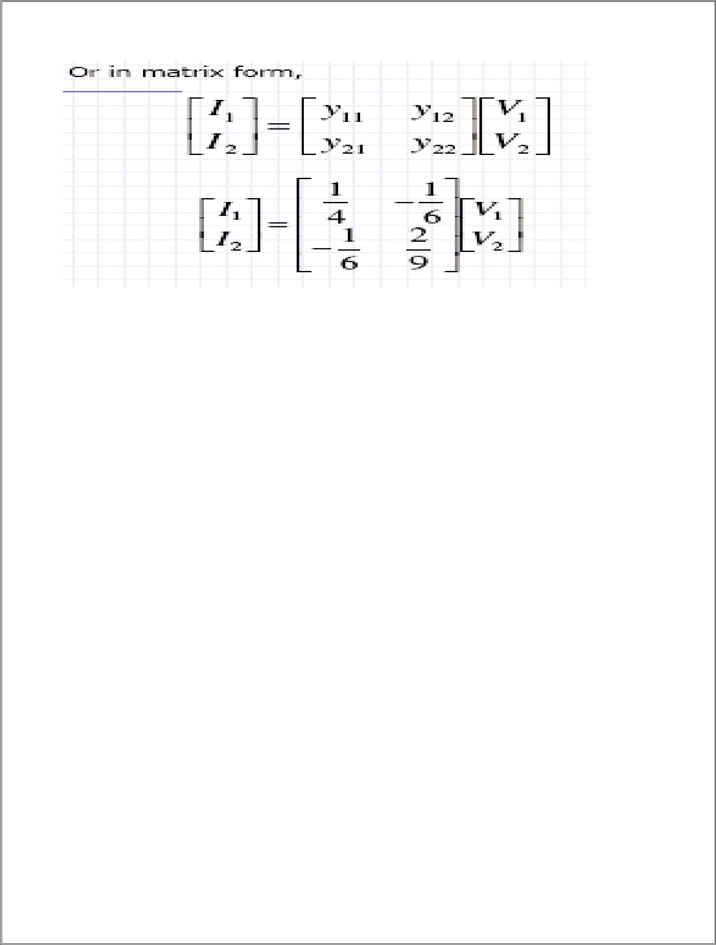
6

Linear Two Port Parameters

Although there are six possible ways to arrange for two independent variables from the set of 4 port variables (V1, V2, I1 and I2), there are only 5 useful parameter sets:
- Z Parameters

- Y Parameters

- H Parameters
- G Parameters
- ABCD Parameters

Two Port Interconnections

There are 5 useful interconnections used in working with two ports, each with its relevant two port parameter set

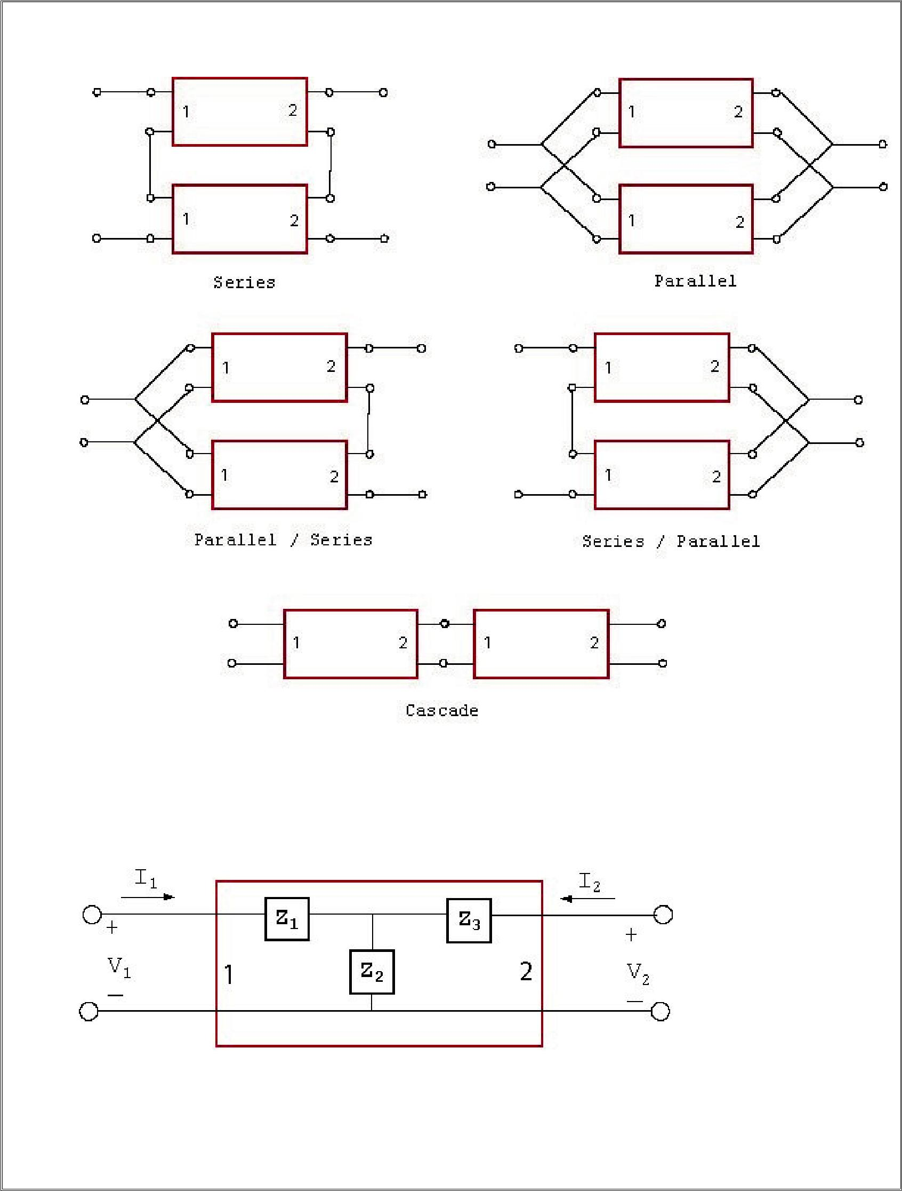
7

Z Parameters

The Z parameters or “OPEN CIRCUIT” parameters relate the output currents from the ports to their input voltages. We say OPEN CIRCUIT because to calculate for example Z11 we need to do open circuit the output (I2 = 0).

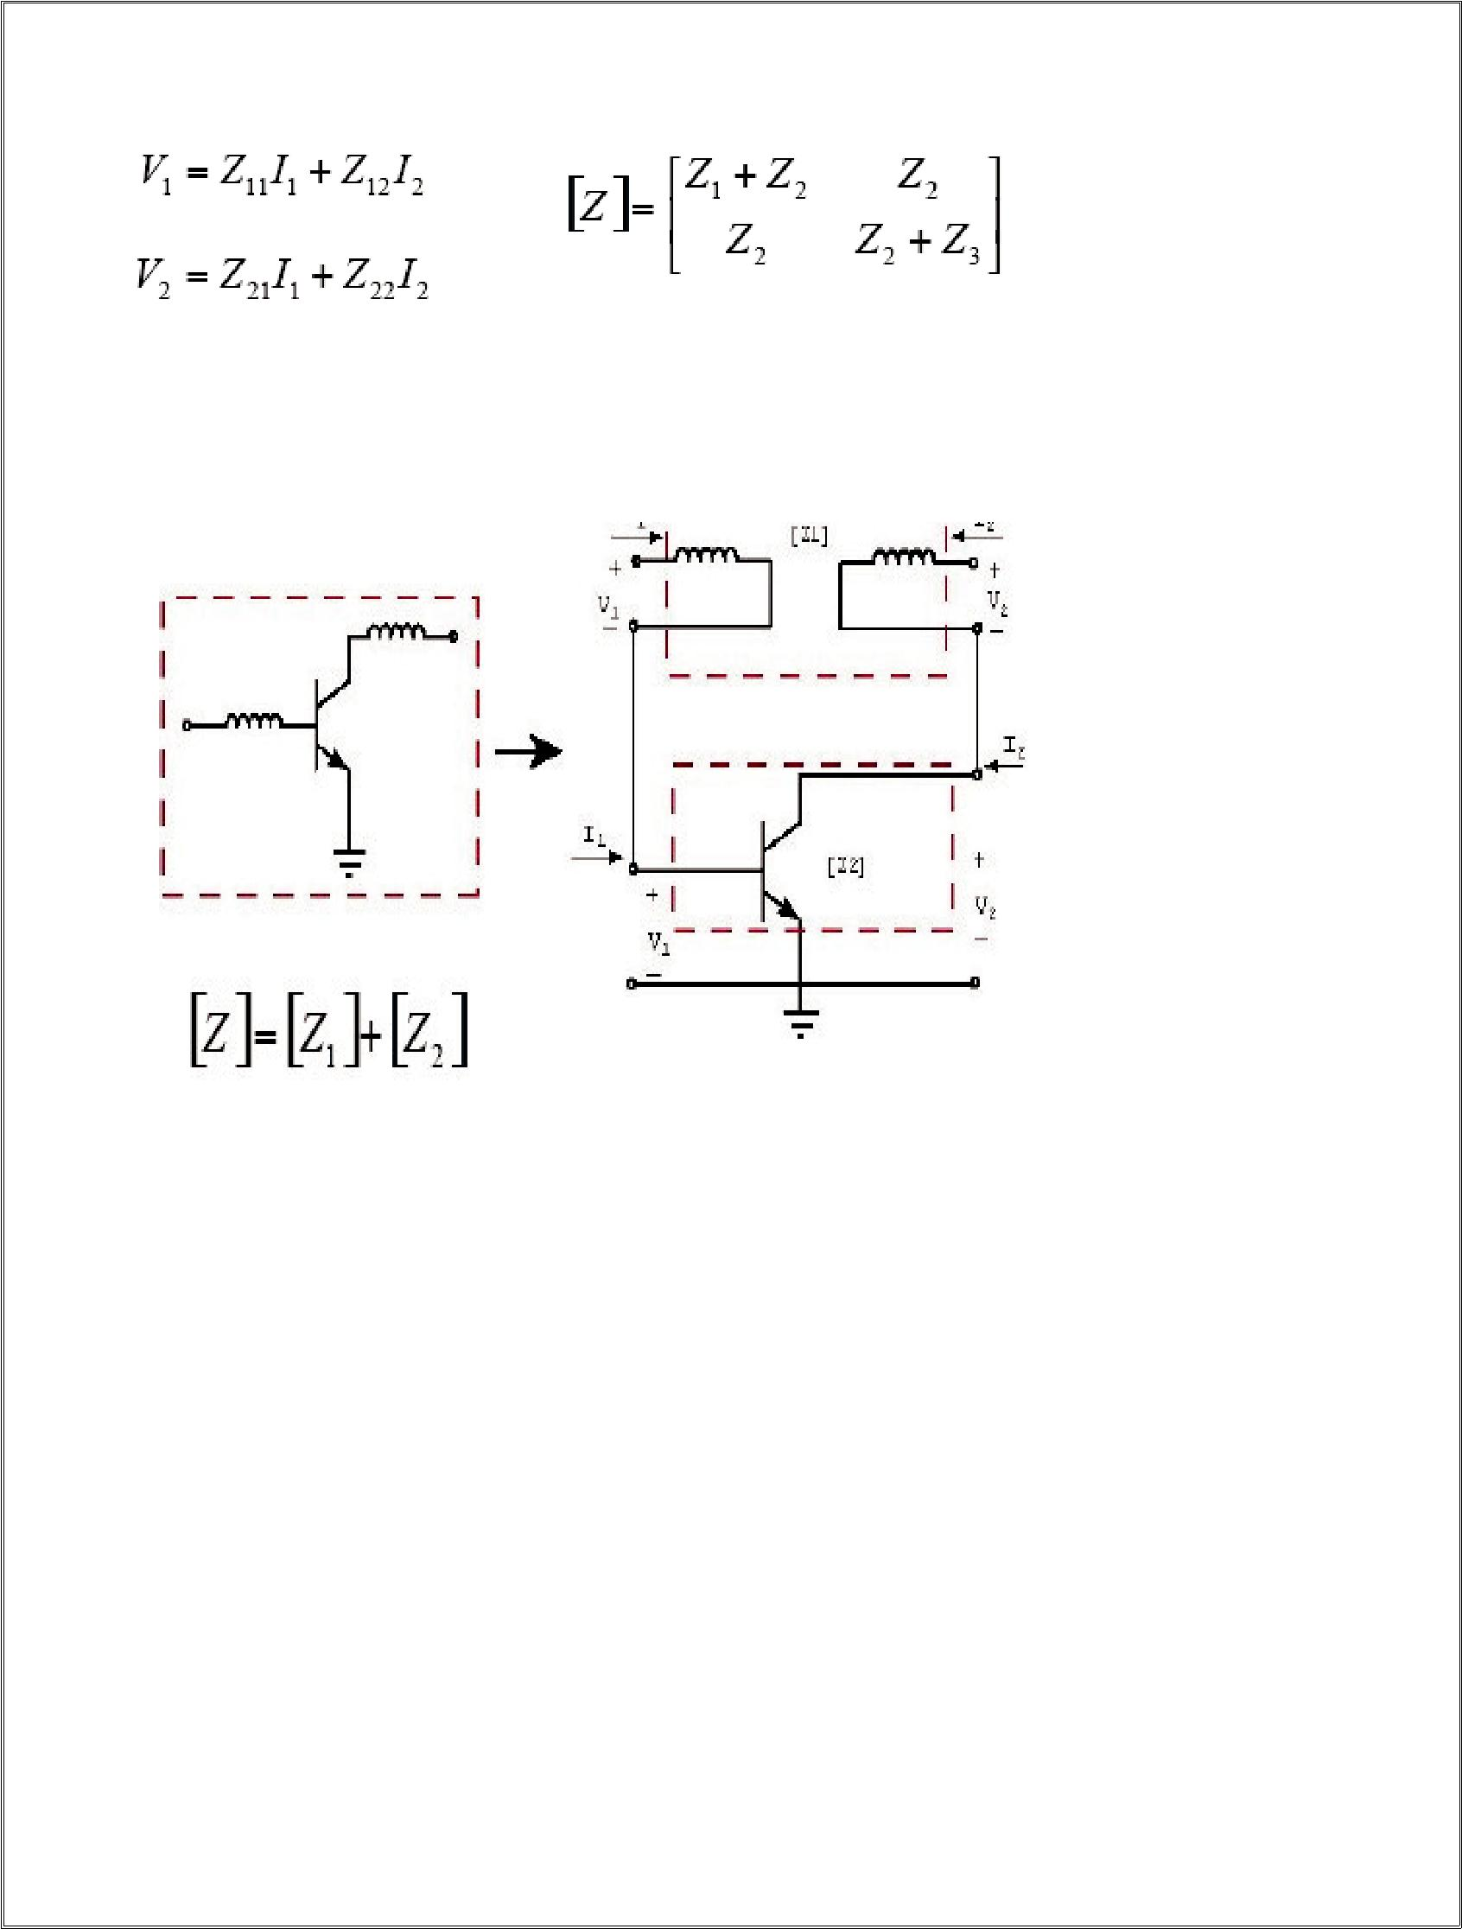
8

Z Parameters

The [Z] resulting from the interconnection of the two series ports is the sum of the individual Z parameters.

Y Parameters

The Y parameters or “SHORT CIRCUIT” parameters relate the output voltages from the ports to their input currents.We say SHORT CIRCUIT because to calculate for example Y1 we need to do short circuit the output (V2 = 0).

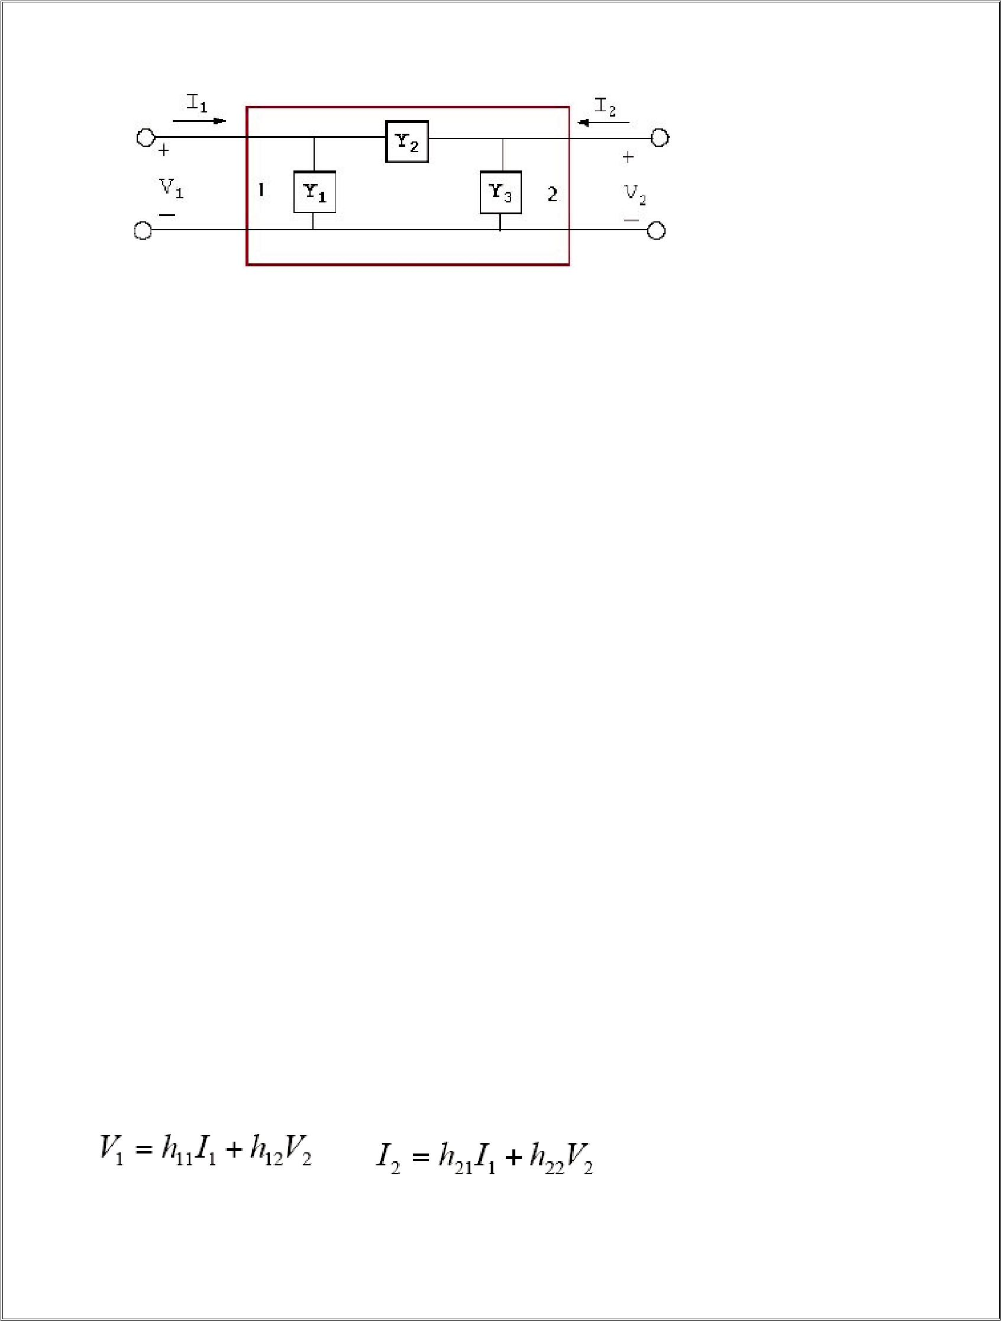
9

Y Parameters

The [Y] resulting from the interconnection of the two parallel ports is the sum of the individual Y matrices.

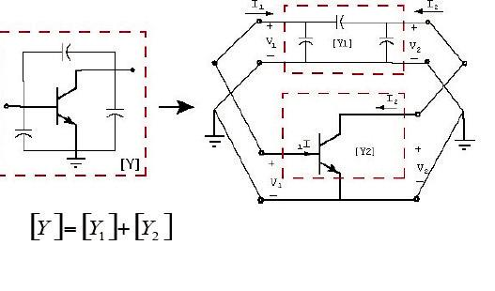H

Parameters

The H parameters use the input current at port 1 and the output voltage at port 2 as the independent variables.

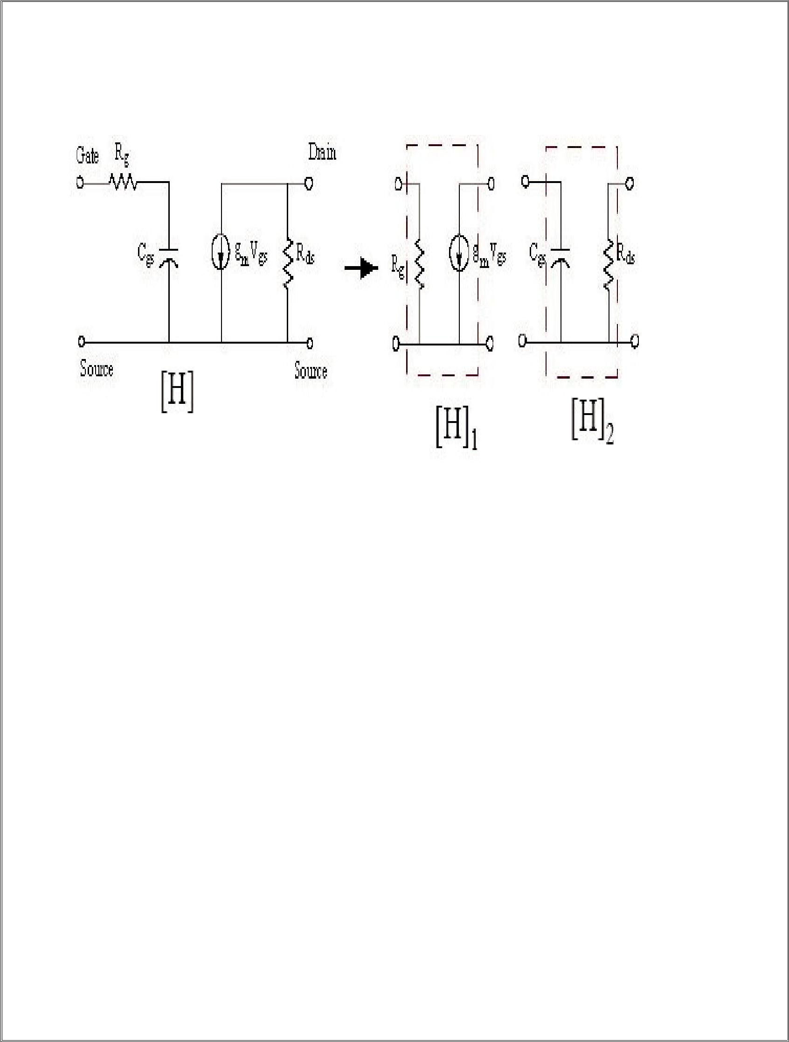
10

The most common application of the H parameters is in the device modeling of a transistor.

[H] = [H]1+[H]2

G Parameters

The G parameters use the input current at port 2 and the output voltage at port 1 as the independent variables.
I = g V + g I ,V = g V + g I

The two ports are connected with their input ports in parallel and their output ports in series. G parameters are the least common of the configuration used

ABCD Parameters

The ABCD “CHAIN PARAMETERS” relates the input current and voltage at port

1 to the output current and voltage at port 2.

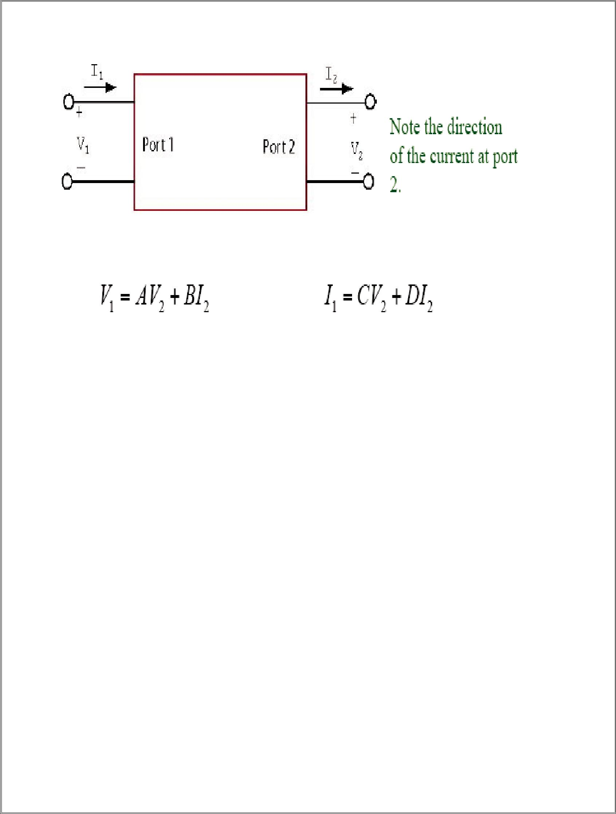
11

ABCD Parameters

The ABCD parameters are used to analyze cascaded two ports. The ABCD matrix of two cascaded blocks is equal to the matrix
multiplication of the two separate ABCD matrices.

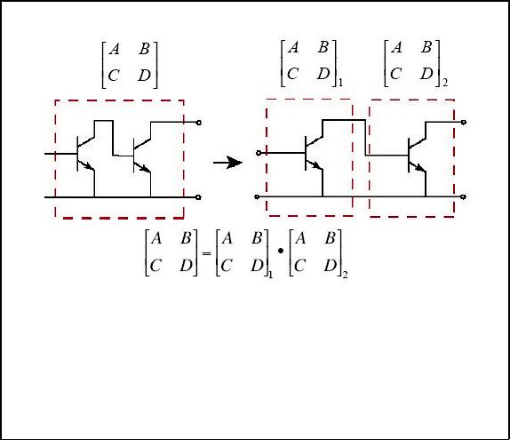
12

S Parameters

We used the power waves in determining the S parameters.

Assuming that the voltages and currents behave in a fashion similar to those found on a transmission line, and that Zi is real, we can write:

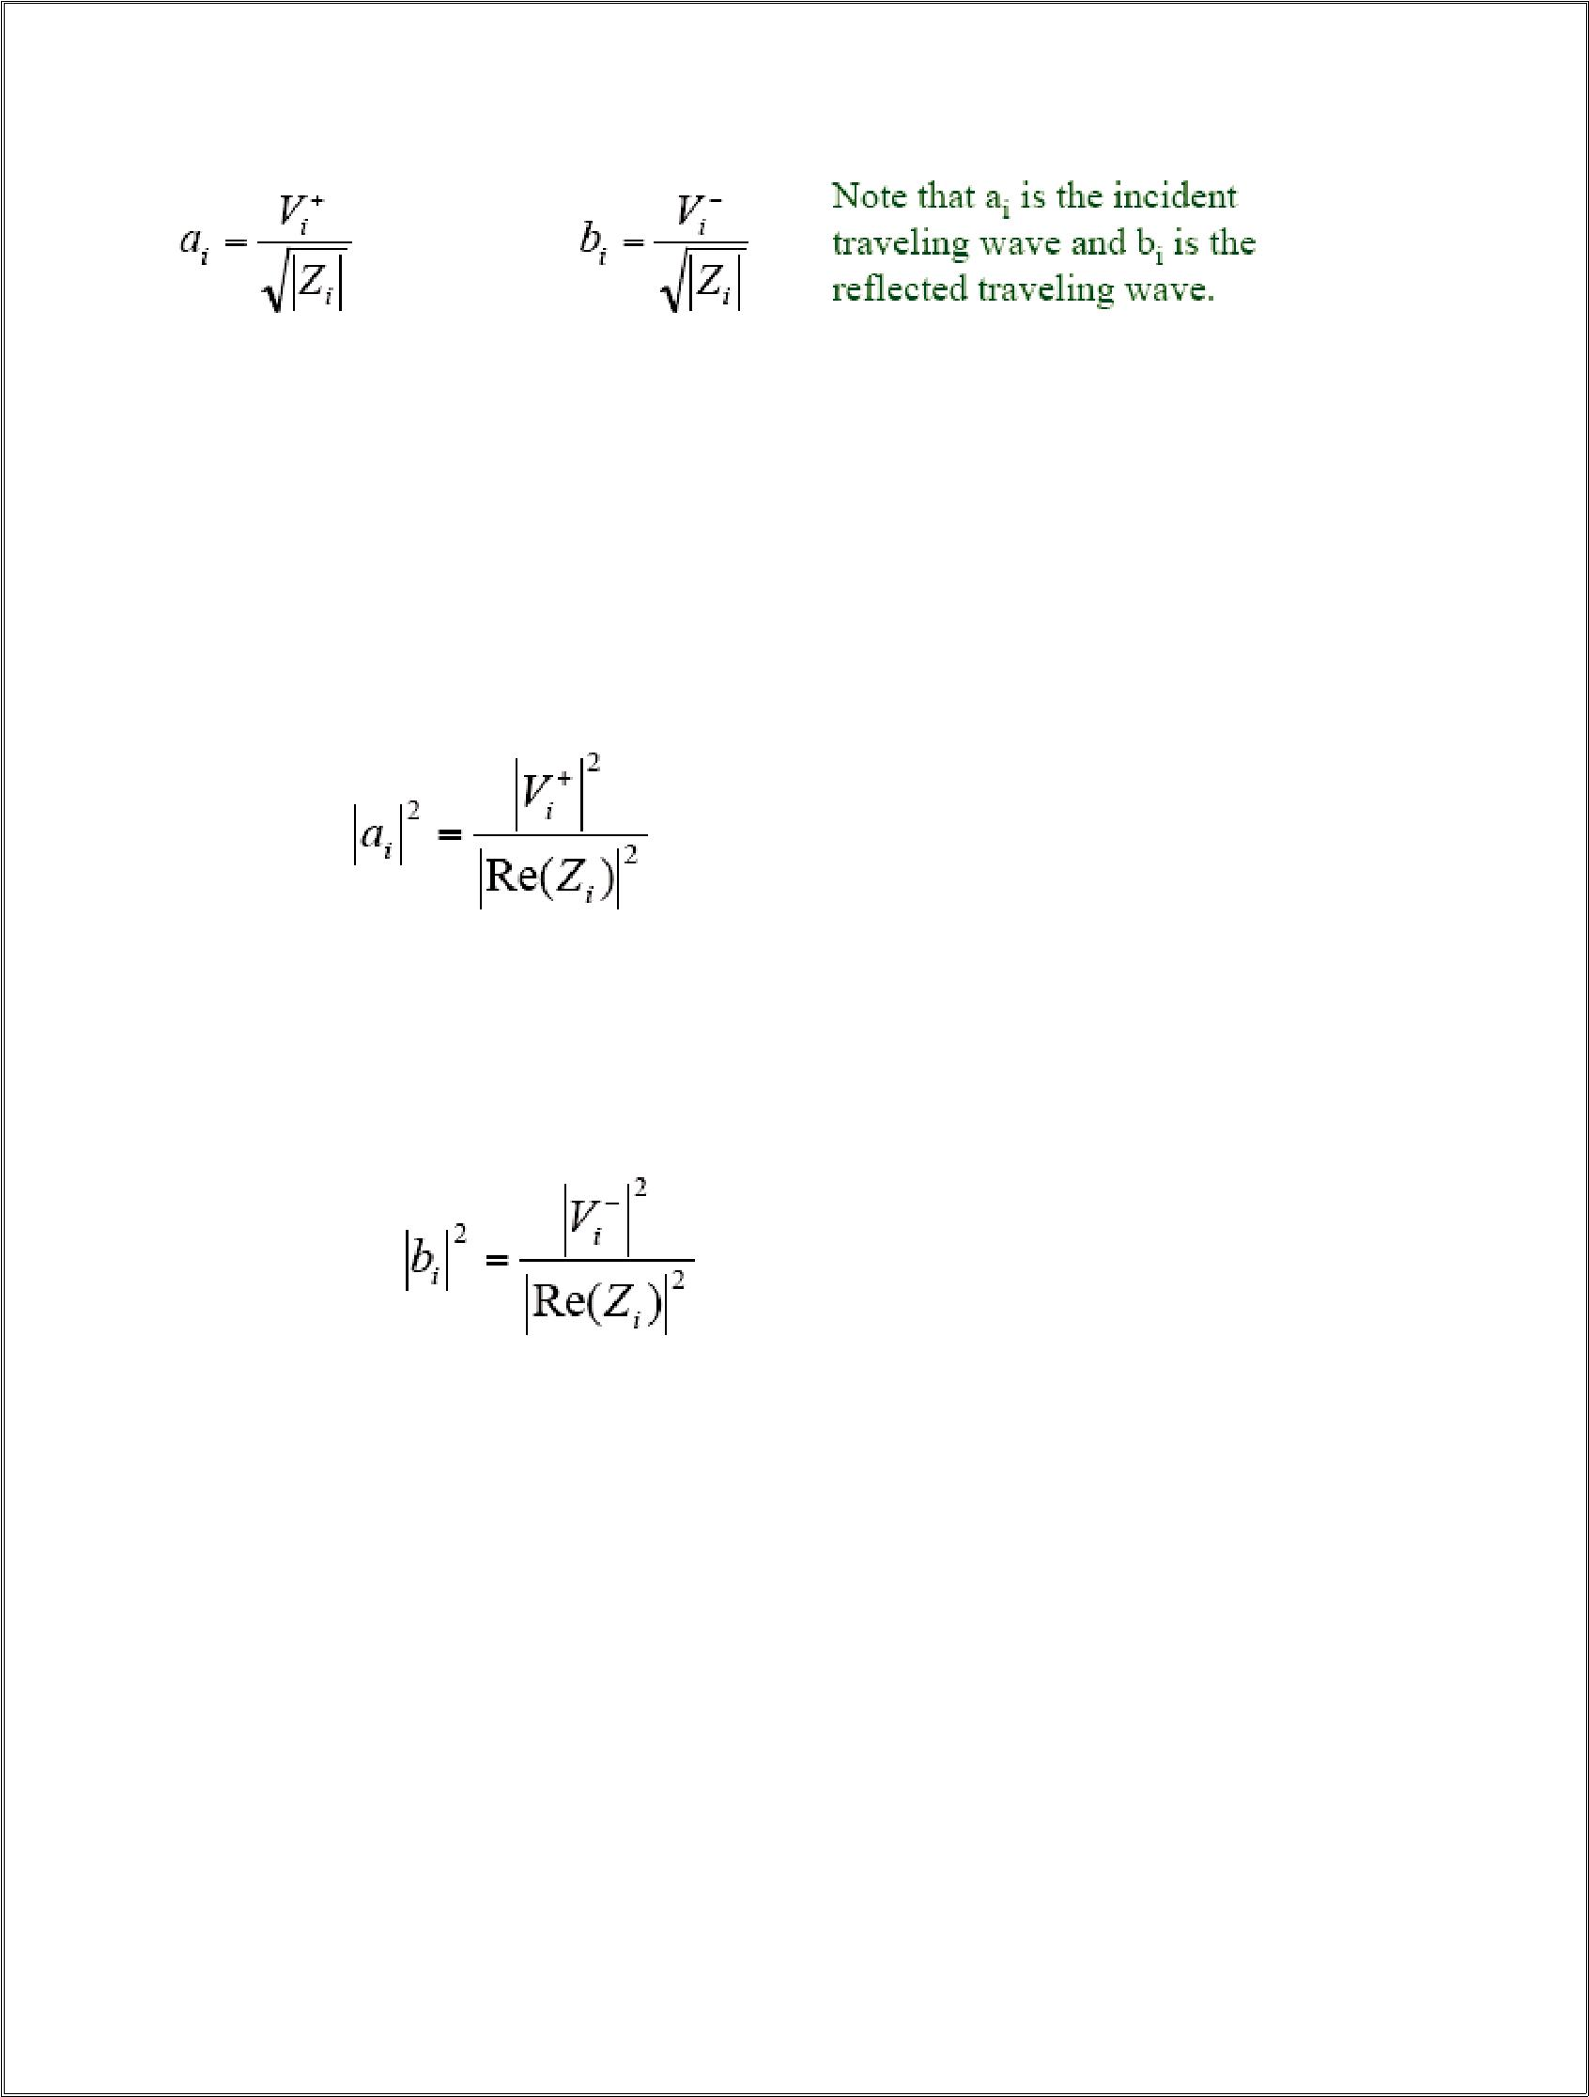
13

Both ai and bi have units that are the square root of power.

S Parameters and Power

The power of forward (incident) wave

on the port:

The power of reflection wave

from the port:

The reflected wave from each port is the sum of the incident waves at all ports modified by the S parameters matrix????

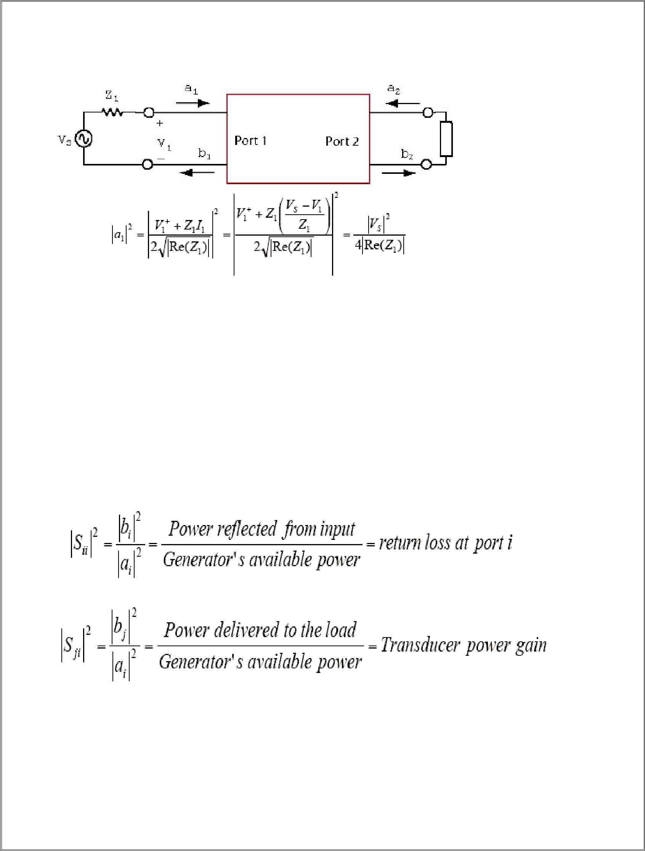
14

S Parameters and Power

- Therefore, is the power available from the source.

- Available power is the power delivered by the source to a perfectly matched load (maximum power transfer).

- The source is always sending the power to the load (regardless of the value of the load impedance.

- If the load is not matched, then some of the incident power is reflected back to the generator.

S Parameters and Power

Therefore, |b2|2 is the power delivered to the load if a2 = 0. In summary

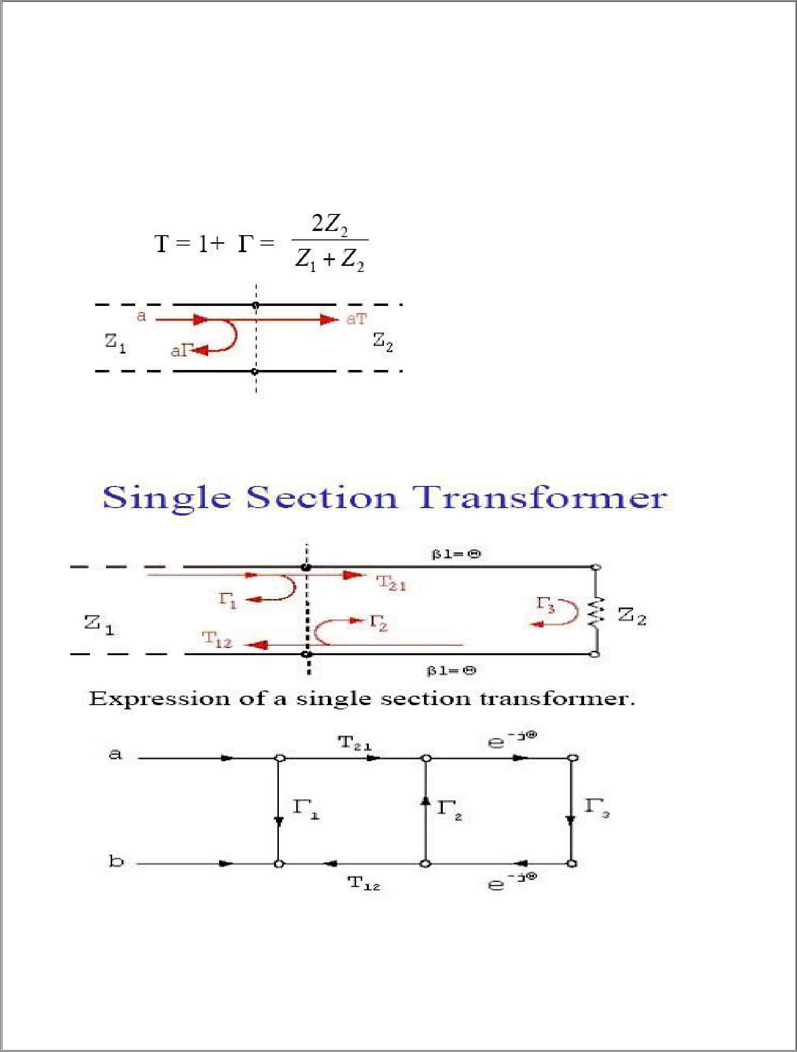
15

The Transmission Coefficient

Most of the time some of the incident energy is transmitted through the junction. The reflected energy is characterized by the

reflection coefficient ℘. The energy that passes through is characterized by the transmission coefficient T, where:

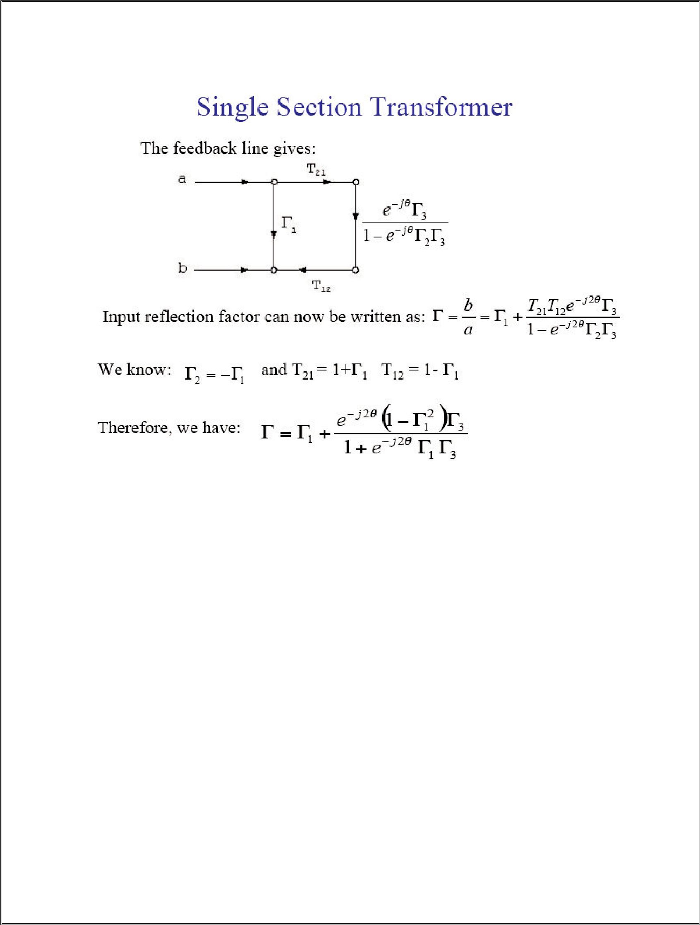
16

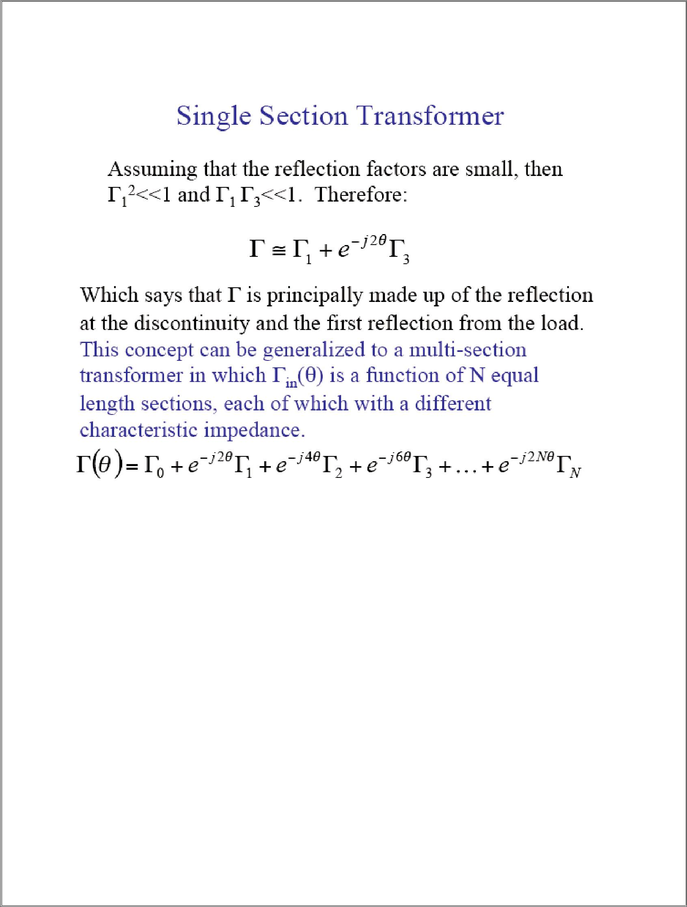
17

Beyond syllabus
S-parameters describe the input-output relationship between ports (or terminals) in an electrical system. For instance, if we have 2 ports (intelligently called Port 1 and Port 2), then S12 represents the power transferred from Port 2 to Port 1. S21 represents the power transferred from Port 1 to Port 2. In general, SNM represents the power transferred from Port M to Port N in a multi-port network.
A port can be loosely defined as any place where we can deliver voltage and current. So, if we have a communication system with two radios (radio 1 and radio 2), then the radio terminals (which deliver power to the two antennas) would be the two ports. S11 then would be the reflected power radio 1 is trying to deliver to antenna 1. S22 would be the reflected power radio 2 is attempting to deliver to antenna 2. And S12 is the power from radio 2 that is delivered through antenna 1 to radio 1. Note that in general S-parameters are a function of frequency (i.e. vary with frequency).
As an example, consider the following two-port network:
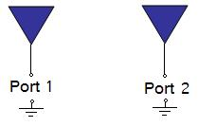
In the above Figure, S21 represents the power received at antenna 2 relative to the power input to antenna 1. For instance, S21=0 dB implies that all the power delivered to antenna 1 ends up at the terminals of antenna 2. If S21=-10 dB, then if 1 Watt (or 0 dB) is delivered to antenna 1, then -10 dB (0.1 Watts) of power is received at antenna 2.
If an amplifier exists in the circuitry, then S21 can show gain (i.e. S21 > 0 dB). This means that for 1 W of power delivered to Port 1, more than 1 W of power is received at Port 2.

