Notes

Network Theory

2

UNIT-I

- Active and Passive Devices-Independent and dependent voltage and current sources are active devices; they normally (but Not always) deliver power to some external device. Resistors, inductors and capacitors are passive Devices; they normally receive (absorb) power from an active device.
- Independent and Dependent Sources-

1.2.(a) Ideal Independent Voltage Source 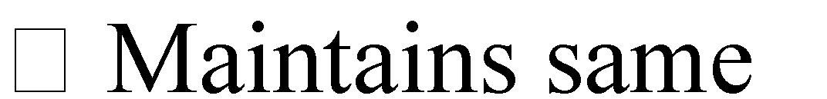 voltage regardless of the amount of current that flows through it. Its value is either constant (DC) or sinusoidal (AC).

1.2.(b)Ideal Independent Current Source 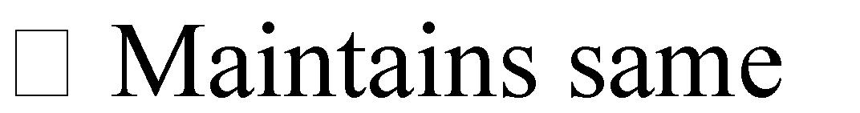 current regardless of the voltage that appears across its terminals. Its value is either constant (DC) or sinusoidal (AC).

1.2.(c)Dependent Voltage Source voltage or current elsewhere in the circuit.

1.2.(d)Dependent Current Source current or voltage elsewhere in the circuit.

3.Linear Devices

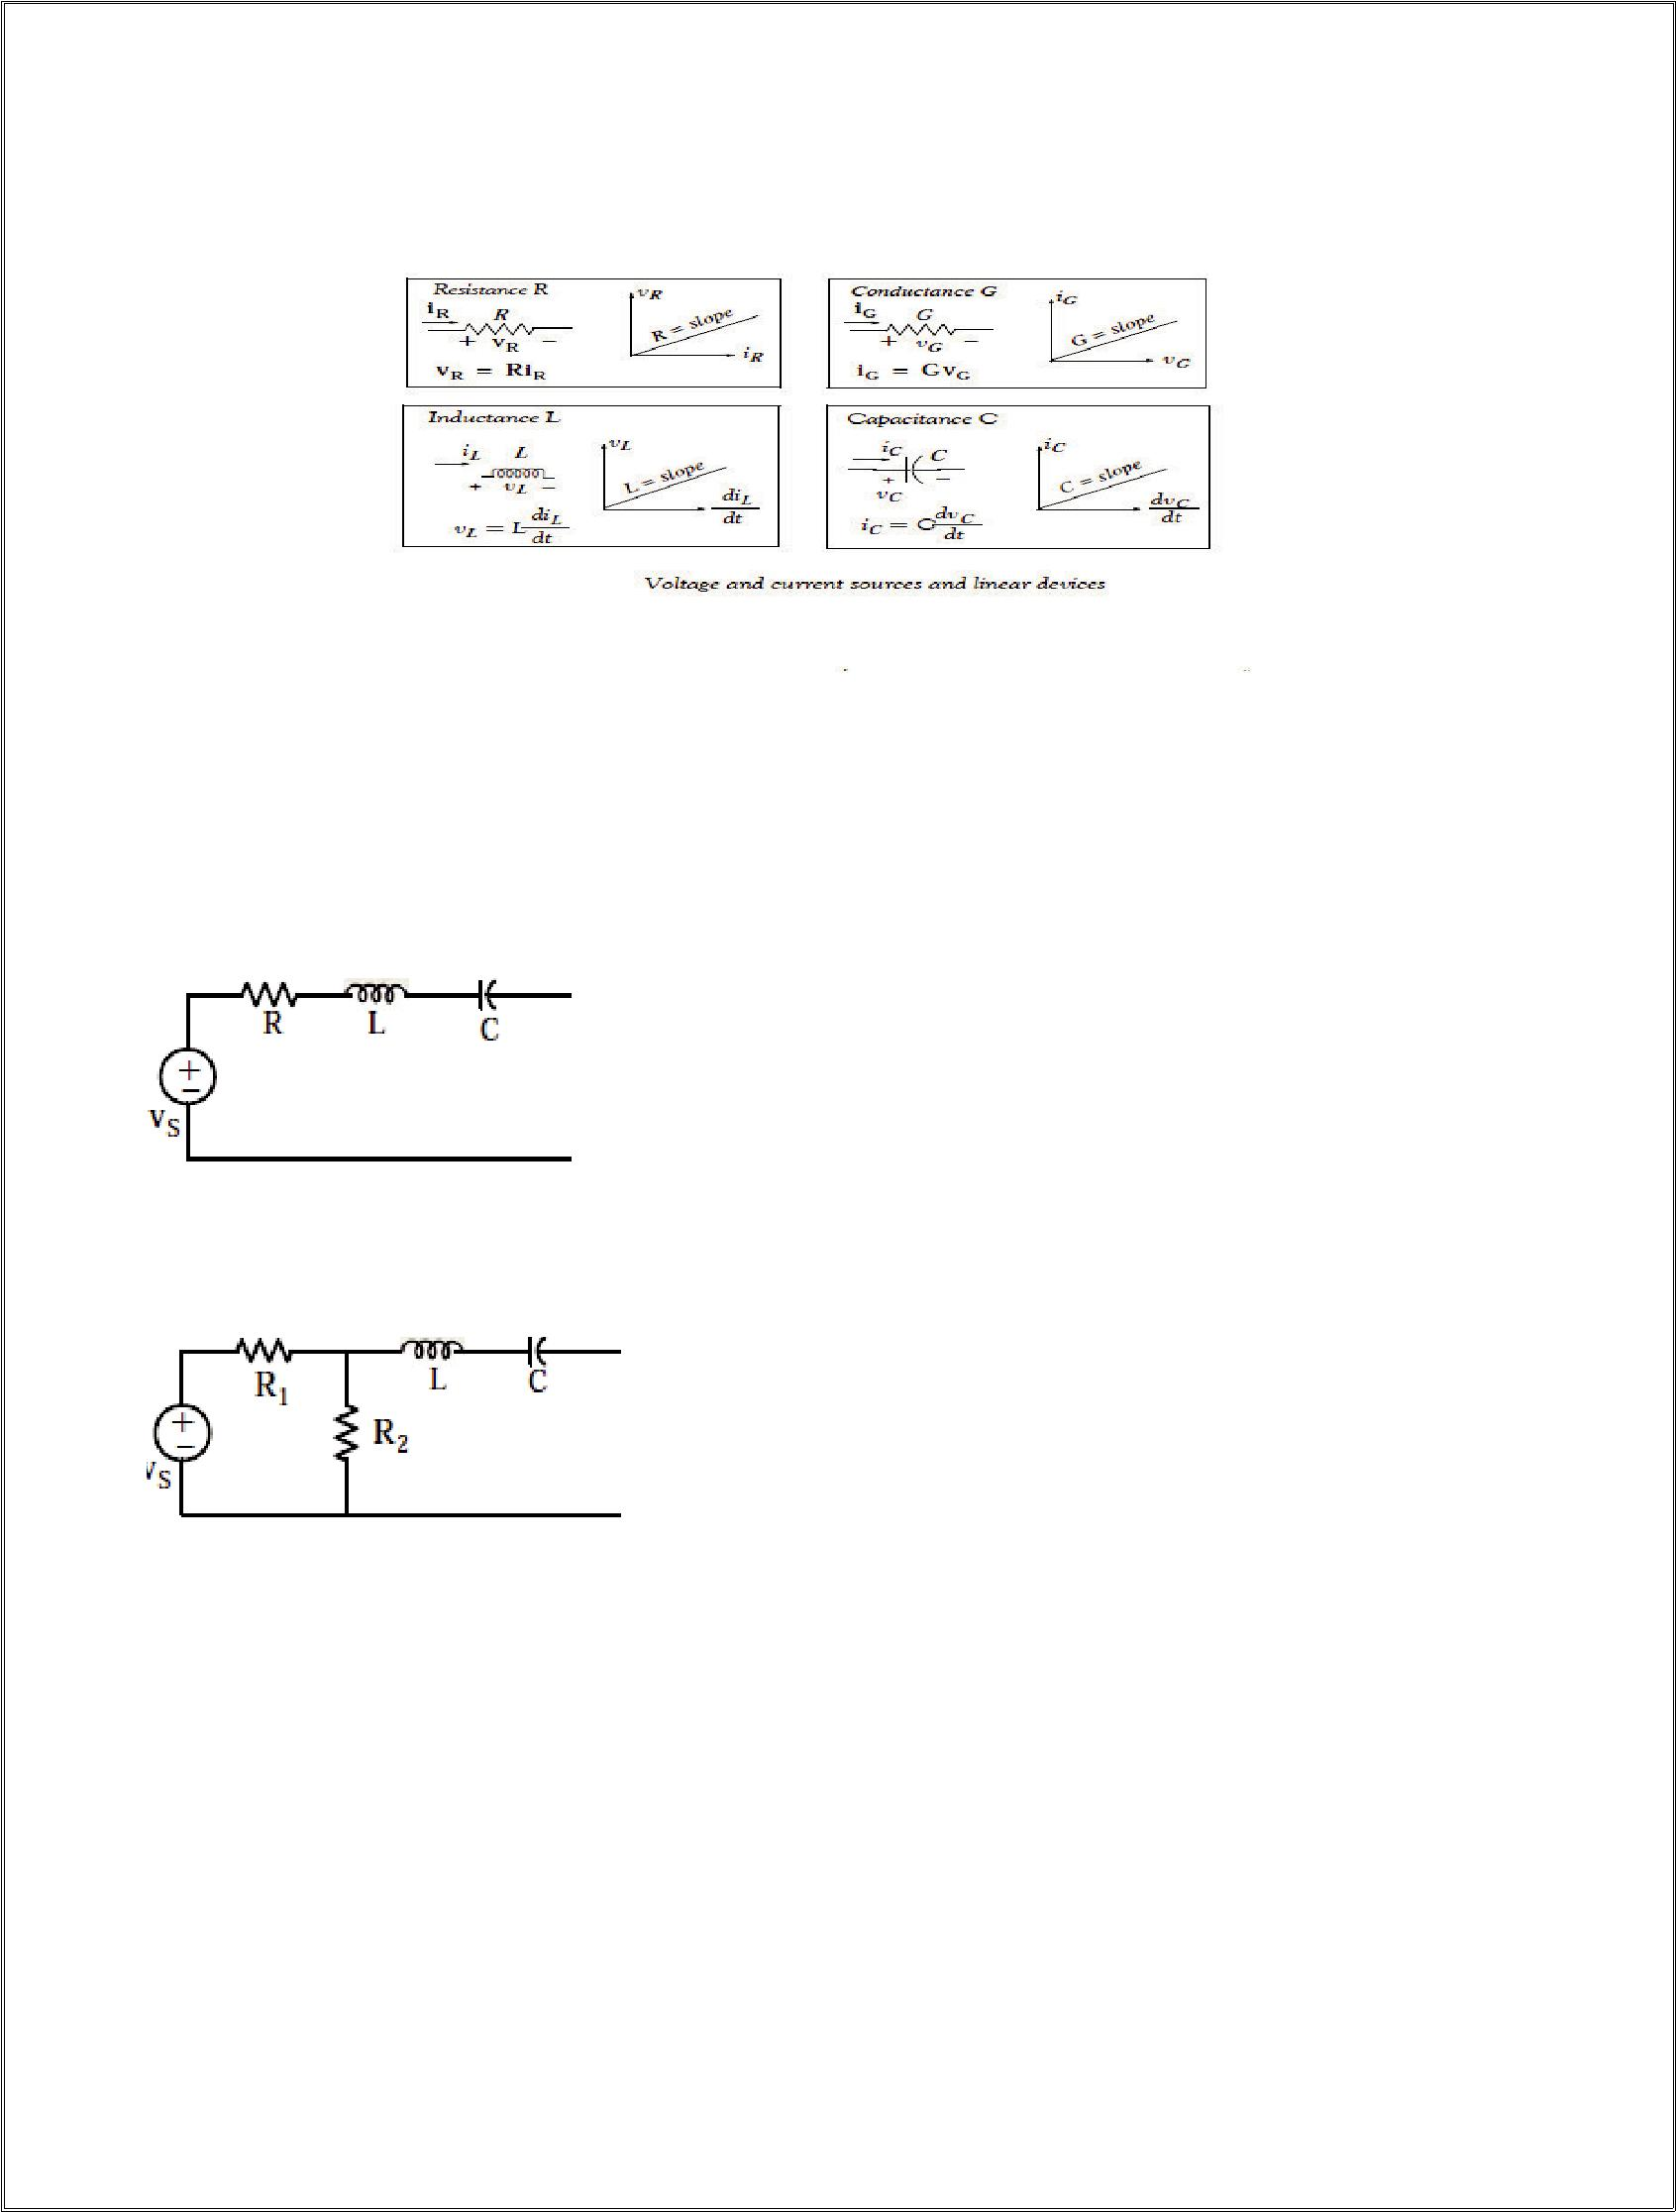
3

4. Circuits and Networks

A network is the interconnection of two or more simple devices as shown

A circuit is a network which contains at least one closed path. Thus every circuit is a network but not all networks are circuits. An example is shown

5.Active and Passive Networks

Active Network is a network which contains at least one active device (voltage or current Source).

Passive Network is a network which does not contain any active device.

Basic Concepts and Definitions

- An ideal independent voltage source maintains the same voltage regardless of the amount of current that flows through it.

4

- An ideal independent current source maintains the same current regardless of the amount of voltage that appears across its terminals.

- The value of an dependent voltage source depends on another voltage or current elsewhere in the circuit.

- The value of an dependent current source depends on another current or voltage elsewhere in the circuit.

- Ideal voltage and current sources are just mathematical models.

- Independent and Dependent voltage and current sources are active devices; they normally (but not always) deliver power to some external device.

- Resistors, inductors, and capacitors are passive devices; they normally receive (absorb) power from an active device.

- A network is the interconnection of two or more simple devices.

- A circuit is a network which contains at least one closed path. Thus every circuit is a network but not all networks are circuits.

- An active network is a network which contains at least one active device (voltage or current source).

- A passive network is a network which does not contain any active device.

- To set up and maintain a flow of current in a network or circuit there must be a voltage source (potential difference) present to provide the electrical work which will force current to flow and the circuit must be closed.

- Linear devices are those in which there is a linear relationship between the voltage across that device and the current that flows through that device.

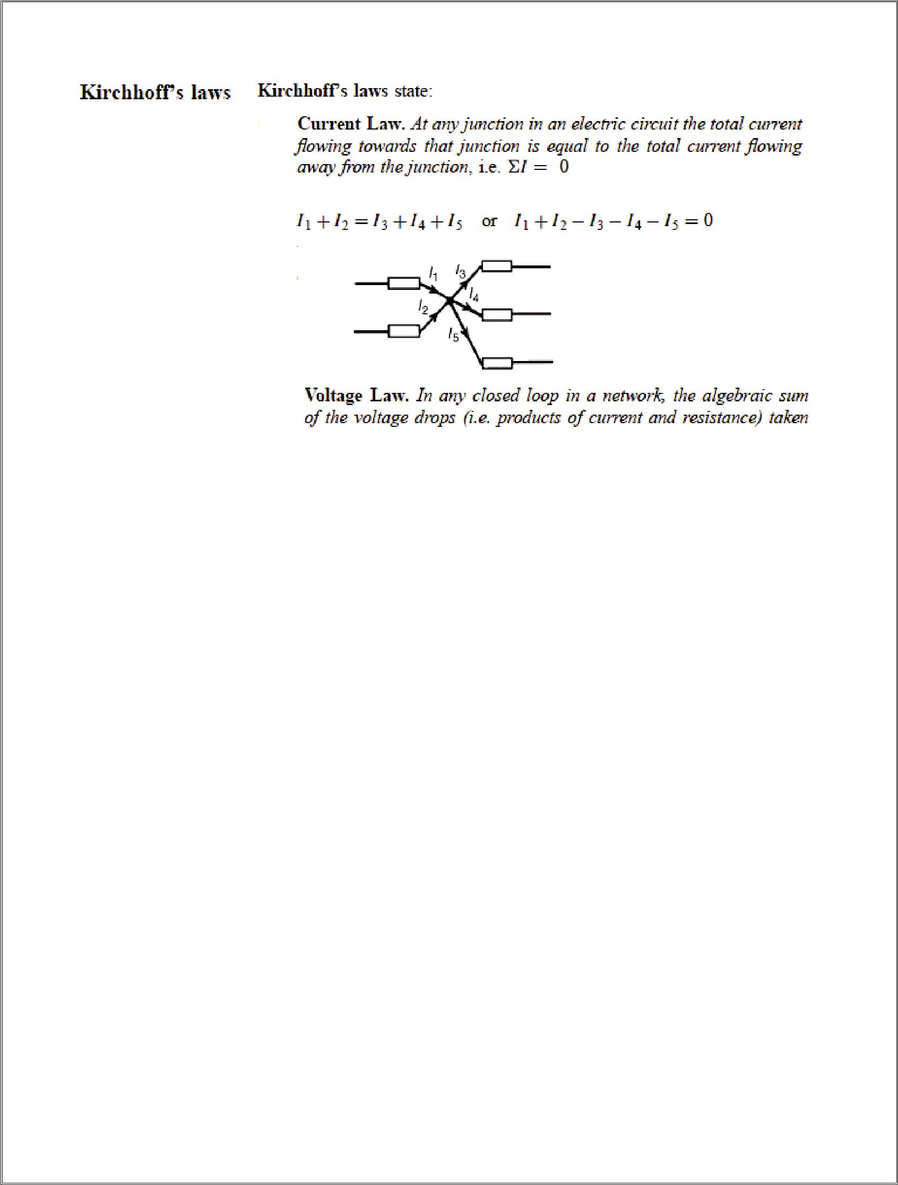
5

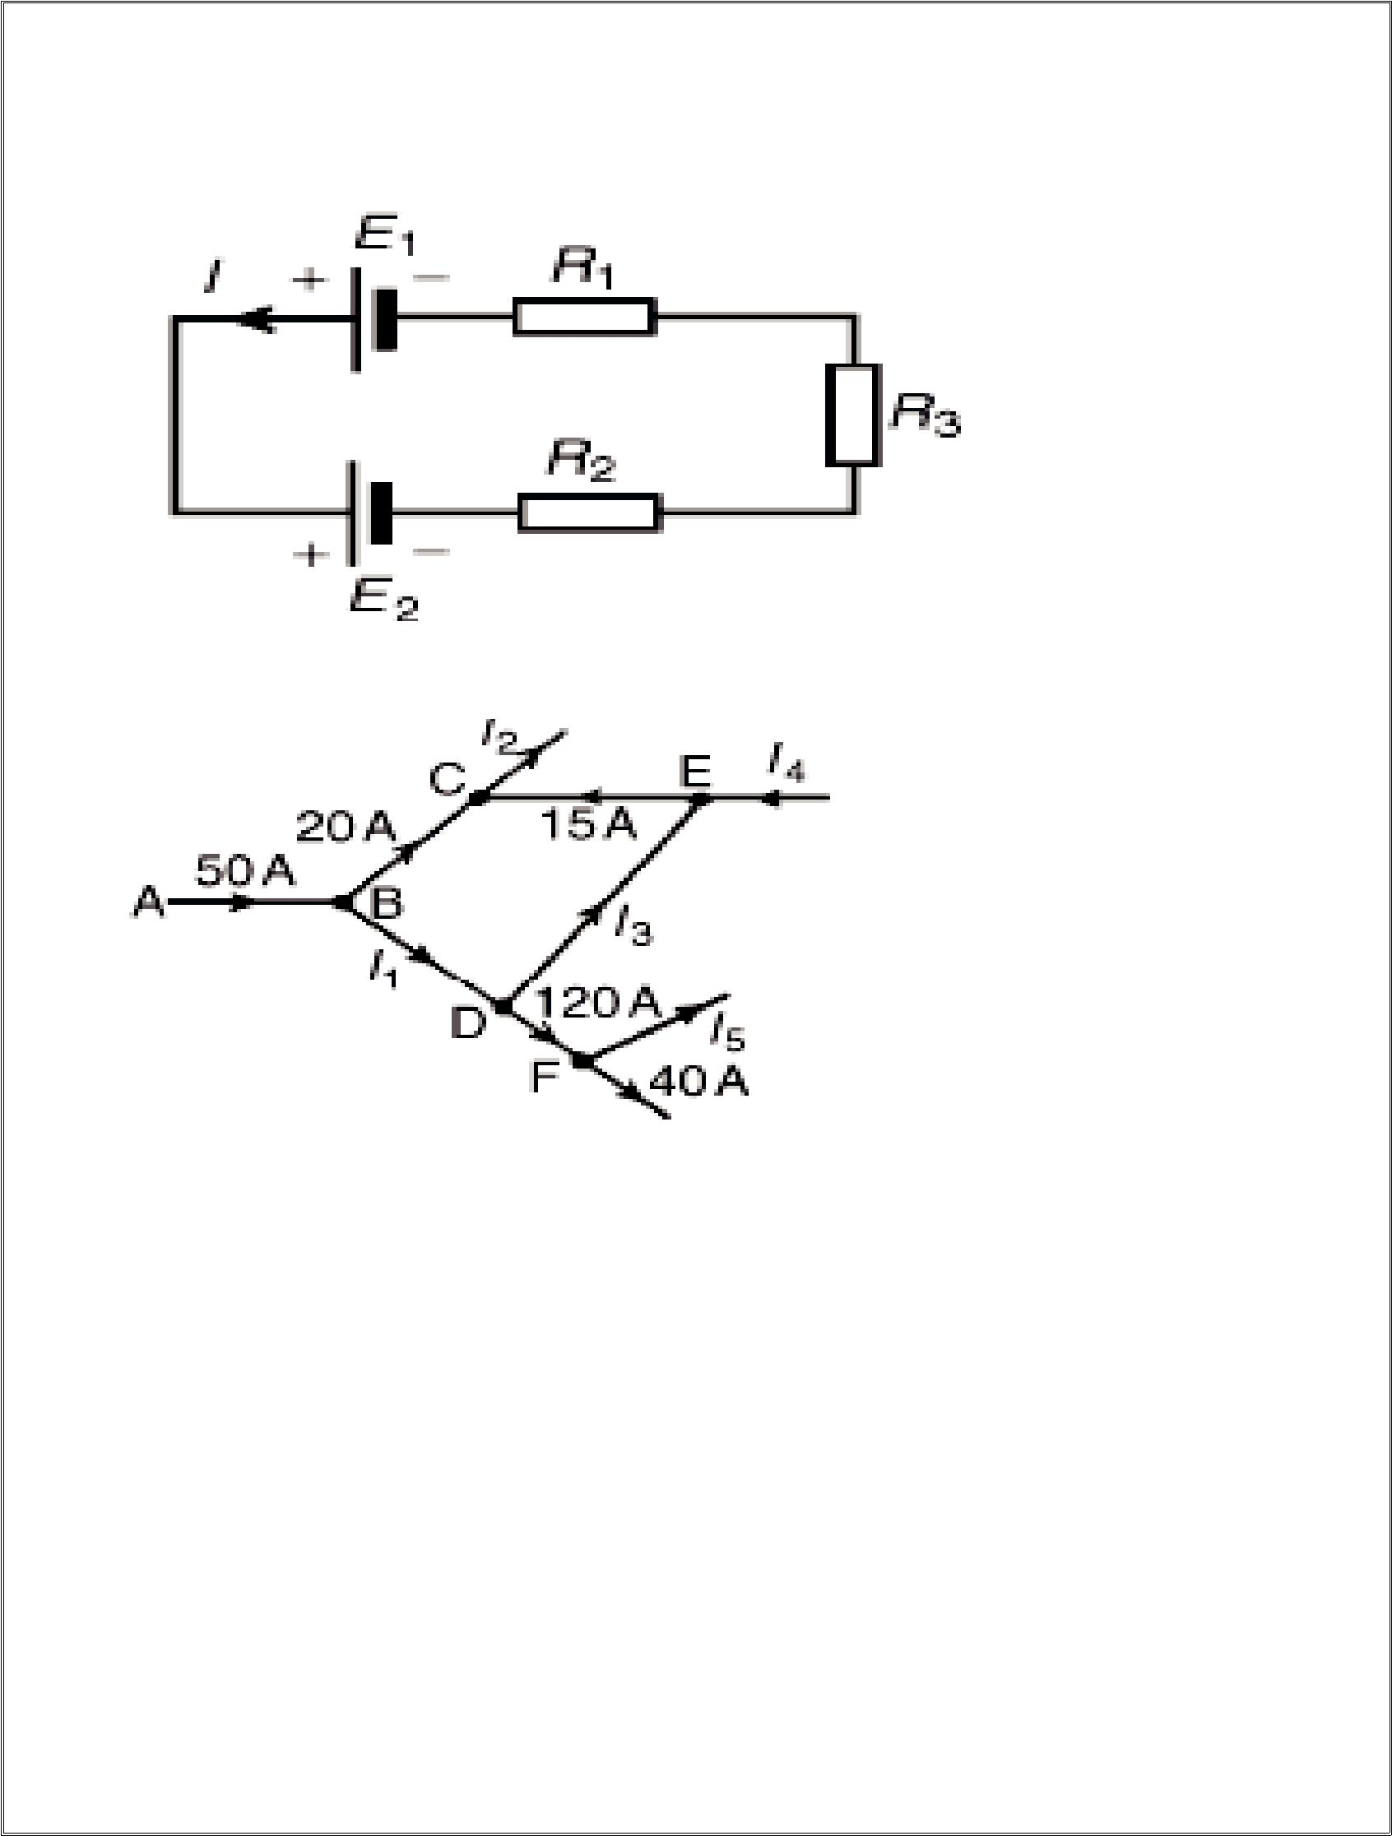
6

. loop is equal to the resultant
e.m.f. acting in that loop

Thus E1 - E2 = IR1 + IR2 + IR3 Problem 1Find the unknown currents marked in Figure as below-

Solution-Applying Kirchhoff’s current law:

For junction B: 50 = 20 + I1. Hence I1 = 30 A For junction C: 20 + 15 = I2. Hence I2 = 35 A

For junction D: I1 = I3 + 120 i.e. 30 = I3 + 120. Hence I3 = −90 A (in the opposite direction)

For junction E: I4 + I3 = 15 i.e. I4 =15 –(-90). Hence I4 = 105 A
For junction F: 120 = I5 + 40. Hence I5 = 80 A

Problem 2 Determine the value of e.m.f. E

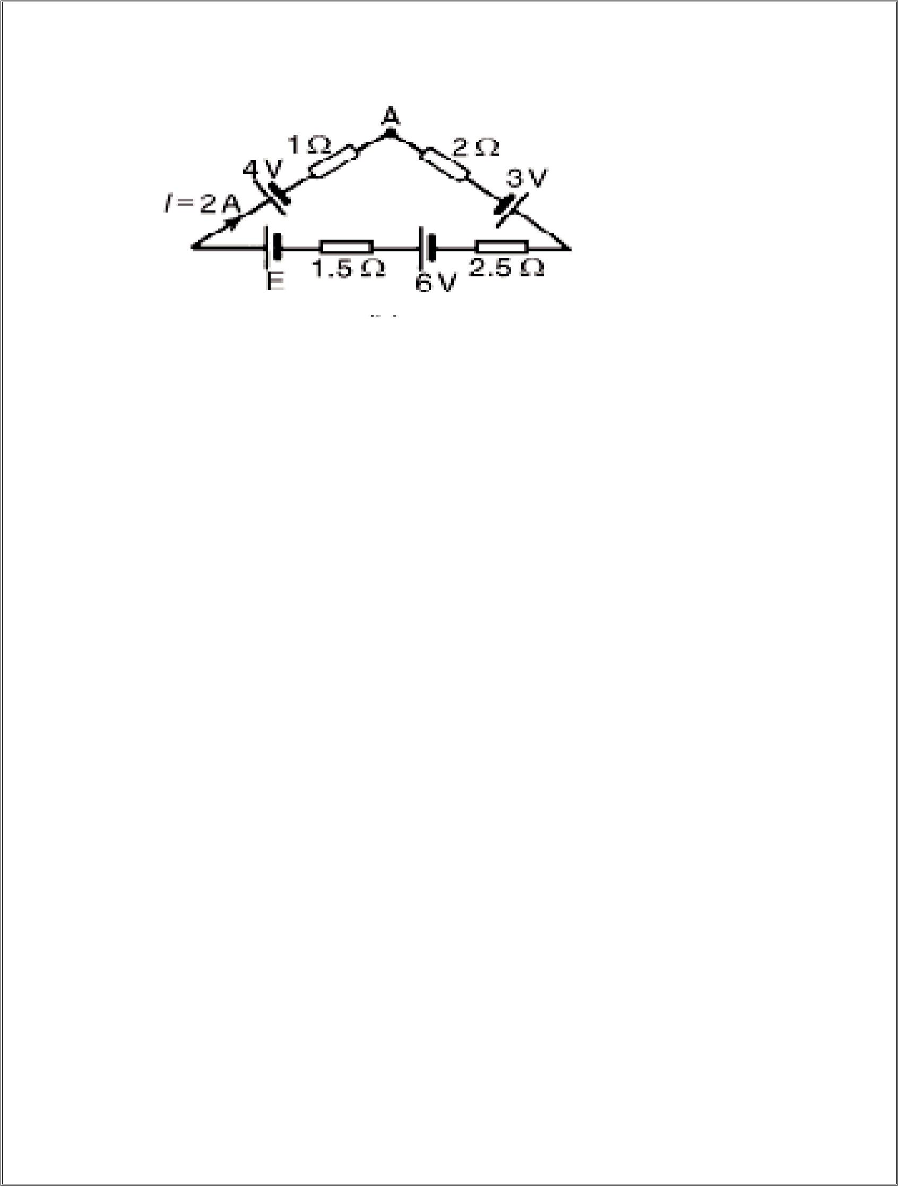
7

Solution-Applying Kirchhoff’s voltage law and moving clockwise around the loop of F starting at point A:

3 + 6 + E - 4 = I2 + I2.5 + I1.5 + I1

=I (2 +2.5 + 1.5 + 1) i.e. 5 + E = 2(7) since I = 2 A Hence E = 14 - 5 = 9 V

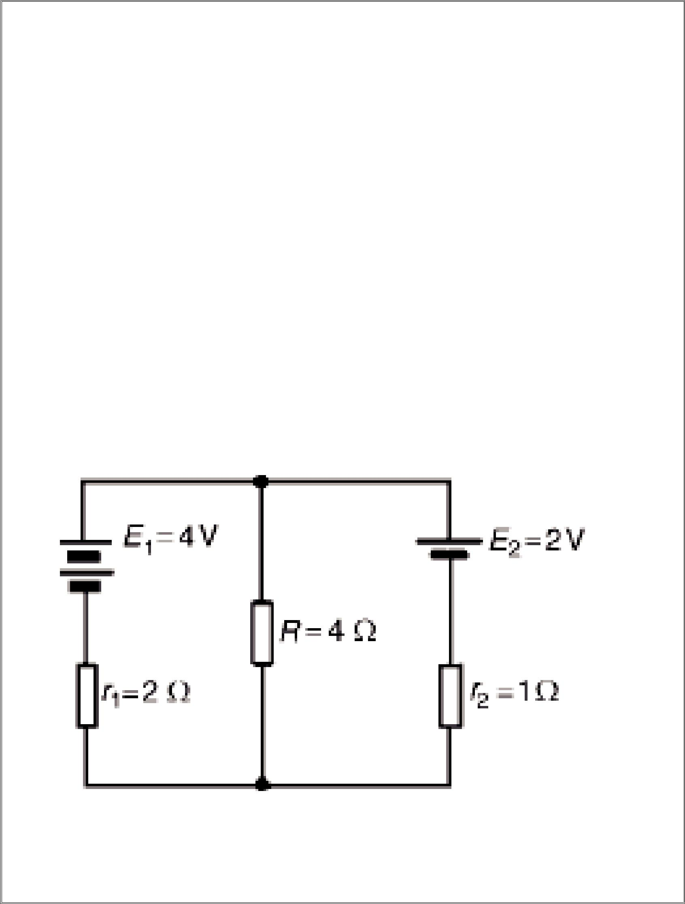
8

6.SUPERPOSITION THEOREM

superposition theorem states:-

‘In any network made up of linear resistances and containing more than one source of e.m.f., the resultant current flowing in any branch is the algebraic sum of the currents that would flow in that branch if each source was considered separately, all other sources being replaced at that time by their respective internal resistances.’

Problem 3 Determine the current in each branch of the network by using the superposition theorem.

Solution-

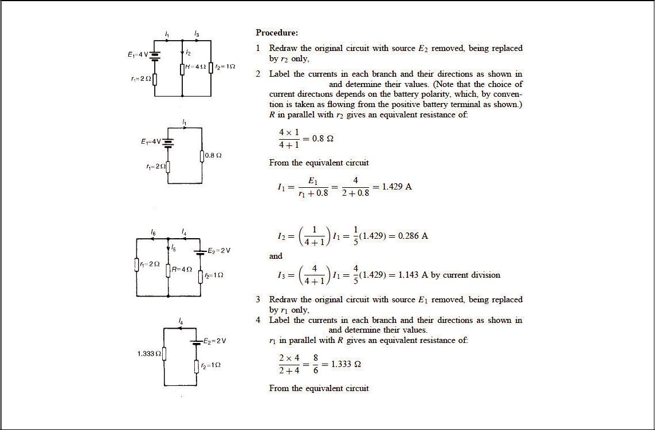
9

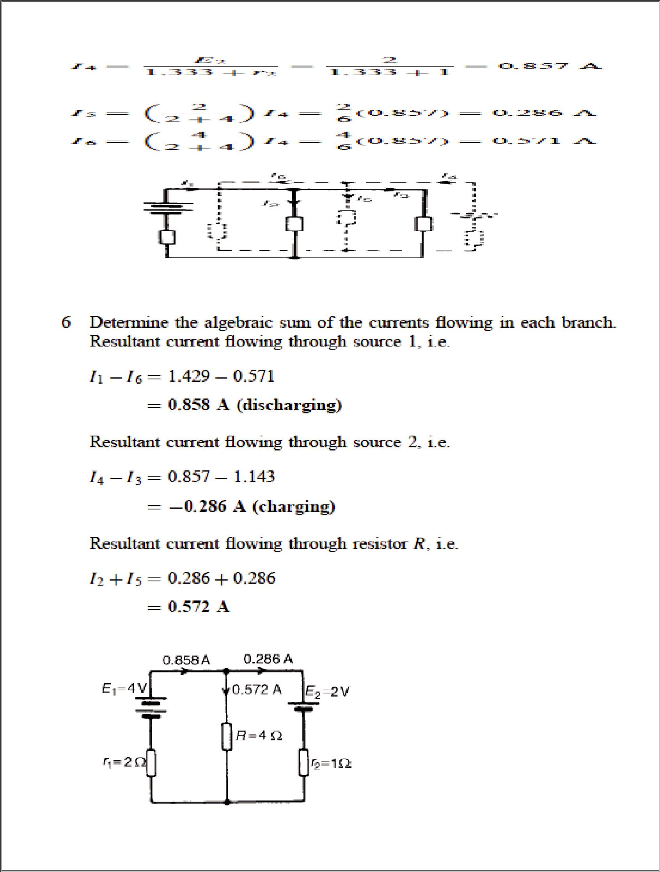
10

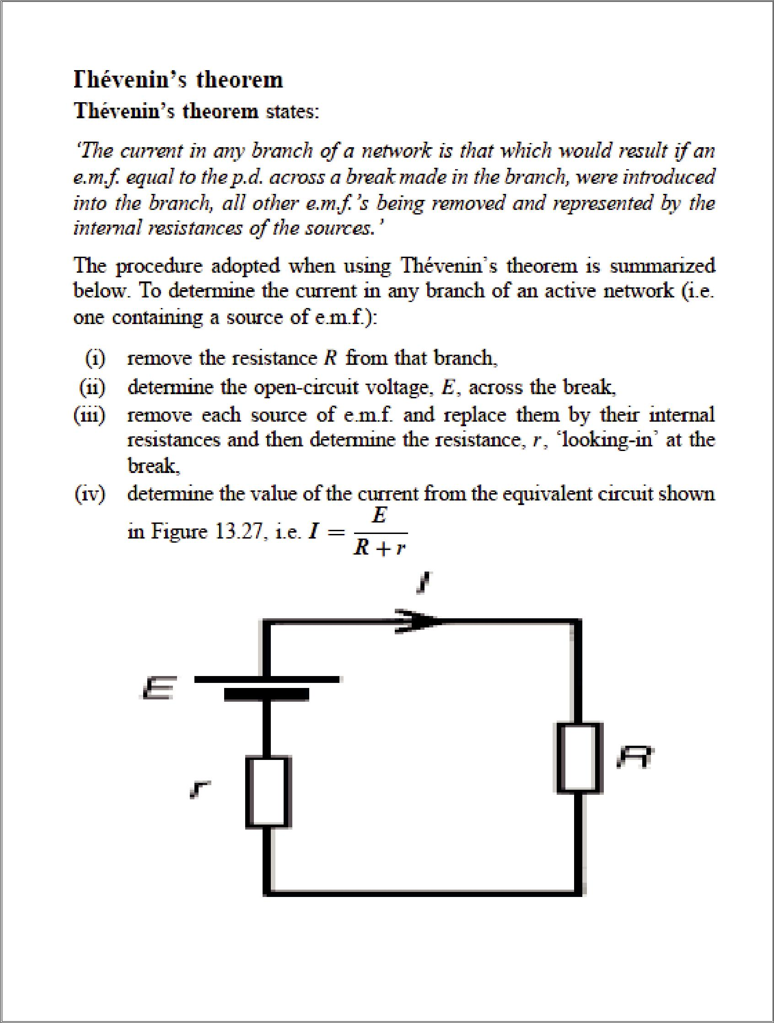
11

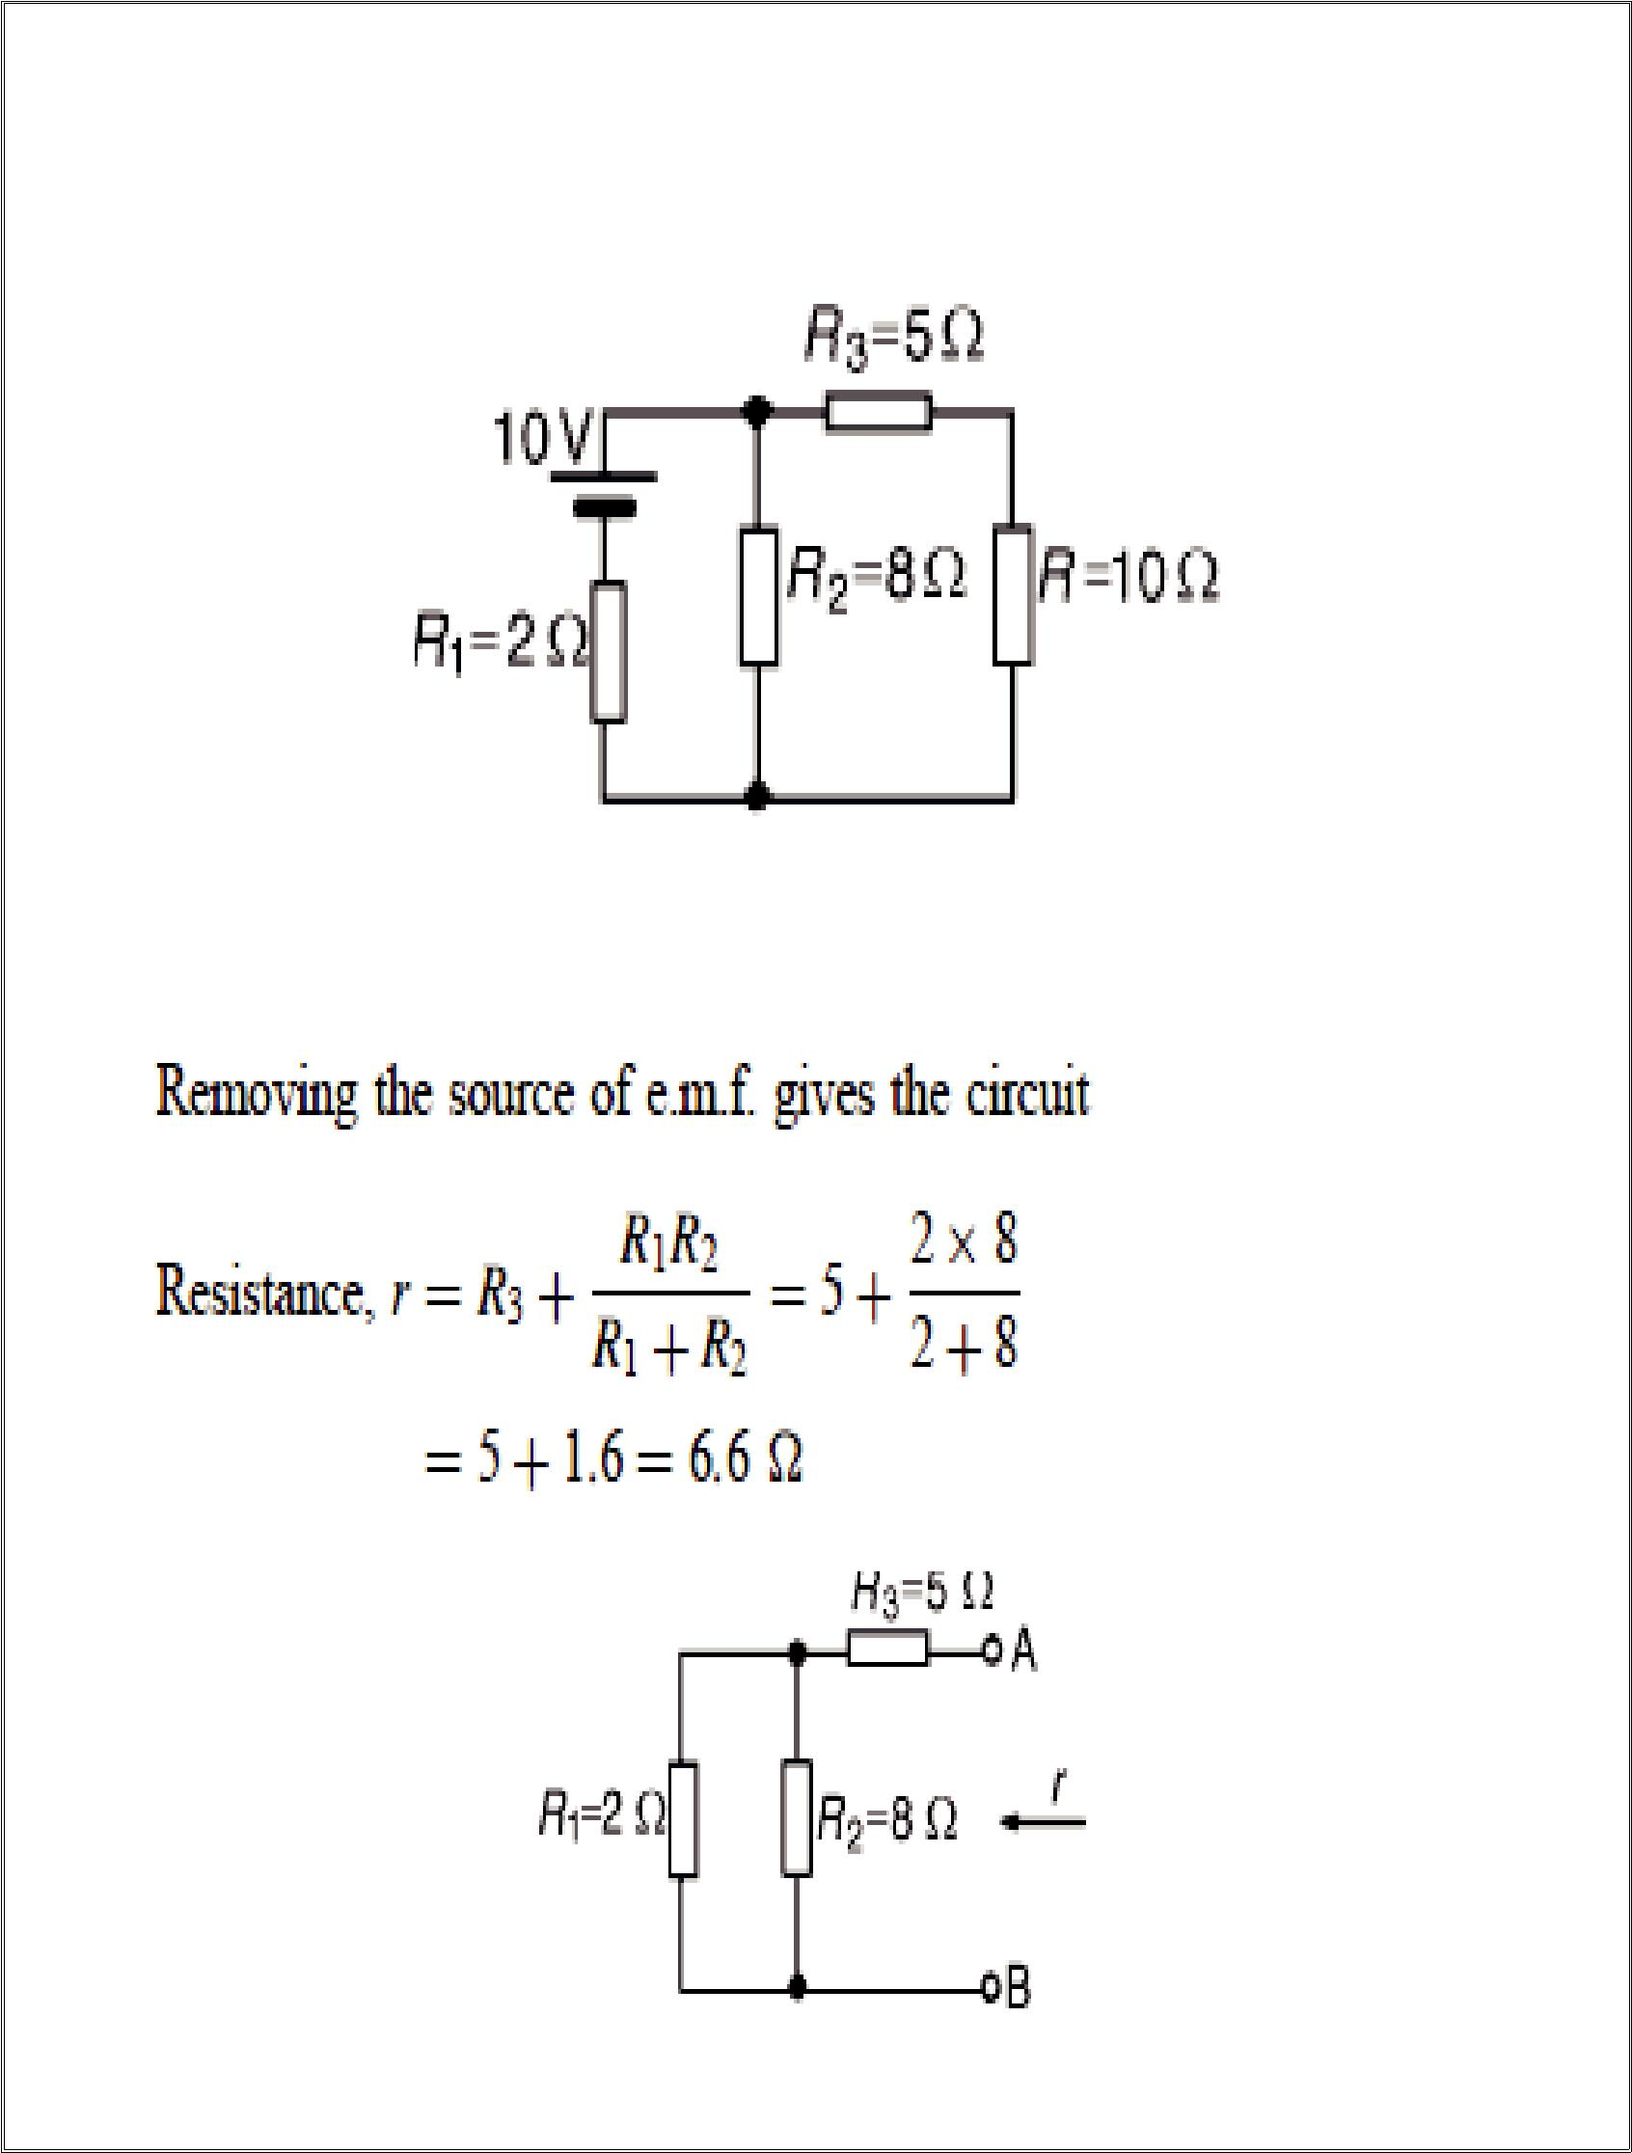
12

Problem-4 Use Th´evenin’s theorem to find the current flowing in the 10 resistor for the circuit shown.

Solution-

Step-1

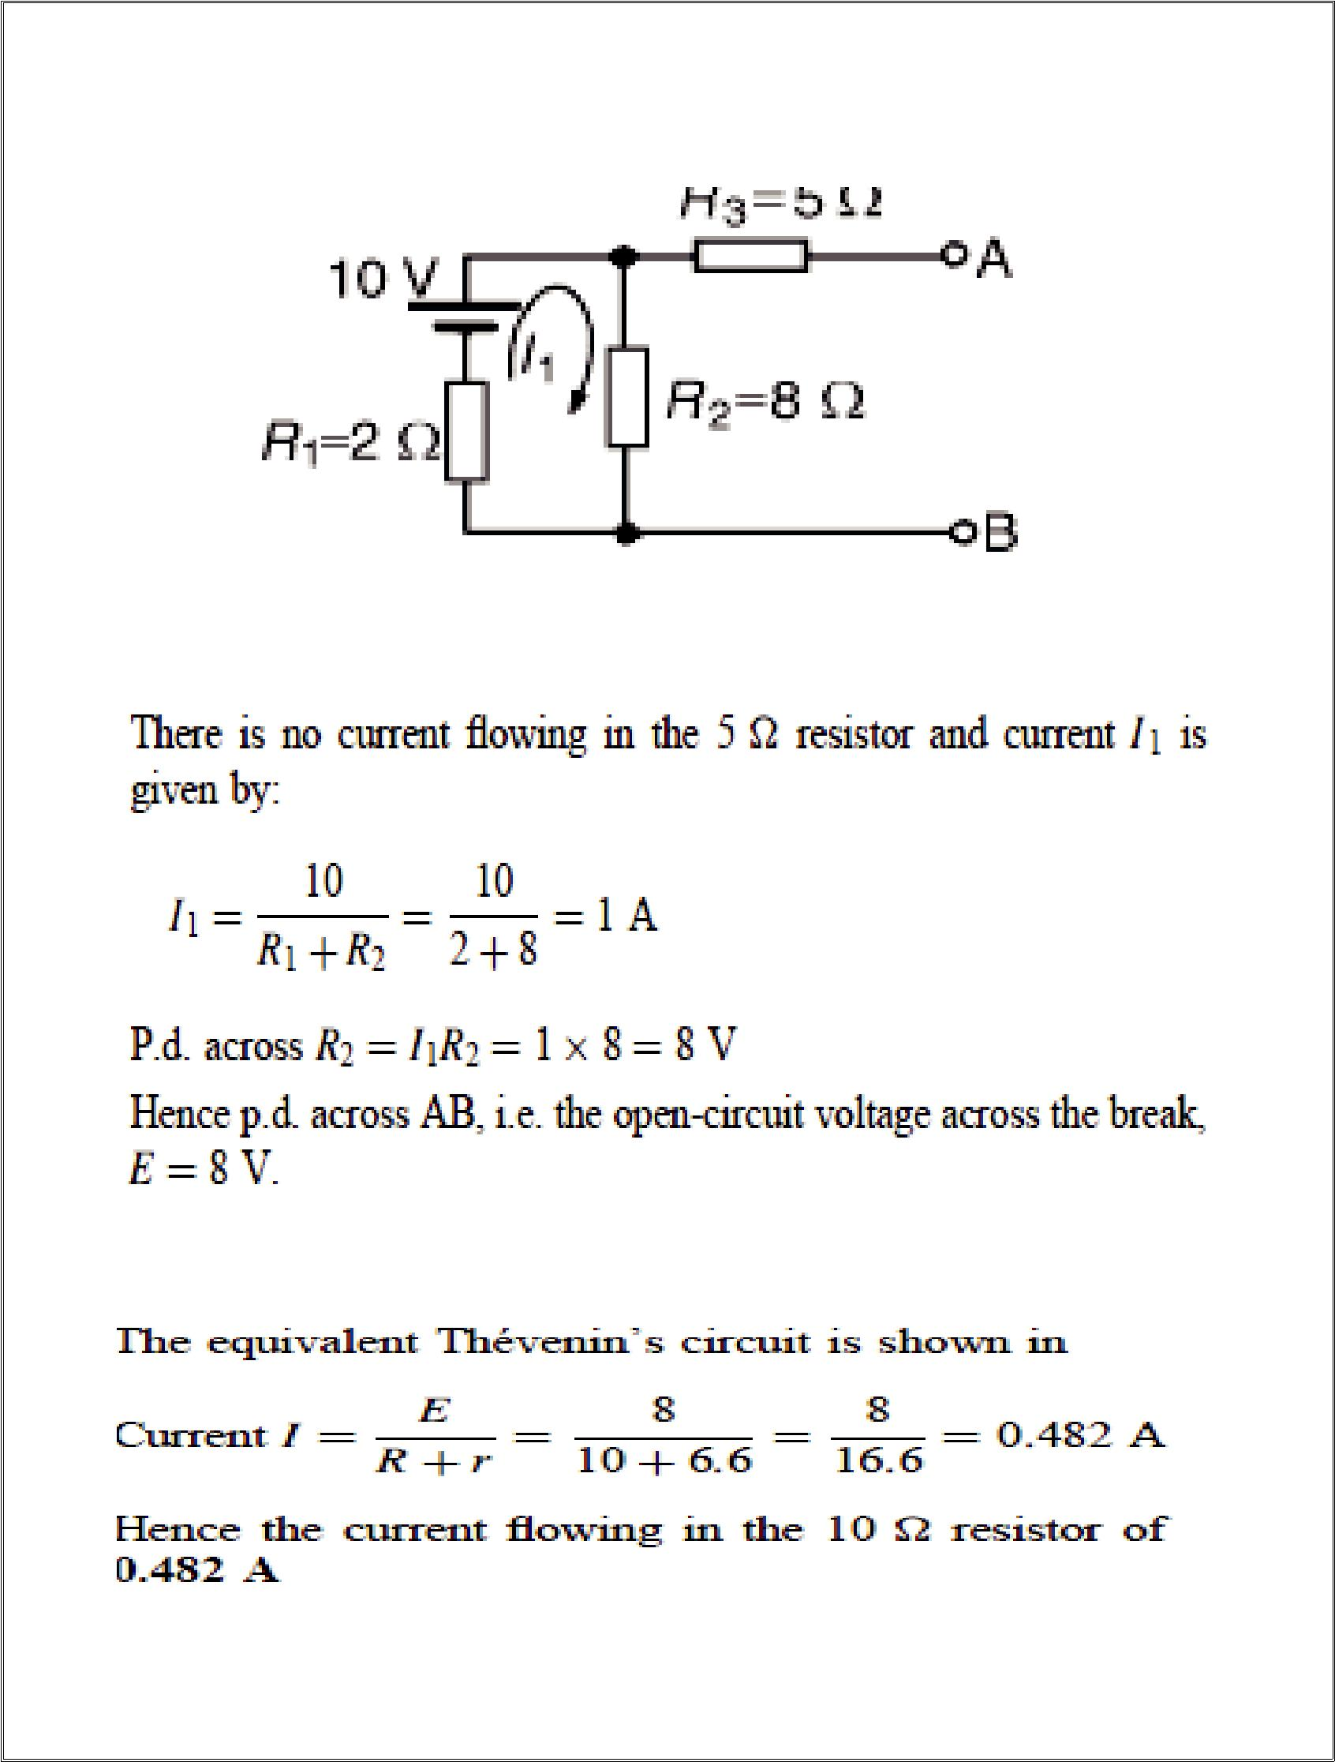
13

Step-2

First of all The 10 resistance is removed from the circuit as shown

Step-3

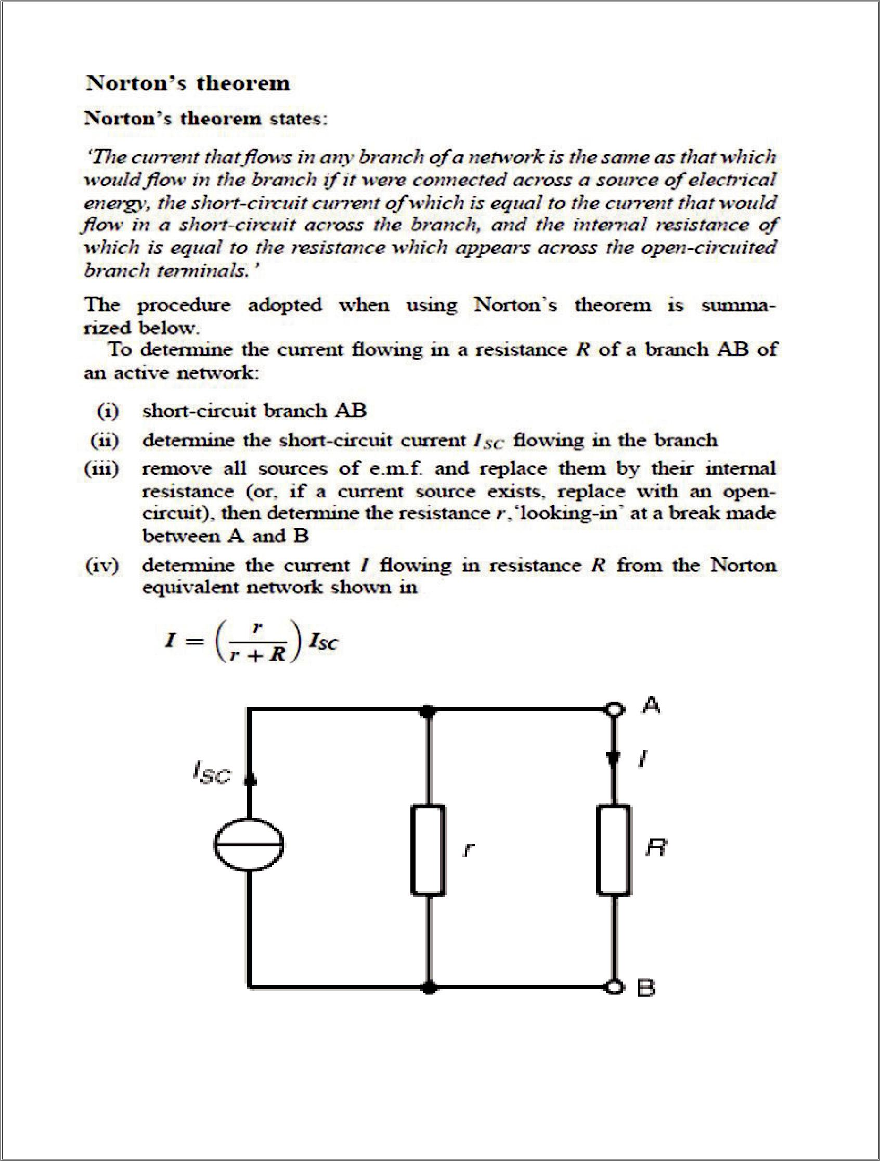
14
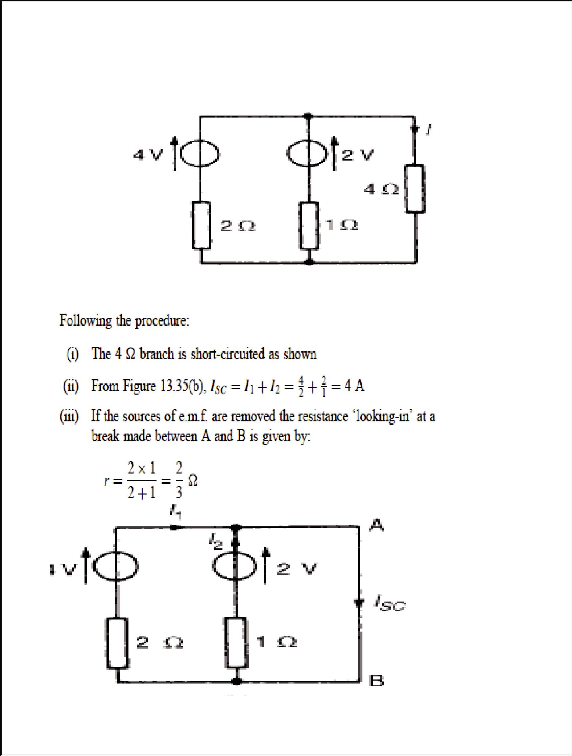
15

Problem-5

Use Norton’s theorem to determine the current I flowing in the 4 resistance

\Solution-

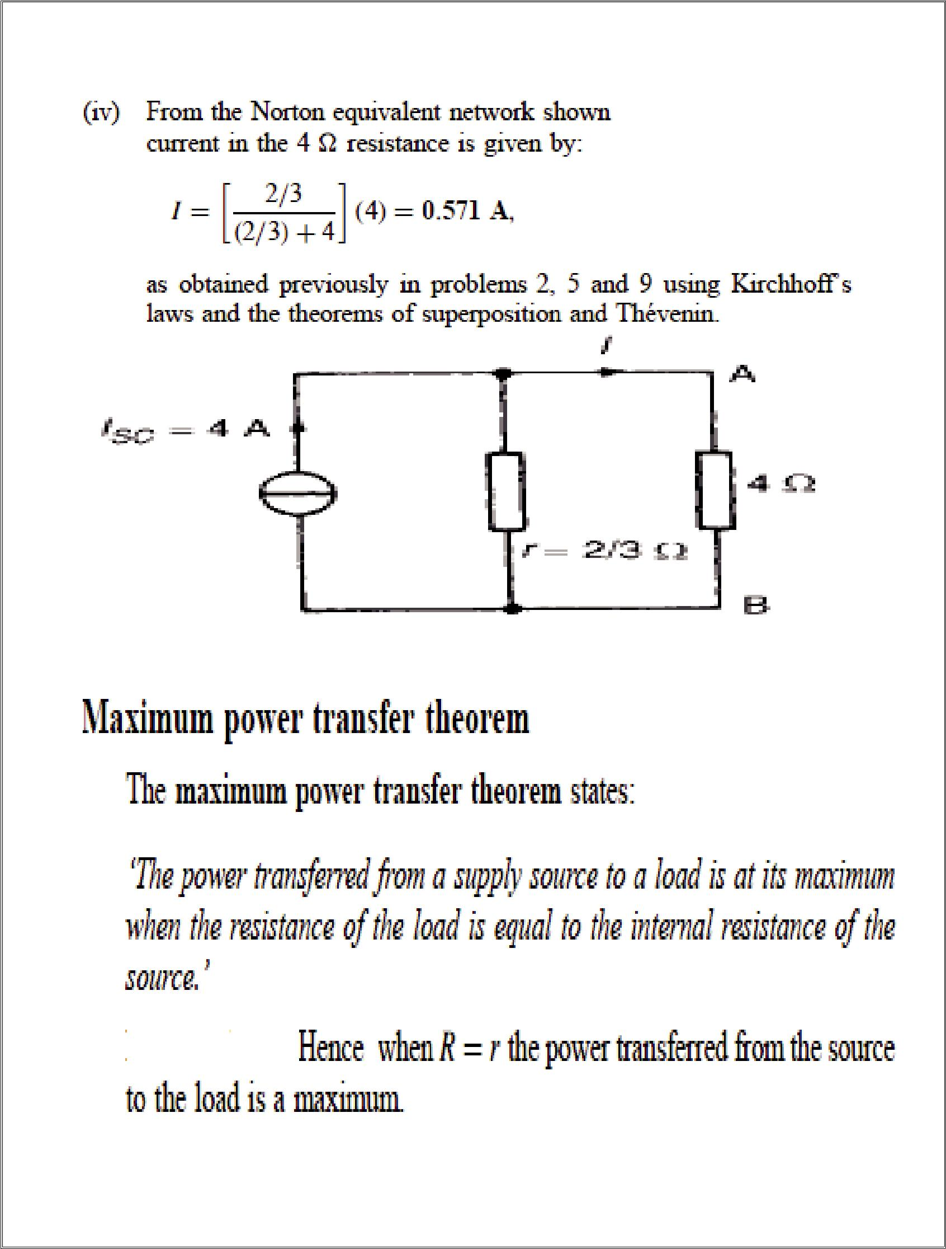
16

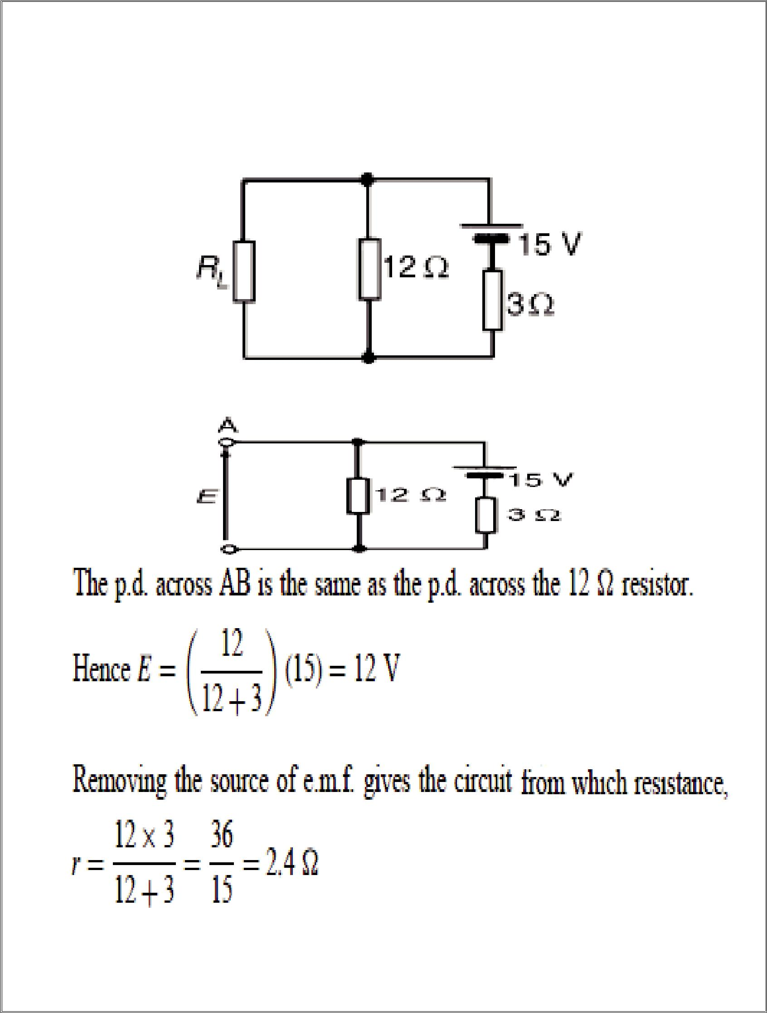
17

Problem-6

Find the value of the load resistor RL that gives maximum power dissipation and determine the value of this power.

Solution-

Resistance RL is removed from the circuit

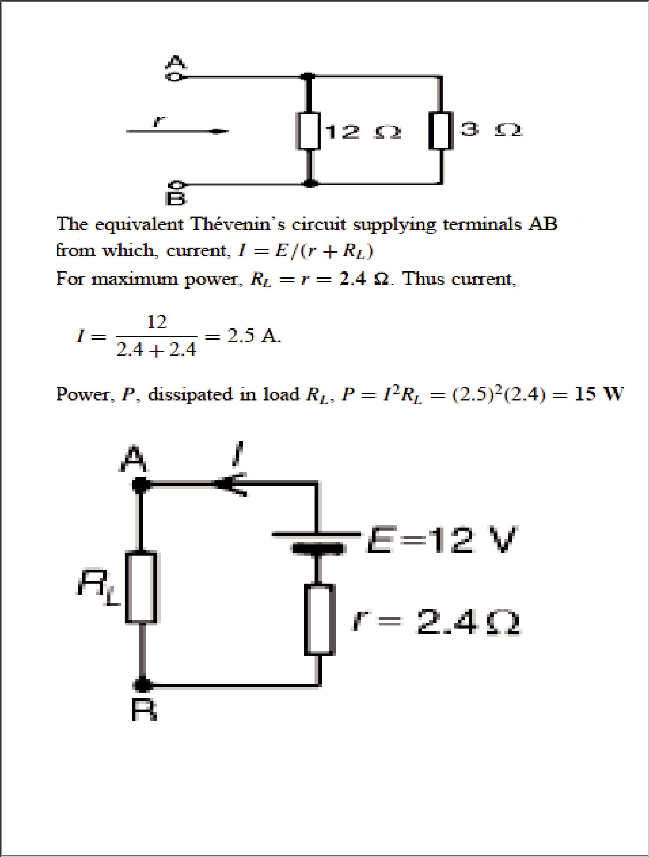
18

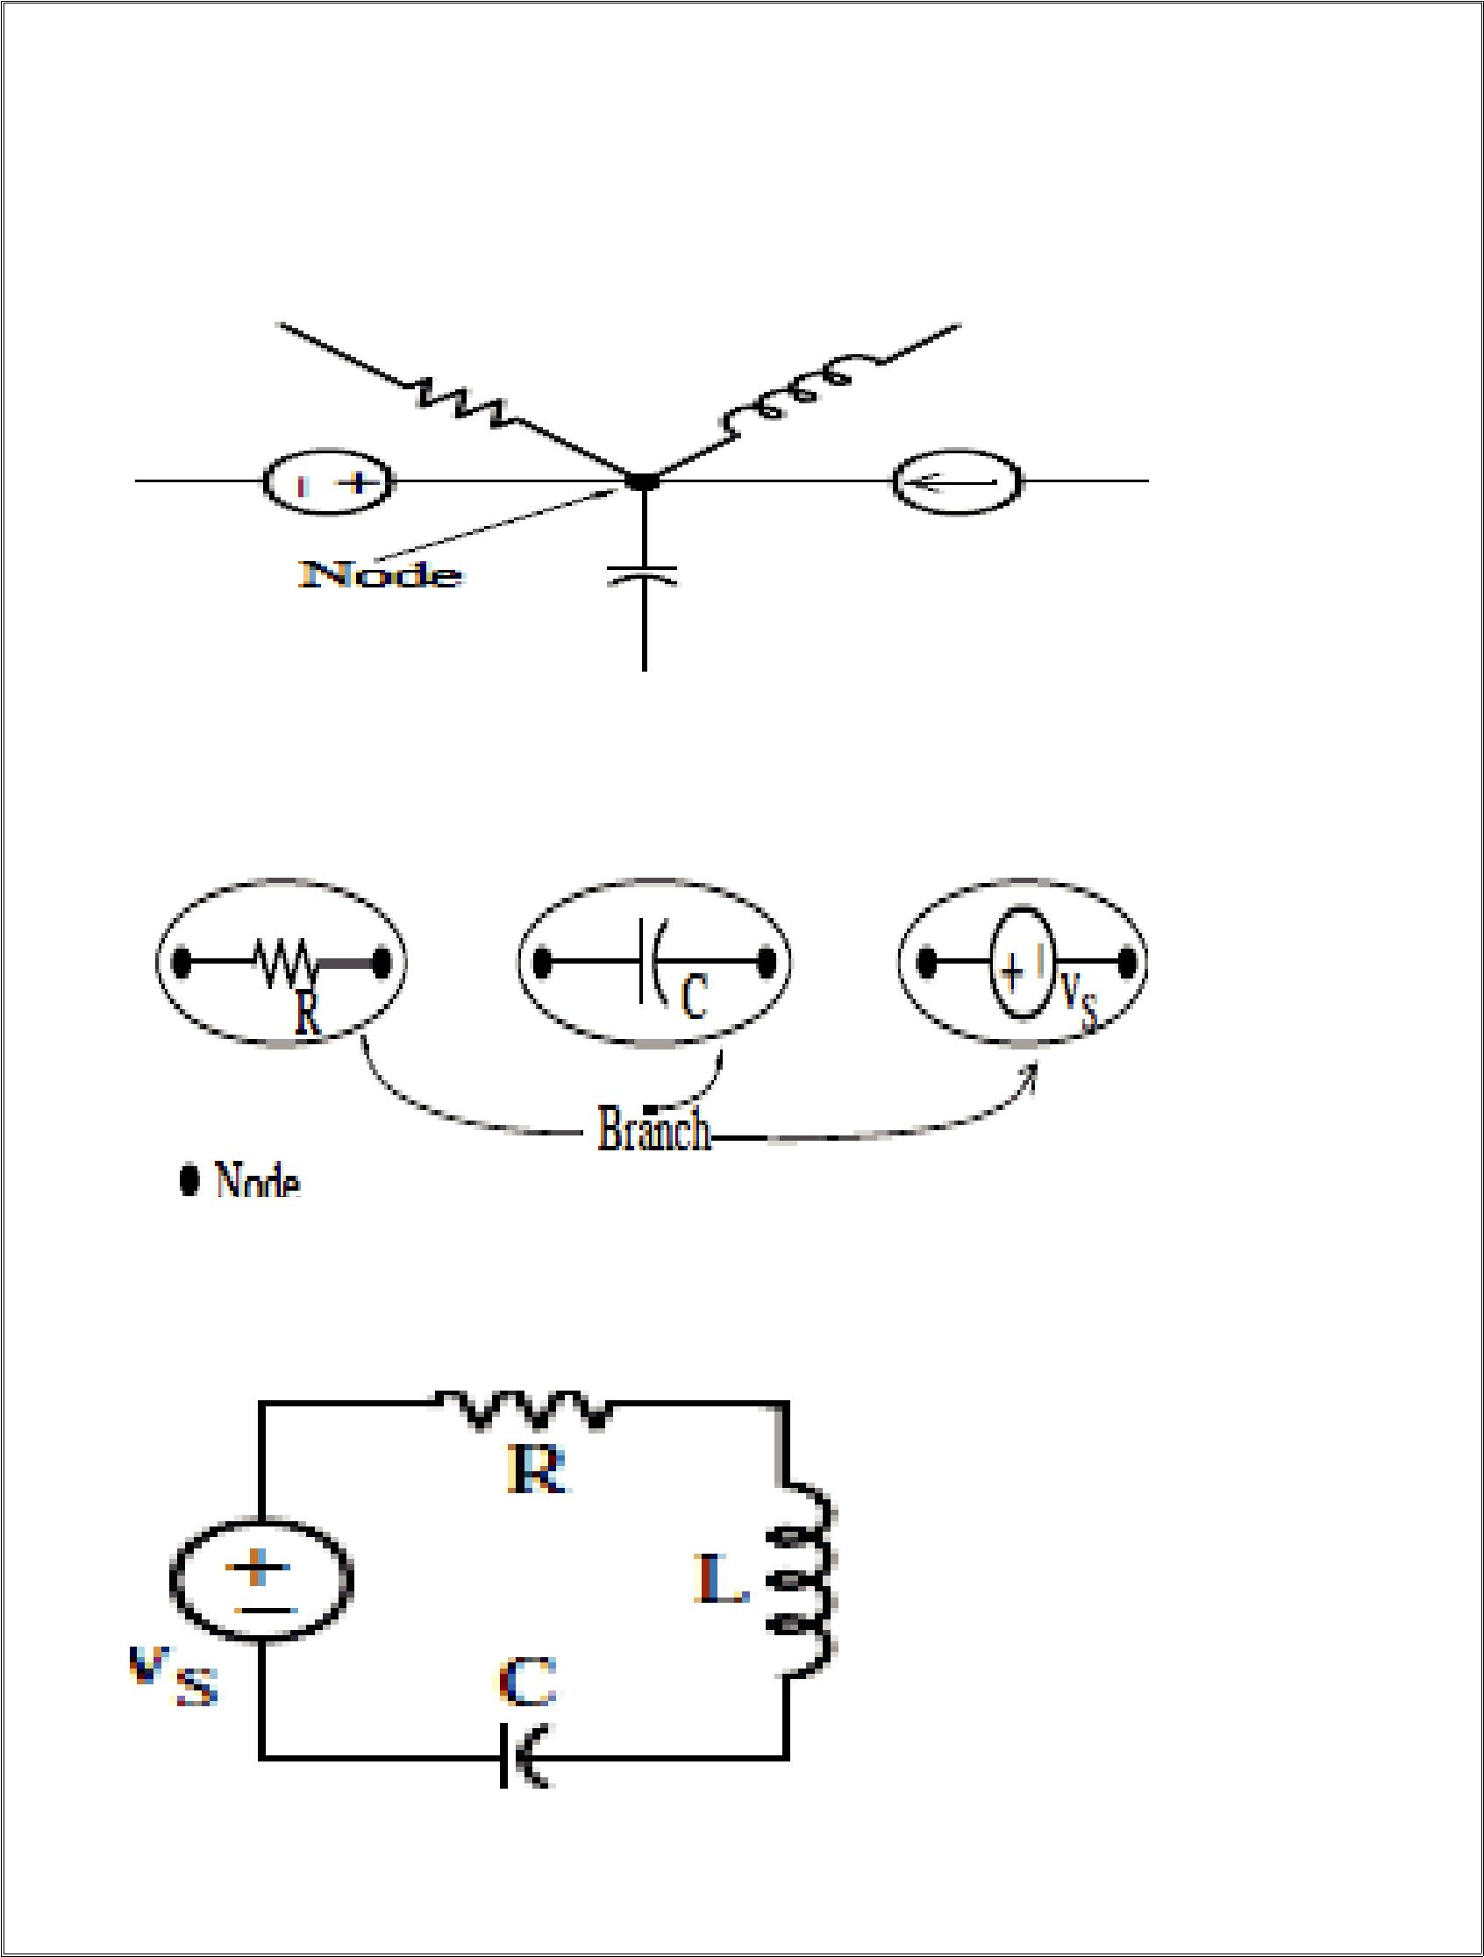
19

Nodes, Branches, Loops and Meshes

A node is the common point at which two or more devices (passive or active) are connected. An example of a node is shown

A branch is a simple path composed of one single device as shown

A loop is a closed path formed by the interconnection of simple devices. For example, the network shown

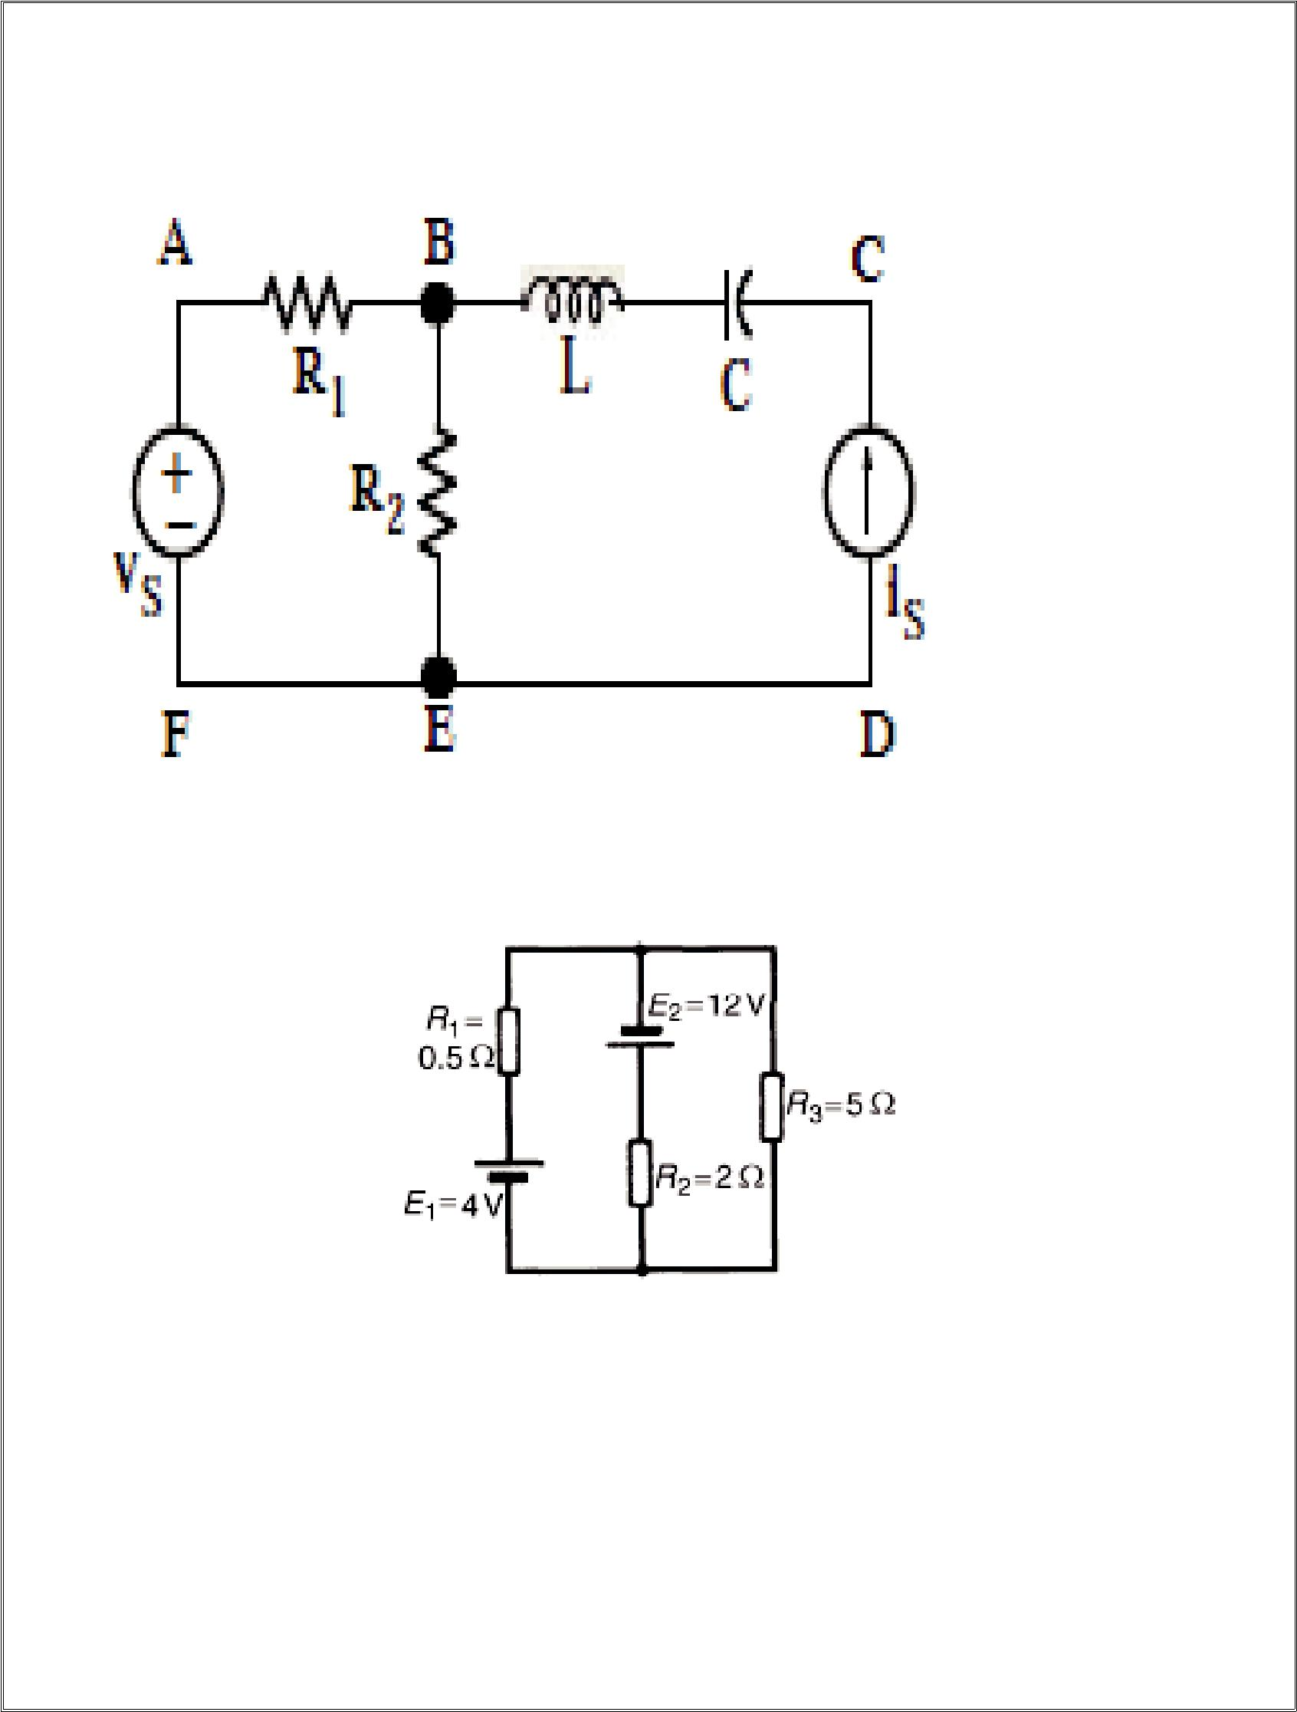
20

A mesh is a loop which does not enclose any other loops

Problem-6 Find the currents in all loops by Loop Analysis

Solution:

The network is divided into two loops as shown

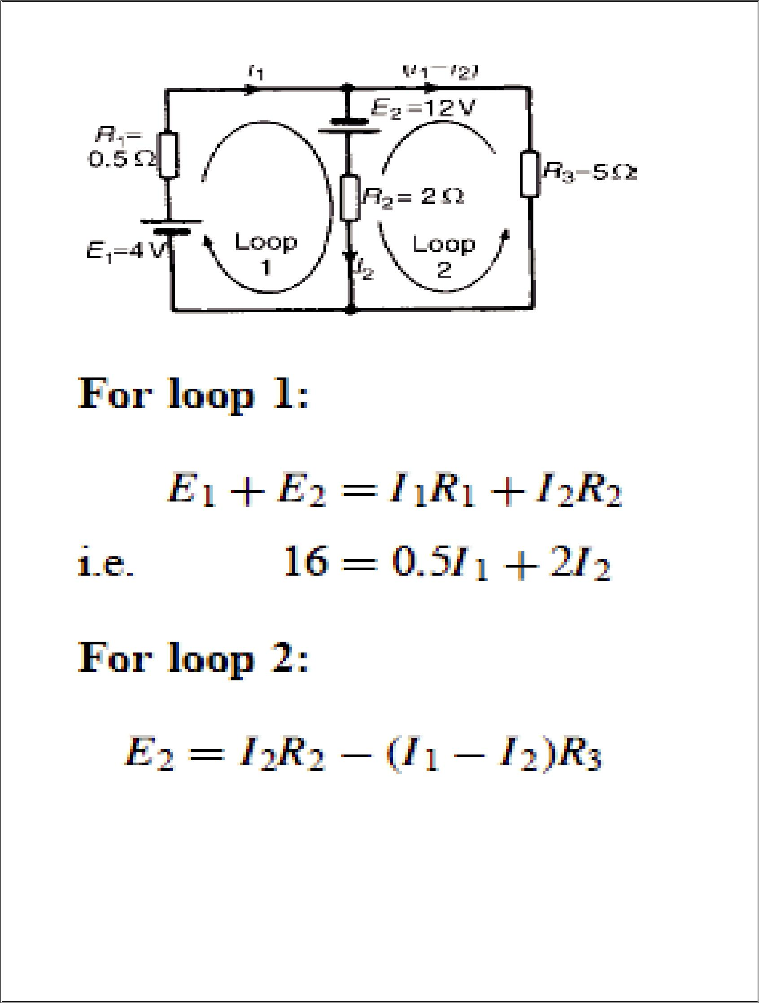
21

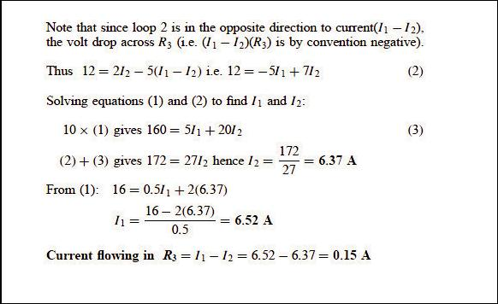
22

Beyond Syllabus

Star Delta Transformation
We can now solve simple series, parallel or bridge type resistive networks using Kirchoff´s Circuit Laws, mesh current analysis or nodal voltage analysis techniques but in a balanced 3-phase circuit we can use different mathematical techniques to simplify the analysis of the circuit and thereby reduce the amount of math's involved which in itself is a good thing.
Standard 3-phase circuits or networks take on two major forms with names that represent the way in which the resistances are connected, a Star connected network which has the symbol of the letter, Υ (wye) and a Delta connected network which has the symbol of a triangle, Δ (delta). If a 3-phase, 3-wire supply or even a 3-phase load is connected in one type of configuration, it can be easily transformed or changed it into an equivalent configuration of the other type by using either the Star Delta Transformation or Delta Star Transformation process.
A resistive network consisting of three impedances can be connected together to form a T or "Tee" configuration but the network can also be redrawn to form a Star or Υ type network as shown below.

T-connected and Equivalent Star Network
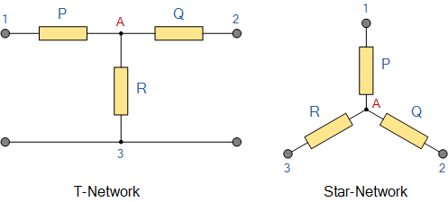
As we have already seen, we can redraw the T resistor network to produce an equivalent Star or Υ type network. But we can also convert a Pi or π type resistor network into an equivalent Delta or Δ type network as shown below.

Pi-connected and Equivalent Delta Network.
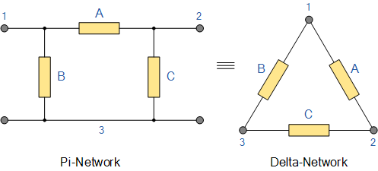
Having now defined exactly what is a Star and Delta connected network it is possible to transform the Υ into an equivalent Δ circuit and also to convert a Δ into an equivalent Υ circuit using a the transformation process. This process allows us to produce a mathematical relationship between the various resistors giving us a Star Delta Transformation as well as a Delta Star Transformation.
These transformations allow us to change the three connected resistances by their equivalents measured between the terminals 1-2, 1-3 or 2-3 for either a star or delta connected circuit. However, the resulting networks are only equivalent for voltages and currents external to the star or delta networks, as internally the voltages and currents are different but each network will consume the same amount of power and have the same power factor to each other.

Delta Star Transformation
To convert a delta network to an equivalent star network we need to derive a transformation formula for equating the various resistors to each other between the various terminals. Consider the circuit below.

Delta to Star Network.
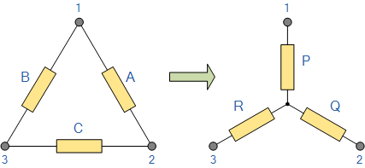
Compare the resistances between terminals 1 and 2.
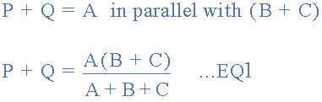
Resistance between the terminals 2 and 3.
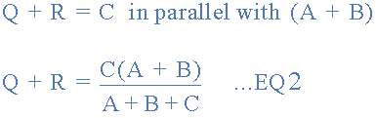
Resistance between the terminals 1 and 3.
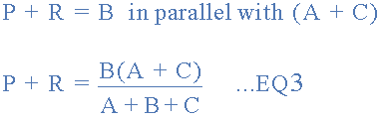
This now gives us three equations and taking equation 3 from equation 2 gives:
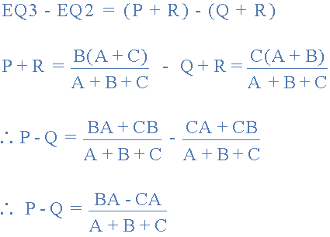
Then, re-writing Equation 1 will give us:
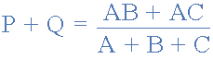
Adding together equation 1 and the result above of equation 3 minus equation 2 gives:
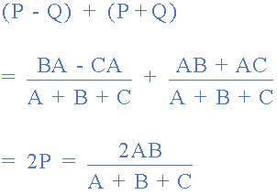
From which gives us the final equation for resistor P as:
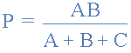
Then to summarize a little the above maths, we can now say that resistor P in a Star network can be found as Equation 1 plus (Equation 3 minus Equation 2) or Eq1 + (Eq3 - Eq2).
Similarly, to find resistor Q in a star network, is equation 2 plus the result of equation 1 minus equation 3 or Eq2 + (Eq1 - Eq3) and this gives us the transformation of Q as:
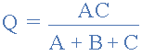
and again, to find resistor R in a Star network, is equation 3 plus the result of equation 2 minus equation 1 or Eq3 + (Eq2 - Eq1) and this gives us the transformation of R as:
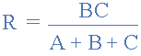
When converting a delta network into a star network the denominators of all of the transformation formulas are the same: A + B + C, and which is the sum of ALL the delta resistances. Then to convert any delta connected network to an equivalent star network we can summarized the above transformation equations as:

Star Delta Transformation
We have seen above that when converting from a delta network to an equivalent star network that the resistor connected to one terminal is the product of the two delta resistances connected to the same terminal, for example resistor P is the product of resistors A and B connected to terminal 1.
By rewriting the previous formulas a little we can also find the transformation formulas for converting a resistive star network to an equivalent delta network giving us a way of producing a star delta transformation as shown below.

Star to Delta Network.
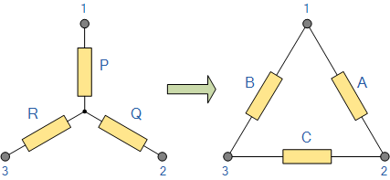
The value of the resistor on any one side of the delta, Δ network is the sum of all the two-product combinations of resistors in the star network divide by the star resistor located "directly opposite" the delta resistor being found. For example, resistor A is given as:
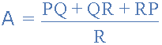
with respect to terminal 3 and resistor B is given as:
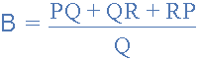
with respect to terminal 2 with resistor C given as:
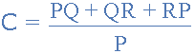
with respect to terminal 1.
By dividing out each equation by the value of the denominator we end up with three separate transformation formulas that can be used to convert any Delta resistive network into an equivalent star network as given below.
Star Delta Transformations allow us to convert one circuit type of circuit connection to another in order for us to easily analyise a circuit and one final point about converting a star resistive network to an equivalent delta network. If all the resistors in the star network are all equal in value then the resultant resistors in the equivalent delta network will be three times the value of the star resistors and equal, giving: R_{DELTA} = 3R_{STAR}

Circuit Analysis
In the previous tutorial we saw that complex circuits such as bridge or T-networks can be solved using Kirchoff's Circuit Laws. While Kirchoff´s Laws give us the basic method for analysing any complex electrical circuit, there are different ways of improving upon this method by using Mesh Current Analysis or Nodal Voltage Analysis that results in a lessening of the math's involved and when large networks are involved this reduction in maths can be a big advantage.

Mesh Analysis Circuit
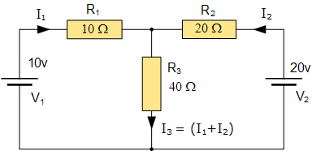
One simple method of reducing the amount of math's involved is to analyse the circuit using Kirchoff's Current Law equations to determine the currents, I₁ and I₂ flowing in the two resistors. Then there is no need to calculate the current I₃ as its just the sum of I₁ and I₂. So Kirchoff's second voltage law simply becomes:
- Equation No 1 : 10 = 50I₁ + 40I₂
- Equation No 2 : 20 = 40I₁ + 60I₂
therefore, one line of math's calculation have been saved.

Mesh Current Analysis
A more easier method of solving the above circuit is by using Mesh Current Analysis or Loop Analysis which is also sometimes called Maxwell´s Circulating Currents method. Instead of labelling the branch currents we need to label each "closed loop" with a circulating current. As a general rule of thumb, only label inside loops in a clockwise direction with circulating currents as the aim is to cover all the elements of the circuit at least once. Any required branch current may be found from the appropriate loop or mesh currents as before using Kirchoff´s method.
For example: : i₁ = I₁ , i₂ = -I₂ and I₃ = I₁ - I₂
We now write Kirchoff's voltage law equation in the same way as before to solve them but the advantage of this method is that it ensures that the information obtained from the circuit equations is the minimum required to solve the circuit as the information is more general and can easily be put into a matrix form.
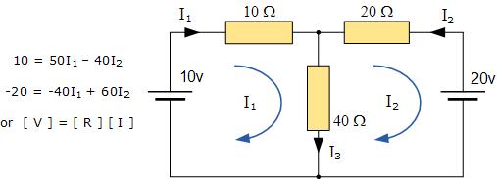
These equations can be solved quite quickly by using a single mesh impedance matrix Z. Each element ON the principal diagonal will be "positive" and is the total impedance of each mesh. Where as, each element OFF the principal diagonal will either be "zero" or "negative" and represents the circuit element connecting all the appropriate meshes. This then gives us a matrix of:
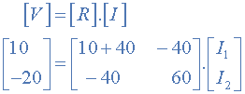
Where:
- [ V ] gives the total battery voltage for loop 1 and then loop 2.
- [ I ] states the names of the loop currents which we are trying to find.
- [ R ] is called the resistance matrix.
and this gives I₁ as -0.143 Amps and I₂ as -0.429 Amps
As : I₃ = I₁ - I₂
The current I₃ is therefore given as : -0.143 - (-0.429) = 0.286 Amps
which is the same value of 0.286 amps, we found using Kirchoff´s circuit law in the previous tutorial.

Mesh Current Analysis Summary.
This "look-see" method of circuit analysis is probably the best of all the circuit analysis methods with the basic procedure for solving Mesh Current Analysis equations is as follows:
1. Label all the internal loops with circulating currents. (I₁, I₂, ...I_{L} etc)
2. Write the [ L x 1 ] column matrix [ V ] giving the sum of all voltage sources in each loop.
3. Write the [ L x L ] matrix, [ R ] for all the resistances in the circuit as follows;
R₁₁ = the total resistance in the first loop.
R_{nn} = the total resistance in the Nth loop.
R_{JK} = the resistance which directly joins loop J to Loop K.
4. Write the matrix or vector equation [V] = [R] x [I] where [I] is the list of currents to be found.
As well as using Mesh Current Analysis, we can also use node analysis to calculate the voltages around the loops, again reducing the amount of mathematics required using just Kirchoff's laws. In the next tutorial about DC Theory we will look at Nodal Voltage Analysis to do just that.

Nodal Voltage Analysis
As well as using Mesh Analysis to solve the currents flowing around complex circuits it is also possible to use nodal analysis methods too. Nodal Voltage Analysis complements the previous mesh analysis in that it is equally powerful and based on the same concepts of matrix analysis. As its name implies, Nodal Voltage Analysis uses the "Nodal" equations of Kirchoff's first law to find the voltage potentials around the circuit.
So by adding together all these nodal voltages the net result will be equal to zero. Then, if there are "n" nodes in the circuit there will be "n-1" independent nodal equations and these alone are sufficient to describe and hence solve the circuit.
At each node point write down Kirchoff's first law equation, that is: "the currents entering a node are exactly equal in value to the currents leaving the node" then express each current in terms of the voltage across the branch. For "n" nodes, one node will be used as the reference node and all the other voltages will be referenced or measured with respect to this common node.
For example, consider the circuit from the previous section.

Nodal Voltage Analysis Circuit
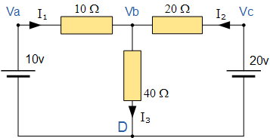
In the above circuit, node D is chosen as the reference node and the other three nodes are assumed to have voltages, Va, Vb and Vc with respect to node D. For example;
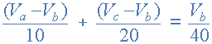
As Va = 10v and Vc = 20v , Vb can be easily found by:
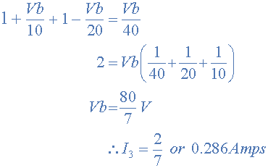
again is the same value of 0.286 amps, we found using Kirchoff's Circuit Law in the previous tutorial.
From both Mesh and Nodal Analysis methods we have looked at so far, this is the simplest method of solving this particular circuit. Generally, nodal voltage analysis is more appropriate when there are a larger number of current sources around. The network is then defined as: [ I ] = [ Y ] [ V ] where [ I ] are the driving current sources, [ V ] are the nodal voltages to be found and [ Y ] is the admittance matrix of the network which operates on [ V ] to give [ I ].

Nodal Voltage Analysis Summary.
The basic procedure for solving Nodal Analysis equations is as follows:
1. Write down the current vectors, assuming currents into a node are positive. ie, a (N x 1)
matrices for "N" independent nodes.
2. Write the admittance matrix [Y] of the network where:
Y₁₁ = the total admittance of the first node.
Y₂₂ = the total admittance of the second node.
R_{JK} = the total admittance joining node J to node K.
3. For a network with "N" independent nodes, [Y] will be an (N x N) matrix and that Ynn will be
positive and Yjk will be negative or zero value.
4. The voltage vector will be (N x L) and will list the "N" voltages to be found.
We have now seen that a number of theorems exist that simplify the analysis of linear circuits. In the next tutorial we will look at Thevenins Theorem which allows a network consisting of linear resistors and sources to be represented by an equivalent circuit with a single voltage source and a series resistance.

