JAIPUR ENGINEERING COLLEGE AND RESEARCH CENTRE
JECRC Campus, Shri Ram Ki Nangal, Via-Vatika,Jaipur

Department of Electrical Engineering
Question Bank
Academic Year – 2020-21

Subject: Basic Electrical Engineering (2FY3-08)
Course Outcomes
CO1 | Analyze the DC and AC electrical circuits using network theorems.
CO2 | Understand the construction and working principle of the transformer, AC and DC rotating machines.
CO3 | Understand the concepts of power converters and switchgear requirements.

Q.1- Solve the circuit shown in figure-1 using mesh analysis and determine the mesh currents I₁,I₂,I₃. Evaluate the power developed in the 10V voltage source. (Gate EE 1999)
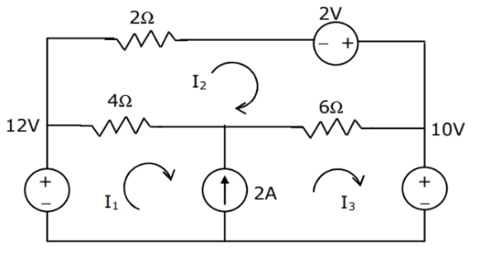
Fig.-1
Q.2- In the resister network shown in fig-2, all resistor values are 1Ω. A current of 1A passes from terminal a to terminal b, as shown in fig. calculate the voltage between terminal a and b.
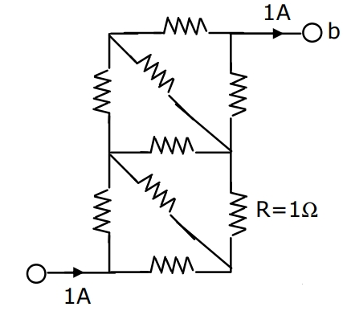 (Gate EE 2002)
Fig.-2

Q.3- In fig-3 the value of R is-
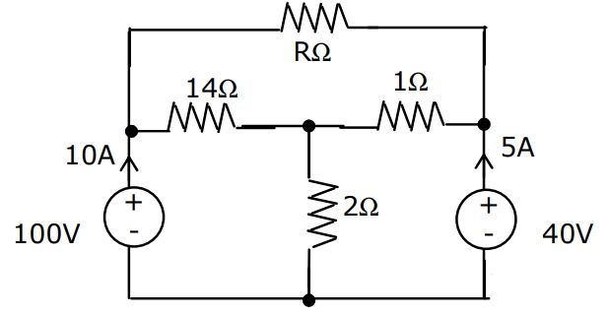 (Gate EE 2003)
Fig.-3
Q.4- In Fig.-4 the value of source voltage is-
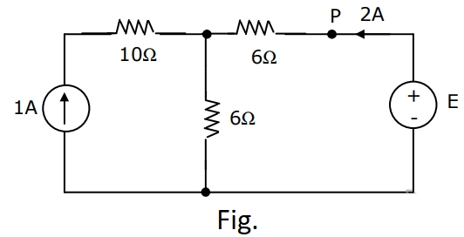 (Gate EE 2004)
Fig.-4
Q.5- Assuming ideal elements in the circuit shown below, The voltage V_{ab} will be-
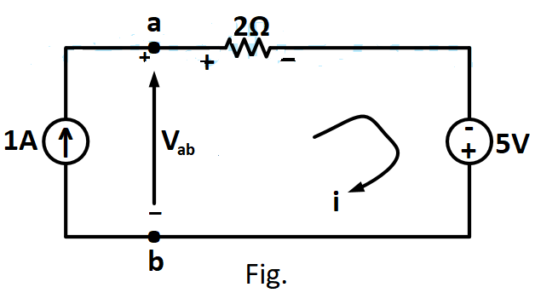 (Gate EE 2008)
Fig.-5

Q.6- For circuit shown in figure-6, the Norton equivalent source current value is……..A and its resistance is …….ohms.
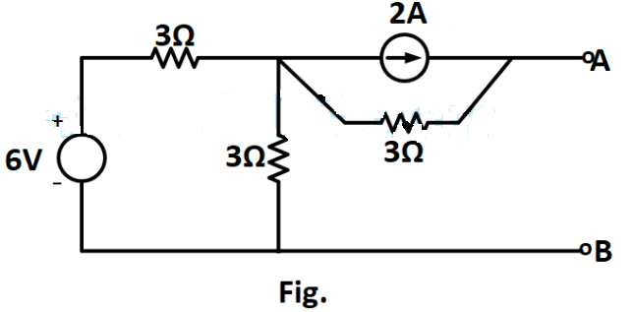 (Gate EE 2008)
Fig.-6

Q.7- Viewed from the terminal A and B the following circuit shown in figure-7 can be reduced to an equivalent circuit of a single voltage source in series with a single resister with the following parameters:

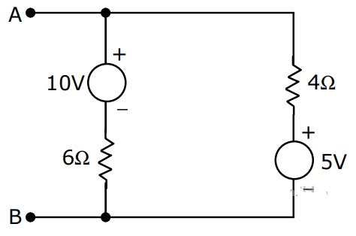 (Gate EE 1998)
Fig.-7

Q.8- Use mesh analysis to find the current I_{o} in the circuit of Fig.-8.
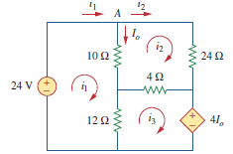
Fig.-8
Q.9- Using the principle of superposition, find the current I2 through the 12 kilo ohm resistor in Fig.-9.
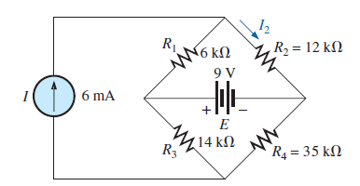
Fig.-9
Q.10- Find I in the circuit of Fig. 10, using the superposition principle.
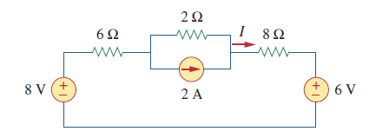
Fig.10
Q.11- The laws of electromagnetic induction (Faraday’s law and Lenz’s law) are summarized in following equation:
(a) e = iR (b) $e=L\frac{di}{dt}$ (c) $e=-\frac{dφ}{dt}$ (d) None of these (Gate EE 1998)

Q.12- An inductive coil has a resistance of 5 Ω and inductance of 15.6 mH. It is connected across a 200 V, 50 HZ supply. Find current drawn from supply, Voltage across resistance and inductance, power factor of the circuit.
Q.13- A 100 Ω resistance is connected in series with choke coil. When a 440 V, 50 HZ single phase alternating voltage is applied to this combination, the voltage across the resistance and chock coil are 200 V and 300 V respectively. Calculate (i) Resistance and inductance of the coil, (ii) The total resistance and impedance of circuit, (iii) The power absorbed by the chock coil and the circuit.
Q.14- The voltage and current in series circuit are V=200√2 sin (314t-30⁰) and I = 20√2 sin (314t+30⁰)
Determine (i) Circuit elements (ii) power factor of circuit (iii) Active , Reactive and apparent power (iv) Draw triangles.
Q.15- A coil having a resistance of 5Ω and inductance of (1/π) H is connected in series with a capacitor of (100/π) µF. A 200 V, 50 Hz alternating voltage source is applied across the circuit.
(i) Find the total impedance of the circuit.
(ii) Find the current flowing through the voltage source.
(iii) Find the voltage across R,L,C components.
(iv) Draw the phasor diagram.
Q.16- Write a short note on series resonance in ac circuits.

Q.17- Write the construction and working principle of single phase transformer.
Q.18- Derive the EMF equation of a single phase transformer.
Q.19- Differentiate between the core type and shell type transformer.
Q.20- Draw the phasor diagram of a single phase practical transformer at RL load.
Q.21- Explain the losses in transformer.
Q.22- A 250 KVA, 11000/415 V, 50 HZ, single phase transformer has 80 turns on the secondary side, calculate:
(i) The approximate value of full load primary and secondary currents.
(ii) The approximate number of primary turns.
(iii) The maximum value of the flux.

Q.23- A 200 KVA, 66000/400 V, 50 HZ, single phase transformer has 80 turns on the secondary side and cross sectional area of the core is 80 sq.cm. Neglecting losses, calculate:
(i) The full load primary and secondary currents.
(ii) The number of primary turns.
(iii) The maximum value of the flux.
Q.24- A 230/110 V ,single phase transformer takes an input of 350 VA at no load and rated voltage. The core loss is 110W. Find (i) no- load power factor,(ii) the iron loss component of no- load current, and (iii) magnetize component of no- load current.
Q.25- A 30 KVA, 2400/120 V, 50 HZ, transformer has a high voltage winding resistance of 0.1 Ω and leakage reactance of 0.22 Ω. The low voltage winding resistance is 0.035Ω and leakage reactance of 0.012 Ω. Calculate for the transformer:
(i) Equivalent resistance as referred to both primary and secondary.
(ii) Equivalent reactance as referred to both primary and secondary.
(iii) Equivalent impedance as referred to both primary and secondary.
(iv) Copper loss at full load.

Q.26- A 600 KVA, single phase transformer has an efficiency of 92% at full load and also at half load, working at unity pf. Calculate the efficiency of the transformer at 60% full load and unity pf.

Q.27- A 240 V, DC shunt motor with an armature resistance of 0.5Ω has a full load current of 40 A. Find a ratio of the stalling torque to the full load torque when a resistance of 1 Ω is connected in series with the armature?
(a) 4 (b) 12 (c) 6 (d) none of the above. (Gate EE 1998)
Q.28- A DC shunt motor is running at 1200 rpm, when exited with 220 V DC. Neglecting the losses and saturation, the speed of the motor when connected to a 175 V DC supply is-
(a) 750 RPM (b) 900 RPM (c) 1050 RPM (d) 1200 RPM (Gate EE 1999)

Q.29- With the help of neat sketches the difference between the three phase slip ring induction motor and three phase squirrel cage induction motor. Discuss the merits of one over the other.

Q.30- Explain the construction and working of three phase induction motor.
Q.31- Discuss the concept of production of rotating magnetic field in a three phase induction motor.
Q.32- Why does an induction motor never attains synchronous speed?
Q.33- Write a short note on starting of induction motor.
Q.34- An induction motor runs at 1460 rpm under full load condition when supplied by 50 HZ supply. Find the number of poles and slip of motor.

Q.35- Explain the various methods of speed control of induction motor.

Q.36- Explain the constructional features of DC machine.
Q.37- Explain the working principle of DC generator and DC motor.

Q.38- Draw and explain a typical V-I characteristics of a semiconductor diode.

Q.39- Explain the working of NPN transistor and with the help of necessary diagram explain the current components of transistor.
Q.40- Draw and explain the V-I characteristics of SCR.

Q.41- Draw the circuit diagram of a bridge rectifier and explain its working.
Q.42- Draw the circuit diagram of a full wave rectifier and explain its working.

Q.43- Write a short note on IGBT.
Q.44- Draw a typical layout of LT switchgear.
Q.45- Write a short note on followings.
(a) SFU (b) MCB
Q.46- Explain two wattmeter method of measuring power of a three phase delta connected load.

Q.47- A 1500 W electric washing machine is used for 90 minutes. Determine the energy consumption of the machine. Assuming one unit cost as Rs. 8.00, Find the cost of energy consumed.

Q.48- The input power to a three phase motor was measured using two wattmeters. The readings were 5.2 KW and -1.7 KW, and the line voltage was 415 V. Calculate-
(a) the total active power, (b) the power factor, and (c) the line current.

Q.49- In a balanced three phase, 400 V circuit, the line current is 115 amp. When power is measured by two wattmeter method, one wattmeter reads 40 KW and the other one reads zero. What is the power factor of load? If the power factor was unity and the line currents are same, what would be the reading of each wattmeter?

Q.50- A laptop uses 75 watt. Electricity cost is Rs. 8/KWh. Calculate for how much time it runs in a day for one year so that yearly energy consumption cost is Rs.1314. Assume laptop runs for same number of hours in a year.

