JAIPUR ENGINEERING COLLEGE AND RESEARCH CENTRE

Year & Sem – III Year/ V sem
Subject – Electrical Machine Design
Subject Code – 5EE4-05
Unit – 3.1
Presented by – Mr. Atul Kulshrestha, Asstt Professor, EE

DESIGN OF INDUCTION MOTOR

1

Construction of Induction Motor
The AC induction motor comprises two electromagnetic parts:
- Stationary part called the stator
- Rotating part called the rotor
The stator and the rotor are each made up of
- An electric circuit, usually made of insulated copper or aluminium winding, to carry current
- A magnetic circuit, usually made from laminated silicon steel, to carry magnetic flux

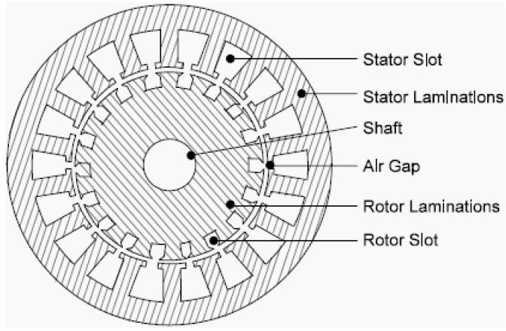

Stator
The stator is the outer stationary part of the motor, which consists of:
- The outer cylindrical frame of the motor or yoke, which is made either of welded sheet steel, cast iron or cast aluminium alloy.
- The magnetic path, which comprises a set of slotted steel laminations called stator core pressed into the cylindrical space inside the outer frame. The magnetic path is laminated to reduce eddy currents, reducing losses and heating.
- A set of insulated electrical windings, which are placed inside the slots of the laminated stator. The cross-sectional area of these windings must be large enough for the power rating of the motor. For a 3-phase motor, 3 sets of windings are required, one for each phase connected in either star or delta.

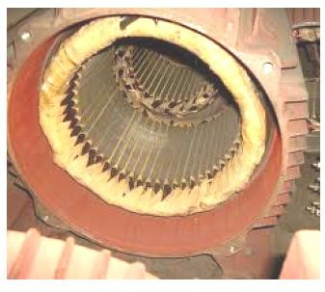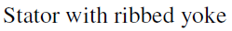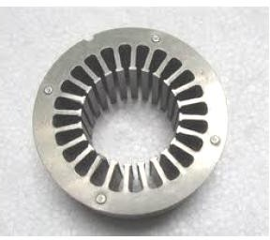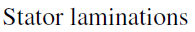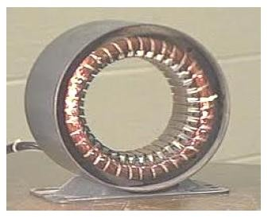

Rotor
Rotor is the rotating part of the induction motor. The rotor also consists of a set of slotted silicon steel laminations pressed together to form of a cylindrical magnetic circuit and the electrical circuit. The electrical circuit of the rotor is of the following nature
Squirrel cage rotor consists of a set of copper or aluminium bars installed into the slots, which are connected to an end-ring at each end of the rotor. The construction of this type of rotor along with windings resembles a ‘squirrel cage’. Aluminium rotor bars are usually die-cast into the rotor slots, which results in a very rugged construction. Even though the aluminium rotor bars are in direct contact with the steel laminations, practically all the rotor current flows through the aluminium bars and not in the lamination

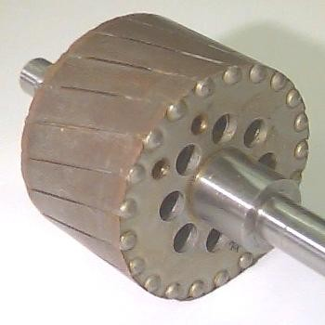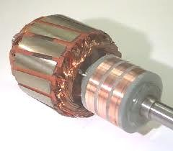

Wound rotor consists of three sets of insulated windings with connections brought out to three slip rings mounted on one end of the shaft. The external connections to the rotor are made through brushes onto the slip rings. Due to the presence of slip rings such type of motors are called slip ring motors.

Some more parts to complete the constructional details of an induction motor, are given below:
- Two end-flanges to support the two bearings, one at the driving-end and the other at the non driving-end, where the driving end will have the shaft extension.
- Two sets of bearings to support the rotating shaft,
- Steel shaft for transmitting the mechanical power to the load.
- Cooling fan located at the non driving end to provide forced cooling for the stator and rotor
- Terminal box on top of the yoke or on side to receive the external electrical
connection.

Cut sectional view of the induction motor
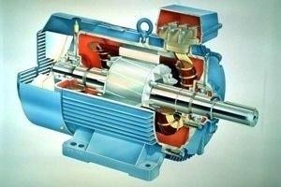

Introduction to Design

The main purpose of designing an induction motor is to obtain the complete physical dimensions of all the parts of the machine as mentioned below to satisfy the customer specifications. The following design details are required.
1. The main dimensions of the stator. 2. Details of stator windings.
- Design details of rotor and its windings
- Performance characteristics.

Main Dimensions: The armature diameter (stator bore) D and armature core length L are known as the main dimensions of a rotating machine.
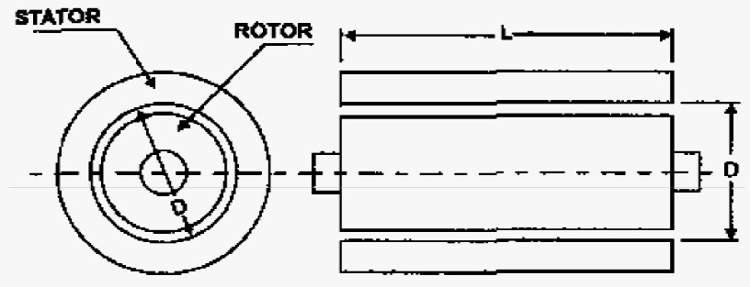

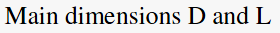

Total Loadings:
Total Magnetic Loading: the total flux around the armature (or stator) periphery at the air gap is called the total magnetic loading.
total magnetic loading = pφ

Total Electric Loading: the total number of ampere conductors around the armature (or stator) periphery is called the total electric loading.
total electric loading = Iz Z

Specific Loadings:
Specific Magnetic Loading: the average flux density over the air gap of a machine is known as specific magnetic loading.

specific magnetic loading
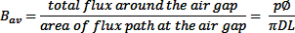
Specific Electric Loading: the number of armature (or stator) ampere conductors per meter of armature (or stator) periphery at the air gap is known as specific electric loading.
specific electric loading

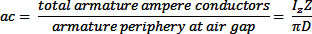

Let

Output Equation

Vph = phase voltage ; Iph = phase current
Zph = no of conductors/phase; Tph = no of turns/phase
Ns = Synchronous speed in rpm; ns = synchronous speed in rps p = no of poles ; ac = Specific electric loading
Ф= air gap flux/pole; Bav = Average flux density
Kw = winding factor ; η = efficiency
D = Diameter of the stator; L = Gross core length
Co = Output coefficient; cos υ = power factor

Consider an ‘m’ phase machine, with usual notations Out put Q in kW = Input x efficiency
Input to motor = mVph Iph cosφ * 10-3 kW For a 3 –φ machine m = 3
Input to motor = 3Vph Iph cosφ * 10-3 kW Assuming Vph = Eph, Vph = Eph = 4.44 f Ф TphKw
= 2.22 f Ф ZphKw
f = PNS/120 = P* ns/2
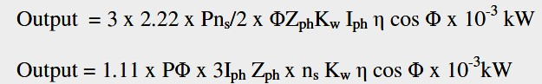

PФ = Bav πDL, and 3Iph Zph/ π D = ac
Output to motor = 1.11 * Bav π D L * π D ac * ns Kw η cos φ * 10-3 kW
Q = (1.11 π2 Bav ac Kw η cosφ * 10-3) D2 L ns kW Q = (11 Bav ac Kw η cosφ * 10-3) D2 L ns kW
Therefore Output Q = Co D2 L ns kW
where Co = (11 Bav ac Kw η cosφ * 10-3) = Output coefficient

Choice of Specific Loadings

Specific Magnetic loading or Air gap flux density
- Power factor: poor power factor for high flux density in air gap
- Iron loss: iron losses increase with increase in flux density
- Overload capacity: overload capacity increase with increase in
flux density

Limitations :
Flux density in teeth < 1.8 Tesla Flux density in core 1.3 – 1.5 Tesla Advantages of Higher value of Bav
- Size of the machine reduced
- Cost of the machine decreases
- Overload capacity increases
For 50 Hz machine the value of Bav lies between 0.35 – 0.6 Tesla.

Specific electric loading or ampere conductors per meter
- Copper loss and temperature rise: a large value of ac gives higher copper losses and large temp. rise

Voltage: for high voltage machine value of ac should be small
- Overload capacity: overload capacity decreased with high value of ac.

The value of ac depends upon the size of the motor, voltage of stator
winding, type of ventilation and overload capacity desired.
It varies between 5000 – 45000 ampere conductors per meter.

Separation of D and L

The output equation gives the relation between D2L and output of the machine. To separate D and L for this product a relation has to be assumed. Following are the various design considerations based on which a suitable ratio between gross length and pole pitch (L/τ) assumed.

- To obtain minimum over all cost 1.5 to 2.0
- To obtain good efficiency 1.4 to 1.6
- To obtain good over all design 1.0 to 1.1
- To obtain good power factor 1.0 to 1.3

Power factor plays a very important role in the performance of induction motors. Hence to obtain the best power factor the following relation will be usually assumed for separation of D and L.
Pole pitch/ Core length = 0.18/pole pitch or (πD/p) / L= 0.18/ (πD/p)
i.e D = 0.135P√L where D and L are in meter.

Peripheral Speed

The obtained values of D and L have to satisfy the condition imposed on the value of peripheral speed.
For the normal design of induction motors the calculated diameter of the motor should be such that the peripheral speed must be below 30 m/s. In case of specially designed rotor the peripheral speed can be 60 m/s.

Stator Design
Stator slots: in general two types of stator slots are employed in induction motors viz, open slots and semi closed slots. Operating performance of the induction motors depends upon the shape of the slots
- Open slots: In this type of slots the slot opening will be equal to that of the width of the slots. In such type of slots, assembly and repair of winding are easy. However such slots will lead to higher air gap contraction factor and hence poor power factor.
- Semi closed slots: In such type of slots, slot opening is much smaller than the width of the slot. Hence in this type of slots assembly of windings is more difficult and takes more time compared to open slots and hence it is costlier. However the air gap characteristics are better compared to open type slots.
- Tapered slots: In this type of slots also, opening will be much smaller than the slot width. However the slot width will be varying from top of the slot to bottom of the slot with minimum width at the bottom.

Selection of number of stator slots:

Number of stator slots must be properly selected at the design stage as such this number affects the weight, cost and operating characteristics of the motor. As there are no rules for selecting the number of stator slots, the advantages and disadvantages of selecting higher number slots help to serve as guidelines in the selection. Following are the advantages and disadvantages of selecting higher number of slots.
Advantages :

Reduced leakage reactance.
- Reduced tooth pulsation losses.
- Higher over load capacity.

Disadvantages:
- Increased cost
- Increased weight
- Increased magnetizing current
- Increased iron losses
- Poor cooling
- Increased temperature rise
- Reduction in efficiency
The number of slots/pole/phase should not be less than 2 otherwise the leakage reactance becomes high. The number of slots should be selected to give an integral number of slots per pole per phase. The stator slot pitch at the air gap surface should be between 1.5 to 2.5 cm.
Stator slot pitch at the air gap surface = τss= πD/Sss where Sss is the number of stator slots

Turns per phase :

EMF equation of an induction motor is given by
Eph = 4.44fФTph Kw

Hence turns per phase can be obtained from emf equation
Tph = Eph/ 4.44f Фm Kw

Generally the induced emf can be assumed to be equal to the applied voltage per phase
Flux/pole, Фm = Bav * πDL/p,

winding factor Kw may be assumed as 0.955 for full pitch distributed
winding unless otherwise specified.
Number conductors /phase, Zph = 2 x Tph, and hence Total number of stator conductors Z = 6*Tph and conductors/slot Zs = Z/Ss or 6*Tph/Ss

Conductor cross section:
Area of cross section of stator conductors can be estimated from the stator current per phase and suitably assumed value of current density for the stator windings.
Sectional area of the stator conductor as = Is /δs where δs is the current density in stator windings
Stator current per phase Is = Q / (3Vph cosυ)
A suitable value of current density has to be assumed considering the advantages and disadvantages.
Advantages of higher value of current density:
- reduction in cross section
- reduction in weight
- reduction in cost

Disadvantages of higher value of current density:
- increase in resistance
- increase in cu loss
- increase in temperature rise
- reduction in efficiency
Higher value is assumed for low voltage machines and small machines. Usual value of current density for stator windings is 3 to 5 amps/mm2.
Area of stator slot: Slot area is occupied by the conductors and the insulation. Out of which almost more than 25 % is the insulation. Once the number of conductors per slot is decided, approximate area of the slot can be estimated.
Slot space factor = Copper area in the slot /Area of each slot
This slot space factor so obtained will be between 0.25 and 0.4.

Length of the mean Turn:
Length of the mean turn is calculated using formula
Lmt = 2L + 2.3 τ + 0.24
where L is the gross length of the stator and τ is pole pitch in meter.
Depth of stator core below the slots: There will be certain solid portion below the slots in the stator which is called the depth of the stator core. The flux density in the stator core lie between 1.2 to 1.4 Tesla. The flux passing through the stator core is half of the flux per pole.
Flux in the stator core section Фc = ½ Ф
Area of stator core Ac = Фc /2Bc
Area of stator core Ac = Li x dcs
Hence, depth of the core (dcs ) = Ac / Li = Фc /2Bc*Li
Using the design data obtained so far outer diameter of the stator core can be calculated as
Do = D + 2(depth of stator slots + depth of core)
= D + 2 dss + 2 dcs

Rotor Design
There are two types of rotor construction. One is the squirrel cage rotor and the other is the slip ring rotor. Most of the induction motor are squirrel cage type. These are having the advantage of rugged and simple in construction and comparatively cheaper. However they have the disadvantage of lower starting torque. In this type, the rotor consists of bars of copper or aluminium accommodated in rotor slots. In case slip ring induction motors the rotor complex in construction and costlier with the advantage that they have the better starting torque. This type of rotor consists of star connected distributed three phase windings.

Length of Air-gap

Between stator and rotor is the air gap which is a very critical part. The performance parameters of the motor like magnetizing current, power factor, over load capacity, cooling and noise are affected by length of the air gap.
Power Factor:- the mmf required to send the flux through air gap is

proportional to the product of flux density and length of air gap.
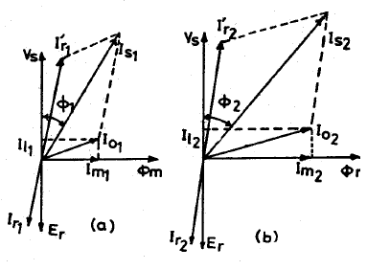fig shows phasor diagrams of an induction motor with two different air gap lengths. With increase in air gap length, magnetizing mmf increases and hence greater the
29
magnetizing current. Therefore, the phase angle between applied voltage and stator current will increase which gives low power factor.

Overload Capacity:- overload capacity of induction motor is the ratio of maximum output to rated output and the maximum output is obtained from circle diagram. The diameter of circle diagram is Vs/Xs where Xs is reactance of motor. The length of air gap affects the leakage reactance. If
the length of air gap is large, the leakage flux is reduced, hence reduced value of leakage reactance. With decrease in the value of leakage reactance the diameter of circle diagram increases and hence the overload capacity increases.
Pulsation loss:- the tooth pulsation losses, which is produced due to
variation in reactance of the air gap, is reduced with large air gap.
Cooling:- the large air gap provide better facilities for cooling at the gap surfaces due to the cylindrical surfaces of stator and rotor are separated by large distance.
Noise:- noise in induction motor reduced with increase in air gap length due to reduction in leakage flux which is the cause of noise.

Hence length of the air gap is selected considering the advantages and disadvantages of larger air gap length.

Advantages:
  - Increased overload capacity
  - Increased cooling
  - Reduced unbalanced magnetic pull
  - Reduced in tooth pulsation
  - Reduced noise

Disadvantages
- Increased Magnetising current
- Reduced power factor
Magnetising current and power factor being very important parameters in deciding the performance of induction motors, the induction motors are designed for optimum value of air gap or minimum air gap possible. Hence in designing the length of the air gap following empirical formula is employed.
Air gap length lg = 0.2 + 2√DL mm

Design of Squirrel Cage Rotor

Number of slots: Proper numbers of rotor slots are to be selected in relation to number of stator slots otherwise undesirable effects will be found at the starting of the motor. Cogging and Crawling are the two phenomena which are observed due to wrong combination of number of rotor and stator slots. In addition, induction motor may develop unpredictable hooks and cusps in torque speed characteristics or the motor may run with lot of noise.

Crawling: The rotating magnetic field produced in the air gap will be usually nonsinusoidal and generally contains odd harmonics of the order 3rd, 5th and 7th. The third harmonic flux will produce the three times the magnetic poles compared to that of the fundamental. Similarly the 5th and 7th harmonics will produce the poles five and seven times the fundamental respectively. The presence of harmonics in the flux wave affects the torque speed characteristics. The motor with presence of 7th harmonics is to have a tendency to run the motor at one seventh of its normal speed.

Cogging: In some cases where in the number of rotor slots are not proper in relation to number of stator slots the machine refuses to run and remains stationary. Under such conditions there will be a locking tendency between the rotor and stator. Such a phenomenon is called cogging.
Hence in order to avoid such bad effects a proper number of rotor slots are to be selected in relation to number of stator slots. In addition rotor slots will be skewed by one slot pitch to minimize the tendency of cogging, torque defects like synchronous hooks and cusps and noisy operation while running. Effect of skewing will slightly increase the rotor resistance and increases the starting torque. However this will increase the leakage reactance and hence reduces the starting current and power factor.

Selection of number of rotor slots: The number of rotor slots may be selected
using the following guide lines.
- To avoid cogging and crawling: (a)Ss ≠ Sr (b) Ss - Sr ≠ 3P
- To avoid synchronous hooks and cusps in torque speed characteristics Ss - Sr
≠ P, 2P, 5P.
- To noisy operation Ss - Sr ≠ 1, 2, (P ±1), (P ±2)
Rotor Bar Current: Bar current in the rotor of a squirrel cage induction motor may be determined by comparing the mmf developed in rotor and stator. The stator mmf is about 15% higher because of the magnetizing mmf.
Rotor mmf = 0.85 (stator mmf)
Number of rotor bars = Nb = Sr = number of rotor slots Rotor bar current = Ib
Rotor mmf = Ib. Sr/2
Stator mmf = 3. Is . Ts
Thus Ib.Sr/2 = 0.85 (3. Is . Ts) or Ib = 0.85 * (6*Is*Ts/Sr)

Cross sectional area of Rotor bar: Sectional area of the rotor conductor can be calculated by rotor bar current and assumed value of current density for rotor bars. As a guide line the rotor bar current density can be assumed between 4 to 7 Amp/mm2 .
Hence sectional area of the rotor bars can be calculated as
Ab = Ib /δb mm2
Shape and Size of the Rotor slots: Generally semi-closed slots or closed slots with very small or narrow openings are employed for the rotor slots. In case of fully closed slots the rotor bars are force fit into the slots from the sides of the rotor.
The rotors with closed slots are giving performance to the motor in the following way. (i) As the rotor slot is closed the rotor surface is smooth at the air gap and hence the motor draws lower magnetizing current. (ii) reduced noise as the air gap characteristics are better (iii) increased leakage reactance and (iv) reduced starting current. (v) Over load capacity is reduced (vi) Undesirable and complex air gap characteristics. From the above it can be concluded that semi- closed slots are more suitable and hence are employed in rotors.

Copper loss in rotor bars: Knowing the length of the rotor bars and
resistance of the rotor bars cu losses in the rotor bars can be calculated. Length of rotor bar lb = L + allowance for skewing
Rotor bar resistance = 0.021 x lb / Ab
Copper loss in rotor bars = I 2 x rb x number of rotor bars.
b

End Ring Current: All the rotor bars are short circuited by connecting them to the end rings at both the end rings. As the rotor is a short circuited, there will be current flow because of induced emf in the rotor bars. The distribution of current and end rings are as shown in Fig. Considering the bars under one pole pitch, half of the number of bars and the end ring carry the current in one direction and the other half in the opposite direction. Thus the maximum end ring current may be taken as the sum of the average current in half of the number of bars under one pole.

Maximum end ring current Ie(max)
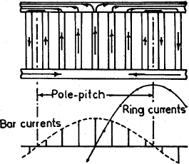
= (Number of bars over half a pole pitch) Ib(av)
= Sr/2P*[2/π * Ib(max) ]
= (Sr*Ib(max))/πP
rms value of bar current Ib = Ib(max)/√2 Ie(max) = (Sr*Ib * √2)/πP
rms value of end ring current Ie = Ie(max)/√2
Ie = (Sr*Ib)/πP
Area of end ring: Knowing the end ring current and assuming suitable value for the current density in the end rings cross section
for the end ring can be calculated. Current density in the end ring may be assume as 4.5 to 7.5 amp/mm2.
Area of each end ring Ae = Ie /δe mm2
Ae = te*de whre te = thickness of end ring and de = depth of end ring

Design of wound Rotor
These are the types of induction motors where in rotor also carries distributed star connected 3 phase winding. At one end of the rotor there are three slip rings mounted on the shaft. Three ends of the winding are connected to the slip rings. External resistances can be connected to these slip rings at starting, which will be inserted in series with the windings which will help in increasing the torque at starting. Such type of induction motors are employed where high starting torque is required.
Number of rotor slots: The number of rotor slots should never be equal to number of stator slots. Generally for wound rotor motors a suitable value is assumed for number of rotor slots per pole per phase, and then total number of rotor slots are calculated. So selected number of slots should be such that tooth width must satisfy the flux density limitation. Semi-closed slots are used for rotor slots.

Number of rotor Turns: The voltage between the slip rings on open circuit must be limited to safety values. In general the voltage between the slip rings for low and medium voltage machines must be limited to 400 volts. For motors with higher voltage ratings and large size motors this voltage must be limited to 1000 volts. Based on the assumed voltage between the slip rings comparing the induced voltage ratio in stator and rotor, the number of turns on rotor winding can be calculated.
Voltage ratio Er/ Es = (Kwr x Tr) / (Kws x Ts )
Hence rotor turns per phase Tr = (Er/Es) (Kws/Kwr)Ts Er = open circuit rotor voltage/phase
Es = stator voltage /phase
Kws = winding factor for stator
Kwr = winding factor for rotor
Ts = Number of stator turns/phase

Rotor Current and conductor section Assuming rotor mmf = 0.85* stator mmf 2x3xIr.Tr = (0.85) 2x3xIs.Ts

Rotor current per phase Ir = (0.85) Is.Ts/T
Rotor conductor area Ar = Ir/δr
The current density could be taken as 3 to 5 A/mm2

No load current: The no load current of an induction motor has two
components magnetizing component, Im and iron loss component, Iw. Thus the no load current I0 = √(Im)2 + (Iw)2 amps

Magnetising current: Magnetising current of an induction motor is responsible for producing the required amount of flux in the different parts of the machine. Hence this current can be calculated from all the magnetic circuit of the machine. The ampere turns for all the magnetic circuit such as stator core, stator teeth, air gap, rotor core and rotor teeth gives the total ampere turns required for the magnetic circuit. Based on the total ampere turns of the magnetic circuit the magnetizing current can be calculated as

Magnetising current Im= P*AT60 / (2.34 kw Tph )
where p – no of pairs of poles, AT30 – Total ampere turns of the magnetic circuit at 600 from the centre of the pole, Tph – Number of stator turns per phase.

Iron loss component of current: This component of current is responsible for supplying the iron losses in the magnetic circuit. Hence this component can be calculated from no load losses and applied voltage.
Iron loss component of current Iw= Total no load losses / ( 3 x
phase voltage)
No load Power Factor: No load power factor of an induction motor is very poor. As the load on the machine increases the power factor improves. No load power factor can be calculated knowing the components of no load current.
No load power factor cosυ0 = Iw / I0

Dispersion Coefficient:
Power factor is an important factor in designing of induction motor.

Power factor depends upon two factors:
  - Magnetizing current :a large value of the magnetizing current
indicates poor power factor
  - Ideal short circuit current (Isc): it is defined as the current drawn by the motor at standstill neglecting its resistance. A large value of ideal short circuit current will be drawn for small value of leakage reactance giving good power factor.
Dispersion coefficient defined as the ratio of magnetizing current to
ideal short circuit current.
Thus dispersion coefficient, σ = Im/Isci
=Im/(Es/Xs) Isci = Es/Xs
=Im.Xs/Es

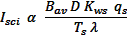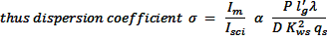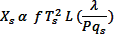For small values of Im and Xs dispersion coefficient is small and power factor is good. Thus for a small value of dispersion coefficient power factor is good, where as for large value of dispersion coefficient power factor is poor.
Magnetizing current Im = P*AT60 / (2.34 kw Tph )
Where AT60 is the total mmf consumed by flux path, out of which a
large part is consumed by air gap length.
AT air gap = 800000* 1.36* Bav l’g Im α P * Bav l’g / Kws. Ts
Isci = Es/Xs

From equation , machine a given L and D, the dispersion coefficient is large for grater number of poles, consequently making power factor poor. Thud slow speed machine have poor power factor.
Effect of dispersion coefficient on induction motor characteristics:
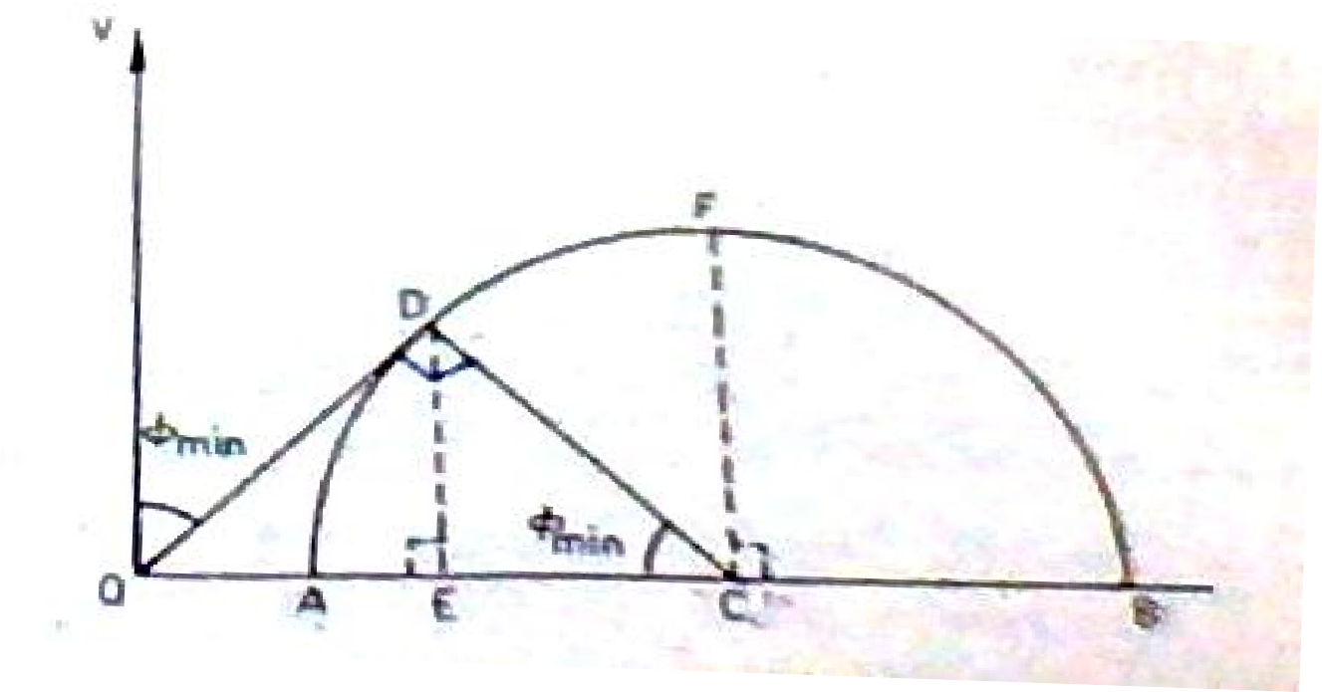
- Effect on maximum power factor:
As shown in circle diagram OA=magnetizing current OB=ideal short circuit current Dispersion coefficient:
σ = OA/OB

For maximum power factor OD is tangent to the circle and
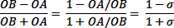
∟ODC =90o

For σ = 0.05, maximum p.f. = 0.905
For σ = 0.10, maximum p.f. = 0.818
Hence there is a large decrease in maximum p.f. when the dispersion
coefficient increases.

Effect on overload capacity:
Assuming, an induction motor is designed to have maximum pf at full load
, its corresponding output will be DE. The maximum output will be
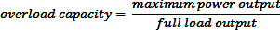
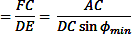
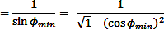
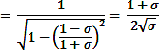
corresponding to FC

For σ = 0.05 overload capacity = 2.348 For σ = 0.10 overload capacity = 1.740
Hence overload capacity decreases with increase in dispersion coeff.

