3INDUCTIVE vs DEDUCTIVE
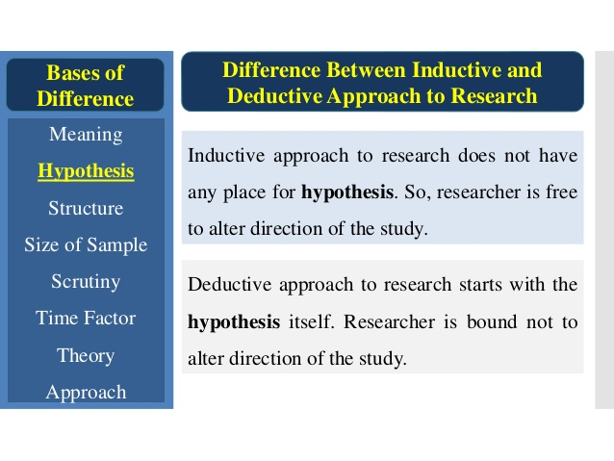 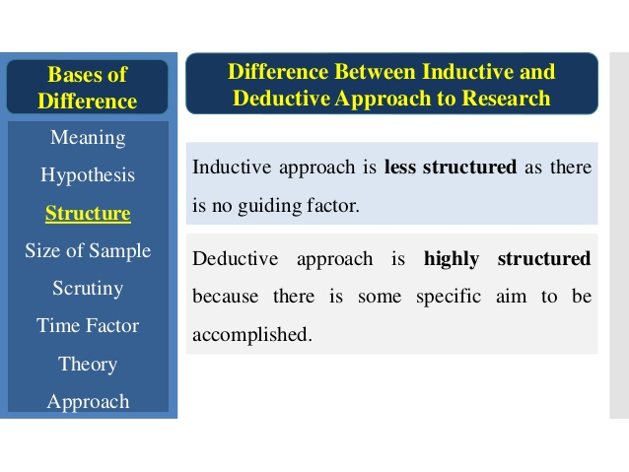 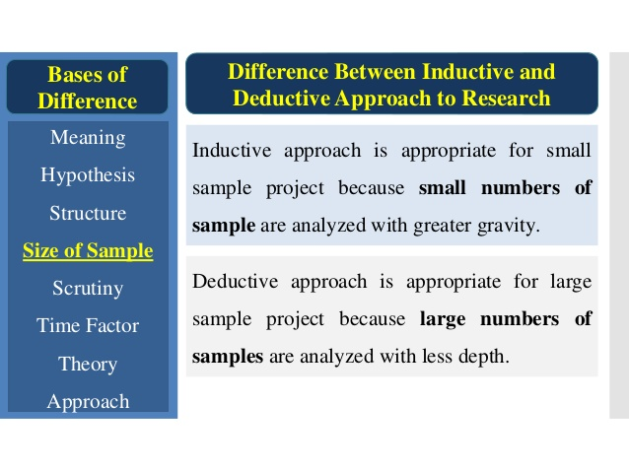 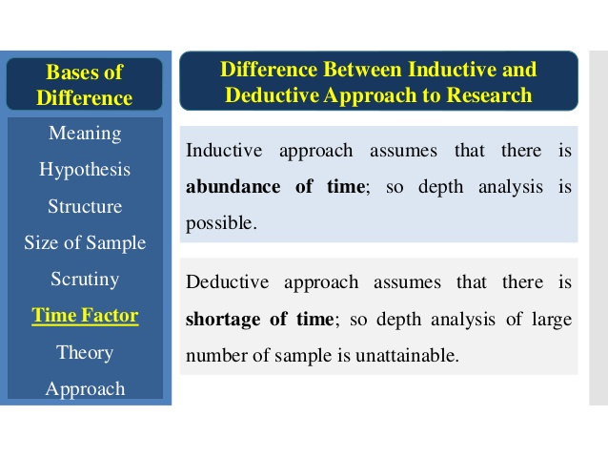 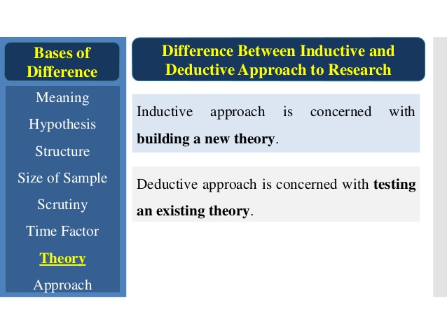 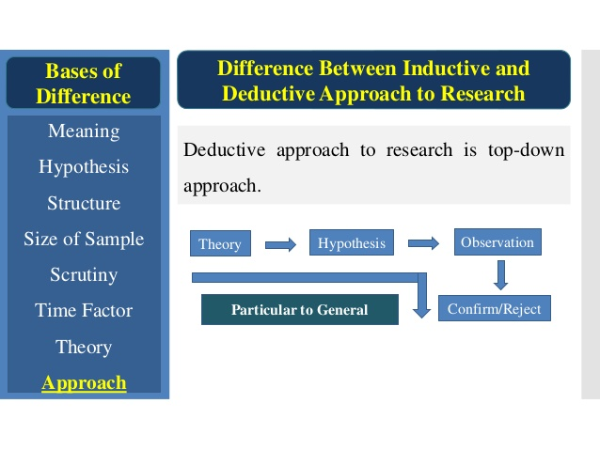 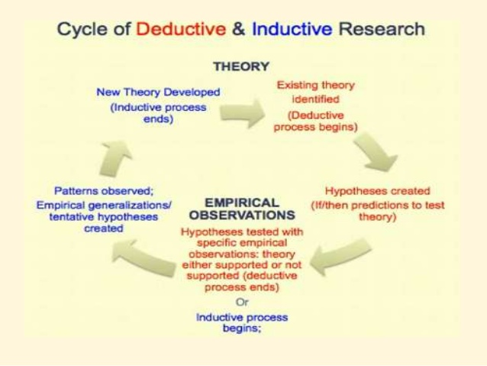---------------------------------------------------------------------------------------------------------------------
Deductive reasoning and inductive reasoning are two different approaches to conducting scientific research. Using deductive reasoning, a researcher tests a theory by collecting and examining empirical evidence to see if the theory is true. Using inductive reasoning, a researcher first gathers and analyzes data, then constructs a theory to explain her findings.
Within the field of sociology, researchers use both approaches. Often the two are used in conjunction when conducting research and when drawing conclusions from results.

Deductive Reasoning
Many scientists consider deductive reasoning the gold standard for scientific research. Using this method, one begins with a theory or hypothesis, then conducts research in order to test whether that theory or hypothesis is supported by specific evidence. This form of research begins at a general, abstract level and then works its way down to a more specific and concrete level. If something is found to be true for a category of things, then it is considered to be true for all things in that category in general.
An example of how deductive reasoning is applied within sociology can be found in a 2014 study of whether biases of race or gender shape access to graduate-level education. A team of researchers used deductive reasoning to hypothesize that, due to the prevalence of racism in society, race would play a role in shaping how university professors respond to prospective graduate students who express interest in their research. By tracking professor responses (and lack of responses) to imposter students, coded for race and gender by name, the researchers were able to prove their hypothesis true. They concluded, based on their research, that racial and gender biases are barriers that prevent equal access to graduate-level education across the U.S.

Inductive Reasoning
Unlike deductive reasoning, inductive reasoning begins with specific observations or real examples of events, trends, or social processes. Using this data, researchers then progress analytically to broader generalizations and theories that help explain the observed cases. This is sometimes called a "bottom-up" approach because it starts with specific cases on the ground and works its way up to the abstract level of theory. Once a researcher has identified patterns and trends amongst a set of data, he or she can then formulate a hypothesis to test, and eventually develop some general conclusions or theories.
A classic example of inductive reasoning in sociology is Émile Durkheim's study of suicide. Considered one of the first works of social science research, the famous and widely taught book, "Suicide," details how Durkheim created a sociological theory of suicide—as opposed to a psychological one—based on his scientific study of suicide rates among Catholics and Protestants. Durkheim found that suicide was more common among Protestants than Catholics, and he drew on his training in social theory to create some typologies of suicide and a general theory of how suicide rates fluctuate according to significant changes in social structures and norms.
While inductive reasoning is commonly used in scientific research, it is not without its weaknesses. For example, it is not always logically valid to assume that a general principle is correct simply because it is supported by a limited number of cases. Critics have suggested that Durkheim's theory is not universally true because the trends he observed could possibly be explained by other phenomena particular to the region from which his data came.

By nature, inductive reasoning is more open-ended and exploratory, especially during the early stages. Deductive reasoning is more narrow and is generally used to test or confirm hypotheses. Most social research, however, involves both inductive and deductive reasoning throughout the research process. The scientific norm of logical reasoning provides a two-way bridge between theory and research. In practice, this typically involves alternating between deduction and induction. 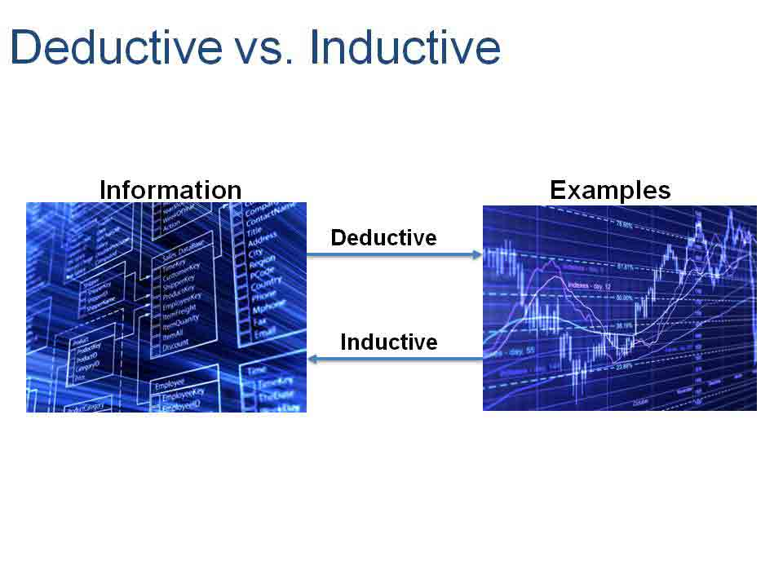- The Deductive Method:
ADVERTISEMENTS:
Deduction Means reasoning or inference from the general to the particular or from the universal to the individual. The deductive method derives new conclusions from fundamental assumptions or from truth established by other methods. It involves the process of reasoning from certain laws or principles, which are assumed to be true, to the analysis of facts.
Then inferences are drawn which are verified against observed facts. Bacon described deduction as a “descending process” in which we proceed from a general principle to its consequences. Mill characterised it as a priori method, while others called it abstract and analytical.
Deduction involves four steps: (1) Selecting the problem. (2) The formulation of assumptions on the basis of which the problem is to be explored. (3) The formulation of hypothesis through the process of logical reasoning whereby inferences are drawn. (4) Verifying the hypothesis. These steps are discussed as under.
ADVERTISEMENTS:
(1) Selecting the problem:
The problem which an investigator selects for enquiry must be stated clearly. It may be very wide like poverty, unemployment, inflation, etc. or narrow relating to an industry. The narrower the problem the better it would be to conduct the enquiry.
(2) Formulating Assumptions:
The next step in deduction is the framing of assumptions which are the basis of hypothesis. To be fruitful for enquiry, the assumption must be general. In any economic enquiry, more than one set of assumptions should be made in terms of which a hypothesis may be formulated.
(3) Formulating Hypothesis:
The next step is to formulate a hypothesis on the basis of logical reasoning whereby conclusions are drawn from the propositions. This is done in two ways: First, through logical deduction. If and because relationships (p) and (q) all exist, then this necessarily implies that relationship (r) exists as well. Mathematics is mostly used in these methods of logical deduction.
(4) Testing and Verifying the Hypothesis:
The final step in the deductive method is to test and verify the hypothesis. For this purpose, economists now use statistical and econometric methods. Verification consists in confirming whether the hypothesis is in agreement with facts. A hypothesis is true or not can be verified by observation and experiment. Since economics is concerned with human behaviour, there are problems in making observation and testing a hypothesis.
For example, the hypothesis that firms always attempt to maximise profits, rests upon the observation that some firms do behave in this way. This premise is based on a priori knowledge which will continue to be accepted so long as conclusions deduced from it are consistent with the facts. So the hypothesis stands verified. If the hypothesis is not confirmed, it can be argued that the hypothesis was correct but the results are contradictory due to special circumstances.
ADVERTISEMENTS:
Under these conditions, the hypothesis may turn out to the wrong. In economics, most hypotheses remain unverified because of the complexity of factors involved in human behaviour which, in turn, depend upon social, political and economic factors. Moreover, controlled experiments in a laboratory are not possible in economics. So the majority of hypotheses remain untested and unverified in economics.

Merits of Deductive Method:
The deductive method has many advantages.
(1) Real:
It is the method of “intellectual experiment,” according to Boulding. Since the actual world is very complicated, “what we do is to postulate in our own minds economic systems which are simpler than reality but more easy to grasp. We then work out the relationship in these simplified systems and by introducing more and more complete assumptions, finally work up to the consideration of reality itself.” Thus, this method is nearer to reality.
(2) Simple:
The deductive method is simple because it is analytical. It involves abstraction and simplifies a complex problem by dividing it into component parts. Further, the hypothetical conditions are so chosen as to make the problem very simple, and then inferences are deduced from them.
(3) Powerful:
It is a powerful method of analysis for deducing conclusions from certain facts. As pointed out by Cairnes, The method of deduction is incomparably, when conducted under proper checks, the most powerful instrument of discovery ever wielded by human intelligence.
(4) Exact:
The use of statistics, mathematics and econometrics in deduction brings exactness and clarity in economic analysis. The mathematically trained economist is able to deduce inferences in a short time and make analogies with other generalisations and theories. Further, the use of the mathematical-deductive method helps in revealing inconsistencies in economic analysis.
(5) Indispensable:
The use of deductive method is indispensable in sciences like economics where experimentation is not possible. As pointed out by Gide and Rist, “In a science like political economy, where experiment is practically impossible, abstraction and analysis afford the only means of escape from those other influences which complicate the problem so much.”
(6) Universal:
The deductive method helps in drawing inferences which are of universal validity because they are based on general principles, such as the law of diminishing returns.

Demerits of Deductive Method:
Despite these merits, much criticism has been levelled against this method by the Historical School which flourished in Germany.
1 .Unrealistic Assumption:
Every hypothesis is based on a set of assumptions. When a hypothesis is tested, assumptions are indirectly tested by comparing their implications with facts. But when facts refute the theory based on the tested hypothesis, the assumptions are also indirectly refuted. So deduction depends upon the nature of assumptions. If they are unrealistic, in this method, economists use the ceteris paribus assumption. But other things seldom remain the same which tend to refute theories.
2. Not Universally Applicable:
Often the conclusions derived from deductive reasoning are not applicable universally because the premises from which they are deduced may not hold good at all time and places. For instance, the classicists assumed in their reasoning that particular conditions prevailing in England of their times were valid universally. This supposition was wrong. Prof. Lerner, therefore, points out that the deductive method is simply “armchair analysis” which cannot be regarded as universal.
3. Incorrect Verification:
The verification of theories, generalisations or laws in economics is based on observation. And right observation depends upon data which must be correct and adequate. If a hypothesis is deduced from wrong or inadequate data, the theory will not correspond with facts and will be refuted. For instance, the generalisations of the classicists were based on inadequate data and their theories were refuted. As pointed out by ircholson, “the great danger of the deductive method lies in the natural aversion to the labour of verification.”
4. Abstract Method:
The deductive method is highly abstract and requires great skill in drawing inferences for various premises. Due to the complexity of certain economic problems, it becomes difficult to apply this method even at the hands of an expert researcher. More so, when he uses mathematics or econometrics.
5. Static Method:
This method of analysis is based on the assumption that economic conditions remain constant. But economic conditions are continuously changing. Thus this is a static method which fails to make correct analysis.
6. Intellectually:
The chief defect of the deductive method “lies in the fact that those who follow this method may be absorbed in the framing of intellectual toys and the real world may be forgotten in the intellectual gymnastics and mathematical treatment.”

The Inductive Method:
Induction “is the process of reasoning from a part to the whole, from particulars to generals or from the individual to the universal.” Bacon described it as “an ascending process” in which facts are collected, arranged and then general conclusions are drawn.
The inductive method was employed in economics by the German Historical School which sought to develop economics wholly from historical research. The historical or inductive method expects the economist to be primarily an economic historian who should first collect material, draw gereralisations, and verify the conclusions by applying them to subsequent events. For this, it uses statistical methods. The Engel’s Law of Family Expenditure and the Malthusian Theory of Population have been derived from inductive reasoning.
The inductive method involves the following steps:
1. The Problem:
In order to arrive at a generalisation concerning an economic phenomenon, the problem should be properly selected and clearly stated.
2. Data:
The second step is the collection, enumeration, classification and analysis of data by using appropriate statistical techniques.
3. Observation:
Data are used to make observation about particular facts concerning the problem.
4. Generalisation:
On the basis of observation, generalisation is logically derived which establishes a general truth from particular facts.
Thus induction is the process in which we arrive at a generalisation on the basis of particular observed facts.
The best example of inductive reasoning in economics is the formulation of the generalisation of diminishing returns. When a Scottish farmer found that in the cultivation of his field an increase in the amount of labour and capital spent on it was bringing in less than proportionate returns year after year, an economist observed such instances in the case of a number of other farms, and then he arrived at the generalisation that is known as the Law of Diminishing Returns.

Merits of Inductive Method:
The chief merits of this method are as follows:
(1) Realistic:
The inductive method is realistic because it is based on facts and explains them as they actually are. It is concrete and synthetic because it deals with the subject as a whole and does not divide it into component parts artificially
(2) Future Enquiries:
Induction helps in future enquiries. By discovering and providing general principles, induction helps future investigations. Once a generalisation is established, it becomes the starting point of future enquiries.
(3) Statistical Method:
The inductive method makes use of the statistical method. This has made significant improvements in the application of induction for analysing economic problems of wide range. In particular, the collection of data by governmental and private agencies or macro variables, like national income, general prices, consumption, saving, total employment, etc., has increased the value of this method and helped governments to formulate economic policies pertaining to the removal of poverty, inequalities, underdevelopment, etc.
(4) Dynamic:
The inductive method is dynamic. In this, changing economic phenomena can be analysed on the basis of experiences, conclusions can be drawn, and appropriate remedial measures can be taken. Thus, induction suggests new problems to pure theory for their solution from time to time.
(5) Histrico-Relative:
A generalisation drawn under the inductive method is often histrico-relative in economics. Since it is drawn from a particular historical situation, it cannot be applied to all situations unless they are exactly similar. For instance, India and America differ in their factor endowments. Therefore, it would be wrong to apply the industrial policy which was followed in America in the late nineteenth century to present day India. Thus, the inductive method has the merit of applying generalisations only to related situations or phenomena.

Demerits of Inductive Method:
However, the inductive method is not without its weaknesses which are discussed below.
(1) Misenterpretation of Data:
Induction relies on statistical numbers for analysis that “can be misused and misinterpreted when the assumptions which are required for their use are forgotten.”
(2) Uncertain Conclusions:
Boulding points out that “statistical information can only give us propositions whose truth is more or less probable it can never give us certainty.”
(3) Lacks Concreteness:
Definitions, sources and methods used in statistical analysis differ from investigator to investigator even for the same problem, as for instance in the case of national income accounts. Thus, statistical techniques lack concreteness.
(4) Costly Method:
The inductive method is not only time-consuming but also costly. It involves detailed and painstaking processes of collection, classification, analyses and interpretation of data on the part of trained and expert investigators and analysts
(5) Difficult to Prove Hypothesis:
Again the use of statistics in induction cannot prove a hypothesis. It can only show that the hypothesis is not inconsistent with the known facts. In reality, collection of data is not illuminating unless it is related to a hypothesis.
(6) Controlled Experimentation not Possible in Economics:
Besides the statistical method, the other method used in induction is of controlled experimentation. This method is extremely useful in natural and physical sciences which deal with matter. But unlike the natural sciences, there is little scope for experimentation in economics because economics deals with human behaviour which differs from person to person and from place to place.
Further, economic phenomena are very complex as they relate to man who does not act rationally. Some of his actions are also bound by the legal and social institutions of the society in which he lives. Thus, the scope for controlled experiments in inductive economics is very little. As pointed Out by Friendman, “The absence of controlled experiments in economics renders the weeding out of unsuccessful hypo-these slow and difficult.”

Conclusion:
The above analysis reveals that independently neither deduction nor induction is helpful in scientific enquiry. In reality, both deduction and induction are related to each other because of some facts. They are the two forms of logic that are complementary and co-relative and help establish the truth.
Marshall also supported the complementary nature of the two methods when he quoted Schmoller: “Induction and deduction are both needed for scientific thought as the right and left foot are needed for walking.” And then Marshall stressed the need and use of integrating these methods.
Now-a-days, economists are combining induction and deduction in their studies of economic phenomena in various fields for arriving at generalisations from observed facts and for the indirect verification of hypotheses. They are using the two methods to confirm the conclusions drawn through deduction by inductive reasoning and vice versa. Thus true progress in economic enquiries can be made by a wise combination of deduction and induction.

Induction Vs. Deduction Economics
By Shane Hall
Reason is the tool by which the human mind comes to understand the world. There are two processes by which reason tries to understand events: deductive reasoning, based on generally accepted principles, and inductive reasoning, in which general principles are formed from observed events. The field of economics has deductive and inductive sides, which are complementary to each other.

Deduction in Economics
Deductive economics starts with a set of axioms about economies and how they work, and relies on these principles to explain individual cases or events. Supply and demand analysis, a staple in any introductory economics course, is an example of deductive reasoning because it involves a set of generally accepted principles about demand and supply. To summarize, deduction in economics starts with a generally accepted principle and proceeds to the specific.

Induction in Economics
Inductive reasoning in economics does the reverse of deductive reasoning; namely, it begins with an individual problem or question and proceeds to form a general principle based on the evidence observed in the real world of economic activity. For example, an economist who asks if a government program of public works spending will stimulate a region's economy will proceed to research the issue, collect and analyze data, and based on conclusions, form a general theory about the economic impact of fiscal policies.

Induction-Deduction Link
Although deduction and induction represent two differing approaches to understanding economic phenomena, the 19th century American economist Henry George observed that they are related. George noted that induction involves the use of human reason to investigate facts, while deduction is the derivative of the former.

Effects
Applying George's insight on deduction and induction in economics, deduction involves the use of economic principles and theories that have been empirically verified through observation, research, and critical analysis. Generally accepted principles of supply and demand, for example, can inform our understanding of economic transactions only if they are based on empirical evidence, collected and analyzed through the inductive process.

Features
Induction in economics requires rigorous use of the methodology of economic research. This includes use of the mathematical modeling and statistical processes used in econometrics, or economic measurement. Findings from inductive reasoning then form economic theories used in deductive analysis.
----------------------------------------------------------------------------------------------------------------------------------------------------------------

The Deductive Method:
ADVERTISEMENTS:
Deduction Means reasoning or inference from the general to the particular or from the universal to the individual. The deductive method derives new conclusions from fundamental assumptions or from truth established by other methods. It involves the process of reasoning from certain laws or principles, which are assumed to be true, to the analysis of facts.
Then inferences are drawn which are verified against observed facts. Bacon described deduction as a “descending process” in which we proceed from a general principle to its consequences. Mill characterised it as a priori method, while others called it abstract and analytical.
Deduction involves four steps: (1) Selecting the problem. (2) The formulation of assumptions on the basis of which the problem is to be explored. (3) The formulation of hypothesis through the process of logical reasoning whereby inferences are drawn. (4) Verifying the hypothesis. These steps are discussed as under.
ADVERTISEMENTS:
(1) Selecting the problem:
The problem which an investigator selects for enquiry must be stated clearly. It may be very wide like poverty, unemployment, inflation, etc. or narrow relating to an industry. The narrower the problem the better it would be to conduct the enquiry.
(2) Formulating Assumptions:
The next step in deduction is the framing of assumptions which are the basis of hypothesis. To be fruitful for enquiry, the assumption must be general. In any economic enquiry, more than one set of assumptions should be made in terms of which a hypothesis may be formulated.
(3) Formulating Hypothesis:
The next step is to formulate a hypothesis on the basis of logical reasoning whereby conclusions are drawn from the propositions. This is done in two ways: First, through logical deduction. If and because relationships (p) and (q) all exist, then this necessarily implies that relationship (r) exists as well. Mathematics is mostly used in these methods of logical deduction.
(4) Testing and Verifying the Hypothesis:
The final step in the deductive method is to test and verify the hypothesis. For this purpose, economists now use statistical and econometric methods. Verification consists in confirming whether the hypothesis is in agreement with facts. A hypothesis is true or not can be verified by observation and experiment. Since economics is concerned with human behaviour, there are problems in making observation and testing a hypothesis.
For example, the hypothesis that firms always attempt to maximise profits, rests upon the observation that some firms do behave in this way. This premise is based on a priori knowledge which will continue to be accepted so long as conclusions deduced from it are consistent with the facts. So the hypothesis stands verified. If the hypothesis is not confirmed, it can be argued that the hypothesis was correct but the results are contradictory due to special circumstances.
ADVERTISEMENTS:
Under these conditions, the hypothesis may turn out to the wrong. In economics, most hypotheses remain unverified because of the complexity of factors involved in human behaviour which, in turn, depend upon social, political and economic factors. Moreover, controlled experiments in a laboratory are not possible in economics. So the majority of hypotheses remain untested and unverified in economics.

Merits of Deductive Method:
The deductive method has many advantages.
(1) Real:
It is the method of “intellectual experiment,” according to Boulding. Since the actual world is very complicated, “what we do is to postulate in our own minds economic systems which are simpler than reality but more easy to grasp. We then work out the relationship in these simplified systems and by introducing more and more complete assumptions, finally work up to the consideration of reality itself.” Thus, this method is nearer to reality.
(2) Simple:
The deductive method is simple because it is analytical. It involves abstraction and simplifies a complex problem by dividing it into component parts. Further, the hypothetical conditions are so chosen as to make the problem very simple, and then inferences are deduced from them.
(3) Powerful:
It is a powerful method of analysis for deducing conclusions from certain facts. As pointed out by Cairnes, The method of deduction is incomparably, when conducted under proper checks, the most powerful instrument of discovery ever wielded by human intelligence.
(4) Exact:
The use of statistics, mathematics and econometrics in deduction brings exactness and clarity in economic analysis. The mathematically trained economist is able to deduce inferences in a short time and make analogies with other generalisations and theories. Further, the use of the mathematical-deductive method helps in revealing inconsistencies in economic analysis.
(5) Indispensable:
The use of deductive method is indispensable in sciences like economics where experimentation is not possible. As pointed out by Gide and Rist, “In a science like political economy, where experiment is practically impossible, abstraction and analysis afford the only means of escape from those other influences which complicate the problem so much.”
(6) Universal:
The deductive method helps in drawing inferences which are of universal validity because they are based on general principles, such as the law of diminishing returns.

Demerits of Deductive Method:
Despite these merits, much criticism has been levelled against this method by the Historical School which flourished in Germany.
1 .Unrealistic Assumption:
Every hypothesis is based on a set of assumptions. When a hypothesis is tested, assumptions are indirectly tested by comparing their implications with facts. But when facts refute the theory based on the tested hypothesis, the assumptions are also indirectly refuted. So deduction depends upon the nature of assumptions. If they are unrealistic, in this method, economists use the ceteris paribus assumption. But other things seldom remain the same which tend to refute theories.
2. Not Universally Applicable:
Often the conclusions derived from deductive reasoning are not applicable universally because the premises from which they are deduced may not hold good at all time and places. For instance, the classicists assumed in their reasoning that particular conditions prevailing in England of their times were valid universally. This supposition was wrong. Prof. Lerner, therefore, points out that the deductive method is simply “armchair analysis” which cannot be regarded as universal.
3. Incorrect Verification:
The verification of theories, generalisations or laws in economics is based on observation. And right observation depends upon data which must be correct and adequate. If a hypothesis is deduced from wrong or inadequate data, the theory will not correspond with facts and will be refuted. For instance, the generalisations of the classicists were based on inadequate data and their theories were refuted. As pointed out by ircholson, “the great danger of the deductive method lies in the natural aversion to the labour of verification.”
4. Abstract Method:
The deductive method is highly abstract and requires great skill in drawing inferences for various premises. Due to the complexity of certain economic problems, it becomes difficult to apply this method even at the hands of an expert researcher. More so, when he uses mathematics or econometrics.
5. Static Method:
This method of analysis is based on the assumption that economic conditions remain constant. But economic conditions are continuously changing. Thus this is a static method which fails to make correct analysis.
6. Intellectually:
The chief defect of the deductive method “lies in the fact that those who follow this method may be absorbed in the framing of intellectual toys and the real world may be forgotten in the intellectual gymnastics and mathematical treatment.”

The Inductive Method:
Induction “is the process of reasoning from a part to the whole, from particulars to generals or from the individual to the universal.” Bacon described it as “an ascending process” in which facts are collected, arranged and then general conclusions are drawn.
The inductive method was employed in economics by the German Historical School which sought to develop economics wholly from historical research. The historical or inductive method expects the economist to be primarily an economic historian who should first collect material, draw gereralisations, and verify the conclusions by applying them to subsequent events. For this, it uses statistical methods. The Engel’s Law of Family Expenditure and the Malthusian Theory of Population have been derived from inductive reasoning.
The inductive method involves the following steps:
1. The Problem:
In order to arrive at a generalisation concerning an economic phenomenon, the problem should be properly selected and clearly stated.
2. Data:
The second step is the collection, enumeration, classification and analysis of data by using appropriate statistical techniques.
3. Observation:
Data are used to make observation about particular facts concerning the problem.
4. Generalisation:
On the basis of observation, generalisation is logically derived which establishes a general truth from particular facts.
Thus induction is the process in which we arrive at a generalisation on the basis of particular observed facts.
The best example of inductive reasoning in economics is the formulation of the generalisation of diminishing returns. When a Scottish farmer found that in the cultivation of his field an increase in the amount of labour and capital spent on it was bringing in less than proportionate returns year after year, an economist observed such instances in the case of a number of other farms, and then he arrived at the generalisation that is known as the Law of Diminishing Returns.

Merits of Inductive Method:
The chief merits of this method are as follows:
(1) Realistic:
The inductive method is realistic because it is based on facts and explains them as they actually are. It is concrete and synthetic because it deals with the subject as a whole and does not divide it into component parts artificially
(2) Future Enquiries:
Induction helps in future enquiries. By discovering and providing general principles, induction helps future investigations. Once a generalisation is established, it becomes the starting point of future enquiries.
(3) Statistical Method:
The inductive method makes use of the statistical method. This has made significant improvements in the application of induction for analysing economic problems of wide range. In particular, the collection of data by governmental and private agencies or macro variables, like national income, general prices, consumption, saving, total employment, etc., has increased the value of this method and helped governments to formulate economic policies pertaining to the removal of poverty, inequalities, underdevelopment, etc.
(4) Dynamic:
The inductive method is dynamic. In this, changing economic phenomena can be analysed on the basis of experiences, conclusions can be drawn, and appropriate remedial measures can be taken. Thus, induction suggests new problems to pure theory for their solution from time to time.
(5) Histrico-Relative:
A generalisation drawn under the inductive method is often histrico-relative in economics. Since it is drawn from a particular historical situation, it cannot be applied to all situations unless they are exactly similar. For instance, India and America differ in their factor endowments. Therefore, it would be wrong to apply the industrial policy which was followed in America in the late nineteenth century to present day India. Thus, the inductive method has the merit of applying generalisations only to related situations or phenomena.

Demerits of Inductive Method:
However, the inductive method is not without its weaknesses which are discussed below.
(1) Misenterpretation of Data:
Induction relies on statistical numbers for analysis that “can be misused and misinterpreted when the assumptions which are required for their use are forgotten.”
(2) Uncertain Conclusions:
Boulding points out that “statistical information can only give us propositions whose truth is more or less probable it can never give us certainty.”
(3) Lacks Concreteness:
Definitions, sources and methods used in statistical analysis differ from investigator to investigator even for the same problem, as for instance in the case of national income accounts. Thus, statistical techniques lack concreteness.
(4) Costly Method:
The inductive method is not only time-consuming but also costly. It involves detailed and painstaking processes of collection, classification, analyses and interpretation of data on the part of trained and expert investigators and analysts
(5) Difficult to Prove Hypothesis:
Again the use of statistics in induction cannot prove a hypothesis. It can only show that the hypothesis is not inconsistent with the known facts. In reality, collection of data is not illuminating unless it is related to a hypothesis.
(6) Controlled Experimentation not Possible in Economics:
Besides the statistical method, the other method used in induction is of controlled experimentation. This method is extremely useful in natural and physical sciences which deal with matter. But unlike the natural sciences, there is little scope for experimentation in economics because economics deals with human behaviour which differs from person to person and from place to place.
Further, economic phenomena are very complex as they relate to man who does not act rationally. Some of his actions are also bound by the legal and social institutions of the society in which he lives. Thus, the scope for controlled experiments in inductive economics is very little. As pointed Out by Friendman, “The absence of controlled experiments in economics renders the weeding out of unsuccessful hypo-these slow and difficult.”

Conclusion:
The above analysis reveals that independently neither deduction nor induction is helpful in scientific enquiry. In reality, both deduction and induction are related to each other because of some facts. They are the two forms of logic that are complementary and co-relative and help establish the truth.
Marshall also supported the complementary nature of the two methods when he quoted Schmoller: “Induction and deduction are both needed for scientific thought as the right and left foot are needed for walking.” And then Marshall stressed the need and use of integrating these methods.
Now-a-days, economists are combining induction and deduction in their studies of economic phenomena in various fields for arriving at generalisations from observed facts and for the indirect verification of hypotheses. They are using the two methods to confirm the conclusions drawn through deduction by inductive reasoning and vice versa. Thus true progress in economic enquiries can be made by a wise combination of deduction and induction.

