Name of Faculty: Hetram Sharma
Subject Name : RRS (5CE4-14 )
COURSE OUTCOMES
CO-1 | Student will able to the causes of deterioration of concrete in structures & details about cracks
CO-2 | Student will able to the different types of non destructive testing & details about corrosion
CO-3 | Student will able to understand various materials which is use in repair and rehabilitation of structure.
CO-4 | Student will able to understand repair technique of structure.

Course: - | RRS
Semester: - | 5th
Code:- | 5CE5-14
 | PO 1 | PO 2 | PO 3 |  |  | PO 4 |  | PO 5 | PO 6 | PO 7 | PO 8 | PO 9 | PO 10 | PO 11 | PO 12
CO 1 | H | L | H |  |  | H |  | M | H | H | M | L | L | H | M
CO 2 | H |  | H |  |  | M |  | M | M | H | M | M | L | M | M
CO 3 | H | M | M |  |  | L |  | L | M | H | M | M | L | H | L
CO 4 | H | M | M |  |  | M |  | M | M | H | L | M | L | M | M

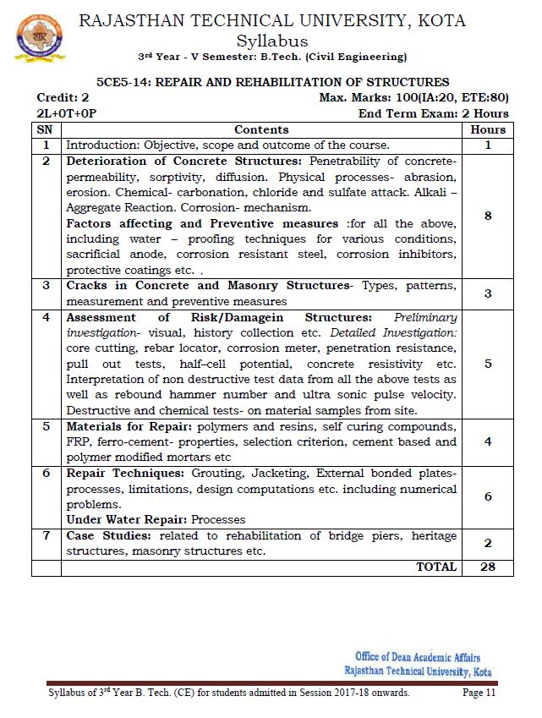

JAIPUR ENGINEERING COLLEGE AND RESEARCH CENTER
Department of CIVIL ENGINEERING
LECTURE PLAN
Subject: 5CE5-14: REPAIR AND REHABILITATION OF STRUCTURES
No. of Lecture Req./(Avl.) : /(28)
Semester Starting: 02.07.2020 Semester Ending: …/0../2020

Unit No./ Total lec. Req. | Topics | Lect. Req. | Lect. No. | Date of Delivery | Remark/  Actual lect. Taken
 | Introduction: Objective, scope and outcome of the course. | 2 | 1,2
 | Deterioration of Concrete Structures: Penetrability of concrete permeability | 1 | 3
 | sorptivity, diffusion. Physical processes- abrasion | 1 | 4
 | erosion. Chemical- carbonation,chloride and sulfate attack | 1 | 5
 | Alkali –Aggregate Reaction,Corrosion- mechanism | 1 | 6
 | Factors affecting and Preventive measures :for all the above,including water – proofing techniques for various conditions | 2 | 7-8
 | Cracks in Concrete and Masonry Structures- Types, patterns, | 2 | 9
 | measurement and preventive measures | 1 | 10
 | Assessment of Risk/Damagein Structures: Preliminary | 1 | 11
 | investigation- visual, history collection etc. Detailed Investigation: | 1 | 12
 | core cutting, rebar locator, corrosion meter, penetration resistance, | 1 | 13
 | pull out tests, half–cell potential, concrete resistivity etc. | 1 | 14
 | Interpretation of non destructive test data from all the above tests as | 1 | 15
 | number and ultra sonic pulse velocity.  Destructive and chemical tests- on material samples from site. | 2 | 16-17
 | Materials for Repair: polymers and resins, self curing compounds, | 1 | 18
 | FRP, ferro-cement- properties, selection criterion, | 2 | 19-20
 | cement based and polymer modified mortars etc | 1 | 21
 | Repair Techniques: Grouting, Jacketing | 1 | 22
 | External bonded platesprocesses, limitations, design computations | 1 | 23
 | numerical problems | 1 | 24
 | Under Water Repair: Processes | 1 | 25
 | Case Studies: related to rehabilitation of bridge piers | 1 | 26
 | heritage structures | 2 | 27
 | masonry structures etc | 2 | 28

