COURSE FILE

Subject Name | : | Building Planning
Subject Code | : | 4CE4-07
Branch | : | Civil Engineering
Year | : | 2nd

Jaipur Engineering College and Research Center, Jaipur
Department of civil engineering
(Rajasthan Technical University, KOTA)

JAIPUR ENGINEERING COLLEGE AND RESEARCH CENTRE

DEPARTMENT OF CIVIL ENGINEERING

VISION
To become a role model in the field of Civil Engineering for the sustainable development of the society.

MISSION
- To provide outcome base education.

- To create a learning environment conducive for achieving academic excellence.

- To prepare civil engineers for the society with high ethical values.

Program Educational Objectives

1. To strengthen students with fundamental knowledge, effective computing, problem solving and communication skills enable them to have successful career in civil engineering.
2. To enable students in acquiring civil engineering’s latest tools, technologies and management principles to give them an ability to solve multidisciplinary engineering problems.
3. To impart students with ethical values and commitment towards sustainable development in collaborative mode.
4. To reinforce students with research aptitude and innovative approaches which help them to identify, analyze, formulate and solve real life problems and motivates them for lifelong learning.
5. To empower students with leadership quality and team building skills that prepare them for employment, entrepreneurship and to become competent professionals to serve societies and global needs

PROGRAMME OUTCOMES (PO)

1. Engineering knowledge: Apply the knowledge of mathematics, science, engineering Fundamentals and an engineering specialization to the solution of complex engineering
problems.
2. Problem analysis: Identify, formulate, research literature, and analyze complex engineering
problems reaching substantiated conclusions using first principles of mathematics, natural
sciences, and engineering sciences.
3. Design/development of solutions: Design solutions for complex engineering problems and
design system components or processes that meet the specified needs with appropriate
consideration for the public health and safety, and the cultural, societal, and environmental
considerations.
4. Conduct investigations of complex problems: Use research-based knowledge and
research methods including design of experiments, analysis and interpretation of data, and
synthesis of the information to provide valid conclusions.
5. Modern tool usage: Create, select, and apply appropriate techniques, resources, and modern
engineering and IT tools including prediction and modeling to complex engineering activities
with an understanding of the limitations.
6. The engineer and society: Apply reasoning informed by the contextual knowledge to assess
societal, health, safety, legal and cultural issues and the consequent responsibilities relevant
to the professional engineering practice.
7. Environment and sustainability: Understand the impact of the professional engineering
solutions in societal and environmental contexts, and demonstrate the knowledge of, and need
for sustainable development.
8. Ethics: Apply ethical principles and commit to professional ethics and responsibilities and
norms of the engineering practice.
9. Individual and team work: Function effectively as an individual, and as a member or leader
in diverse teams, and in multidisciplinary settings.
10. Communication: Communicate effectively on complex engineering activities with the
engineering community and with society at large, such as, being able to comprehend and write
effective reports and design documentation, make effective presentations, and give and
receive clear instructions.
11. Project management and finance: Demonstrate knowledge and understanding of the
engineering and management principles and apply these to one’s own work, as a member and
leader in a team, to manage projects and in multidisciplinary environments.
12. Life-long learning: Recognize the need for, and have the preparation and ability to engage in
independent and life-long learning in the broadest context of technological change.

Subject: BUILDING PLANNING Code: 4CE4-07
CO-1 | STUDENTS WILL BE ABLE TO UNDERSTAND TYPES OF BUILDING & APPROPRIATE SELECTION OF SITE WITH SUN CONSIDERATION.
CO-2 | STUDENTS WILL BE ABLE TO UNDERSTAND ABOUT BYE-LAW AND NBC REGULATION ALONG WITH ORIENTATION, CLIMATE&COMFORT CONSIDERATION.
CO-3 | STUDENTS WILL BE ABLE TO UNDERSTAND BUILDING PLANNING. STUDENTS WILL ABLE TO USE PRINCIPALS OF OF VASTU SHASTRA
CO-4 | STUDENTS WILL BE ABLE TO UNDERSTAND FUNCTIONAL DESIGN AND ACCOMMODATION REQUIREMENTS OF RESIDENTIAL BUILDING AND NON-RESIDENTIAL BUILDING WITH PROVIDING DIFFERENT SERVICES

Subject Code | COs | Program Outcomes (POs)
 |  | PO-1 | PO-2 | PO-3 | PO-4 | PO-5 | PO-6 | PO-7 | PO-8 | PO-9 | PO-10 | PO-11 | PO-12
4CE4-07 | CO-1 | 3 | 1 | 3 | 3 | 2 | 3 | 3 | 2 | 1 | 1 | 3 | 2
 | CO-2 | 3 |  | 3 | 2 | 2 | 2 | 3 | 2 | 1 | 1 | 2 | 2
 | CO-3 | 3 | 1 | 2 | 1 | 1 | 2 | 3 | 2 | 2 | 1 | 3 | 1
 | CO-4 | 3 | 2 | 2 | 2 | 2 | 2 | 3 | 1 | 2 | 1 | 2 | 2

Subject Code | COs | Program Specific Outcomes (PSO)
 |  | PSO-1 | PSO-2 | PSO-3
4CE4-07 | CO-1 | 2 | 3 | 2
 | CO-2 | 3 | 1 | 1
 | CO-3 | 2 | 2 | 2
 | CO-4 | 3 | 3 | 1

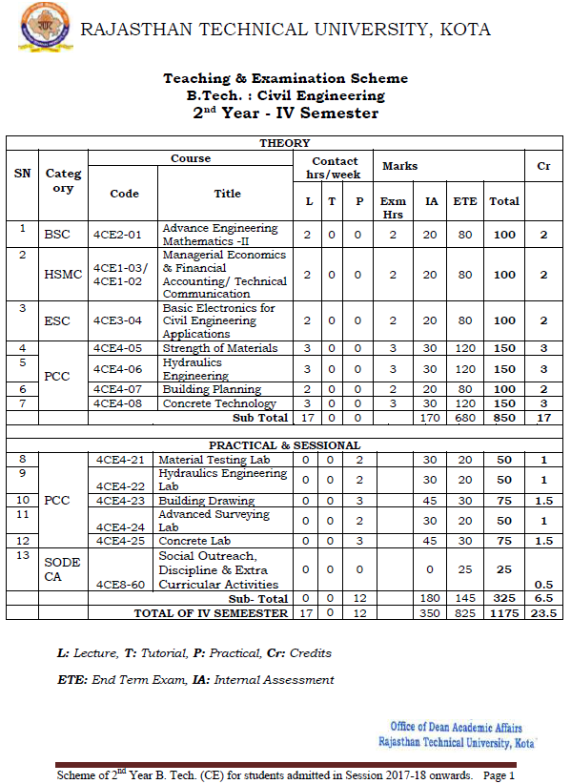

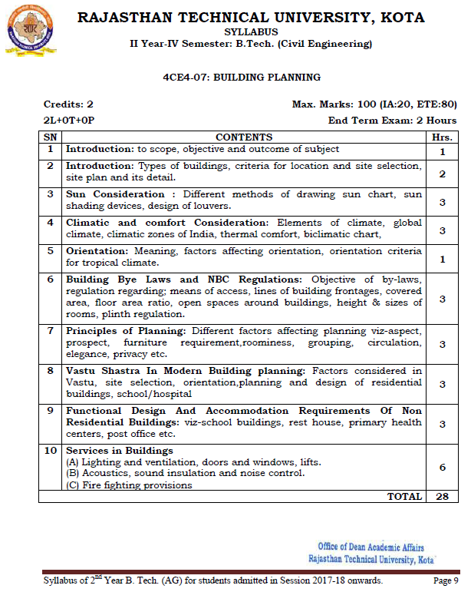

JAIPUR ENGINEERING COLLEGE AND RESEARCH CENTER
Department of CIVIL ENGINEERING
LECTURE PLAN
Subject: 4CE4-07: BUILDING PLANNING
No. of Lecture Req./(Avl.) : /(28)
Semester Starting: ….01.2021 Semester Ending: …/0../2021

Unit No./ Total lec. Req. | Topics | Lect. Req. | Lect. No. | Date of Delivery | Remark/  Actual lect. Taken
 | scope, objective and outcome of subject | 1 | 1
 | Introduction: Types of buildings, criteria for location | 1 | 2
 | site selection, site plan and its detail. | 1 | 3
 | Sun Consideration : Different methods of drawing sun chart | 1 | 4
 | Sun shading devices, | 1 | 5
 | design of louvers. | 1 | 6
 | Climatic and comfort Consideration: Elements of climate, | 1 | 7
 | Global climate, climatic zones of India, | 1 | 8
 | thermal comfort, biclimatic chart, | 1 | 9
 | Orientation: Meaning, factors affecting orientation, orientation criteria for tropical climate. | 1 | 10
 | Building Bye Laws and NBC Regulations: Objective of by-laws, regulation regarding; | 1 | 11
 | means of access, lines of building frontages, covered area, floor area ratio, | 1 | 12
 | open spaces around buildings, height & sizes of rooms, plinth regulation. | 1 | 13
 | Principles of Planning: Different factors affecting planning viz-aspect, prospect, | 1 | 14
 | furniture requirement, roominess, grouping, | 1 | 15
 | circulation, elegance, privacy etc. | 1 | 16
 | Vastu Shastra In Modern Building planning: Factors considered in Vastu, |  | 17
 | site selection, orientation, planning | 1 | 18
 | design of residential buildings, school/hospital | 1 | 19
 | Functional Design And Accommodation Requirements Of Non-Residential Buildings: viz-school buildings, | 1 | 20
 | rest house, primary health centers, | 1 | 21
 | post office etc. | 1 | 22
 | Services in Buildings  (A) Lighting and ventilation, doors and windows, lifts. | 2 | 24
 | (B) Acoustics, sound insulation and noise control. | 2 | 26
 | (C) Fire fighting provisions | 2 | 28

Assignment -I

Q.1 Define the following terms.
- 1. Building 2. Site Plan 3. Louvers 4. Climate 5. Sun Chart
- Orientation 7. Thermal Comfort 8. FAR 9. Open space 10. Grouping
Q. 2. Write a scope, objective and outcome of Building Planning.
Q. 3. Draw the sun chart and its application.
Q.4. How are the building classified as per NBC of India?
Assignment –II

Q.1 Describe the criteria for location and site selection in building.
Q. 2. What is the covered area & floor area ratio, explain it.
Q.3. What is planning? Discuss various principles of planning.
Q.4. Write down the comfort conditions in building.
Assignment –III
Q. 1. Define the following terms.
1. Cooling and heating in building 2. Plan 3. Elevation 4. Sectional elevation 5. Circulation space
Q. 2. Define the following terms.
1. Ventilation 2. Noise pollution 3. Sound insulation 4. Fire fighting provisions
5. Types of doors and windows

Q.3. Design and draw the plan of residential building on a plot of 30’ X 60’ road is on the north side of the plot.
Q.4. Which factors of “VASTU SASTRA” is affected planning and orientation of residential building.
Assignment –IV
Q.1. What are the objects of building? State the provision of lighting and ventilation according to different climate in India.

Q.2. Explain different services provided in residential or non-residential buildings.
Q.3. What is orientation and describe the factors affecting of orientation.

