Technical Event

Report of
NATIONAL PROJECT EXPO

Organized by
IEEE JECRC Student Branch

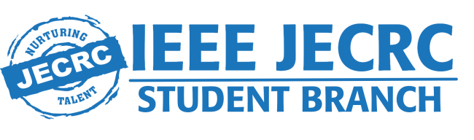
Session 2024-25

Department of Electronics &Communication Engineering
Jaipur Engineering College & Research Centre, Jaipur

INDEX
S.No. | Topic
1 | About Event
2 | Event Poster
3 | List of participants
4 | Profile of judges
5 | Glimpses of event
6 | Feedback
7 | Sample certificates

About Event
As we celebrate our two-years of journey of IEEE Student Branch JECRC we organized a National Project Expo on 21st Feb 2025.Congratulations to all participants for working towards science, innovation, and technology. Thanks to our mentor Dheemant Agrawal Sir whose guidance and motivation brings so much of positive energy and learning to us. Lots of gratitude to Prof (Dr.) Vinay Chandna Sir for showcasing new ideas and always working towards the betterment of students. Arpit Agrawal thanks for always believing in us and supporting us.
Much gratitude to Aryan Singh and Rohit Gupta for your precious time and judging students.
As we organized a Project Exhibition under the umbrella of IEEE JECRC Student Branch to showcase the innovative ideas and technical prowess of students. This event provided a platform for budding engineers to present their projects, demonstrate problem-solving skills, and highlight real-world applications of technology.
The best projects were recognized and awarded, encouraging students to take their ideas to the next level.The event exemplified the tireless efforts and unwavering commitment of my dearest IEEE Team.
Detailed Overview
- Cash Prize 15,000/-

- 1st Prizes -6000+Certificate+Trophy
2nd Prizes -4000+ Certificate+ Trophy
3rd Prizes -2000+ Certificate+ Trophy
- Consolation 3 prizes
- Registration Amount per team 400 for Non IEEE Member
300 for IEEE Member
- Certificates to all participants
- Out of Jaipur participants
3rd tire AC travel one way,
Accommodation on sharing basis including one time meal
- Workshop by Famous Influencer
- Last date of Registration 15th Feb

Event Poster

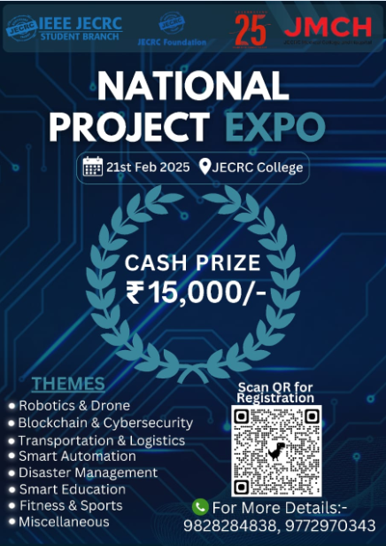

List of participants
S.No. | Team Name | Team Leader Name | Mobile Number (Preferably WhatsApp) | College/Institute Name | Team Member Name 2 | Team Member Name 3 | Team Member Name 4
1 | The Power Players | Deshraj Meena | 9664417699 | Poornima University | Sachin Meena
2 | I N E X I A | S NAMRUTH | 8660152801 | M.N.TECHNICAL INSTITUTE | Chandrashekar P | NILL | NILL
3 | Team Swasthya | Tanishq Pariwala | 8094184381 | College of Technology and Engineering | Palak Jain | Aditya Goyal | Premanshu Asnani
4 | Avinya | Mukul Garg | 8267883154 | Jaipur engineering college and research centre | Pushpendra Singh | Rohit khandelwal | Mayur choudhary
5 | Code Seekers | Anuj | 8813015820 | Arya College of Engineering and IT | Anshula | Deepak Kumar Jha | Dheeraj Saini
6 | RENEWABLE RANGERS | RITIK GOYAL | 7055381658 | JAIPUR ENGINEERING COLLEGE AND RESEARCH CENTRE | NISHEET SAINI | KUNAL SAIN | LAKSHAY AGARWAL
7 | Scooby | Kumar yash | 6205383545 | Vivekananda global university | Sohan biswas | Arya chandra
8 | AIR REVOLUTIONARIES | Jaideep Chouhan | 7878944425 | Arya college of engineering and it | Jai Bhugra | Vinay Kumar Jangid
9 | EDUCATION GURU | Gopal sharma | 8177904081 | ARYA College Jaipur | Abhinandan jain | Diksha chawla
10 | TEAM FALCON | Devarsh | 9727630593 | Indus University | Hitarth
11 | Binary Brains | Dheeraj Saini | 9116902118 | Arya college of engineering and IT | Harsh patidar | Vinay patidar | Sameer Rathore
12 | Hack4Health | Khushi Sharma | 8532936010 | Arya College of Engineering and IT | Mishti Jain | Prachi Pandey | Rahul Kumawat
13 | THE SOVIET STARFLEET- IEEE RAS | Hiten Balara Singh Choudhary | 9166513933 | Manipal University Jaipur | Mridul Sharma | Arjun Nain | Harshit Singh Raushan
14 | Dharmendra Thakur | Dharmendra Thakur | 8000685342 | JECRC Foundation | Manvi Jain | Harshita | Ansh Prajapati
15 | Avish Gupta | Avish Gupta | 9828940017 | JECRC Foundation | Honey Badgujar | Akshita airan | Ishita mayatwal
16 | MARS : Mollify alert response system | Mananshi Sethi | 8440961151 | JECRC Foundation | Akshita Jain | Krish Modi | Srishti Kushwaha
17 | NavShield | Mayank Agarwal | 9309316497 | Jecrc Foundation | Tarun gupta | Gunjan Jain
18 | Blackbird | Prateek bhardwaj | 8094609678 | JECRC foundation | Aftab Khan
19 | The Smashers | Sangam | 8271741401 | Arya College of engineering and Information technology | Shubhrat Chaurasiya | Tosif Mohammad Sheikh
20 | HoloMove | Saish Atwadkar | 7022096703 | Manipal University Jaipur | Raghvendra Shukla | Shuvh Somani
21 | JU Makerspace Fusion | Abhishek Rajauria | 9315064581 | JECRC University | Dushyant Singh | Vikas Tiwari | Vidit Shringi
22 | Sarthihub.ai | Sujaan Bhalla | 7339728371 | Arya College of Engineering | Priya Saini | Vijay Singh
23 | HandDrive Innovators | Tanishq Bharadwaj | 9352518003 | Jecrc Foundation | Shobhit Kumar | Kanika Maheshwari | Komal Yadav
24 | Dynamic Vortex | Sarthak Chopra | 9929575464 | Poornima Institute of Engineering and Technology | Yash Khadagta | Avi Mathur | Somya Garg
25 | LIC | Mayank Gupta | 9873747706 | JECRC college | Akshat panchal | Devansh Bhatnagar | Fateh Singh meena
26 | ProNovators | Pushpendra Tiwari | 9351306823 | Anand International College of Engineering | Ujjawal sharma | Chhote lal Meena | Sumit Sharma
Glimpses of event
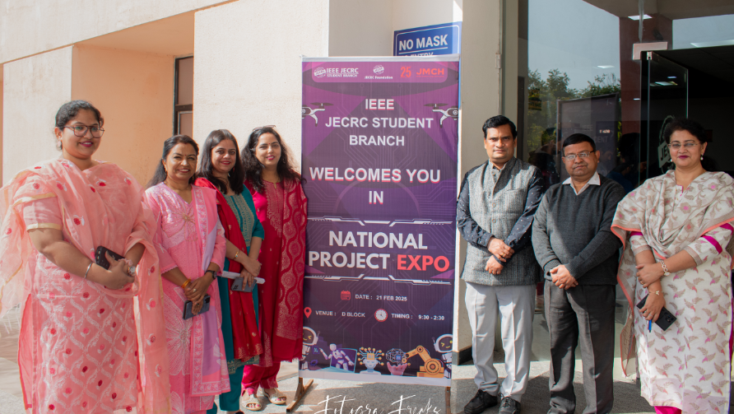
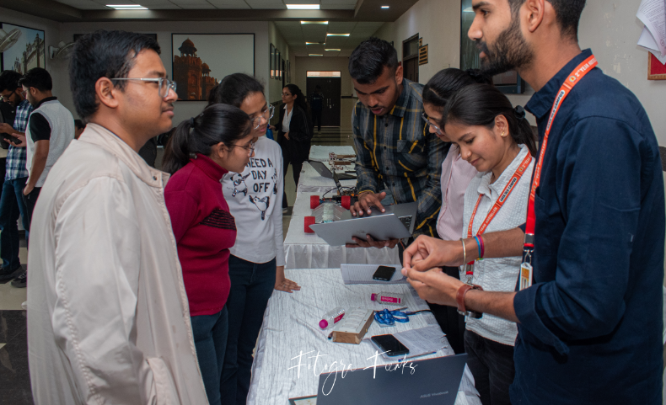
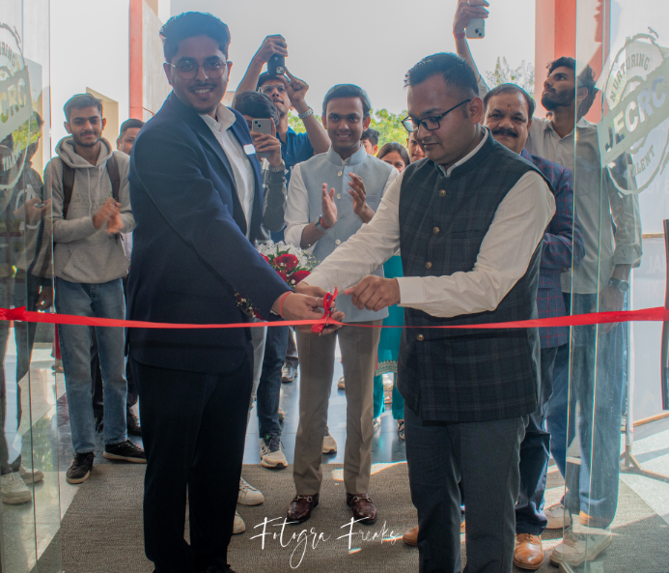
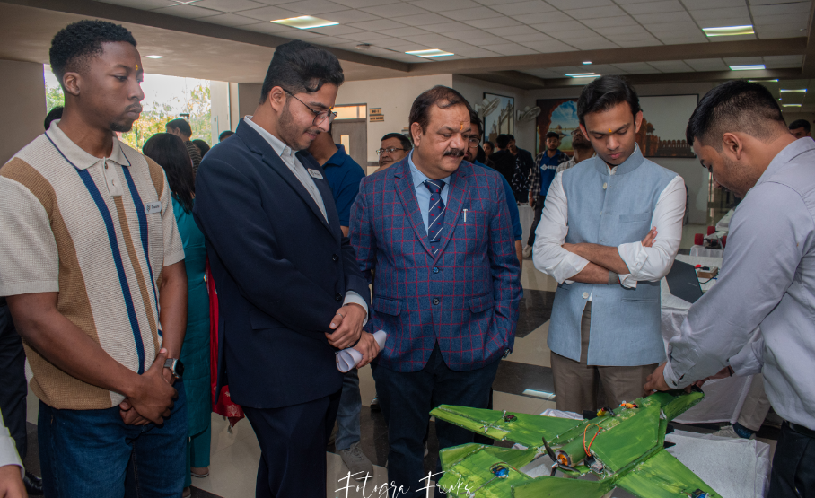
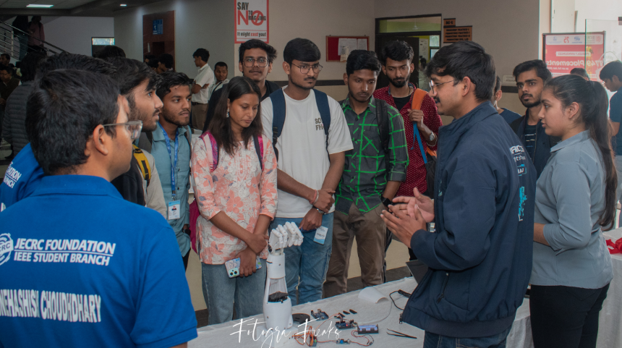

Feedback of event

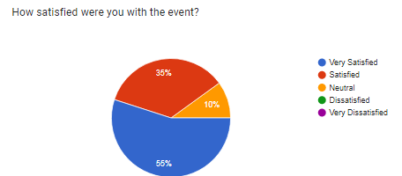
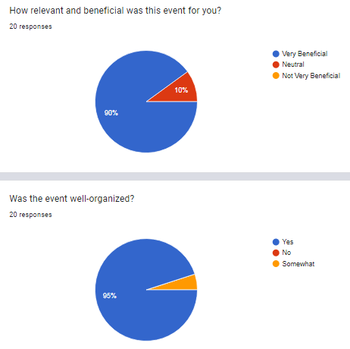
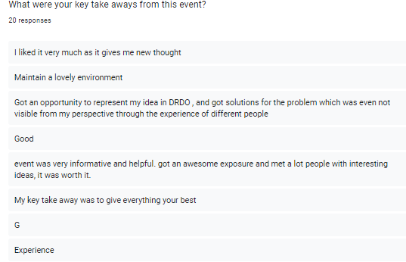
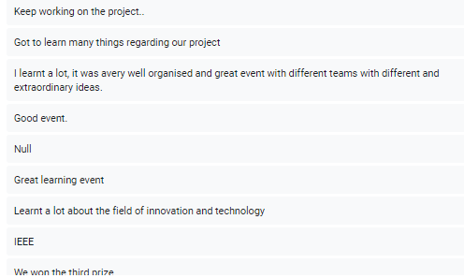
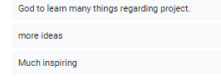

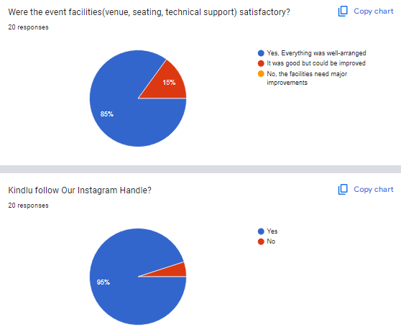

Sample Certificate
