Jaipur Engineering College & Research Centre, Jaipur

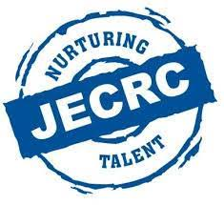

Teachers Day Celebration
Session (2019-20)

Teachers Day 2019
In the honor of Birth Anniversary of second President of India, Dr. SarvepalliRadhakrishnan, 5th Sept. is celebrated as Teacher’s Day since 1962. It creates a bond of faith between both the teachers and the students. The Teacher’s Day was also celebrated in the Mechanical Engineering Department of JECRC foundation. The students of 3rd & 5th semester managed the event in a good manner. There was peace and pretty environment everywhere. All students welcome the teachers in a proper way. Welcome speech was delivered in honor of the teachers. The event started by cutting of cake. HOD Sir of ME Department Dr. M.P. Singh was invited on the stage to share his experience on the event and to give the right direction for future of the students.
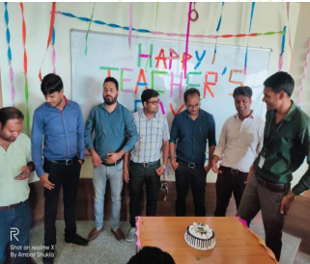
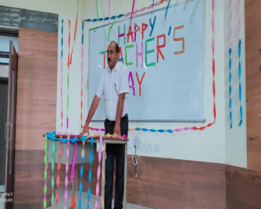
On the auspicious occasion of Teacher’s day the students of Civil Engineering Department organised a celebration event in which various performances and games are performed. On the very starting of the day all the students of department invited the H.O.D., staff faculties and other respected members of civil department. All the faculties given their presence in the event at 9:30 AM. Firstly, all the faculties are welcomed by the students with a great enthusiasm. The event started with chanting of the shlokas.

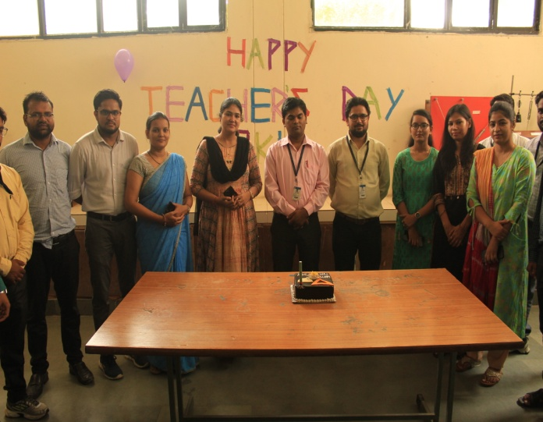
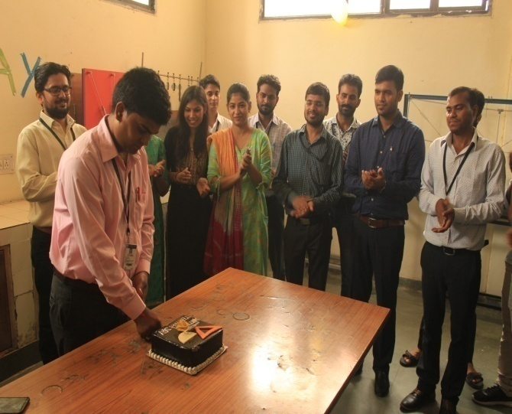
After that the cake cutting ceremony was done by the H.O.D and other faculty members.
With having good enthusiasm and Energetic Environment the teachers are requested to take their respective seats and enjoy the activities which are going to be held.
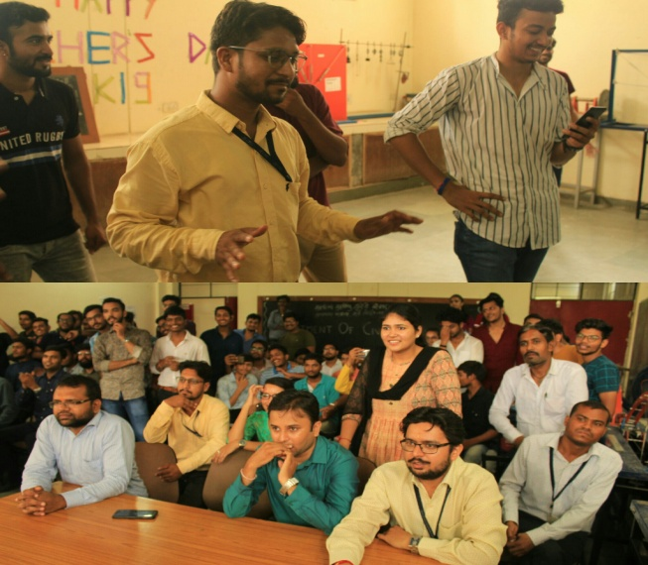
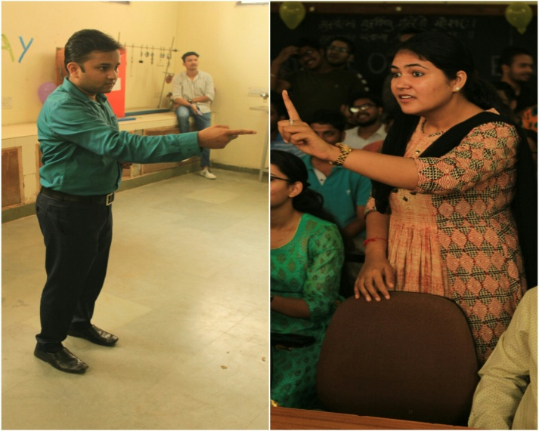
First the Games and Fun activities are organised by the students for their teachers, the Fun Activities are following –
- Dumb Charades (Divided in TWO team)
- Balloon Blowing and Burst by sitting
- Lemon- Spoon Race
- Each Teacher Special Performance
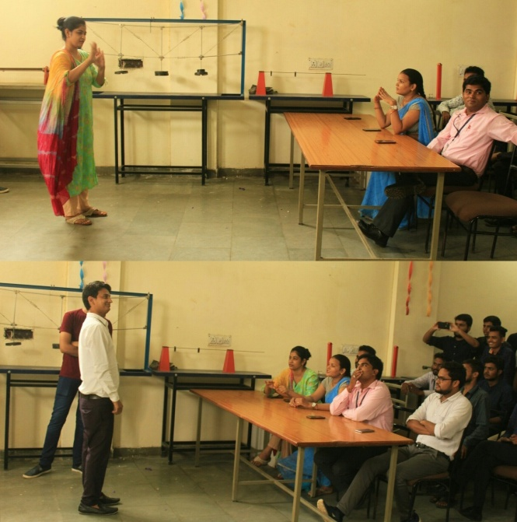
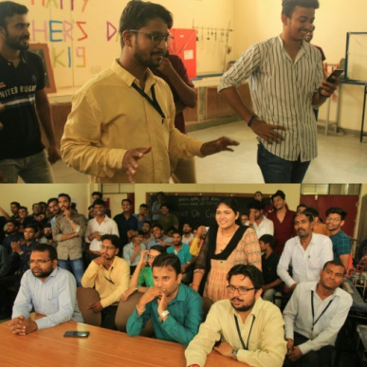
After cake ceremony, the main attraction of the event, the game “Dumb Charades“in which following faculties -
- Mr. Hetram Sharma
- Mrs. Monika Sharma
- Mr. Jitesh Kumar Jain
- Mr. Pradeep Kumar Jain
- Mr. Amit Mittal
- Mr. Yogesh Kumar Agarwal
- Mr. Ashish Boraida
- Mr. Teekam Singh
- Mr. AkhilMaheshwari
- Mr. Hitesh Nagar
- Mr. Narendra Sipani
- Mrs. Anuradha Singh
- Ms. NidaKhanam
- Ms. ShivanganiKhandelwal
- Mrs. Brijlata Sharma
And including following Lab Technicians –
- Mr. Hemraj Saini
- Mr. Ghanshyam Chaudhary
- Mr. KamleshBairwa
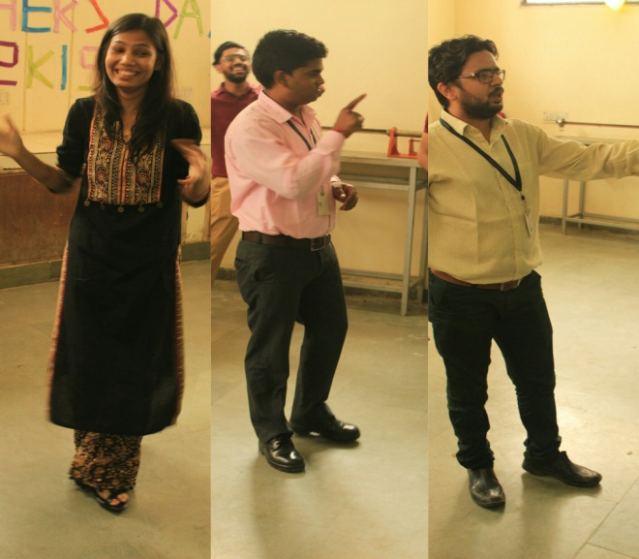

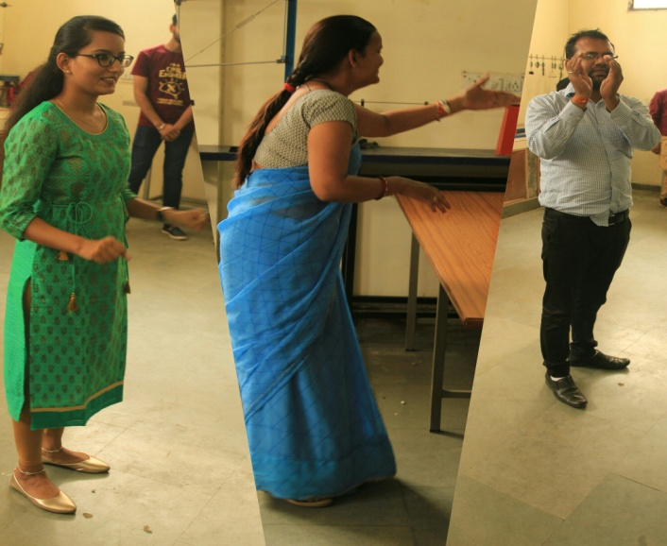
and other faculties enacted the movie names like Sholay, Golmaal, Drishyam, Sultan etc. All the faculties enacted the movie names very well in their own ways. All the faculties and students enjoyed the game.
After the enthusiastic performances “1 min. Balloon” competition in which duo of the two faculty members had to blow and burst maximum numbers of balloons in 1 minute by sitting on them started . In which duo teams are made by students itself are followingand other faculty duo’s played the game and enjoyed.
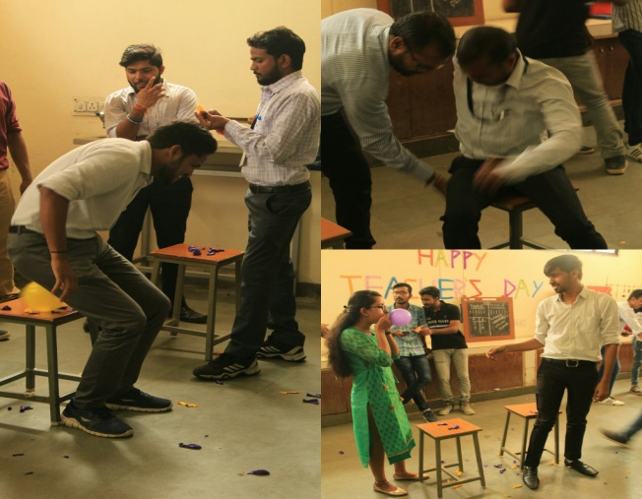
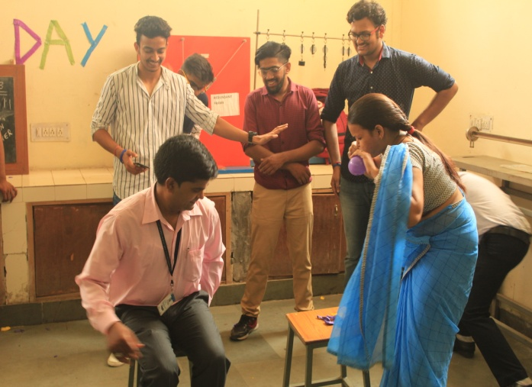
- Mr. Narendra Sipani – Ms. ShivangniKhandelwal
- Mr. Hetram Sharma – Mrs. Brijlata Sharma
- Mr. GhanshyamChoudary- Mr. Hemraj Saini
After the balloon game, overwhelming singing performances were presented by the students. After that dances was performed by the students of department. Then mimicry was performed of various faculties by the students. The Performances which are performed by the students of 1st, 2nd, 3rd year are such an amazing and energetic performances in the following talent
- Dancing
- Singing
- Poetry
- Mimicry,etc
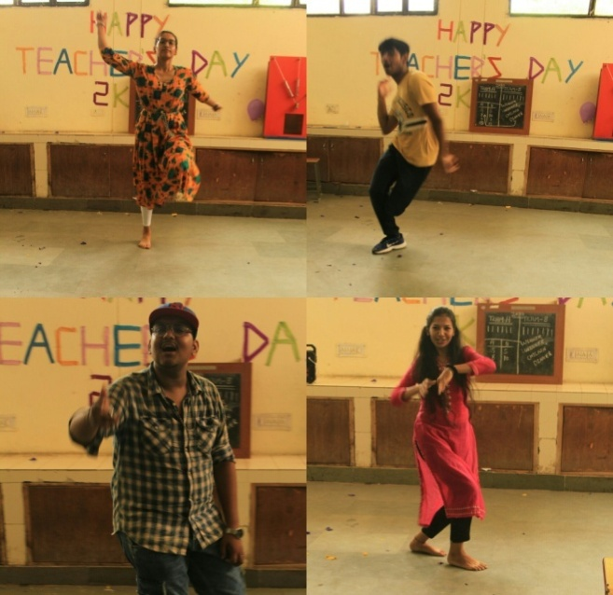
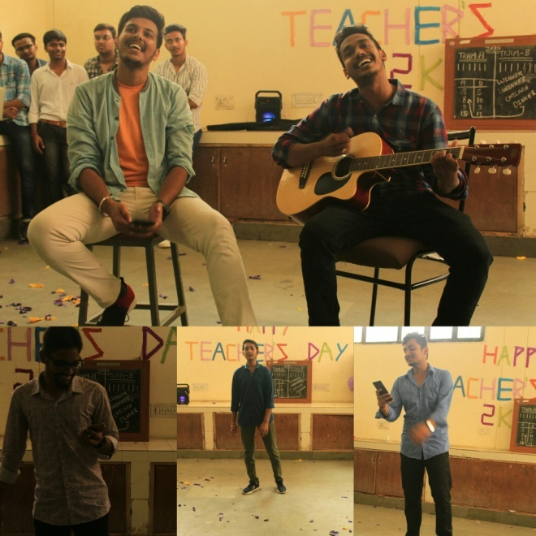
After that “Lemon Spoon Race” was played and enjoyed by the whole faculty members which was played in the corridor of C-Block basement. Then the faculties performed the dances and enjoyed the event with the students of the department.
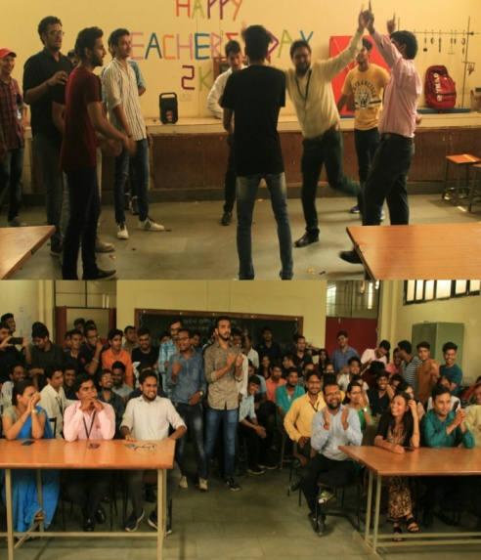
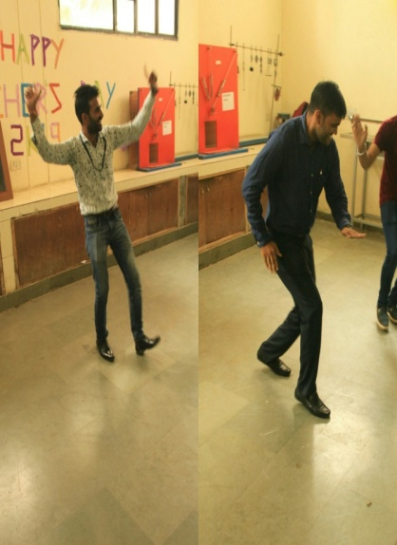
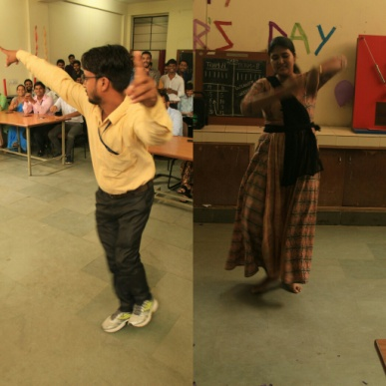
And in last the respected H.O.D sir of the Civil Department Mr. Hetram Sharma delivered the speech thanking and praising and congratulating the students for performances and organising such a beautiful event for the staff and faculties and wished good luck for future.
At the end, students arranged the refreshments for the faculties and are made sit in the same room with great arrangements where they have done their Breakfast and had Cold drinks.
After having all things and activities done including refreshments the Teachers have thanked and appreciated the students for organising such an enjoyable and memorable event.

