Jaipur Engineering College & Research Centre, Jaipur

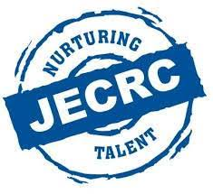

# Teachers Day Celebration

**Session (2018-19)**

**Teachers Day 2018**

Teacher's day is celebrated every year on 5th of September to pay honour to our selfless teachers and their priceless job. 5th of September is a birth anniversary of our earlier President Dr. SarvapalliRadhakrishnan. This year also students of JECRC Mechanical Department celebrated the Teachers day. Different activities wereperformed & students greeted there faculties.

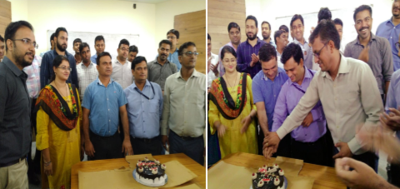

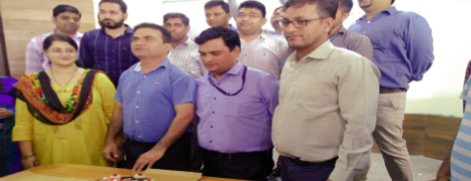

A teacher is a friend, philosopher, and guide who holds our hand, opens our mind, and touches our heart. The contribution of a teacher cannot be ignored at all. In many countries across the world, teacher's day is a special day where teachers of schools, colleges, and universities are honoured specially. The date varies from country to country. The universally accepted World Teacher's Day is 5th October. In India, the Teacher's Day is celebrated on 5th September and this tradition started from 1962.

On the occasion of teacher's day, a function was organised by "Theos club" in which teachers of the department was invited and many fun activities were done by them.

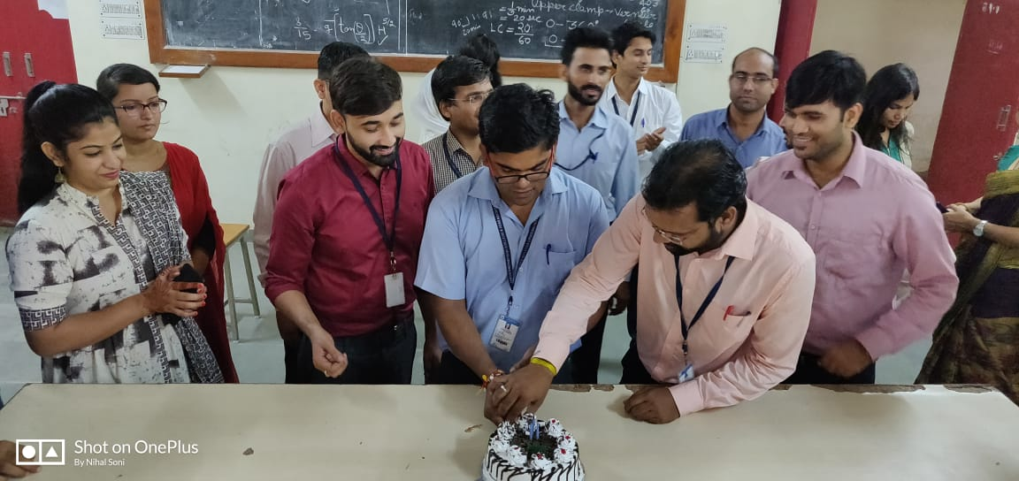First of all, at the starting of the program cake was reap by the teachers and after that many performances were done by the students and appreciated by the teacher faculty also.

**Events in the program:**

1. Dumb Charades - 10:00am - 10:45am

2. Quiz - 10:55am - 11:25am

3. Tic-Toc-Toe (corridor) - 11:35am - 12:05pm

4. Time for Truth - 12:20pm - 12:50pm

5. Student Performance - till 2:00pm

**Performances included**

A beautiful song is singed by Ashish"Guru dev day karke" which is very respecting and heart touching song.

And a beautiful poetry was spoken by Priyanka loyal which was made by her for the teachers and was loved by all the teachers.

Many dance performances were done by the students such as bhangra by Yash and Western dance performance by Sanjana.

Including these all, a mimicry act on Hetram Sir was also done by the Tanishq 3rd year boy and Yash 2nd year; even appreciated by the sir himself also.

**Fun Activities**

After this fun activity were done including the task like - 'pick the paper and do the task’ in which every teacher did the task well and many of the fastest answers were given by the Nida ma’am and Amit Sir and many teachers.

Bollywood related Quiz were asked by the teachers in which they enjoyed a lot in giving answers.

Even Ashish Sir, Hetram Sir, Nida ma’am, Prateek Sir played well in expression exploring game and quiz.

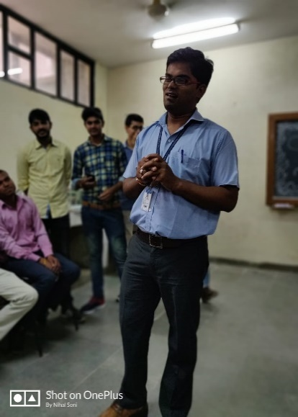

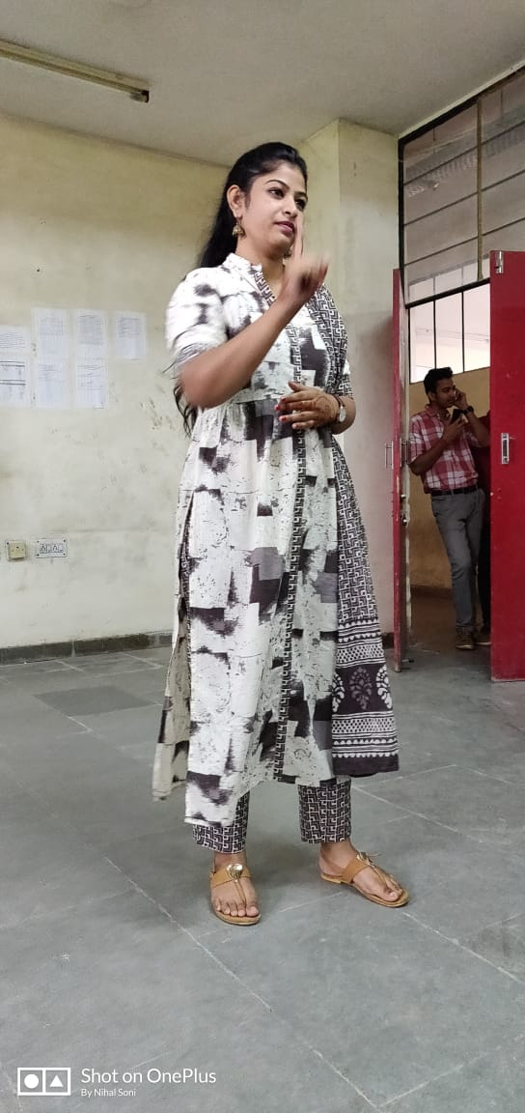

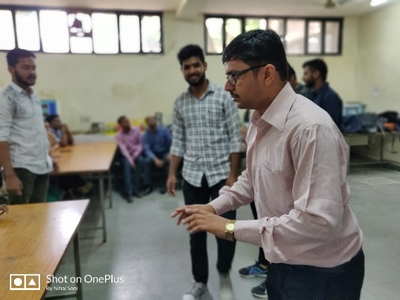

Nida Ma’am, Hetram Sir and Ashish Sir expressing the movie title with great enthusiasm.

**Games**

And at the end of the program a small game was played by the teachers "Tic Tac Toe" and a team were made there and the teachers actively played the game.

The program for the teachers were organised by the:

**3rd year students namely:** Mahesh Merotha, Gaurav, ManasweeVerma, Tanishq Jain, Rajveer, KamleshChoudhary.

**2nd year students namely:**Aniruddh Singh, YashSingodia, Mohit Agarwal, Bharat Choudhary, Arun, Raghuveer.

And the program was enjoyed and loved by the teachers and even the students also.

**Many useful messages were given by the teachers also…..**

* Prateek sir (deputy HOD) said that the as a teammate he got very friend full and helpful teachers mate and the responsible and very admiring students also and said many words about his teachers and make the moment special.

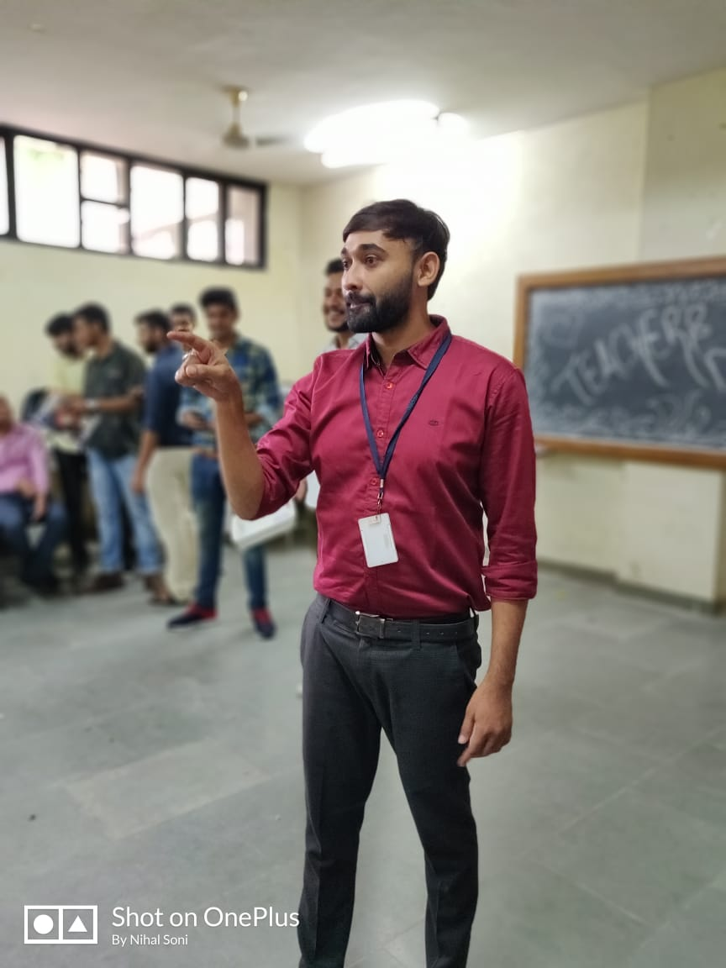

* Amit sirsaid a very beautiful short story with a moral value and lovable message. Even he also thanks to the students for the best program and said that he got the best teaching staff and the students.

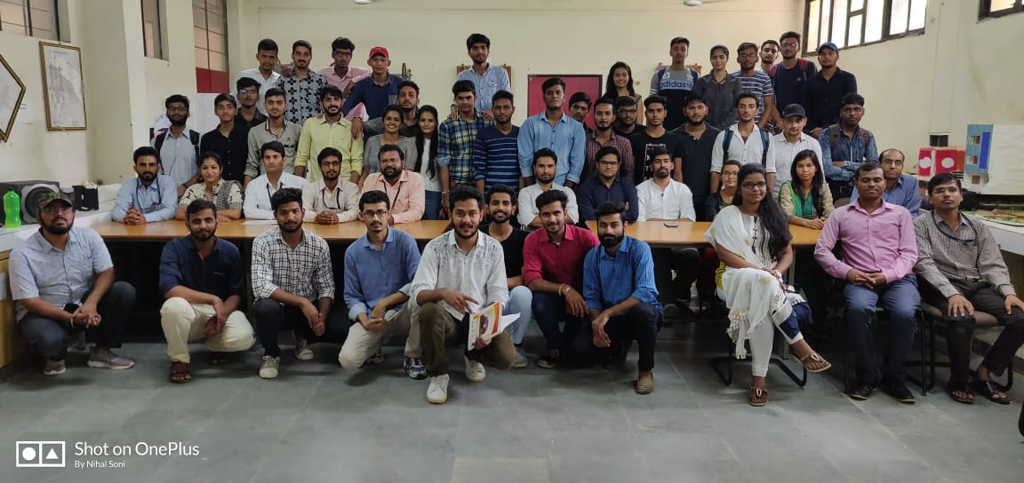

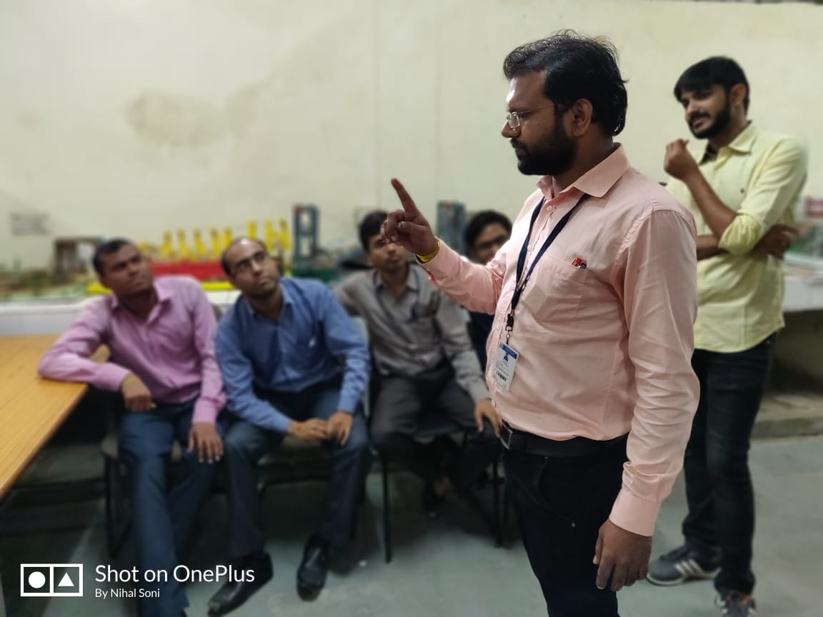

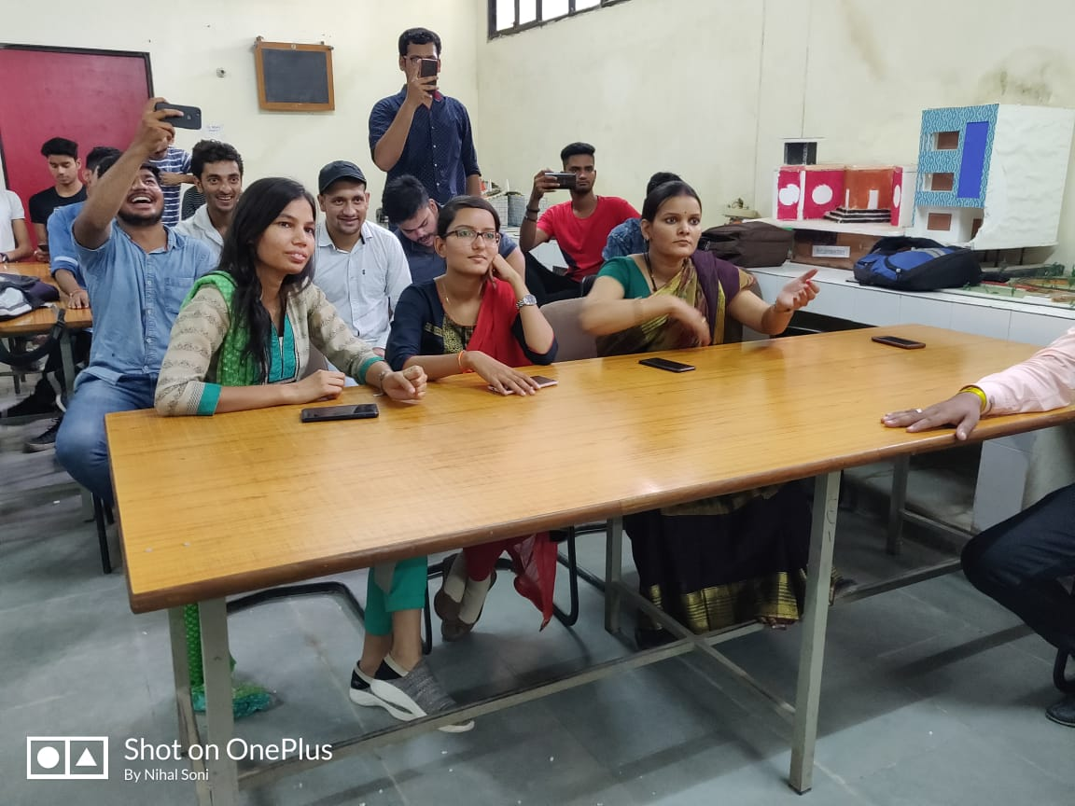

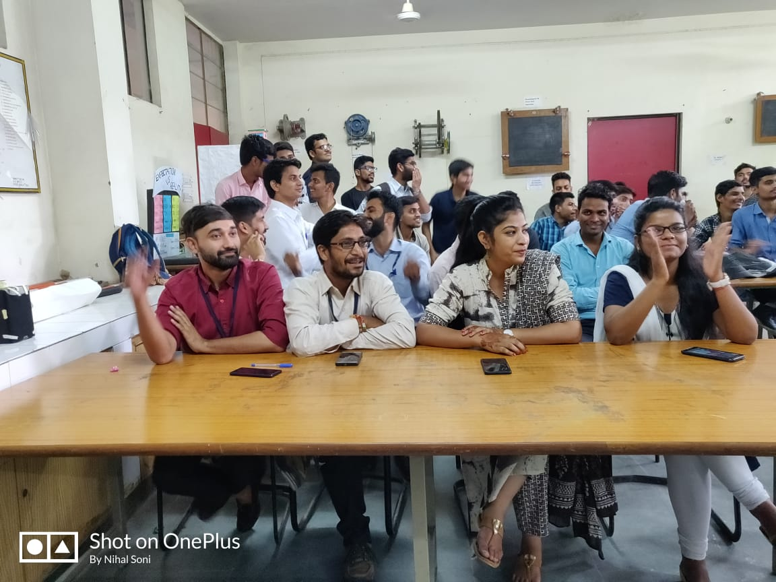

With energetic dynamism, a celebration was conducted in IT department by the students of 3rd year on 5th September, 2018. It was an auspicious day for students, to celebrate with all the faculties of the department. Teachers’ day celebration began as the students greeted all the teachers, as a token of respect.

All students created an aura of love and appreciation as they sang, recited a poem and presented a cake for all the teachers. The cake cutting was followed by the inspirational thoughts of the teachers. Some of the teachers and respected Sunil sir motivated everyone by their words of wisdom.

It concluded with a ‘thank you note’ delivered by a student, marking the importance of teachers. A lot of memories were created as the celebration filled a different zeal among everyone.

With energetic dynamism, a celebration was conducted in IT department by the students of 3rd year on 5th September, 2018. It was an auspicious day for students, to celebrate with all the faculties of the department. Teachers’ day celebration began as the students greeted all the teachers, as a token of respect.

All students created an aura of love and appreciation as they sang, recited a poem and presented a cake for all the teachers. The cake cutting was followed by the inspirational thoughts of the teachers. Some of the teachers and respected Sunil sir motivated everyone by their words of wisdom.

It concluded with a ‘thank you note’ delivered by a student, marking the importance of teachers. A lot of memories were created as the celebration filled a different zeal among everyone.



