Report
Session on Immunity Masterclass by Ruchi Rajoria
14th May, 2021

About the Event:
During the pandemic everyone was trying to find ways for their families staying at home as it was scary everywhere and the only thing that could be heard was “Immunity” .
So the First year Family of JECRC took the initiative of conducting a session “ Immunity Masterclass live with Ruchie Rajore” on 14th May 2021, to help the students & their families to work as boasters i.e. how to improve their immunity by sitting at home and working from home or during online classes.
The session was started with welcome note by Ms. Sonia Khoobchandani followed by the address of Dean First Year Dr. Ruchi Mathur.
The event was conducted through online mode (Zoom platform) by Ruchi Rajoria, Living facilitator & a Certified Yoga & Meditation Teacher by the Ministry of Ayush, Govt. of India. She advised about the healthy diet, immunity boosters, home remedies along with the practice of beathing patterns, pranayam & other aasanas & other excercises. It was really a wonderful session full of activities & knowledge.
Approximately 500 students were participants in this live session. The session ended with the question-answer round folled by vote of thanks by Dr. Barkha Shrivastva, Dy. Dean First Year.

Dr. Ruchi Mathur
Dean First Year
Event Date &Time: 14th May, 2021, at 4 P.M
Total Registrations: 710
Coordinator: Ms. Sonia Khoobchandani
Event Gallary:
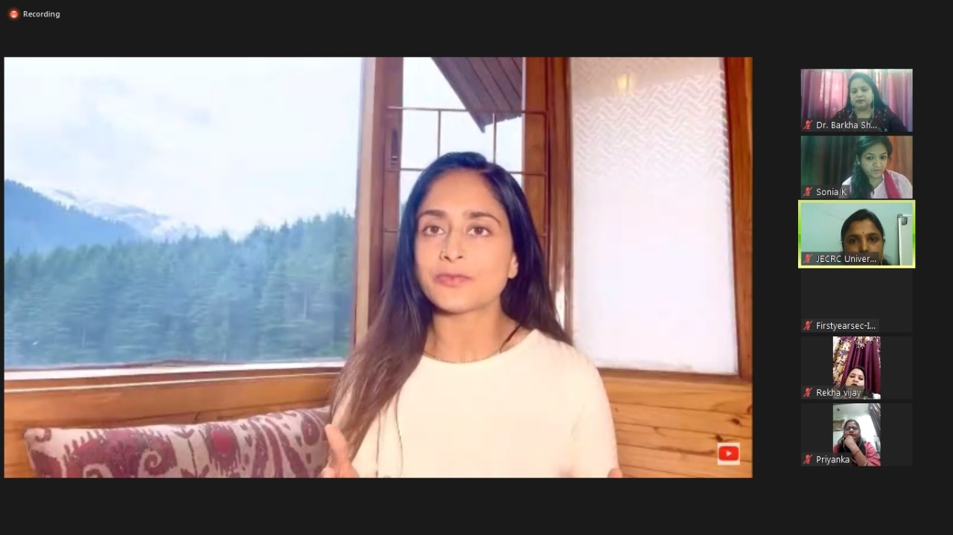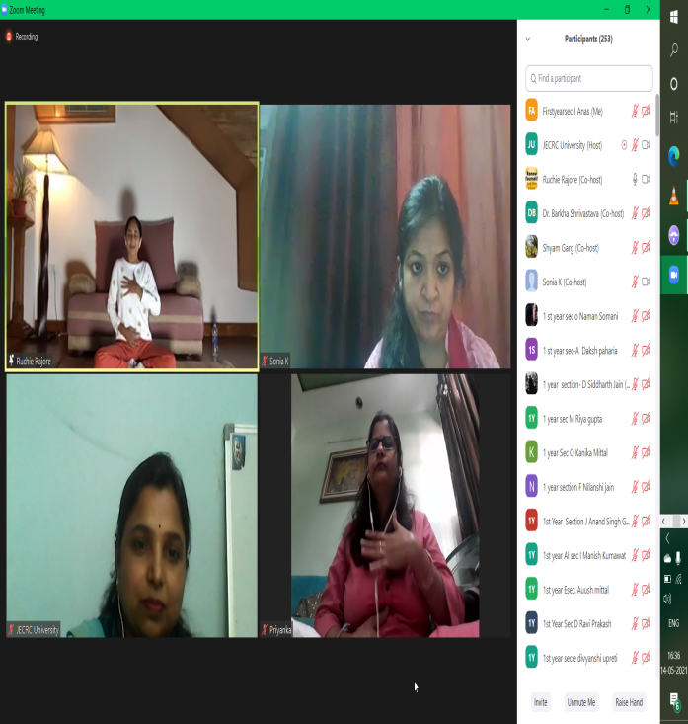
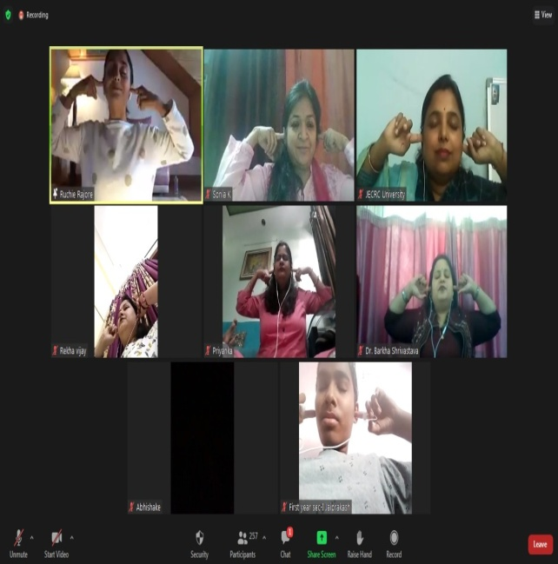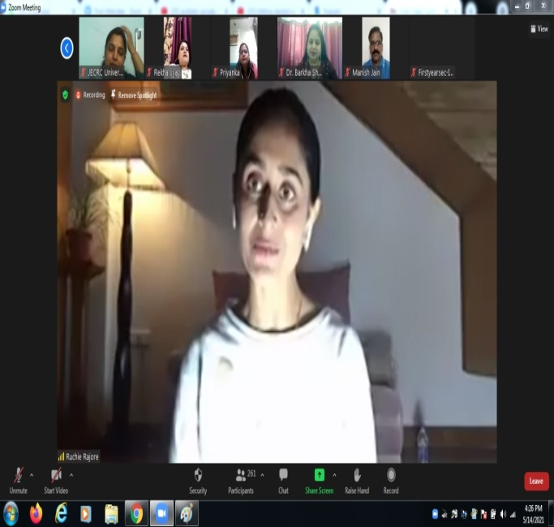
Dr. Ruchi Mathur
Dean First Year

Notice for Immunity Masterclass
Greetings !!!

Department of *Applied Science, JECRC, Jaipur is organizing a Live session " Immunity Masterclass" with *Ruchie Rajore* on 14/05/2021 from 04:00 PM to 5.30 PM.

*Ruchie Rajore* is an Art of Living facilitator & a Certified Yoga & Meditation Teacher by the Ministry of Ayush, Govt. of India.
With over 10 years of teaching experience with the Art of Living, Ruchie Rajore enjoys serving the global wellness community through various Breath & Meditation workshops. Her dedication to yoga as a practice shines through her classes, which blend an easy flow with crisp alignment instruction & a sense of playfulness.
E-certificate: All registered participants will be eligible to get e-certificate after joining complete session and submitting feedback form. Feedback link will be provided at the end of the session treated as attendance.
*SESSION: 1 Hour*
*IMMUNITY MASTERCLASS WITH BREATHWORK & MEDITATION with Ruchie Rajore*
13 min - VIDEO
13 min BREATHWORK
13 min SUKSHMA VYAYAMA ( EXERCISES )
10 min MEDITATION
10 min question

Dr. Ruchi Mathur
Dean First Year

Registration Fee: No registration fee required
Joining credentials will be shared only after successful registration.

*Registration form* :-
https://docs.google.com/forms/d/e/1FAIpQLSddFu6oom2a9OVnZnkCsjvgdk6H0UiOyVPzj9wrqObJKJrttQ/viewform?usp=sf_link

Faculty Coordinator: Ms. Sonia Khoobchandani

Regards

Dr. Ruchi Mathur Dr. Barkha Shrivastava
(Dean First Year) ( Dy. Dean First Year)

List of Participants:
S.No. | Timestamp | Name | Father's Name
1 | 5/13/2021 9:59:22 | Dr. Barkha Shrivastava | MR. R KnShrivastava
2 | 5/13/2021 10:06:56 | Dr Avani Pareek | Me Rajendra Kumar pareek
3 | 5/13/2021 10:08:09 | Khushwant Vyas | Vinod Vyas
4 | 5/13/2021 10:08:27 | Mohan lal | Kewal ram
5 | 5/13/2021 10:08:39 | Manu garg | Dhanesh garg
6 | 5/13/2021 10:08:53 | Arham Jain | Surendra kumar jain
7 | 5/13/2021 10:08:57 | Puneet Goyal | Pankaj Goyal
8 | 5/13/2021 10:09:08 | Bhunesh Dadheech | Mahendra Kumar Sharma
9 | 5/13/2021 10:09:11 | Harshit singh | Hanumant singh
10 | 5/13/2021 10:09:15 | Yashraj Verma | Rajaram verma
11 | 5/13/2021 10:09:20 | Gajendra Sharma | K R Sharma
12 | 5/13/2021 10:09:21 | Opal Jain | Mahavir Jain
13 | 5/13/2021 10:09:25 | Karan Sharma | Manish Sharma
14 | 5/13/2021 10:09:25 | Jaiprakash | Satyanarayan Maheshwari
15 | 5/13/2021 10:09:49 | Ankit Kumar | Dharmendra Kumar
16 | 5/13/2021 10:09:51 | Daksh sharma | Devesh sharma
17 | 5/13/2021 10:09:51 | Kaushal Yadav | Babinder Singh Yadav
18 | 5/13/2021 10:09:57 | Aksha mishra | Sanjay kumar mishra
19 | 5/13/2021 10:10:01 | Soniya singh | Ramdayal Chaudhary
20 | 5/13/2021 10:10:01 | Arpit Kumar Jain | Vinod Kumar Jain
21 | 5/13/2021 10:10:12 | Kartik Pachlangia | Vipin Pachlangia
22 | 5/13/2021 10:10:22 | Ayushi george | H. Vishal George
23 | 5/13/2021 10:10:24 | Yashika singh bhati | Mr.Raghunath singh bhati
24 | 5/13/2021 10:10:26 | Anshika Jain | Sanjay Kumar Jain
25 | 5/13/2021 10:10:36 | Priyanka sharma | Romesh chander
26 | 5/13/2021 10:10:44 | Vartika Karora | Mr surendra kumar karora
27 | 5/13/2021 10:10:46 | Sujal jain | Nirmal kumar jain
28 | 5/13/2021 10:10:53 | Deepak Verma | Mr.Vijay Kumar Verma
29 | 5/13/2021 10:10:55 | KHEM RAJ | Suresh chand meena
30 | 5/13/2021 10:10:58 | Deendayal Meena | Chhotu lal Meena
31 | 5/13/2021 10:11:01 | Grahit Goyal | Nandlal Goyal
32 | 5/13/2021 10:11:05 | Avika mour | Deepak mour
33 | 5/13/2021 10:11:08 | Hanumant singh shekhawat | Vikram singh shekhawat
34 | 5/13/2021 10:11:09 | Dixant gautam | Avinash gautam
35 | 5/13/2021 10:11:21 | Sneha agarwal | Mukesh agarwal
36 | 5/13/2021 10:11:23 | Abhinav Sharma | Ram Chandra Sharma
37 | 5/13/2021 10:11:25 | Alok meena | Chiranji lal meena
38 | 5/13/2021 10:11:32 | Kirtan Soni | Manoj Soni
39 | 5/13/2021 10:11:47 | Aashutosh jwala | Suresh Kumar jwala
40 | 5/13/2021 10:11:56 | Ashutosh Sharma | Omhari sharma
41 | 5/13/2021 10:11:58 | Mohd akib Theem | Abu Husain Theem
42 | 5/13/2021 10:11:59 | Anumeha khandelwal | Dharmendra gupta
43 | 5/13/2021 10:12:10 | Himanshu mangal | Vishnu Kumar Gupta
44 | 5/13/2021 10:12:15 | Himanshu gour | Ghanshyam gour
45 | 5/13/2021 10:12:21 | Garbhit Kumawat | Ramawatar Kumawat
46 | 5/13/2021 10:12:28 | Dr.Rajkumar | Shri Mange Ram
47 | 5/13/2021 10:12:30 | Chelsi Nagar | Amar Singh
48 | 5/13/2021 10:12:54 | Jaiprakash | Satyanarayan Maheshwari
49 | 5/13/2021 10:12:57 | Anshul Yadav | Mr. Devki Nandan Yadav
50 | 5/13/2021 10:12:59 | Kaushal Yadav | BABINDER SINGH YADAV
51 | 5/13/2021 10:13:04 | Devesh Kumar | LALJEE RAM MEENA
52 | 5/13/2021 10:13:14 | Kush sharma | Laxman Prasad sharma
53 | 5/13/2021 10:13:22 | Himanshu mangal | Vishnu Kumar Gupta
54 | 5/13/2021 10:13:35 | Ashwani Kumar | Gyan Chand
55 | 5/13/2021 10:13:36 | Rekha vijay | K.L .vijay
56 | 5/13/2021 10:13:52 | Manshi Singh | Pushpendra Singh
57 | 5/13/2021 10:13:52 | DEVESH JHARWAL | RAJENDRA KUMAR MEENA
58 | 5/13/2021 10:13:55 | Dipesh meena | Mr. Prem Prakash meena
59 | 5/13/2021 10:13:58 | Muskan Tambi | Mr. Manish Tambi
60 | 5/13/2021 10:14:07 | divyansh dhakar | dalchand dhakar
61 | 5/13/2021 10:14:37 | REHANSH SHARMA | Mr. ANIL SHARMA
62 | 5/13/2021 10:14:53 | Shubham sharma | Ashok kumar
63 | 5/13/2021 10:14:56 | Mohak Bardwa | Ripusudan
64 | 5/13/2021 10:14:59 | Dhawan kumar nama | Kailash chand nama
65 | 5/13/2021 10:15:08 | RAHUL PAREEK | RAJENDRA PAREEK
66 | 5/13/2021 10:15:10 | Sujal jain | Nirmal kumar jain
67 | 5/13/2021 10:16:31 | Bhawin ameta | Ameta
68 | 5/13/2021 10:16:33 | Ritisha sharma | Kamlesh sharma
69 | 5/13/2021 10:16:41 | GOURAV RAWAT | KAILASAH CHAND
70 | 5/13/2021 10:17:16 | Rohit Tiwari | Pankaj Tiwari
71 | 5/13/2021 10:17:19 | Sooraj garg | Keshav dev garg
72 | 5/13/2021 10:17:20 | Lavkush | Mr. Brajmohan Singh
73 | 5/13/2021 10:17:38 | MANISH SOLANKI | RAJESH SOLANKI
74 | 5/13/2021 10:17:40 | Lakshya R Saadh | Ramanuj Saadh
75 | 5/13/2021 10:17:43 | Nishant Singh Kushwah | Arjun Singh Kushwah
76 | 5/13/2021 10:17:52 | Harsh bansal | Shyam sunder bansal
77 | 5/13/2021 10:18:06 | Karan Sharma | Manish Sharma
78 | 5/13/2021 10:18:09 | KUMUD JAIN | Pushpendra Bakliwal
79 | 5/13/2021 10:18:09 | Naman Gupta | Lalit Mohan Gupta
80 | 5/13/2021 10:18:09 | Akshat Khandelwal | Mahendra Khandelwal
81 | 5/13/2021 10:18:10 | Mohit Aggarwal | Mr. Rajesh Kumar
82 | 5/13/2021 10:18:12 | Ayush Jain | Mahendra Bilala
83 | 5/13/2021 10:18:14 | Gautam Vijay | Ravi Shankar Vijay
84 | 5/13/2021 10:18:17 | Akash singh bhadoria | Mr. Indraj singh bhadoria
85 | 5/13/2021 10:18:35 | kanak saini | Mangal singh saini
86 | 5/13/2021 10:18:36 | Khwaish | Sunil kumar
87 | 5/13/2021 10:18:43 | Mayank Sharma | Mukesh Kumar Sharma
88 | 5/13/2021 10:18:50 | vikas dhaka | ramswroop dhaka
89 | 5/13/2021 10:18:53 | Ishita Jain | Manoj Kumar Jain
90 | 5/13/2021 10:18:54 | Aryank Gupta | Jeetendra Gupta
91 | 5/13/2021 10:19:16 | Khushi Garg | Roop Chand Garg
92 | 5/13/2021 10:19:22 | Aashish kumar | Hari prasad
93 | 5/13/2021 10:19:27 | Pradeep mahawar | Ram ji lal mahawar
94 | 5/13/2021 10:19:32 | Kshitiz Mathur | Mr.Lokesh Mathur
95 | 5/13/2021 10:19:35 | Vartika Karora | Mr Surendra Kumar Karora
96 | 5/13/2021 10:19:42 | Megha Sharma | Pramod Kumar Sharma
97 | 5/13/2021 10:19:43 | Ronak maheshwari | Satish kumar bahedia
98 | 5/13/2021 10:19:45 | Dr Sarita Poonia | Ram jeewan
99 | 5/13/2021 10:19:46 | Khushi sharma | Satish sharma
100 | 5/13/2021 10:19:50 | Sushil Thapa | Amrit Thapa
101 | 5/13/2021 10:19:51 | Krishankant Sharma | Rajendra parsad Sharma
102 | 5/13/2021 10:19:54 | Vipin pareek | Vimlesh kumar pareek
103 | 5/13/2021 10:20:03 | Prakash meena | Jai ram meena
104 | 5/13/2021 10:20:29 | Ayush Kumar | Manoj kumar singh
105 | 5/13/2021 10:20:46 | Kanishk pareek | Ramakant pareek
106 | 5/13/2021 10:20:47 | Radhika Baheti | Late . Moti lal baheti
107 | 5/13/2021 10:20:49 | Mananya Gaur | Mr. Anil Gaur
108 | 5/13/2021 10:20:55 | Yashwant rawat | Harbir singh rawat
109 | 5/13/2021 10:20:59 | Naman agrawal | Ajay agrawal
110 | 5/13/2021 10:21:00 | Krishankant Sharma | Rajendra parsad Sharma
111 | 5/13/2021 10:21:14 | Rahul meena | Kamlesh Meena
112 | 5/13/2021 10:21:20 | Sushil Thapa | Amrit Thapa
113 | 5/13/2021 10:21:46 | Prerana Sharma | Mahesh Chandra Sharma
114 | 5/13/2021 10:21:47 | Khushi Verma | Rajesh Kumar Verma
115 | 5/13/2021 10:22:40 | Rachit koolwal | Pawan koolwal
116 | 5/13/2021 10:22:57 | Rahul meena | Kamlesh meena
117 | 5/13/2021 10:22:58 | Aman Sharma | Nitesh kumar Sharma
118 | 5/13/2021 10:24:39 | shubhanshu kumawat | chandra prakash kumawat
119 | 5/13/2021 10:26:17 | Roopam Agrawal | Girish Agrawal
120 | 5/13/2021 10:26:25 | aryan yadav | Mr. Rakesh Kumar yadav
121 | 5/13/2021 10:26:44 | Jalaj bohra | Shailendra pareek
122 | 5/13/2021 10:27:24 | DEVANSHU SHARMA | SANTOSH SHARMA
123 | 5/13/2021 10:27:33 | VINIT PRADHAN | Purushottam das sharma
124 | 5/13/2021 10:27:43 | Shivam garg | Mr.Radhamohan garg
125 | 5/13/2021 10:27:49 | Raina gupta | Nikhilesh gupta
126 | 5/13/2021 10:27:55 | RAJAT JAIN | MANOJ JAIN
127 | 5/13/2021 10:27:59 | Ridhima solet | Vijay singh solet
128 | 5/13/2021 10:28:38 | Mohit Agrawal | Santosh Kumar Gupta
129 | 5/13/2021 10:28:54 | Vishakha Mulani | Narendra Mulani
130 | 5/13/2021 10:29:17 | Shivam sharma | Mr kedar nath sharma
131 | 5/13/2021 10:30:03 | Vasudev Gupta | Ramavtar Gupta
132 | 5/13/2021 10:30:07 | Suvesh sharma | Dr. Bijendra sharma
133 | 5/13/2021 10:30:26 | Ishita sharma | Subhash Sharma
134 | 5/13/2021 10:30:29 | Kirtan Soni | Manoj Soni
135 | 5/13/2021 10:30:32 | Himanshu Mishra | Birendra Kumar Mishra
136 | 5/13/2021 10:30:44 | RIYA SHARMA | HARISH SHARMA
137 | 5/13/2021 10:32:03 | Nikita Agarwal | Suresh Kumar Agarwal
138 | 5/13/2021 10:32:22 | Riya Sharma | Harish Sharma
139 | 5/13/2021 10:32:29 | Soumya Agarwal | Subhash Agarwal
140 | 5/13/2021 10:32:57 | Naman somani | Kamal kumar somani
141 | 5/13/2021 10:33:15 | Sameer maheshwari | Mr Rajesh Kumar maheshwari
142 | 5/13/2021 10:33:52 | Manan soni | Manoj soni
143 | 5/13/2021 10:34:40 | Harshit Kumar Parashar | Bhupesh Kumar Sharma
144 | 5/13/2021 10:35:01 | Saloni | Sameer Shrivastava
145 | 5/13/2021 10:35:25 | Shubham sharma | Ashok kumar
146 | 5/13/2021 10:36:07 | Puneet Goyal | Pankaj Goyal
147 | 5/13/2021 10:36:15 | Naman Jain | Sushil Jain
148 | 5/13/2021 10:37:53 | Kuldeep Suthar | Ganesh ram suthar
149 | 5/13/2021 10:39:39 | Nehal Mittal | Manoj Mittal
150 | 5/13/2021 10:40:16 | Kanika Mittal | Liladhar Mittal
151 | 5/13/2021 10:42:59 | Kamal Verma | Dharamveer Verma
152 | 5/13/2021 10:44:04 | Anshika Jain | Sanjay Kumar Jain
153 | 5/13/2021 10:45:43 | Himanshu | Gajendar
154 | 5/13/2021 10:48:10 | Jatin Lakhotia | Mahesh Lakhotia
155 | 5/13/2021 10:48:16 | SAURAV KUMAR | SHASHI BHUSHAN KUMAR
156 | 5/13/2021 10:51:04 | Mohit Aggarwal | Mr. Rajesh Kumar
157 | 5/13/2021 10:54:25 | Siddhi nahar | Paras nahar
158 | 5/13/2021 10:54:59 | Anjali | Ravi Chand Mukesh
159 | 5/13/2021 10:55:10 | Amit Solanki | Mr Ishwar SOLANKI
160 | 5/13/2021 10:55:20 | Gajendra Dayma | Durgesh Kumar Dayma
161 | 5/13/2021 10:55:36 | HARSH GUPTA | Rakesh Kumar Gupta
162 | 5/13/2021 10:55:45 | Diwya sudarshan kaushik | pramod kaushik
163 | 5/13/2021 10:56:40 | Shashank Sharma | Girdhari lal sharma
164 | 5/13/2021 10:56:51 | Nilesh | Mr. Shanti Lal Dave
165 | 5/13/2021 10:57:52 | Nilesh | Mr. Shanti Lal Dave
166 | 5/13/2021 10:58:39 | Shaksham Gouttam | Mr. Purushottam Gouttam
167 | 5/13/2021 10:58:40 | Arya jaif | Mukesh meena
168 | 5/13/2021 10:59:09 | Rahul Dey | Somen Dey
169 | 5/13/2021 11:01:46 | Shivansh Bhardwaj | Sunil Bhardwaj
170 | 5/13/2021 11:01:53 | Vishal Singhal | Prahalad Singhal
171 | 5/13/2021 11:01:54 | Garvita Gupta | Dinesh Chand Gupta
172 | 5/13/2021 11:02:11 | Rohit Sankhala | Sajjan Sankhala
173 | 5/13/2021 11:02:12 | Siddharth Sharma | Vinod Kumar Sharma
174 | 5/13/2021 11:02:19 | Yash kumar more | Manoj more
175 | 5/13/2021 11:02:46 | Ritik hada | Ram singh hada
176 | 5/13/2021 11:03:17 | Krishna pal | Kuldeep singh
177 | 5/13/2021 11:04:18 | Naveen kumar burdak | Begaram burdak
178 | 5/13/2021 11:06:31 | Tanishk Maheshwari | Ramavatar Maheshwari
179 | 5/13/2021 11:06:57 | Aditya Sharma | Paras Ram Sharma
180 | 5/13/2021 11:07:11 | Aditya Shah | Suresh Kumar Shah
181 | 5/13/2021 11:08:11 | Devendra | Ashok kumar
182 | 5/13/2021 11:08:49 | Subrat Shukla | Vivek Shukla
183 | 5/13/2021 11:09:12 | Vanshita khanda | Mr. Jugal Kishore khanda
184 | 5/13/2021 11:11:10 | Priyanshi Khandelwal | Lt.Pramod Khandelwal
185 | 5/13/2021 11:11:17 | Sandeep pareek | Yogesh pareek
186 | 5/13/2021 11:11:25 | Priyul Agrawal | Rajendra Agrawal
187 | 5/13/2021 11:12:35 | Priyal Mathur | Adesh Mohan Mathur
188 | 5/13/2021 11:14:00 | Sakshi Sarotiya | Arun Kumar Sarotiya
189 | 5/13/2021 11:15:42 | Varsha Jain | Mr. Gunwant Chandra Jain
190 | 5/13/2021 11:19:21 | Yash Mantri | Lakshmi Kant Mantri
191 | 5/13/2021 11:21:22 | Arya Raj | Ashok Kumar Sharma
192 | 5/13/2021 11:22:17 | Ishaan joshi | Mukesh joshi
193 | 5/13/2021 11:28:41 | Vedika Garg | Govind Garg
194 | 5/13/2021 11:28:44 | Prafful Palod | Sunil Palod
195 | 5/13/2021 11:31:43 | Lakshya Jain | Rajendra Kumar Jain
196 | 5/13/2021 11:33:24 | Manish Kumawat | Bajrang Lal Kumawat
197 | 5/13/2021 11:33:41 | Pulak Gupta | Nalin Kumar
198 | 5/13/2021 11:33:59 | Varnika Jain | Dhananjay Jain
199 | 5/13/2021 11:35:55 | Khushi Bindal | Kamal Bindal
200 | 5/13/2021 11:38:08 | Kushal Pareek | Manoj Kumar Pareek
201 | 5/13/2021 11:40:35 | Kalash Kshetija | Duwarka Dass Kshetija
202 | 5/13/2021 11:40:54 | Shruti Singh | Mr.Praveen Kumar Singh
203 | 5/13/2021 11:41:01 | Nidhi Tirthani | Mr. Vishnu Tirthani
205 | 5/13/2021 11:41:29 | Daksh Paharia | L L Paharia
206 | 5/13/2021 11:42:07 | Naumit Kumar | Santosh Kumar Badetia
207 | 5/13/2021 11:42:53 | Shruti Singh | Mr.Praveen Kumar Singh
208 | 5/13/2021 11:43:14 | Vartika Jain | Vivek Jain
209 | 5/13/2021 11:47:06 | Ravi Prakash | Manoj Kumar
210 | 5/13/2021 11:49:04 | Nishant Gupta | Ravindra Gupta
211 | 5/13/2021 11:49:06 | Rachit prajapati | Satyanarayan prajapati
212 | 5/13/2021 11:50:32 | Aryan Jaiman | Tarun Kumar Jaiman
213 | 5/13/2021 11:52:04 | Siddharth Jain | Yogesh Kumar Jain
214 | 5/13/2021 11:54:04 | Abhi Soni | Raghuveer Singh verma
215 | 5/13/2021 11:55:40 | Yuvraj Singh | Narendra Singh Rathore
216 | 5/13/2021 12:04:35 | Khushi garg | Satyanarayan garg
217 | 5/13/2021 12:07:39 | Shoyab Tanwar | Mohd Akhtar Tanwar
218 | 5/13/2021 12:07:45 | MOHIT KUMAR LALWANI | ANIL KUMAR
219 | 5/13/2021 12:08:07 | Suhani Bhargava | Dr. Sanjay Bhargava
220 | 5/13/2021 12:09:52 | Tejpal Singh Rathore | Jaimal Singh Rathore
221 | 5/13/2021 12:10:04 | Shivdayal Dhakar | Ramswroop Dhakar
222 | 5/13/2021 12:10:45 | Vikash choudhary | Mr. Madan lal burdak
223 | 5/13/2021 12:11:28 | Jyoti Soni | Manish Kumar Soni
224 | 5/13/2021 12:11:47 | Opal Jain | Mahavir Jain
225 | 5/13/2021 12:26:41 | Sakshi singh | Narayan singh
226 | 5/13/2021 12:26:53 | Rohit Baghel | Rajesh Baghel
227 | 5/13/2021 12:26:56 | Ashish Pahadia | SL Pahadia
228 | 5/13/2021 12:28:31 | Mayank sharma | Vijay sharma
229 | 5/13/2021 12:31:27 | Saransh Jain | Praveen Kumar Jain
230 | 5/13/2021 12:39:19 | Astha Agarwal | Rakesh Kumar Agrawal
231 | 5/13/2021 12:39:12 | Satyam Rawat | Mukesh Rawat
232 | 5/13/2021 12:41:19 | Abhinav Kumar Mittal | Mr.Mukesh Kumar Mittal
233 | 5/13/2021 12:42:35 | Hardik Rathi | Kailash chandra Rathi
234 | 5/13/2021 12:44:11 | Priyanka | Mr Prahlad Ram
235 | 5/13/2021 12:47:06 | Devang rathod | Manish rathod
236 | 5/13/2021 12:47:20 | Shailendra Shrivastava | Sri P. N. Shrivastava
237 | 5/13/2021 12:47:30 | Kritika Gupta | Revati Raman Gupta
238 | 5/13/2021 12:53:27 | Komal Sharma | Narendra Kumar Sharma
239 | 5/13/2021 12:55:01 | Abhijeet Sharma | Kamlesh Kumar Sharma
240 | 5/13/2021 12:55:14 | Shivam yadav | Rameshwar yadav
241 | 5/13/2021 12:55:42 | Priyanka jangid | Prakash chand jangid
242 | 5/13/2021 12:55:47 | Diya jain | Mukesh Jain
243 | 5/13/2021 12:57:04 | Ishita Goyal | Deepak Goyal
244 | 5/13/2021 12:57:05 | DINESH LOMROR | JOGA RAM LOMROR
245 | 5/13/2021 12:57:19 | Abhinav Kumar Mittal | Mr.Mukesh Kumar Mittal
246 | 5/13/2021 12:58:10 | Manish Kumawat | Bajrang Lal Kumawat
247 | 5/13/2021 12:58:10 | Sanjay Nitharwal | Shishpal Nitharwal
248 | 5/13/2021 12:58:16 | VISHAL SHIVHARE | DEEPAK SHIVHARE
249 | 5/13/2021 12:58:19 | Manu garg | Dhanesh garg
250 | 5/13/2021 12:58:58 | Priyanshu khandelwal | Kamlesh kumar gupta
251 | 5/13/2021 12:59:12 | Ishita Goyal | Deepak Goyal
252 | 5/13/2021 13:00:15 | Aarshi Agrawal | Rajkumar Agrawal
253 | 5/13/2021 13:00:31 | Aishwarya Jain | Mr Chhitar mal ji Jain
254 | 5/13/2021 13:03:24 | Jerin Jacob | Jeby Mammen
255 | 5/13/2021 13:03:25 | Arham Jain | Mr Surendra kumar jain
256 | 5/13/2021 13:03:38 | Bharat Mohta | Dinesh Mohta
257 | 5/13/2021 13:03:40 | Sagar Jain | Sanjeev Jain
258 | 5/13/2021 13:04:12 | Khushi saraswat | Mr. Shivcharan ojha
259 | 5/13/2021 13:04:22 | Hitesh Prajapat | Mukesh Prajapat
260 | 5/13/2021 13:04:24 | Vishal Didwaniya | Shyam lal Didwaniya
261 | 5/13/2021 13:04:45 | Sachin Kumar singhal | Rajendra Prasad
262 | 5/13/2021 13:05:53 | Karan Kumawat | Mr.Ramdev Kumawat
263 | 5/13/2021 13:06:26 | Anchit Parwal | Ajay Kumar Parwal
264 | 5/13/2021 13:06:46 | Khushi saraswat | Mr. Shivcharan ojha
265 | 5/13/2021 13:06:51 | Dheeraj Bairwa | Lalchand Bairwa
266 | 5/13/2021 13:07:31 | Karan Kumawat | Mr. Ramdev Kumawat
267 | 5/13/2021 13:07:50 | Harsh Sahu | LOKESH SAHU
268 | 5/13/2021 13:08:19 | Bhunesh Dadheech | Mahendra Kumar Sharma
269 | 5/13/2021 13:08:52 | Chitransh sharma | Mr. Vinod sharna
270 | 5/13/2021 13:09:31 | Yash kumawat | Dinesh kumawat
271 | 5/13/2021 13:09:43 | Harshvardhan soni | Bhagirath soni
272 | 5/13/2021 13:10:11 | Aishwarya Lodha | Sunil Kumar Lodha
273 | 5/13/2021 13:10:18 | Abhinav Kumar Mittal | Mr.Mukesh Kumar Mittal
274 | 5/13/2021 13:10:32 | Manu garg | Dhanesh garg
275 | 5/13/2021 13:10:59 | Abhinav Kumar Mittal | Mr.Mukesh Kumar Mittal
276 | 5/13/2021 13:11:15 | Bhawna Golchha | Manoj Golchha
277 | 5/13/2021 13:11:30 | Kshitiz Shrivastava | Jagmohan Shrivastava
278 | 5/13/2021 13:12:34 | Aman Kaushik | Manish Kumar Kaushik
279 | 5/13/2021 13:15:13 | Kanishk Parth Yadav | Om Prakash Yadav
280 | 5/13/2021 13:16:11 | Saroj Kumar | Anant Yadav
281 | 5/13/2021 13:16:39 | Abhishek Surana | Hasti Mal Surana
282 | 5/13/2021 13:16:59 | Arpita Maheshwari | Kamlesh Maheshwari
283 | 5/13/2021 13:18:09 | Ankur Kumar Singh | Sanjeet Kumar Singh
284 | 5/13/2021 13:18:59 | Aryank Gupta | Jeetendra Gupta
285 | 5/13/2021 13:19:13 | Apoorv Sharma | Pawan kumar sharma
286 | 5/13/2021 13:19:23 | SAPNA MEENA | RAJESH KUMAR MEENA
287 | 5/13/2021 13:20:25 | Apurva Singhal | Mr. Anil Singhal
288 | 5/13/2021 13:20:26 | Aayush Sharma | Mr.Krishnavtar Sharma
289 | 5/13/2021 13:21:44 | Priyanshu Saini | Deepchand Saini
290 | 5/13/2021 13:22:08 | DINESH LOMROR | JOGA RAM LOMROR
291 | 5/13/2021 13:22:54 | Priyanka Harchandani | Mahesh Kumar
292 | 5/13/2021 13:23:12 | Parth dadhich | Ajay dadhich
293 | 5/13/2021 13:24:25 | Manjeet | Dale singh
294 | 5/13/2021 13:25:47 | Prasham Jain | Sunil Jain
295 | 5/13/2021 13:26:35 | Aniket | Gopal Ram Buldak
296 | 5/13/2021 13:26:47 | Rishi Vyas | Nirmal Kumar Vyas
297 | 5/13/2021 13:33:03 | Anchit Parwal | Ajay Kumar Parwal
298 | 5/13/2021 13:35:10 | Apoorva jain | Pankaj chopra
299 | 5/13/2021 13:35:34 | Divya Ahuja | Dilip Ahuja
300 | 5/13/2021 13:36:45 | Sahil Chandani | Chetan Chandani
301 | 5/13/2021 13:39:40 | Ashika agrawal | Rajesh kumar bansal
302 | 5/13/2021 13:40:18 | Mohammad Anas khan | Mohammad Ayyub Khan
303 | 5/13/2021 13:41:54 | Harsh rawal | Rajendra rawal
304 | 5/13/2021 13:42:41 | Ansh khandelwal | Rakesh khandelwal
305 | 5/13/2021 13:43:14 | Ayushi Joshi | Manoj Joshi
306 | 5/13/2021 13:44:02 | Piyush Gupta | Mahesh Gupta
307 | 5/13/2021 13:45:03 | Tushar Khandelwal | Rajesh Khandelwal
308 | 5/13/2021 13:46:56 | Aditya maheshwari | Raj kumar maheshwari
309 | 5/13/2021 13:47:53 | Balpreet Kaur | Manjeet Singh Khanuja
310 | 5/13/2021 13:48:22 | Annu Kumar Gupta | Rakesh Kumar
311 | 5/13/2021 13:48:22 | Garvit Choudhary | Virendra Rinwa
312 | 5/13/2021 13:48:24 | Ankit Kumar | Dharmendra Kumar
313 | 5/13/2021 13:48:52 | Abhay Agrawal | Mr. Rakesh Agrawal
314 | 5/13/2021 13:48:56 | Arpit Raychand Sansi | Bheru Lal Raychand Sansi
315 | 5/13/2021 13:49:04 | Akansha gupta | Rajive gupta
316 | 5/13/2021 13:49:08 | Hardik Maheshwari | Rajesh Kumar Jhanwar
317 | 5/13/2021 13:49:13 | Ayush Kumar | Manoj Kumar Singh
318 | 5/13/2021 13:49:58 | Aksha mishra | Sanjay kumar mishra
319 | 5/13/2021 13:50:07 | Harsh Jangid | Suresh Jangid
320 | 5/13/2021 13:51:32 | Lalit dhakad | Nihal singh
321 | 5/13/2021 13:52:48 | Gaurav Agarwal | Deepak Agarwal
322 | 5/13/2021 13:53:59 | Deven kumawat | Rajendra kumawat
323 | 5/13/2021 13:54:35 | Divyansh garg | Mr. Rachit garg
324 | 5/13/2021 13:55:04 | Abhay bansal | Budh prakash bansal
325 | 5/13/2021 13:55:47 | Aditya Gupta | Rajesh Kumar golia
326 | 5/13/2021 13:55:58 | Priyanka Mitra | Mr. Pradeep
327 | 5/13/2021 13:56:00 | Gaurav Verma | Ramchandra verma
328 | 5/13/2021 13:56:20 | Hardik Maheshwari | Raj Kumar Maheshwari
329 | 5/13/2021 13:58:49 | Naman Gupta | Naresh Gupta
330 | 5/13/2021 14:00:09 | Jatin lalwani | Mr. Bhagwan Dass
331 | 5/13/2021 14:01:09 | Anjali singh | Raghuveer Singh
332 | 5/13/2021 14:01:19 | SUDHIR KUMAR DIXIT | Sarvesh Kumar Dixit
333 | 5/13/2021 14:03:19 | Sumit Handa | Hemant Kumar Handa
334 | 5/13/2021 14:06:17 | AYUSH MICHAEL | ROHIT MICHAEL
335 | 5/13/2021 14:07:57 | AYUSH KOTHARI | ANIL KOTHARI
336 | 5/13/2021 14:09:13 | Dr. Neelu Jain | Naveen Sethi
337 | 5/13/2021 14:16:59 | Sonia k | Mr ashok
338 | 5/13/2021 14:17:19 | priyanshi khandelwal | Lt pramod khandelwal
339 | 5/13/2021 14:19:06 | Aman Goyanka | Mukesh Goyanka
340 | 5/13/2021 14:19:17 | Bharat Mohta | Dinesh Mohta
341 | 5/13/2021 14:19:46 | Bharat Mohta | Dinesh Mohta
342 | 5/13/2021 14:20:39 | Anant joshi | Brij raj josbi
343 | 5/13/2021 14:23:07 | Sonalika Sharma | Mr. Vijay Sharma
344 | 5/13/2021 14:24:37 | Yuvraj Deovanshi | Lalit Deovanshi
345 | 5/13/2021 14:25:35 | Deendayal Meena | Chhotu lal Meena
346 | 5/13/2021 14:30:38 | Kishan Sharma | Rajesh Sharma
347 | 5/13/2021 14:30:40 | Aniket | Gopal Ram Buldak
348 | 5/13/2021 14:32:50 | Sahil Chandani | Chetan Chandani
349 | 5/13/2021 14:40:01 | Akshat gupta | Pankaj Gupta
350 | 5/13/2021 14:40:43 | Akshat gupta | Pankaj Gupta
351 | 5/13/2021 14:43:55 | Gaurav singh rajput | Kailash singh rajput
352 | 5/13/2021 14:45:30 | Teekam Singh | Tej Singh
353 | 5/13/2021 14:50:07 | Khushi Khandelwal | Dinesh Kumar Khandelwal
354 | 5/13/2021 14:55:03 | Aman jain | Chittar Mal Jain
355 | 5/13/2021 15:06:11 | Archita Khandelwal | Mahendra Khandelwal
356 | 5/13/2021 15:18:41 | JISHA VARGHESE | MR. P.V. VARGHESE
357 | 5/13/2021 15:21:37 | Vikash Kumar | Anuj Kumar
358 | 5/13/2021 15:22:02 | Vansh Kalra | Gulshan Kumar
359 | 5/13/2021 15:24:32 | Yash gangwal | Mrs sanjeev kumar jain
360 | 5/13/2021 15:30:15 | Vansh Acharya | Mr. Hitesh Acharya
361 | 5/13/2021 15:36:50 | Tanushree Acharya | Ashok Acharya
362 | 5/13/2021 15:37:45 | VAIBHAV SHIVHARE | Vijay shivhare
363 | 5/13/2021 15:38:13 | Anuj Kumar Vijay | Mr. ShivDayal Vijay
364 | 5/13/2021 15:38:55 | Mohammad Anas khan | Mohammad Ayyub Khan
365 | 5/13/2021 15:42:07 | Roma Jamnani | Harish Jamnani
366 | 5/13/2021 15:42:19 | Sanskriti Mittal | Shyam Sundar Mittal
367 | 5/13/2021 15:42:53 | Sahil Goyal | Rakesh Goyal
368 | 5/13/2021 15:44:53 | Chintan Grover | Rajesh Grover
369 | 5/13/2021 15:49:40 | SHANTANU SINGH YADAV | JAIRAJ SINGH YADAV
370 | 5/13/2021 15:51:05 | Dilip Kumar Prajapati | Ramkishor Prajapati
371 | 5/13/2021 15:52:41 | Rudrakshi Malav | Krishna Kant Malav
359 | 5/13/2021 15:54:47 | Tanishq khandelwal | Mr. Hanuman Prasad Gupta
360 | 5/13/2021 15:54:54 | Garvit Agarwal | Atul Kishore Gupta
361 | 5/13/2021 15:55:05 | Ayush Khandelwal | Mohan Lal Gupta
362 | 5/13/2021 15:55:15 | Aman Dhakad | Hari mohan
363 | 5/13/2021 15:56:14 | Manjot singh Anand | Parvinder S Anand
364 | 5/13/2021 15:56:26 | Ankit goyal | .
365 | 5/13/2021 15:56:51 | Saksham Sharma | Keshav Gopal Sharma
366 | 5/13/2021 15:58:59 | Ishika Gupta | Anil Gupta
367 | 5/13/2021 15:59:52 | Ronit Jain | Rajesh Jain
368 | 5/13/2021 16:00:02 | Trilok jain | Mr. Ramdayal jain
369 | 5/13/2021 16:00:46 | Apeksha Pandey | Mr. Sanjay Pandey
370 | 5/13/2021 16:01:09 | Saloni Vijayvargiya | Ajay Vijayvargiya
371 | 5/13/2021 16:03:02 | Shaksham Gouttam | Mr. purushottam gouttam
372 | 5/13/2021 16:05:58 | Swati Jain | Suresh Kumar Jain
373 | 5/13/2021 16:06:19 | Shivesh singh | Dilip Singh
374 | 5/13/2021 16:07:29 | Sakshi Kabra | Mr. Omprakash Kabra
375 | 5/13/2021 16:07:53 | Vineet aalwan | Mr. Rajkumar aalwani
376 | 5/13/2021 16:08:27 | Neha Solanki | Late Rajendra Solanki
377 | 5/13/2021 16:08:36 | ADITYA KUMAR SINGH | BINDA SINGH
378 | 5/13/2021 16:09:15 | Vansh Jain | Suresh Kumar Jain
379 | 5/13/2021 16:09:21 | Manasvi jain | Manoj jain
380 | 5/13/2021 16:09:31 | Divya Jindal | Raj Kumar Jindal
381 | 5/13/2021 16:10:04 | Tarun Soni | Rajendra Soni
382 | 5/13/2021 16:12:03 | Riya Jain | Vimal Kumar Jain
383 | 5/13/2021 16:14:37 | Dixit Bansal | Ravindra Bansal
384 | 5/13/2021 16:14:50 | Rajan Kumar Jha | Mr. Bindeshwar Jha
385 | 5/13/2021 16:14:52 | Utkarsh Jain | Paras jain
386 | 5/13/2021 16:16:33 | Namita Lamba | Mr.Anil kumar Lamba
387 | 5/13/2021 16:16:38 | Bhupendar Sharma | Gyarsi Lal Sharma
388 | 5/13/2021 16:18:34 | kartik jain | paras mal jain
389 | 5/13/2021 16:18:36 | Arti solanki | Mr. Kishan lal solanki
390 | 5/13/2021 16:20:45 | Akshita Bangar | Arvind Kumar Bangar
391 | 5/13/2021 16:26:15 | Lakshya Jhalani | Pawan Jhalani
392 | 5/13/2021 16:26:48 | Utkarsh Jain | Paras jain
393 | 5/13/2021 16:28:35 | Samarth pratap singh | Rajesh kumar
394 | 5/13/2021 16:30:43 | Mukul Mangla | Anil kumar
395 | 5/13/2021 16:33:30 | Gourav Sharma | Sushil Kumar Sharma
396 | 5/13/2021 16:34:12 | Kushal | Rajendra kumar
397 | 5/13/2021 16:35:02 | Shivam yadav | Rameshwar yadav
398 | 5/13/2021 16:39:47 | Tarib Ahmed | Akram Ahmed
399 | 5/13/2021 16:40:17 | Shriyansh Saini | Rakesh Verma
372 | 5/13/2021 16:43:21 | Suhani Gupta | Subhash Chand Gupta
373 | 5/13/2021 16:48:33 | Shreya Kothiwal | Vimal Kothiwal
374 | 5/13/2021 16:50:36 | Ajay chaudhary | Mr. Banty chaudhary
375 | 5/13/2021 16:56:31 | Mayank Kumar | Sanjay Kumar
376 | 5/13/2021 16:56:47 | Raj Sharma | Ashok Kumar Sharma
377 | 5/13/2021 16:58:34 | Vivek Nagda | Mr. Jitendra Nagda
378 | 5/13/2021 17:00:35 | Varun Sharma | Kailash Sharma
379 | 5/13/2021 17:01:53 | Akash Verma | Anil Kumar Verma
380 | 5/13/2021 17:11:13 | Jitendra Singh Meena | Babu Lal Meena
381 | 5/13/2021 17:11:16 | Vishakha jajoo | Om Prakash jajoo
382 | 5/13/2021 17:12:50 | Aryan Khandelwal | Anil Kumar Gupta
383 | 5/13/2021 17:13:24 | Harkirat Singh | Amardeep Singh
384 | 5/13/2021 17:13:31 | Saumya Katariya | Radheyshyam Katariya
385 | 5/13/2021 17:15:13 | Saumya Katariya | Radheyshyam Katariya
386 | 5/13/2021 17:16:26 | Vidhi Agarwal | Mahender Agarwal
387 | 5/13/2021 17:18:13 | Saumya Katariya | Radheyshyam Katariya
388 | 5/13/2021 17:19:22 | Anand Singh Gahlout | Janardan Singh Gahlout
389 | 5/13/2021 17:20:16 | Sneha Gupta | Sanjay Gupta
390 | 5/13/2021 17:29:52 | khushal Jangid | Dulichand Jangid
391 | 5/13/2021 17:33:11 | Laxman Prasad Ojha | Mr. Nawal kishore ojha
392 | 5/13/2021 17:33:33 | Lavkush Bansal | Subhash Chand Bansal
393 | 5/13/2021 17:34:27 | Tanisha garg | Anil kumar Garg
394 | 5/13/2021 17:37:14 | Chelsi Nagar | Amar Singh
395 | 5/13/2021 17:40:50 | Vikrant Tiwari | Manoj Tiwari
396 | 5/13/2021 17:46:34 | Jayesh Gupta | Kamlesh Kumar Gupta
397 | 5/13/2021 17:52:51 | Vishesh jha | Lalan jha
400 | 5/13/2021 17:58:20 | Utkarsh Gujral | Dr. Tara Chand
401 | 5/13/2021 17:58:35 | Aditya Singh Naruka | Vikram singh naruka
402 | 5/13/2021 17:58:54 | Mohit Parwani | Vijay Parwani
403 | 5/13/2021 17:59:11 | Punita Panwar | Om veer singh panwar
404 | 5/13/2021 18:01:04 | Surbhi Mathur | Mr. Vinay Kumar Mathur
405 | 5/13/2021 18:01:11 | Arya Raj | Ashok Kumar Sharma
406 | 5/13/2021 18:01:17 | Ashish Gupta | Mukesh Chand Gupta
407 | 5/13/2021 18:01:25 | Akshat Dhyani | Ashutosh Dhyani
408 | 5/13/2021 18:01:39 | Harsh rawal | Rajendra rawal
409 | 5/13/2021 18:02:00 | Arya Raj | Ashok Kumar Sharma
410 | 5/13/2021 18:02:03 | Ayush mittal | Rajendra kumar gupta
411 | 5/13/2021 18:02:19 | Himanshu mittal | Vijay kumar gupta
412 | 5/13/2021 18:02:30 | Ghanishth Kumawat | Bijendra Kumar Kumawat
413 | 5/13/2021 18:03:10 | Harsh rawal | Rajendra rawal
414 | 5/13/2021 18:03:53 | Himanshu ameta | Ashok ameta
415 | 5/13/2021 18:04:27 | Komal Gupta | Shiv Dayal Gupta
416 | 5/13/2021 18:04:36 | Sarthak Jain | sanjay jain
417 | 5/13/2021 18:06:11 | Amit kumar | Pradhumman singh
418 | 5/13/2021 18:06:32 | Ayush soni | Sushil soni
419 | 5/13/2021 18:07:14 | Akshat Audichya | Krishan Kumar Audichya
420 | 5/13/2021 18:08:16 | Aman Goyal | Naresh Goyal
421 | 5/13/2021 18:10:03 | Chetna agarwal | Sushil agarwal
422 | 5/13/2021 18:12:54 | Chandra prakash gupta | Mr. Gopal krishna gupta
423 | 5/13/2021 18:14:16 | AJAY Detwal | Tarachand detwal
424 | 5/13/2021 18:18:57 | DISHANT CHEJARA | RAMESH CHEJARA
425 | 5/13/2021 18:19:29 | Chirag Jain | SURENDRA KUMAR JAIN
426 | 5/13/2021 18:19:56 | DISHANT chejara | Ramesh chejara
427 | 5/13/2021 18:21:12 | Harshvardhan Singh Nathawat | Mangal Singh Nathawat
428 | 5/13/2021 18:22:37 | Abhijeet Dadheech | Deepak Dadheech
429 | 5/13/2021 18:28:11 | Khushi Maheshwari | Rakesh Chandra Palod
430 | 5/13/2021 18:34:44 | Anurag Kumar Shukla | Rakesh Kumar Shukla
431 | 5/13/2021 18:35:32 | Divya saxena | Parshu Ram
432 | 5/13/2021 18:40:03 | Ashwani Sharma | Manish Sharma
433 | 5/13/2021 18:41:42 | Ankit Kumar Sharma | Devendra Kumar Sharma
434 | 5/13/2021 18:42:42 | Shashank Jain | Sanjay kumar jain
435 | 5/13/2021 18:49:59 | Nishkarsh Gujral | Dr Tara Chand
436 | 5/13/2021 18:54:03 | Abhishek Mittal | Veerendra Kumar Mittal
437 | 5/13/2021 19:13:24 | Sahil Chandani | Chetan Chandani
438 | 5/13/2021 19:19:09 | Akshay Tayade | Arun Tayade
439 | 5/13/2021 19:47:50 | ABHILASHA | Rajkumar Verma
440 | 5/13/2021 19:48:17 | Rajeev Sharma | Ravi Prakash Sharma
441 | 5/13/2021 19:51:33 | Aman kabra | Rajesh kabra
442 | 5/13/2021 20:01:52 | Harsh Gurjar | Raju Gurjar
443 | 5/13/2021 20:02:03 | Harsh Gurjar | Raju Gurjar
444 | 5/13/2021 20:03:32 | Harsh Gurjar | Raju
445 | 5/13/2021 20:10:39 | Shirish jain | Mahaveer kumar jain
446 | 5/13/2021 20:16:50 | Yukti Agarwal | Mukul Mittal
447 | 5/13/2021 20:17:24 | Divyanshi upreti | Naresh chandra upreti
448 | 5/13/2021 20:17:43 | Yukti Agarwal | Mukul Kumar
449 | 5/13/2021 20:37:22 | Harshita sharma | Dheeraj sharma
450 | 5/13/2021 20:39:15 | Piyush Bohra | Jaidayal Bohra
451 | 5/13/2021 20:43:26 | Ruchika Sharma | Sunil Kumar Sharma
452 | 5/13/2021 20:50:38 | Aastha Chhabra | Vikas Chhabra
453 | 5/13/2021 20:52:12 | Rashmi Kaushik | Mukesh ojha
454 | 5/13/2021 20:53:06 | Mohit sharma | Ashoka Kumar Sharma
455 | 5/13/2021 20:56:39 | Himanshu jonwal | Pyar lal
456 | 5/13/2021 20:59:47 | Yogita Punjabi | O. P. Gandhi
457 | 5/13/2021 21:02:06 | Krishna Sharma Vairagi | Nandlal Sharma Vairagi
458 | 5/13/2021 21:02:16 | Chirag parashar | Hariom parashar
459 | 5/13/2021 21:02:46 | Shivraj Singh | Ram Singh
460 | 5/13/2021 21:03:04 | Sneha Sanwal | Sushil Kumar
461 | 5/13/2021 21:04:40 | Mohit Sharma | Giriraj Sharma
462 | 5/13/2021 21:06:54 | Jitesh Kumar Jain | BL Jain
463 | 5/13/2021 21:08:12 | Anubhav singh | Harendra pal singh
464 | 5/13/2021 21:08:48 | Niranjan Kumar Meena | Laxmichand Meena
465 | 5/13/2021 21:13:43 | MD JAUHAR IQBAL | MD Zafar Iqbal
466 | 5/13/2021 21:18:34 | Manoj Kumar | Harbans Singh
467 | 5/13/2021 21:21:52 | Sakshi Naruka | Ajay Singh Naruka
468 | 5/13/2021 21:27:06 | Hiranshi Malvi | Suresh Kumar Malvi
469 | 5/13/2021 21:28:23 | Kishan BHAWAT | Neelkanth bhawat
470 | 5/13/2021 21:32:10 | Dr. Vishnu Kumar Khandelwal | Sh.Ramprakash Khandelwal
471 | 5/13/2021 21:36:28 | PRIYANSH SAINI | Manoj Kumar Saini
472 | 5/13/2021 21:39:40 | Rahul Sain | Ramratan Sain
473 | 5/13/2021 21:41:29 | Aaryan khandelwal | Shyam sunder khandelwal
474 | 5/13/2021 21:46:44 | Manoj kumar | Harbans singh
475 | 5/13/2021 21:52:31 | Muskan Mina | Satya Narayan Meena
476 | 5/13/2021 21:56:14 | DISHANT chejara | Ramesh chejara
477 | 5/13/2021 22:01:37 | Mudita gupta | Neeraj gupta
478 | 5/13/2021 22:02:06 | Ankita Kumawat | Pappu Kumawat
479 | 5/13/2021 22:04:08 | Aditi Malhotra | Ajay Malhotra
480 | 5/13/2021 22:23:46 | Aditya Dadhich | Shanti Lal Sharma
481 | 5/13/2021 22:24:47 | Swayam singh sindal | Praveen singh sindal
482 | 5/13/2021 22:24:53 | Mitali Vinocha | Harish Kumar Vinocha
483 | 5/13/2021 22:38:26 | Sachin Kumar | Hakim Singh
484 | 5/13/2021 22:51:01 | Abhayraj Singh | Manohar Singh
485 | 5/13/2021 22:53:07 | Shashwat Jain | Kamlesh Kumar Jain
486 | 5/13/2021 23:12:54 | Manoj Pathak | Late Sh. O. P. Pathak
487 | 5/13/2021 23:27:45 | Dr Seema Bansal | Sh. Prahlad Kr Gupta
488 | 5/14/2021 0:43:52 | yash | me ashok khubchandani
489 | 5/14/2021 5:56:44 | SAURABH KUMAR | Dinesh yadav
490 | 5/14/2021 7:30:02 | Chirag Garg | Yugal kishor Garg
491 | 5/14/2021 7:54:17 | Jayant mishra | Dinesh mishra
492 | 5/14/2021 8:07:53 | Subrat Shukla | Mr. Vivek Shukla
493 | 5/14/2021 8:16:20 | Aman kabra | Rajesh kabra
494 | 5/14/2021 8:32:22 | Animesh Jain | Abhinav jain
495 | 5/14/2021 8:37:10 | Sachin | Vikram singh
496 | 5/14/2021 8:40:47 | Vaishnavi Maheshwari | Gopal Maheshwari
497 | 5/14/2021 8:44:24 | Sahil Chandani | Chetan Chandani
498 | 5/14/2021 8:45:16 | Aashish kumar | Hari prasad
499 | 5/14/2021 8:54:11 | Jatin Pareek | Rakesh Pareek
500 | 5/14/2021 9:04:31 | Priyanshu garg | Anil garg
501 | 5/14/2021 9:10:44 | Vinit garg | Govind garg
502 | 5/14/2021 9:11:01 | Sanskar Kulshrestha | Piyush Kulshrestha

