6.2.2 Organizational structure of the Institution including governing body, administrative setup, and functions of various bodies, service rules, procedures, recruitment, promotional policies as well as grievance Redressal mechanism.

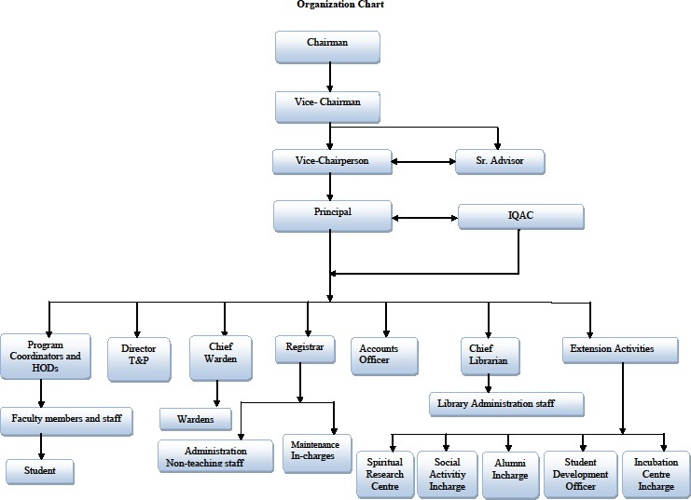
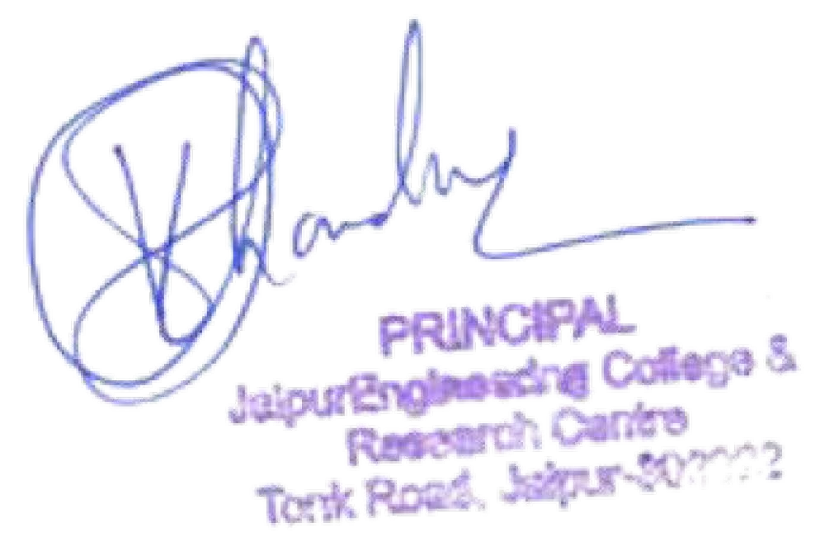

- NSERD (National Society for Engineering Research and Development Jaipur).
Members of society are governing body members include chairman vice chairman secretary, advisor and principal JECRC as invite member. The society member approve all the financial implementation to the institute and also look after the progress of institute from time to time and based on that approval and advise to the institute head is provided by society.

Delegation of Powers to the various Authorities:
The Chairman. JECRC Foundation, and the National Society for Engineering Research and Development, has directed me to convey the delegation of powers to the various authorities working in the NSERD promoted institutions. Our Esteemed Chairman is of the view that the College Principal and the Registrar should have adequate powers so that they are in a position to comply with the requirements of the regulatory and supervising bodies, and conduct day-to-day affairs in a positive and peaceful manner, under their own authority and signatures.
With a view to ensuring smooth and unambiguous functioning of the colleges, viz., Jaipur Engineering College and Research Centre and the delegated powers / authority are detailed hereunder:

Principal
  - As Head of the Institution, he shall exercise his authority for institution building. He will act as Competent Authority for all Faculty Members and Officer staff and be responsible for overall human resource management their appointment, utilization, retrenchment, termination, disciplinary action. etc. He will exercise signing powers as Competent Authority.
  - He will act as superintendent and guide for all items of work related to AICTE RTU (Affiliating University), UGC. MHRD. Technical Education Department GOR,State Level Fees Determination Committee, and other regulatory or higher bodies.
  - Establish a climate in which faculty members and the students can develop self-discipline, and promote research.
  - To formulate the Budget and assess the infrastructural and other requirements well in advance and get the same approved from the Secretary, NSERD before execution.
  - Impress amount of Rs. 1.00,000/- (Rs One Lakh Only) is also delegated for routine exercise.

Registrar
  - He shall act Competent Authority for all office and sub-staff, and exercise signing powers as competent authority for their appointment, utilization. Retrenchment, termination, disciplinary action. etc.
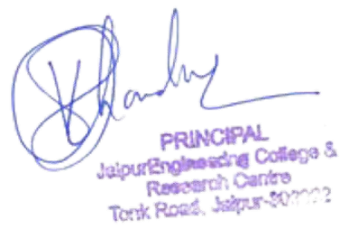
  - He shall act as Compliance Officer to fulfill the regulatory guidelines etc. of AICTE. Will (Affiliating University), UGC, MHRD, Technical Education Department GOR, State Level Fees Determination Committee, and other regulatory or higher bodies. He shall act as signing authority in all such matters.
  - The Registrar shall be the custodian of records and property of the college, and be directly responsible to the Director/Principal of the College for the proper discharge of his duties and

functions, and exercise such other powers and perform such other duties as may be assigned to him by the Director/Principal.
  - In the absence of Director / Principal, all powers shall vest in Registrar and he shall exercise the authority and signing powers of the Principal including Competent Authority for Faculty Members, etc.

Board of Governor (BoG)

The trust and society has a Board of Governor which assists Board of trustees for management of the college activities. The of Governance also comprises of scientists of national repute, renowned academicians and eminent personalities from Industry. The committee assumes a role of Intellectual leadership and evaluates new scientific perspectives. It evolves policies and strategies for generation of innovations and development of technical programs. The main work of this committee is to give vision about new technology and courses that are to be initiated at the trust. It comprises of the Chairman, Member Secretary and the principals of and various institutes.
In addition the BoG shall have:

Board of governance as per AICTE that include chairman, head of institute as secretary, 2-5 senior faculty members , nominated members from AICTE, affiliating university, state of government, invited members from other universities, invited parents, invited industry person,

Its Primary responsibilities include

Secretary presents the report of institute as:-

  - Planning and policy development
  - Review of non –budgeted expenditures
  - Approval of major infrastructural changes
  - Financial and legal compliance
  - Publicity
  - Appointment of members of the governing boards
  - Review of Institutional Budgets
  - Starting new courses or departments or institutions if any to the member and the minutes of meeting of the same are sent to NSERD for approval.
Committees are as follow:-
- NSERD ( National Society for Engineering Research and Development Jaipur)
- Board of Governors (As per AICTE)
- Grievance Redressal Committee
- Anti Ragging Committee
- Anti Ragging Squad
- Women Cell Committee
- Student Disciplinary Committee
- SC/ST Committee
- IQAC Committee
- Sexual Harassment Committee

Grievance Redressal Committee
Established to handle the grievances from various stakeholders such as students, faculty, parents and others. The cell will pay special attention to women’s issues, student issues and any difficulties on SC/ST students.

Composition
- Principal as chairperson
- Member nominated by Governing Body Registrar
- 3 Members of Senior Faculty at least one of whom should be a female
- Controller of Examinations
- Member of Non teaching Staff
- Member of External NGO

Objectives To provide an avenue for the aggrieved students to redress their individual grievances to promote a healthy atmosphere among students, staff and management

Responsibilities
The Committee is responsible to
- To receive complaints and grievances from faculty, staff and students regarding employment, administration and academics
- Maintain all files pertaining to the grievances redressing activities
- Meet once a month or more often if the situation demands, to discuss any grievances to discuss and resolve the grievances, if any received in writing from students maintain the minutes of the meetings and brief the Principal.
- Recommend to the Principal any action that needs to be taken in case of any serious or sensitive issue
- Convey the decision of the Principal to the aggrieved students in writing

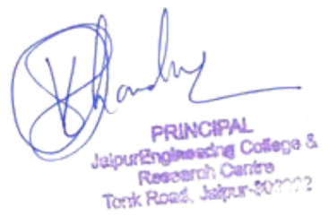

Anti Ragging Squad
Composition: - The anti-ragging squad will comprise of the following:-

- Principal
- 2 HODs
- faculty members(preferably 2 male and 2 female)
- Respective Hostel Wardens
- Non teaching staff

Roles and responsibilities of Anti-ragging squad shall carry out the following functions:-

- It shall work under the overall guidance of the Anti-Ragging Committee
- The Squad shall have vigil and patrolling functions.
- It shall be kept mobile, alert and active at all times and shall be empowered to inspect places of potential ragging and make surprise raids on hostels and other hot spots.
- It will conduct regular and surprise checking at various places, hostels and class rooms from time to time, and will appraise the ARC.
- It shall carry out on-the-spot investigation into any incident of ragging and make recommendations to the ARC.
- It shall conduct anonymous random surveys among freshers to check whether the Campus is indeed free from ragging.
- It shall ensure that anti-ragging posters are displayed in designated places.
- It shall occasionally dine with the newcomers in the hostels to instill confidence among them.
- It shall provide a report to the Anti-Ragging Committee every day for the first month and thereafter as directed by The Dean.

Women Cell Committee
Composition:

  - Senior lady/employee
  - From NGO/Outside activist
  - Legal representative
  - Faculty member
  - Staff/ member secretary

Roles and responsibilities of women committee shall carry out the following functions:-

- Create and sustain a community of learning in which girls acquire knowledge and learn to apply it professionally.

- To create a friendly environment, integrated with education, in establishing centers of excellence and sharing knowledge in all areas.

- To provide solutions to their problems related to academics and general and make them dynamic.

- To develop them physically and mentally on par with changing trends in society through their hidden talents. To improve their integrated development through inspiration for women empowerment.

Student Disciplinary Committee
Composition:
  - 4 HODs
  - Proctor
  - Chef proctor
Roles and responsibilities of student disciplinary committee shall carry out the following functions:-
  - To take care of healthy, enjoyable and disciplined culture in the institute. It comprises of the Principal, HODs, and Senior Faculty members.

SC/ST Committee:
The scheduled Caste (SC) and Scheduled Tribes (ST) Cell in an institute promotes the special interest of students in the reserved category and to provide special inputs in areas where the students experience difficult.
The cell regularly have to conduct remedial coaching classes on life skills, personality development, writing assignments and making presentations and also have to organize interactive sessions and informal meetings with students to attend to their personal, social and academic problems.
The SC/ST/OBC/PWD students can approach the Section Officer/Liaison Officer of the Cell for redressal of any grievance(s) regarding academic, administrative or social problems. The Section Officer/Liaison Officer will meet the concerned students, understand their problem and take necessary action and/or render them necessary advice/help to resolve the matter.

Objectives:
  - Circulate GOI and Commission’s decisions and to collect regularly, on an annual basis, information regarding course-wise admissions to candidates belonging to the Scheduled Castes and Scheduled Tribes in the College.
  - Analyze information on admissions, education, training and employment of SCs and STs; prepare reports for transmission to the Ministry of Human Resource Development/University Grants Commission and such other authorities as may be required.
  - Function as a Grievances Redressal Cell for the grievances of SC/ST students and employees and render them necessary help in solving their academic as well as administrative problems.
  - To promote higher education among these two communities suffering economic, social and educational deprivations

IQAC Committee
From its inception, JECRC has been a quality conscious institution in all its actions and dealings and it has been the uppermost concern and thrust, and its motto
The core values, JECRC abides by are derived from the vision and the efforts to realize it, are
- Accountability and service to all stakeholders
- Integrity and fairness in all practices
- In still innovation and creativity
- Inclusiveness and care for the marginalised
- Resilience and sustainability
- Striving for quality and excellence in all actions
- Thought leadership and quality consciousness
The IQAC-vision, objective, strategies, functions, and benefits to JECRC are stated in the IQAC Policy. JECRC IQAC Committee is constituted accordingly. It is the prime responsibility of IQAC to initiate, plan and supervise various activities that are necessary to increase the quality of the education imparted in an institution or college.
The structure of IQAC in JECRC was finalised as given below according to the directives of NAAC
- Chairperson Principal
- Management Representative
- Administrative Officer
- Teachers (8) including Controller of Exams, Librarian and Training and Placement Officer, NBA coordinator
- Local Society representative
- Alumni Representative
- Parents Representative
- Students Representative
- Industry Representative
- IQAC Coordinator

Anti Ragging Committee
Composition: - The anti-ragging squad will comprise of the following:
  - Principal
  - SHO
  - Civil Admin(revenue/ Civil/Officer)
  - Official of NGO
  - Representatives of students faculty members
  - Representatives of students boys
  - Representatives of students girls
  - Representatives of students non teaching staff
To uphold and comply with the directions of the Hon’ble Supreme Court and be vigilant on nay acts amounting to ragging
  - To publicize to all students and prevalent directives and the actions that can be taken against those indulging in ragging
  - To consider the complaints received from the students and conduct enquiry and submit report to the Anti- Ragging Committee along with punishment recommended for the offenders
  - Oversee the procedure of obtaining undertaking from the students in accordance with the provisions
  - To offer services of counseling and create awareness to the students
  - To take all necessary measures for prevention of Ragging inside the Campus/ Hostels.

Objectives
- To develop a system for conscious, consistent and catalytic action to improve the academic and administrative performance of the institution.
- To promote measures for institutional functioning towards quality enhancement through internalisation of quality culture and institutionalization of best practices.

Responsibilities
- Ensuring timely, efficient and progressive performance of academic, administrative and financial tasks;
- The relevance and quality of academic and research programmes;
- Equitable access to and affordability of academic programmes for various sections of society;
- Optimisation and integration of modern methods of teaching and learning;
- The credibility of evaluation procedures;
- Ensuring the adequacy, maintenance and proper allocation of support structure and services;
- Sharing of research findings and networking with other institutions in India and abroad.
- To keep track of the departments that are accredited by the NBA and ensure that those departments maintain the standards of the NBA
- To complete the NBA-pre qualifier every year for the departments not accredited by the NBA and notify the principal and CDC when any department becomes eligible for accreditation.

Functions
- Development and application of quality benchmarks/parameters for various academic and administrative activities of the institution
- Facilitating the creation of a learner-centric environment conducive to quality education and faculty maturation to adopt the required knowledge and technology for participatory teaching and learning process
- Arrangement for feedback response from students, parents and other stakeholders on quality- related institutional processes
- Dissemination of information on various quality parameters of higher education
- Organization of inter and intra institutional workshops, seminars on quality related themes and promotion of quality circles
- Documentation of the various programmes/activities leading to quality improvement
- Acting as a nodal agency of the Institution for coordinating quality-related activities, including adoption and dissemination of best practices
- Development and maintenance of institutional database through MIS for the purpose of maintaining /enhancing the institutional quality
- Development of Quality Culture in the institution
- Preparation of the Annual Quality Assurance Report (AQAR) as per guidelines and parameters of NAAC, to be submitted to NAAC

Benefits
IQAC will facilitate / contribute
- Ensure heightened level of clarity and focus in institutional functioning towards quality enhancement
- Ensure internalization of the quality culture

Recruitment Policy and Procedure

The same can be found in JECRC Faculty Handbook

Policy
- All Academic faculty and staff recruited should be able to fulfill our Vision, Mission and organizational goal.
- Towards achieving our goal the Organization is committed to train and develop our teachers and provide all facilities to them to grow to their potential. Our HR policies are directed towards this goal.
- In terms of our policy, manpower requirement is decided well in advance of the academic year/semester by the Principal in consultation with Heads of Departments and Coordinators of various streams.
- Rigorous procedure is put into operation so that we are able to locate the best talent. Our recruitment procedure is in line with University requirements.

Procedure
Normal Appointment
- Advertisements inviting application are given in the prominent newspapers.
- Applications received are screened by the Registrar in terms of qualification and other requirements. Potential candidates are invited for an interview before an interview panel.
- Interview panel for faculty consists of the Principal/Director, Subject Expert invited from other college, Heads from the Institute and a Management representative.
- Candidates cleared by the panel are asked to undertake demonstration lectures on the subjects he/she is comfortable with.
- After demonstration lecture feedback of the students on the lecture is taken to decide the suitability of the candidate.
- The candidate finally selected is briefed about the policies and rules of the institution.
- Once the candidate decides to join the Institute his/her application is forwarded to Registrar for appointment and inclusion of his/her name in the register.
- The final appointment order will contain the final terms and conditions of employment.
- All new faculty and staff members shall be on a probation basis for a minimum period of 2 years or more. Employees on probation are not eligible for all the benefits that are granted to regular employees.

Approval of Faculty by the University
The institute will ensure that, within the best of its capacity and within the rules the affiliating university approves all the faculties. Even in case a faculty fails to obtain the approval of the University, despite possessing the necessary qualifications, experience, and competence, he/she shall be treated at par with other approved faculty in terms of pay, allowances and other benefits.

