Administration
Administration looks after students and staff member’s attendance
  - To achieve the target of Paperless IQAC, committee members of it started using Google facilities like
- Google sheet: - For data collection from Various Departments.
- Google Docs: - To prepare notices and activity reports.
- Google Forms: - To prepare Feedback forms and get online feedbacks of Students, Parents other stake holders.
- Google Drives: - To keep all department wise proofs.
  - The college has Biometric attendance for teaching and non-teaching staff.
  - The college campus is equipped with CCTV Cameras installed at various places of need.
  - ICT has been introduced in the Administrative work.
  - College staff uses Smartphone with inbuilt social app like Gmail to communicate.
  - WhatsApp Group helps to provide the brief notices of any event to be happened on college.
  - WhatsApp Groups are also used for awareness and of smooth functioning of the same.

- Library: - Institute library is automated by using Library Automation Software Alice for Windows; it is an Integrated Library Management System (ILMS).

- Faculty Attendance:- Attendance records are maintained through face reading machine by name Real Time T304F.

Student Admission & Support:
Admission are processed through centralized online process -
  - Information to students are disseminated through SMS and WhatsAPP Messages.
  - A Dedicated email-info@jecrcmail.com continuously informs students and reply their specific queries.
  - Campaign on social media primarily on facebook is used to make a digital connect with the students. The information about students and their queries are fetching from Google sheets shared with the campaign.
  - During the joining, every new student is provided with unique college ID to share all important official information throughout his course with the institute.
  - Students are also providing with facility to submit the fee through online mode. After joining, students are provided with a Unique ID with which students can submit their fee for remaining semesters.

Finance and Accounts:
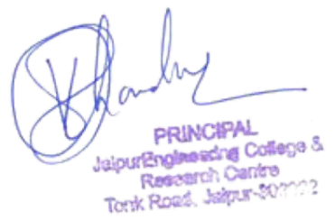
Tally software (Tally ERP 9) is used for finance & accounts related work. With the aim to produce immediate information in finance and Accounts i.e.”Single Click Accounting” , this section of College is partially e- governed. The college uses the Arihant computers, Tally ERP 10 for the transparent functioning of Accounts department.

1 | P a g e

Examination
Automation of examination work: Examination related activity handled by the help of RPA Examination Bot. Bot is an RPA Software developed by the students of CSE to perform tasks of examination like room wise seating plan and duty chart.
Examination BOT: Paperless communication between Exam and other departments, Examination section uses “Examination Bot” Software. Generate various reports like
- To generate seat Numbers
- To generate class wise roll call list for all classes
- Print the exam seat number wise List
- Seating Arrangement for University Exams. Screenshot of examination Bot:

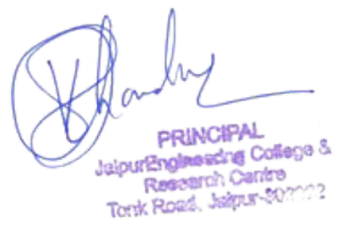

2 | P a g e

