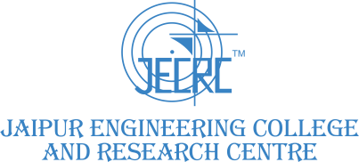

3.1.1 Grants received from Government and non-governmental agencies for research projects / endowments in the institution during 2022-23.

S.  No | Name of the Project/ Endowments, Chairs | Name of the Principal Investigator  /Co- investigator | Departm ent of Principal Investiga tor | Year of Award | Amount Sanctio ned (Lakhs) | Durati on of the project | Name of the Fundin g Agency | Type (Governmen t/non- Government  ) | Link
1 | Up-skilling Science and Logic learning for the youth of Jaipur rural area An Endeavour to Enhance learning through Scientific Convention(TPN /  63324) | Dr. Shruti Kalra / Dr. M.P.Singh | ECE & ME | 2022-23 | 25.69 | 1 Year | DST | Government | View

